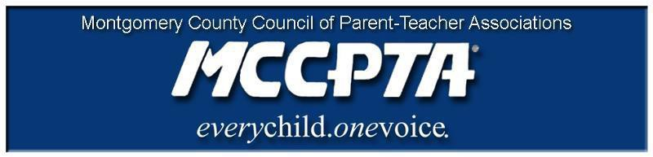

DELEGATES’ ASSEMBLY MEETING AGENDA
Tuesday, March 22, 2022
Meeting Held on Zoom

7:00 pm WELCOME

- Approve Agenda; Approve February 2022 Minutes

7:05 pm INFORMATIONAL UPDATES

- National/MDPTA Update/Delaware PTA
- MCCPTA Processes for Conducting Business
- Election Primer
- MCPS Antiracist Audit Survey - https://maec.iad1.qualtrics.com/jfe/form/SV_bdUgwBrm5eGbtNc

7:25 pm NEW BUSINESS

- MCCPTA Statement on Sexual Abuse
- Year-Round Education Discussion
- Budget Amendment – Vax Grant

8:05 pm OFFICER REPORTS

- Cynthia Simonson, President
- Rodney Peele, Vice President- Educational Issues
- Rochelle Fink, Vice President- Administration
- Charisse Scott, Vice President- Programs
- Laura Mitchell, Vice President- Advocacy
- Francesco Paganini, Treasurer
- All Reports - Committee Reports

8:30 pm COMMITTEE REPORTS

- Health & Wellness Committee Update
- Bylaws Committee
- Membership Committee
- All Reports – Committee Reports

8:55 pm ANNOUNCEMENTS & ADJOURNMENT

DATES:

- April 6, 2022 – BOD Meeting, 7 pm on Zoom
- April 25, 2022 – League of Women Voters Candidate Forum, 7 pm
- April 26, 2022 – Delegates Assembly Meeting, 7 pm on Zoom
- May 11, 2022 – Delegates Assembly Meeting, 7 pm on Zoom
- May 15, 2022 – Celebration of Excellence
- June 8, 2022- BOD Meeting, 7 pm on Zoom

