Dr. Debora Fox-McClary, MD, MBA, FACS, FASCRS

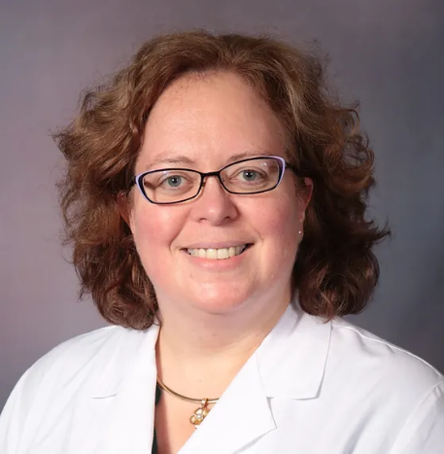
Colon & Rectal Surgery, General Surgery, Robotic and Minimally Invasive Surgery

Dr. Fox-McClary grew up in Western Washington state near the U.S.-Canadian border. She attended Central Washington University for college, where she obtained a BS in Biological Sciences and a BA in Chemistry. She attended the University of Washington School of Medicine for her Medical Doctor (M.D.) degree. During college, she took a break and enlisted in the U.S. Navy as a hospital corpsman, returning home after a brief period of active duty to the reserves. After completion of medical school, she received a commission as a medical officer, continuing in the reserves until 2007, when she resigned as a Lieutenant Commander (O-4) in the Medical Corps. She completed residency training in General Surgery at the Mayo Clinic in Rochester, MN in 1999 and fellowship training in Colon and Rectal Surgery at the Mayo Clinic in Rochester, MN in 2000. She practiced for eight years in Bellingham, WA, then moved here to the valley in 2008 with her husband and children. Her youngest children were born here in Arizona. She completed an MBA with an emphasis in health care administration in 2021 at Grand Canyon University.
Dr. Fox-McClary is board-certified and actively practices in both specialties of General Surgery and Colon and Rectal Surgery. She focuses on surgical treatment of diseases of the colon, rectum, and anus, such as diverticulosis, colorectal cancer, perianal fistula disease, hemorrhoids, and inflammatory bowel disease, as well as general surgical issues such as surgical treatment of hiatal hernias and abdominal wall hernias. She has extensive experience with minimally invasive and robotic surgery, as well as UGI endoscopy and colonoscopy. Dr. Fox-McClary is a surgical proctor on robotic systems, training other surgeons in this method of minimally invasive surgery. She is a fellow of the American College of Surgeons, a fellow of the American Society of Colon & Rectal Surgery, and an Associate Professor of Surgery at Midwestern University Medical School in Glendale, AZ.
Dr. Fox-McClary enjoys her time off with her husband, Joey, a Kroger employee, and four girls: Ella, Becca, Mia, and Tia. She loves crafting, all science fiction, anime-cons with her teenagers, the hot days of Arizona, and RV camping.

Phoenix Unified Surgeons
20333 N 19th Avenue, Ste 230
Phoenix, AZ 85027-9901
(480) 707-9504 Office

