LANGDON DAYS PARADE 2022

PARADE INFORMATION

Thank you for participating in this year’s Langdon Days Parade we hope that you will have a day full of fun
and fond memories.

To assist us in operating in an efficient and safe manner, we ask that you follow these guidelines:

- PARADE BEGINS AT 10:00 A.M. on Saturday, July 23, 2022
- Entries are asked to line up between 9:10 am and 9:30 am. Please check in at our “check-in table” in the parking lot where you will be given instructions on where to line up.
- Please be on time. Floats will be judged for best in show (effort, signage, theme, and overall coolness) from 9:30 am – 9:50 am, and the winners presented with their award. The winning float can display their award during the Parade. Good Luck!!
- We ask that you use all due caution with your float to ensure the safety of all participants, both on and off your float. Only participants between the ages of 5 – 65 years of age are permitted to walk the parade route (younger or older participants may ride in vehicles or on floats). Please remember that your vehicle and float need to be adequately insured. CHILDREN participating in the parade MUST be supervised before, during and after the parade.
- We ask that you show due consideration and respect to your audience along the parade route. If you are distributing candy or other items “to the crowd”, please “handout” with care and distribute to ensure coverage of the entire route from start to end. Again, we ask that you use due caution as children may run onto the road to get these items. Child Safety along the route must be a FIRST CONSIDERATION.

HAVE A GREAT DAY!

For information please contact: Langdon.Days@goodlucktown.ca or visit www.goodlucktown.ca

PARADE ENTRY FORM – Saturday, July 23, 2022

Come join in the fun by completing this entrance form and the waiver (page 3). Print, scan and email or print and mail your completed entry to the address below.

Please check one:

☐ FLOAT ☐ MARCHING GROUP ☐ VEHICLE(S) ☐ LIVE ANIMALS

Please add a description of the entry (i.e. Commercial, Association or Club, Vintage Vehicle, type of Animals, Tractors, music, etc.)

☐ CHECK HERE IF YOU ARE ENCLOSING A MONETARY DONATION TO HELP KEEP LANGDON DAYS RUNNING!
(Note: No entry fee is required and this does not affect position in the parade or eligibility to win award for Best in Show).

☐ CHECK HERE IF YOUR FLOAT WILL HAVE MUSIC OR LOUD SOUNDS ASSOCIATED WITH IT.

Name of Organization/Sponsor:
Name(s) of Participant(s):
Please include a separate list if insufficient space
Contact Person Name:
Contact Person Mailing Address:
Contact Person Phone:
Include area code
Email:
Description of Services You Will Be Providing:

Thank you for your participation – we couldn’t do this without you!

For more information please contact:
Langdon Days website information: www.goodlucktown.ca
Langdon Days Parade Committee
Email: Langdon.Days@goodlucktown.ca
Langdon Days Committee
Box 134, Langdon, AB T0J 1X0

LANGDON DAYS PARADE 2022
WAIVER AND RELEASE OF LIABILITY

In consideration of being allowed to participate in any way in the activities of Langdon Community Association, (the “LCA”) during Langdon Days 2022 the undersigned acknowledges, appreciates, and agrees with the LCA that: The risk of injury from the activities involved, is significant, including the potential for permanent paralysis and death; I knowingly and freely assume all risks in relation to my participation in such activities, both known and unknown, even if arising from the negligence of the Releases or others, and assume full responsibility for my participation; and I willingly agree to comply with the stated and customary terms and conditions for participation. If however, I observe any unusual or significant hazard during my presence or participation, I will remove myself from participation and bring such to the attention of the nearest official immediately; and I, for myself and on behalf of my heirs, assigns, personal representatives and next of kin, hereby release, indemnify and hold harmless the LCA and their respective agents, servants, volunteers, employees, directors and officers (collectively, the “Releases” with respect to any and all claims, demands, causes of action which are in any way connected with my involvement or participation in such activities, whether caused or contributed to be the negligence of the Releases or otherwise.

I HAVE READ THIS RELEASE OF LIABILITY AND ASSUMPTION OF RISK AGREEMENT, FULLY UNDERSTAND ITS TERMS,
UNDERSTAND THAT I HAVE GIVEN UP SUBSTANTIVE RIGHTS BY SIGNING IT, AND SIGN IT FREELY AND VOLUNTARILY WITHOUT
INDUCEMENT IN _____________________ (City, Province) DATED THIS ___________ DAY OF ________________, 2022.

Participant Name – Print | Participant Signature

Organization Name | Organization Address

Witness Name – Print | Witness Signature

Alternate/Emergency Name | Phone Number

LANGDON DAYS 2022 – PARADE ROUTE

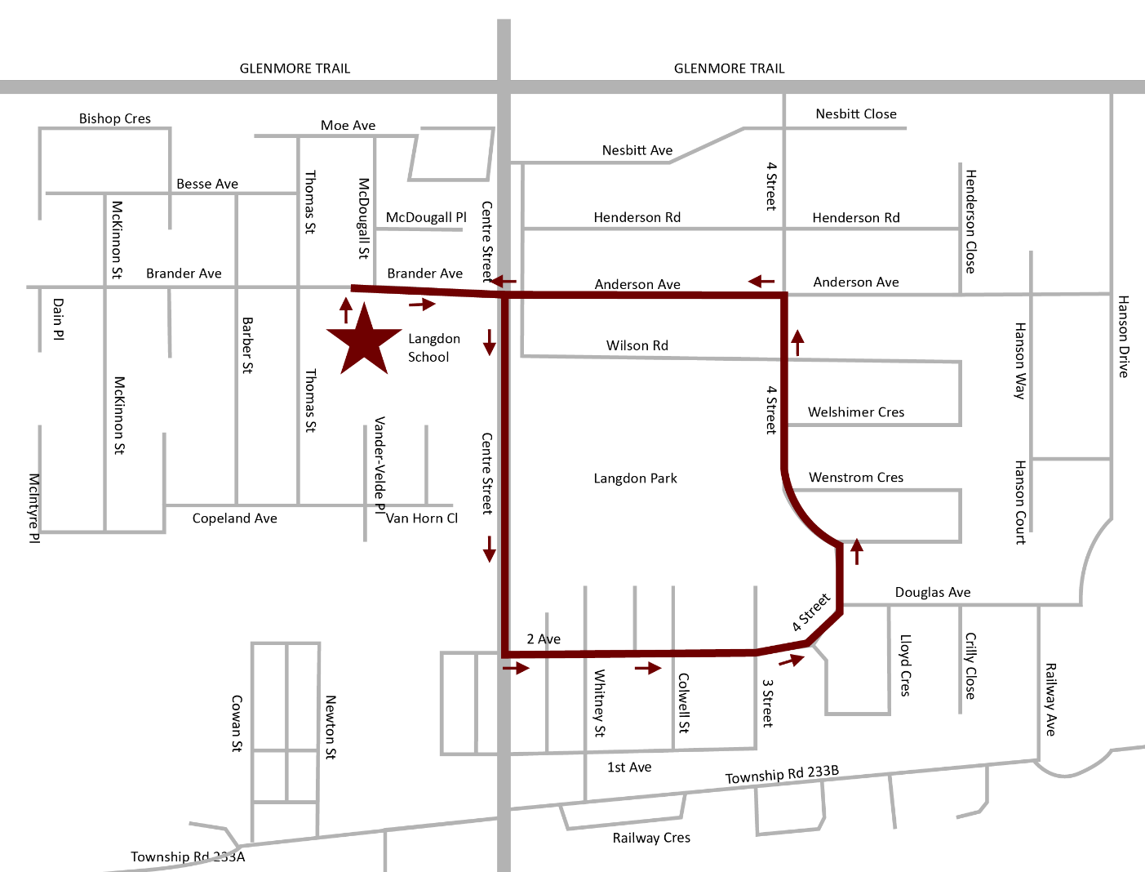

Road will be closed from 9:30 am – 10:45 am
Parade Start and End
Parade Route
Float staging area

