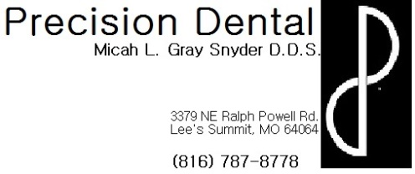
Prescribed Medications.
- Review proper use and dose of your prescribed medications before taking them.
- Be aware of possible side effects associated with medications (these were discussed at your appointment) and never hesitate to contact the office with any questions or concerns.
  - Rash, hives, difficulty breathing, itching and severe diarrhea are potential side effects that would require that you stop taking the medication and contact Emergency Services, if you feel your life is at risk, or our office for consultation.
  - Diarrhea, constipation, and upset stomach is unfortunately a common side effect of many medications, try eating something before taking your medication. Some people also benefit from adding a Probiotic pill, which can be found over the counter, or eating yogurt when taking antibiotics to help with digestive issues.
- If you were given both and antibiotic and a pain medication, remember: that the antibiotic is the most important prescription and that there were good alternatives for the pain medication over the counter, and if a decision has to be made between the two- the antibiotic must be the priority
- Antibiotics will not get rid of the infection, the only way to remove the infection is by removing the infected tooth or nerve in the infected tooth. The antibiotic is prescribed only to “keep the infection in check” until the proposed treatment can be completed. This means that it is vitally important that you keep your appointment for treatment. EVEN IF IT STOPS HURTING, OR THE SWELLING GOES DOWN IT DOES NOT MEAN THAT YOUR TOOTH IS BETTER! You will still require treatment to prevent the pain and swelling from returning.
- Multiple rounds of antibiotics can reduce efficacy and present further complications so prompt treatment of offending tooth is needed.
- Always finish your Antibiotics unless specifically told by Dr. Snyder to do otherwise.
- If you were given a pain medication, remember not to drink alcohol, drive/operate heavy machinery, or sign any important documents while under the influence of the medication.

