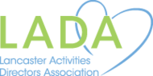
2024 LADA’s
IN-PERSON Conference


Seminar Cost Details:
LADA Member Fee ~ $65

Non-Member Fee ~ $75

Deadline to Register for the LADA Annual Conference is:
Monday, April 22, 2024
Join us for our IN-PERSON Conference!
What: LADA Annual Conference
When: Wednesday, May 8th from 8am-4pm
Where: Wood Crest Villa Viva Center
2001 Harrisburg Pike Lancaster PA 17601

Full Conference Attendance will offer 6 CE’s
(Pending approval through NCCAP)

Conference Schedule:
- 7:45am – Sign-In Starts for Conference Attendees
- 8:15am – Welcome by Hope Long, LADA President
- 8:30am-10am – CEU Session 1: “Stress Management &
Compassion Fatigue” with Lori Dierolf
- 10:00am – Morning Break
- 10:15am-11:45am – CEU Session 2: “Enhancing Lives of Residents
Living with Dementia” with Katie Erb
- 11:45am-12:30pm – Lunch
- 12:30pm-2:00pm – CEU Session 3: “Management: Me, Them, & Us!”
with Danielle Griffith
- 2:00pm – Dessert Break
- 2:15pm-3:45pm – CEU Session 4: “Music is a Legacy” with Lisa Fairman
- 3:45pm – Gift Basket Raffle Drawings and Closing Remarks
- 4:00pm – Distribution of Certificates
- 4:15pm – Dismissal
Please be aware, because this is an IN-PERSON event – we will not be recording any of the sessions for later viewing/credit.

If you have any questions regarding the seminar, please contact:
Hope Long, LADA President at Hope.Long@stannesrc.org

Please fill out the bottom of this form for each registrant, and mail to the address below with your payment:
*** Please Note: Checks made payable to LADA ***
- - - - - - - - - - - - - - - - - - - - - - - - - - - - - - - - - - - - - - - - - - - - - - - - - - - - - - - - - - - - - - - - - - - - - - - - - - - - - - - - - - - - - - - - - - - - - - - - - - - - - - - - - - - - - - - - - - - - - - - - - -

Other Details:
We will be selling raffle tickets for baskets of goodies at the conference. Tickets will be 1 for $1, or 10 for $5.
- Continental Breakfast – Assorted pastries, fresh fruit and beverages will be available.
- Lunch – Hot Buffet Lunch and Salad
- Assorted Drinks and Desserts
- Please List Any Special Dietary Concerns: ________________________________________________________
_____________________________________________________________________________________________________________

Registrant Name: _____________________________________________________________________________
Address: ____________________________________________________________________________________
Phone: __________________________________ Email: _____________________________________________

Deadline: Please detach & return this with your check by Mon., April 22nd, 2024
*There will be no refunds, but registration is transferable. *
**If registration transfer is needed, please notify us ASAP, so our records can reflect the change. Thanks! **
Mail to: Pleasant View Communities Attention: Teresa Good
544 N Penryn Rd. Manheim, PA 17545

2024 LADA Conference

Meet Our Speakers for the
2024 LADA Conference:
Lori Dierolf, BA, SPHR, PCHA, CDP, CADDCT, CMDCP, CAEd – Lori spent thirty years as a Human Resources and Staff Development Professional in the long-term care industry. She is the author of two books, “Set the Course: Best HR Practices for Long-Term Care Leaders” and “Training Your Team for Dementia Care Excellence.” Since 2006, Lori has conducted seminars and on-site educational programs through her company, Open Door Training & Development, and she has been a favorite speaker at conferences throughout the country on the topics of leadership, team building, and dementia care. Her enthusiastic, interactive training style allows Lori to connect with her audience by engaging learners from beginning to end. Using real-life examples of her successes – and failures - as well as sharing lots of simple communication and leadership tips, Lori lives up to her reputation as being a true “Edu-Tainer!”
Katie Erb, BA, ADC/MS, CDP - Katie has worked in long term care for over 13 years in various residential care communities and brings her knowledge and extensive work experience with residents living with Dementia and other intellectual/physical disabilities. Katie is a Certified Activity Director with a concentration in Memory Support (ADC/MS) as well as a Certified Dementia Practitioner (CDP). Katie graduated from Gordon College in Massachusetts in 2011, with a bachelor’s degree in business administration, and she also earned two minors: Recreation & Leisure Studies, and Nonprofit Organization Management & Social Entrepreneurship. Katie has been a popular public speaker at seminars for staff and families, providing informative and inspiring person-centered Dementia education. She loves bringing joy to the lives of the individuals she works with, including their families and caregivers.
Danielle Griffith, BS/MEPAP INSTRUCTOR – Danielle Griffith has a BS Degree in Human Services from York College of Pennsylvania and has an AS Degree in Education. She also has 30+ years of experience – 25 years working in long term care, and 7 years working in psychiatry. She is still working full time in long term care. Danielle is Activity Consultant Certified (ACC) through NCCAP since 1991 and has been an NCCAP Instructor since 1998.
Elissa “Lisa” Fairman BA/RCC – Trained musician and music facilitator specializing in creating and delivering customized music programs for groups of all sizes featuring vocals, hand percussion, guided and sound meditations. Currently, Elissa is employed by WellSpan Philhaven inpatient psychiatric hospital where she provides interactive music programs in the units. She works prn at The Ranch PA as a Holistic Specialist providing guided meditation, sound meditation and music circles to adults in recovery. She is a certified Reiki Master and is self-employed providing customized music programs with her business Earth Rhythms LLC. She works with several non-profits to provide programs including creative writing, songwriting workshops and performances with veterans impacted by PTSD and after school music programs and performances with children impacted by parental incarceration. Singing and providing percussion accompaniment for the Music for Everyone Community Chorus is one of Elissa's great joys when not working. She sings and plays percussion as one half of a duo called Frankie Smiles. Prior to working with music full time, Elissa was a Registered Corporate Coach and a Regional Human Resources Manager.
Lori Dierolf
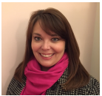
Katie Erb
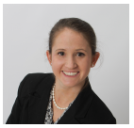
Danielle Griffith
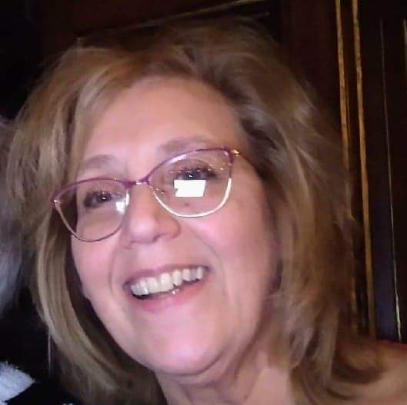
Elissa
Fairman
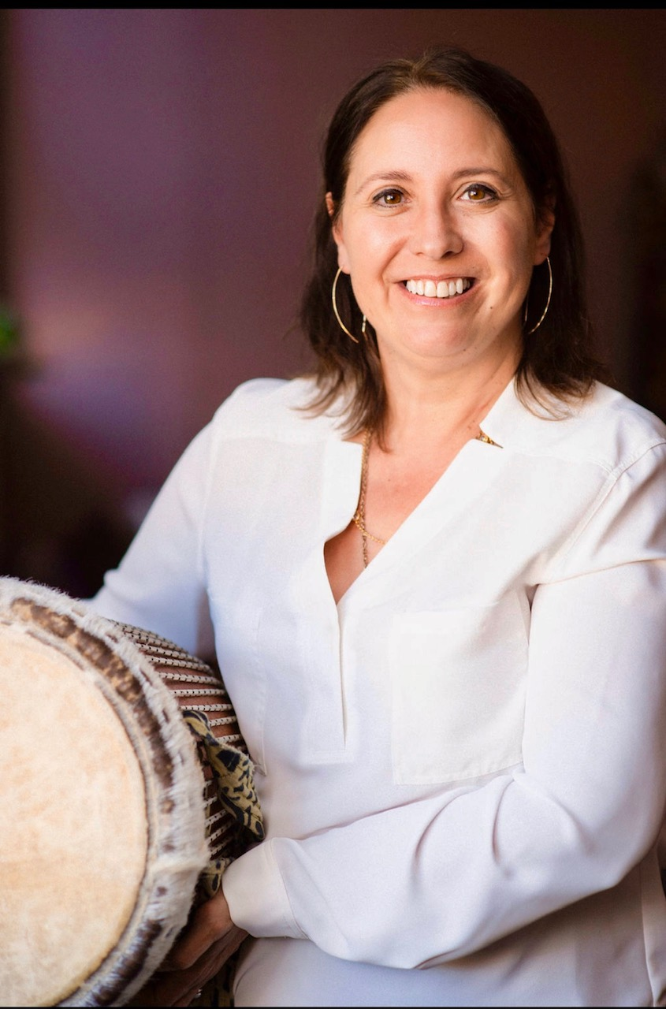

“Develop a passion for learning. If you do, you will never cease to grow.” – Anthony J. D’Angelo

If you have any questions regarding the seminar, please contact:
Hope Long, ADC, CDP, LADA President at Hope.Long@stannesrc.org

Session Descriptions for the Conference:
Wednesday, May 8th, 2024

CEU Session 1 ~ 8:30am-10am (1.5 CEU’s)
- Lori Dierolf, BA, SPHR, PCHA, CDP, CADDCT, CMDCP, CAEd
- “Stress Management & Compassion Fatigue”
  - Now more than ever, healthcare employees struggle with burnout, anxiety, and compassion fatigue. This session defines each, enables attendees to assess their personal stress, and offers eight strategies to combat stress every day!

CEU Session 2 ~ 10:15am-11:45am (1.5 CEU’s)
- Katie Erb, ADC/MS, CDP
- “Enhancing Lives of Residents Living with Dementia”
  - Katie Erb will be speaking on enhancing lives of residents living with Dementia through engaging and innovative education. This session will focus on improving communication, enhancing the dining experience, and supplies every Activity Department should have. Be prepared to engage with material in a fun and participatory way that leaves you saying afterwards, “I wish I had known this earlier!”

CEU Session 3 ~ 12:30pm-2:00pm (1.5 CEU’s)
- Danielle Griffith, BS/MEPAP Instructor
- “MANAGEMENT: ME, THEM and US!”
  - This session will assist you with helping to assess yourself, work with your team, and work with others. We will review management styles to help you understand the dynamics of others as well as yourself. With that, you will begin to understand the management needs of your direct staff to create a great team.

CEU Session 4 ~ 2:15pm-3:45pm (1.5 CEU’s)
- Elissa “Lisa” Fairman, BA/RCC
- “Music is a Legacy”
  - Sharing stories of music in our lives, music milestones, lead participants through experiential learning exercises with handheld instruments, what does music add to life including wellness benefits of music, examining relevant historical aspects of music, generational aspects of music, connections formed through music what does our music say about us, what is the musical legacy we want to give to the next generation.

B
The Lancaster Activities Directors Association…
… was established in 1980 to enhance the lives of elders by supporting, through networking and education, the people in Lancaster County and the surrounding area who work with them as activity professionals. Through monthly meetings, our website, and our annual conference, we provide opportunities for sharing new ideas and methods, working together to provide solutions to common challenges within our profession. We mentor those who are new to the profession and encourage all members to become highly qualified in the profession through certification and continuing education. We promote the work of activity professionals both within communities serving seniors and to the public. We encourage and support state and national participation within our organization.
To join, visit http://www.joinlada.org/join.html

