6/12/2018 Kim Jong Un and the Handwriting on the Wall

YaHuWaH Elohim ordains the conceptions and births of all human beings who will inhabit His creation.

There are some interesting relationships between the calculated conception dates of Donald Trump and Kim Jong Un that should get our attention.

There's a relationship between these two currently globally prominent men and the set apart (Holy) days instituted by YaHuWaH Elohim about 3,400 years ago.

The graphic below notes the births and calculated conception dates of Donald Trump and Kim Jong Un, 280 inclusive days before birth (40 inclusive weeks, the average human gestation period).

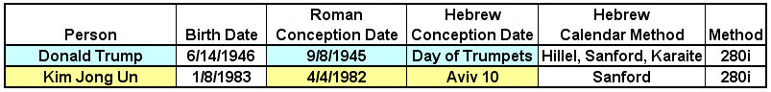

The "Sanford" method of calendar calculation noted in the graphic above is usually, but not always, the day between conjunction and the first observable sliver of the new moon.

This method of determining the 1st day of the Hebrew month might have been the method used in the time of King David.

William Sanford didn't invent the 'book-end" method of calculating the 1st day of the Hebrew month, but it's named "Sanford" in the graphic for want of a different designation.

Mr. Sanford's website and contact information are available here: https://alephtavscriptures.com/

Note that Hillel Calendar Nisan 10 was 4/3/1982 and Karaite Aviv 10 was 4/5/1982. The "book-end" method used by Mr. Sanford identifies 4/4/1982 as Aviv 10, 1982.

The Hebrew Day of Trumpets noted in the graphic above was to be observed on the 1st day of the 7th month, a special Sabbath day set apart for the blowing of trumpets and the assembly of the congregation.

The Hebrew Day Aviv 10, the 10th day of the 1st month, was the day set apart by YaHuWaH Elohim for the selection of the Passover lamb. The Passover lamb would be inspected for disease and defects for 4 days. If found to be perfect , it would then be offered as an acceptable sacrifice to YaHuWaH Elohim four days later on the eve of Passover.

Kim Jong Un and the Handwriting on the Wall

The Handwriting on the Wall event that gave notice to the King of ancient Babylon that his kingdom was being taken away from him occurred on 10/11/539 BC.

Encoded into the Handwriting on the Wall, Mene Mene Tekel Upharsin, was the number value 2520.

Mene = 50 Shekels, Mene = 50 Shekels, Tekel = 1 Shekel, Upharsin = 1/2 Mene = 25 Shekels. The grand total was 126 Shekels which reduces to 2520 gerahs at 20 gerahs per shekel.

By using a Keisan calculator capable of accurately counting the number of days in 2520 years from 10/11/539 BC, we arrive at 10/4/1982 AD. The Keisan calculator can calculate from BC to AD accurately and also compensate for the 10 days removed from the Roman calendar in 1582 AD to arrive at a precise answer.
10/11/539 BC + exactly 2520 years = 10/4/1982 AD.

It happens that the calculated conception date of Kim Jong Un, 4/4/1982, falls precisely in the center of the 2520th year from 10/11/539 BC as indicated in the graphic below.

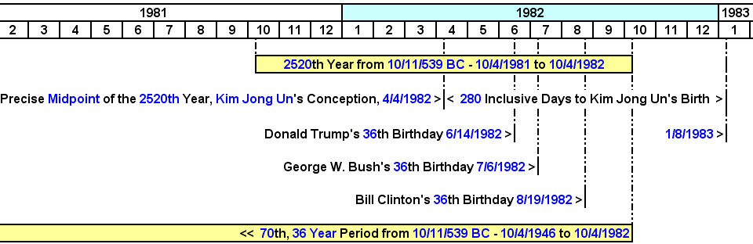

Kim Jong Un's calculated beginning of life falling directly in the middle of the 2520th year from the Handwriting on the Wall incident indicates a chiastic structure intentionally placed there by our Creator Elohim, YaHuWaH El Shaddai. He alone has the ability to order the generation of life in such a timely and prophetic fashion.

According to American records, Kim Jong Un was born on 1/8/1984. He was born on 1/8/1983 according to South Korean records. He was born on 1/8/1982 according to North Korean records.
American athlete Dennis Rodman reported Kim Jong Un's birthdate as 1/8/1983 after visiting personally with Kim Jong Un in North Korea. His birth on 1/8/1983 is also attested to by the graphic above showing the timely relationship with the ancient biblical event of the Handwriting on the Wall.

Note in the graphic above that 3 of modern Babylon's "Kings" completed their first 36 years of life in 1982, also during the 2520th year from the Handwriting on the Wall.

The number 36 was a special number in ancient Babylon, 36 being the number of Babylonian gods. Previous articles have pointed out that the Babylonian Magic Square had the numbers 1 to 36 in a special configuration where each row and each column added to 111, with the total of the numbers from 1 to 36 being 666.

The 2556th Year in 2017, 2018, 2019

The 2556th year from 10/11/539 BC is 10/4/2017 to 10/4/2018.

What's special about the 2556th year? It happens that 7 years of years = 2556.

There are 365.2422 days in a year.

If we count 365.2422 years as being 1 "year" then, 365.2422 years x 7 = 2556.6954 years.

The number 7 in the bible indicates completion and fullness.

So, 7 "years" from 539 BC should indicate some sort of a "fullness" for Babylon.

Know also that the extra .6954 year in the 2556.6954 quantity above brings the precise end of 7 "years of years" from 10/11/539 BC to 6/15/2019, six days after the Shavuot of 6/9/2019 that marks the period mentioned in Daniel as being 7 Shabua and 62 Shabua from the decree to restore Jerusalem given by the Knesset on 4/1/1969.

In the graphic below see that the 36th anniversary of Kim Jong Un's calculated conception was 4/4/2018, precisely in the middle of the 2556th year from 10/11/539 BC.

See also that 3 Babylonian "Kings" have their 72nd (twice 36, "double unto her double" Revelation 18:6) birthday anniversary in 2018. This means that all 3 men, Trump, Bush, and Clinton, have the 2520th year from 539 BC, 1982, as the fulcrum of a balance scale in their lives.

The king of ancient Babylon was "weighed in the balances and found wanting" in the interpretation of the Handwriting on the Wall that Daniel gave to Belshazzar. Now three Babylonian kings are being weighed in the balances of their 72 year lives. They're being weighed with the 2520 year quantity also encoded into the Handwriting on the Wall being the fulcrum of the balance.

Note also that President Obama is missing from the ancient Babylonian "36" Presidential timing arrangement ordained by YaHuWaH Elohim. Humm.

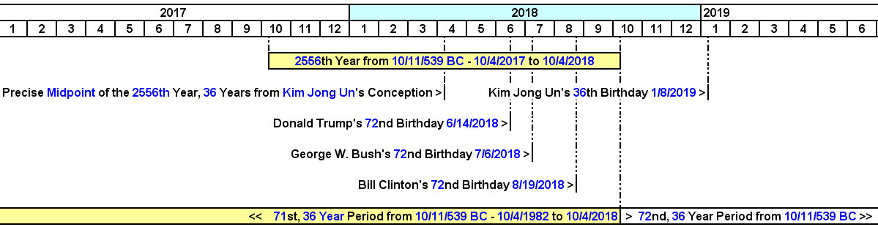

The Signs of Osiris Rex

Without digressing too far, the 71st anniversary, and also the 1st day of the 72nd year, from Donald Trump's calculated conception date of 9/8/1945, the Day of Trumpets, was 9/8/2016.

Know that 9/8/2016 saw the launch of the Osiris Rex space mission. The name "Osiris Rex" means "King of the Dead" or "god of the dead", Osiris being and ancient god.

So, the "King of the Dead" space mission was launched on the day marking the 1st day of the 72nd year from Donald Trump's calculated conception date of 9/8/1945.

The Osiris Rex space mission flew past the earth on the Karaite Day of Trumpets, 9/22/2017, to get a gravity speed boost from the earth in order to reach asteroid 1019550 Bennu in 11/2018. Bennu is the name of an Egyptian god being like the Greek god Phoenix, the name Bennu meaning "to rise brilliantly".

Osiris Rex (god of the dead) will return to earth on the eve of Yom Kippur, the Hebrew Day of Atonement, 9/24/2023, with samples from the asteroid Bennu (rise brilliantly).

Note the biblical associations revealed above between the Osiris Rex mission and Donald Trump's Day of Trumpets calculated conception, the speed boost on the Karaite Day of Trumpets 9/22/2017, and the scheduled return to earth on the eve of the Day of Atonement, 9/24/2023.

Blessed be YaHuWaH Elohim, revealer of secrets, and His Son YaHuShua, King of Kings.

