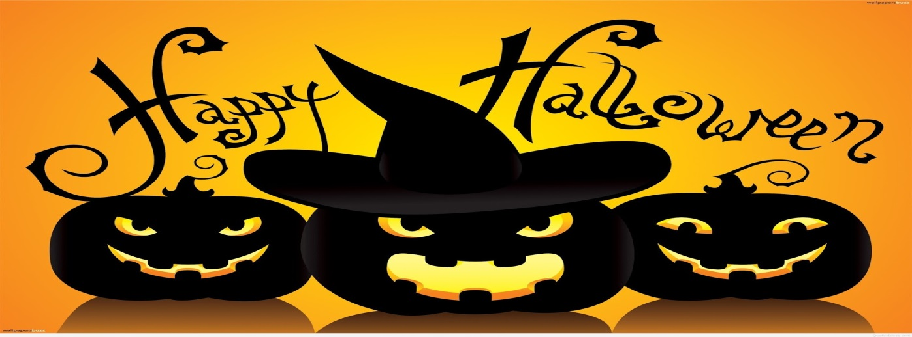
Stationary Appetizers
Halloween Chex Mix
Scarecrow Taco Dip
Baked Brie
NY Reuben
Artichoke Dip with Pumpkin Chips
Asian Chicken Served in Pineapple
Tortellini Skewers
Peapods Filled with Salmon & Dill
Passed Appetizers
Mummy Dogs
Crab Cakes with Remoulade Sauce
Fresh Figs Stuffed with Rosemary & Goat Cheese
Baby Back Ribs
Ghostly Pizza Wedges
Seared Tuna with Wasabi Cream
Desserts
Mini Pumpkin Cheese Cakes
Creepy Witches Fingers

