Mars UP Church

Apostles’ Creed
I believe in God the Father Almighty, Maker of heaven and earth; and in Jesus Christ His only Son our Lord; who was conceived by the Holy Ghost, born of the Virgin Mary, suffered under Pontius Pilate, was crucified, dead and buried; He descended into hell; the third day He rose again from the dead; He ascended into heaven, and sitteth on the right hand of God the Father Almighty; from thence He shall come to judge the quick and the dead. I believe in the Holy Ghost, the holy catholic church; the communion of saints; the forgiveness of sins; the resurrection of the body; and the life everlasting. Amen.

Gloria Patri
Glory be to the Father, and to the Son, and to the Holy Ghost. As it was in the beginning, is now and ever shall be,
world without end.
Amen. Amen.

Come Holy Spirit, Come
Before the Service – Speak to God!
During the Service – Let God speak to you!
After the Service – Speak to each other!

(*Please stand, if able)
Prelude A Mother’s Prayer

Welcome and Mars Messages

*The Call to Worship Adapted from Proverbs 31
Leader: A wife of noble character, is worth far more than
rubies.
People: She sets about her work vigorously; her arms
are strong for her tasks.
Leader: She opens her arms to the poor and extends her
hands to the needy.
People: She is clothed with strength and dignity; she can
laugh at the days to come.
Leader: She speaks with wisdom, and faithful instruction is
on her tongue.
People: She watches over the affairs of her household
and does not eat the bread of idleness.
Leader: Her children arise and call her blessed;
People: “Many women do noble things, but you surpass
them all.”
Leader: Charm is deceptive, and beauty is fleeting; but a
woman who fears the Lord is to be praised.
People: Honor her for all that her hands have done, and
let her works bring her praise at the city gate.

Opening Prayer

*Hymn
“This is Amazing Grace”

Scripture Acts 17:22-31
The
Lord’s Prayer

Our Father,
who art in heaven,

hallowed be Thy
name,

Thy kingdom come,
Thy will be done,
on earth
as it is in heaven.

Give us this day
our daily bread;

and forgive us
our debts,
as we forgive
our debtors;

and lead us not
into temptation,
but deliver us
from evil.

For Thine
is the kingdom,
and the power,
and the glory,
forever. Amen.

The Doxology

Praise God
from whom
all blessings flow;
praise Him
all creatures
here below;
praise Him above,
ye heavenly host;
praise Father, Son,
and Holy Ghost.
Amen.

Children’s Chat

Special Music Mother’s Day Choir
“Be Not Afraid”

Morning Message Rev. Brian Hauser
“The Situational Mother”

*Hymn 788
“Now Thank We All Our God”

Prayers of the People and Lord’s Prayer

Affirmation of Faith Apostles Creed

*Hymn 426
“Blest Be the Tie That Binds”

*Benediction

*Postlude

Flowers are presented to the Glory of God and in loving memory of Marshall, whose birthday was today and to celebrate all our mothers, the mothers of the world and all the woman in our lives who have helped us by the mother of Marshall, Judy Kennedy
Steve Martin would like to thank everyone for the cards, prayers and well wishes during his recent surgery.
Church Staff
Rev. Brian Hauser
Pastor
pastor@mars-up.org
724-689-3412

Mrs. Shelly Bocheff
Administrative Assistant
marsup@mars-up.org

AV TEAM
Alma Staskiewicz, Lisa Barbour, Marie Matthews, Bill Guesman, John Ivory, Mike Bocheff, Herb Wellman

Mars United Presbyterian Church

232 Crowe Ave
PO Box 805
Mars, Pennsylvania 16046
724-625-1365
www.mars-up.org
marsup@mars-up.org

Church Office Hours:
Mon -Thurs from 9 a.m. -2:30 p.m.

MUP Session

Class of 2025 Class of 2024 Class of 2023
John Ivory Alma Staskiewicz Lisa Barbour
Susan Cox Louise Fox Mary Ann Croop
Jay Wilson Marie Matthews Don Lewis
Herb Wellman

Clerk of Session: Herb Wellman
Morning Worship:
10:00 am

6th Sunday of Easter

Prayer of Preparation
Lord, we come to you today with so many things on our hearts.

You call us to be in relationship of trust and love with you and you offer healing to us for those portions of our lives that are broken and injured.

Help us to be open to your mercy and healing love. For we ask this in Jesus’ Name.
AMEN.

MUP Deacons

Class of 2025 Class of 2024 Class of 2023
Jill Cooper Steve Martin Sharon Gibb
Robyn Beckwith Marge Nicklas Carol Kopar
Missy Wells Pat Auld Alice Leonberg

Moderator: Steve Martin

MUP Music Committee
Keith Nichols – Chair
Sally Olsen – Clerk
Alma Staskiewicz
John Ivory
Linda Lees
Karl Kennedy

Mars United Presbyterian Church
Welcome!

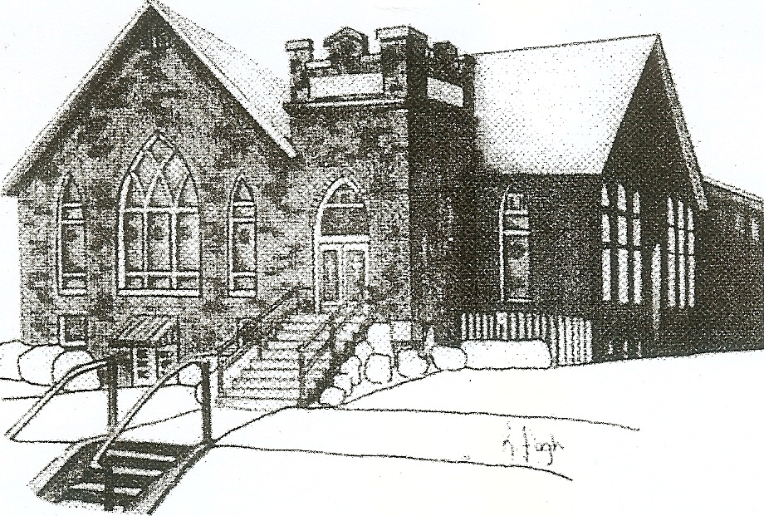
We are your hometown church: Faithful to Tradition, Loving in Fellowship, & Reaching for Tomorrow!

May 14, 2023
Happy Mother’s Day

We welcome you and we are glad you’ve chosen to Worship with us today!

CALENDAR: May 14th – May 21st

Church Office Hours: Monday -Thursday from 9 a.m. – 2:30 p.m.

Today, May 14, 2023
VOLUNTEERS☺

LAST SUNDAY’S In-House ATTENDANCE: 57

LAST SUNDAY’S OFFERING:
Operating Funds: $3342.00
Kindness: $50.00
Mission: $60.00
Total: $3352.00

Tarry N Talk Hosts
Stewardship Committee

9:00 am Sunday School Hour
10:00 a.m. THE MORNING WORSHIP SERVICE
Monday, May 15, 2023
7:00 pm Stewardship Meeting
Tuesday, May 16, 2023
9:00 am A team
7:00 pm AA
Wednesday, May 17, 2023
9:00 am Material Girls
Thursday, May 18, 2023
7:00 pm Session Meeting
Friday, May 19, 2023
Youth Group Golf outing
Saturday, May 20, 2023
Sunday, May 21, 2023 Baptism
9:00 am Sunday School Hour (adult)
10:00 am THE MORNING WORSHIP SERVICE
Welcome to all who are Worshiping with us today!

Guests
We sincerely hope our service is a blessing to you. We ask that our guests please take a few minutes to complete one of the Connect Cards found in the pew holder.

Should you have questions regarding any aspect of our church, including membership, please contact Pastor Brian or the church office during the week at 724-625-1365. Thank you for being with us today.

PRAYER – JOYS & CONCERNS
Lou Beckwith Paige Lauten
Paige Barbour (daughter of Andrew and Steph Barbour) Sandy Wahl
Reid Christopher Hall (June Stirling’s nephew) Sue Morris
Lindy McCartney (Lisa Barbour’s Sister)

ANNOUNCEMENTS
Bulletins are printed Thursday mornings; let us know if you have an announcement…

BAPTISM SUNDAY Next Sunday, May 21st we will be baptizing two of God’s children.

PENTECOST SUNDAY. MAY 28th
Sunday, May 28th is Pentecost Sunday and we would like everyone to wear RED on Sunday.

CALLING ALL GRADUATES If you or someone in our church that you know is graduating from high school, college or another post-high school program, please let us know in the church office. We would like to celebrate these graduates. More details to follow.
SAVE THE DATE- New To You Sale – June 3rd We are accepting donations!!!!
Donations can be dropped off on Tuesday and Thursdays from 9am until 2pm or contact the office for additional needs.
Items not accepted: Televisions, Couches, Mattresses, Large Appliances, Computers, Clothing, Exercise Equipment and please no Junk!!
SAVE THE DATE – Vacation Bible School- July 9th thru July 13th
SAVE THE DATE Mars UP church annual picnic will be held Sunday, September 10th at Adams Township Park. More Details to Follow

