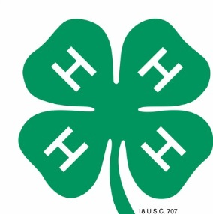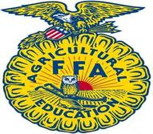

COUNTRY CRITTER FARM GROUP COMPETITION
Create a Country Critter Farm with your group. CREATIVITY IS KEY!!! Think outside the box and include some of the things that might be found on a farm.

Rules:

- Entries may be submitted by 4-H & FFA groups ONLY.
- Entries will be judged and awarded Ribbons and Cash Prizes.
- Placing/Awards will be awarded as follows:
1st Place – Blue Ribbon & $100.00 Cash Reward
2nd Place – Red Ribbon & $50.00 Cash Reward
3rd Place – White Ribbon & $25.00 Cash Reward
- A 5’x5’ space will be available
- Registration forms must be turned into Catie Cox by March 13th, 2025. You can email to flaglerctyfair@bellsouth.net or jonescatie15@gmail.com
- Farm must include a minimum of 6 animals
- Each farm must include a shelter for your animals and a fence
- Each farm must have a name located in/on it
- All group projects will be on display at the fairgrounds during the upcoming Flagler County Fair & Youth Show
- Entrants shall assume all liability for items. The Flagler County Fair and its staff are not responsible for any damage or loss of items.

Judging Criteria: Total Points = 100 POINTS
Creativity – 50 points
General Appearance – 10 points
Originality – 20 points
Theme Conformance – 10 points

Important Dates & Deadlines:
- April 11th, 2026 (2pm-5pm) – Groups will be allowed to set their farm up
- April 13th, 2026 - Judging
- April 18th, 2026, at 9am – Take down farm

Contacts for this Competition:
Penny Buckles – (386) 931-6597
Catie Cox – (386) 279-9792

FLAGLER COUNTY FAIR & YOUTH SHOW, INC.
2026 COUNTRY CRITTER FARM EXHIBIT COMPETITION
REGISTRATION FORM

NAME OF ORGANIZATION ______4H _______FFA
GROUP NAME______________________________________________________
CONTACT PERSON__________________________________________________
PHONE NUMBER___________________________________________________
ADDRESS_________________________________________________________

Signature :_________________________________________Date____________

Exhibit space _____________(fair use)

