5/27/2017 Follow the Man

The Cyclic Prophetic Signs

There were prophetic signs that YaHuShua gave to His disciples that might be applicable today. One of those signs involved a man carrying a pitcher of water.

Mark 14:13 And He sendeth forth two of His disciples, and saith unto them, Go ye into the city, and there shall meet you a man bearing a pitcher of water: follow him.
14 And wheresoever he shall go in, say ye to the goodman of the house, The Master saith, Where is the guestchamber, where I shall eat the passover with My disciples?
15 And he will shew you a large upper room furnished and prepared: there make ready for us.
16 And His disciples went forth, and came into the city, and found as He had said unto them: and they made ready the Passover.

The Cherubim and the Constellations

We previously found that the description of Ezekiel's visions of the Cherubim having four faces (Lion, Ox, Man and Eagle) may have been a symbolic representation of the Hebrew mazzaroth, the constellations of stars surrounding the earth indicated in the graphic below.

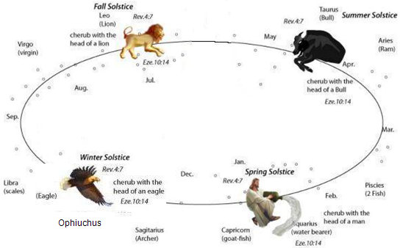

Notice in the graphic above that there is a man emptying a water jar, the constellation Aquarius. This would correspond with the man's face in the four faced Cherubim.

We also know that John was given a vision of four beasts in heaven in Revelation 4:7. The four beasts were a lion, a calf, a man, and a flying eagle. Note in the graphic above that the sequence of John's description, lion-calf-man-flying eagle, follows the exact sequence of the constellations beginning with Leo and going clockwise.

Follow the Man to the Upper Room

Mark 14:13 tells us to follow a man bearing a pitcher of water. He will lead us to the upper room.

On 8/21/2017 a total solar eclipse will cross the United States. It will be the first total solar eclipse to totally cross the United States from the Pacific Ocean to the Atlantic ocean since 6/8/1918. It has been shown in previous articles how that particular eclipse of 6/8/1918 was exactly 49 inclusive years to the day from 6/8/1918 to 6/7/1967 when Jerusalem was taken from Jordan during the Six Days War.

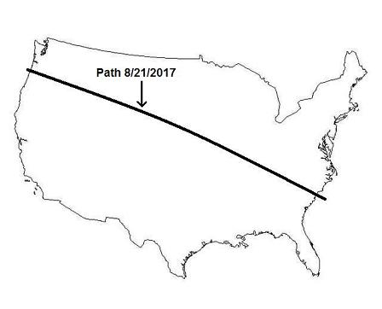

The date 6/7/2017 will be exactly 99 inclusive years to the day from 6/8/1918, and 6/8/2017 will be the 1st day of the 100th year from 6/8/1918. The total solar eclipse of 8/21/2017 will fall during the 100th year from the last total solar eclipse to cross the USA on 6/8/1918.

Let's look at the earth's shadow during the eclipse of 8/21/2017. The earth's shadow at that time will show us where the sun, moon, and earth all fall in line and point to a constellation in the heavens.

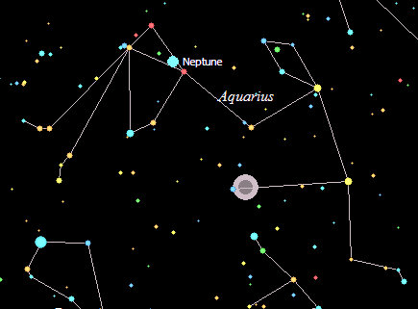
Above: During the total solar eclipse of 8/21/2017 the sun, moon, and earth are in a line that points to the constellation of Aquarius.

The round gray circles on the graphic above are a depiction of the location of the earth's shadow in the sky during the eclipse of 8/21/2017.

Note that the planet Neptune is located at the mouth of the water pitcher in the graphic above. The planet Neptune was named for the Roman "god of the Sea".

Note that the planet Neptune was given the Hebrew name "Rahab" by the Israeli public in 2009, that name for the planet being recognized only in Israel. Rahab has the attributes of a chaotic, multi-headed sea dragon in Isaiah 51:9-10 and Psalms 89:5-10.

The Discovery of Neptune

Neptune was discovered on 9/23/1846. The date 9/23 should ring a bell, because there will be a major sign in the heavens on 9/23/2017 known as the "Woman Clothed with the Sun". We find that 9/23/2017 is the 1st day of the 172nd year from the discovery of the planet Neptune on 9/23/1846.

The number 72 should ring a bell, it being twice 36, the number of ancient Babylonian gods being on the Babylonian Magic Square adding up to 666, etc.

So, 9/23/2017 will be the 1st day of the 100th year + the 72nd year from the discovery of the planet Neptune on 9/23/1846.

Note the earth's shadow in the graphic above and the look at the graphic below of the location of Neptune in the heavens when it was discovered on 9/23/1846.

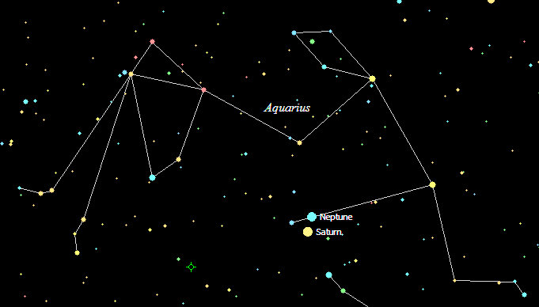
Above: Neptune was discovered in the Water Bearer on the Karaite Day of Trumpets, 9/23/1846

During the total solar eclipse of 8/21/2017 the sun, moon, and earth will be exactly aligned with the location of the planet Neptune in the sky when it was discovered on 9/23/1846.

These facts should bring our attention to a sign given by YaHuShua of a man carrying a pitcher of water. We should follow the man.

Note also in the graphic above that Saturn is present, with Neptune appearing above Saturn's North Pole, the location of the odd hexagonal storm on Saturn that was discovered in 1981.

Karaite Day of Trumpets 9/23/1846

Using the astronomy program, we find that the new moon would have been sighted in Israel after sunset on 9/22/1846, making 9/23/1846 the Karaite Day of Trumpets. So Neptune was discovered on the Day of Trumpets in 1846. Let's look further.

Neptune's orbital period is 60,182 days.

9/23/1846 + 60,182 days = 7/3/2011

7/3/2011 + 2520 days = 5/27/2018

This article is being written on 5/27/2017, exactly 1 year prior to 5/27/2018. This information was revealed to me just yesterday by YaHuWaH Elohim on 5/26/2017.

Note that 5/27/2018 will be the Karaite Feast of Shavuot (Day of Pentecost).

The symbolic "man in the heavens bearing the pitcher of water" has led us to the Karaite Feast of Shavuot in 2018.

Previous articles have shown that the date 5/28/30 AD was the Feast of Shavuot and that the experience of Acts 2 took place on that day.

Acts 2:1 And when the day of Pentecost was fully come, they were all with one accord in one place.
2 And suddenly there came a sound from heaven as of a rushing mighty wind, and it filled all the house where they were sitting.
3 And there appeared unto them cloven tongues like as of fire, and it sat upon each of them.
4 And they were all filled with the Holy Ghost, and began to speak with other tongues, as the Spirit gave them utterance.

The Water was Poured Out on Shavuot

Acts 2:14 But Peter, standing up with the eleven, lifted up his voice, and said unto them, Ye men of Judaea, and all ye that dwell at Jerusalem, be this known unto you, and hearken to my words:
15 For these are not drunken, as ye suppose, seeing it is but the third hour of the day.
16 But this is that which was spoken by the prophet Joel;
17 And it shall come to pass in the last days, saith YaHuWaH , I will pour out of my Spirit upon all flesh: and your sons and your daughters shall prophesy, and your young men shall see visions, and your old men shall dream dreams:
18 And on My servants and on My handmaidens I will pour out in those days of my Spirit; and they shall prophesy:
19 And I will shew wonders in heaven above, and signs in the earth beneath; blood, and fire, and vapour of smoke:
20 The sun shall be turned into darkness, and the moon into blood, before that great and notable day of YaHuWaH come:
21 And it shall come to pass, that whosoever shall call on the name of YaHuWaH shall be saved.

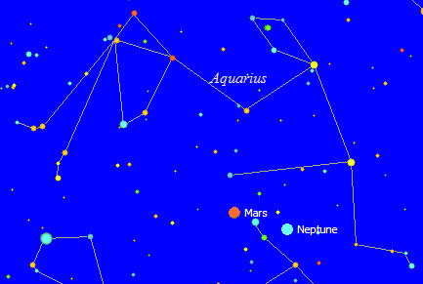
Above: Neptune in the Water Bearer on the Feast of Shavuot 5/28/30 AD

Above: The symbolic "man in the sky with the pitcher of water" at the middle of the 3rd hour of the day on 5/28/30 AD. Neptune is again present with the Water Bearer during the outpouring of Acts 2:4, along with Mars.

The Water Bearer has been Showing Us the Planet Neptune

Neptune was discovered on 9/23/1846. It moved just once around the sun and returned to the same place in its orbit 60,182 days later on 7/3/2011. Exactly 84 weeks transpired, and on the next day, 2/11/2013, Pope Benedict announced his resignation, lightning struck the Vatican, and North Korea tested an atomic device.

Just prior to his resignation, Pope Benedict was able to acquire a seat in a place known as the "upper room" on Mt. Zion. After helping Pope Benedict to acquire a seat in the "upper room", the man helping him, Danny Ayalon, also resigned from his official position in the Israeli government.

The problem with the Pope having a seat in the upper room is that in a lower level is the tomb of King David. He's the same David who, as a shepherd lad, slew Goliath.

The man bearing the pitcher of water has led us to this place:

Isaiah 14:4 That thou shalt take up this proverb against the king of Babylon, and say, How hath the oppressor ceased! the golden city ceased!
5 YaHuWaH hath broken the staff of the wicked, and the sceptre of the rulers.
6 He who smote the people in wrath with a continual stroke, he that ruled the nations in anger, is persecuted, and none hindereth.
7 The whole earth is at rest, and is quiet: they break forth into singing.
8 Yea, the fir trees rejoice at thee, and the cedars of Lebanon, saying, Since thou art laid down, no feller is come up against us.
9 Hell from beneath is moved for thee to meet thee at thy coming: it stirreth up the dead for thee, even all the chief ones of the earth; it hath raised up from their thrones all the kings of the nations.
10 All they shall speak and say unto thee, Art thou also become weak as we? art thou become like unto us?
11 Thy pomp is brought down to the grave, and the noise of thy viols: the worm is spread under thee, and the worms cover thee.
12 How art thou fallen from heaven, O Lucifer, son of the morning! how art thou cut down to the ground, which didst weaken the nations!
13 For thou hast said in thine heart, I will ascend into heaven, I will exalt my throne above the stars of Elohim: I will sit also upon the appointed mountain, in the sides of the north:
14 I will ascend above the heights of the clouds; I will be like the most High.
15 Yet thou shalt be brought down to hell, to the sides of the pit.

The location of YaHuWaH Elohim's appointed mountain:

Psalm 48:1 Great is YaHuWaH , and greatly to be praised in the city of our Elohim, in the mountain of his holiness.
2 Beautiful for situation, the joy of the whole earth, is mount Zion, on the sides of the north, the city of the great King.

It is clear from the verses above that Lucifer wants to sit on Mt. Zion and exalt his seat above the stars of Elohim.

That is exactly what transpired in early 2013 when Pope Benedict was able to acquire a seat in the upper room above King David's tomb.

An emblem displaying the symbolic star of David, a star of Elohim:



Roman Catholicism has acquired a seat on for itself on Mt. Zion in apparent fulfillment of Isaiah 14:13 above, which equates the Roman Catholic Pope with Lucifer.

Mt. Zion in Jerusalem is the only mountain on earth that YaHuWaH Elohim has chosen as His own. It's His appointed mountain.

Fallen man's dislike for YaHuWaH Elohim is evidenced by a challenge to His authority.

Why is His authority challenged? It's probably part of His plan for mankind in order to reveal to everyone who He is, and we may be about to find out (unfortunately).

Summary - Follow the Man with the Pitcher of Water

1. A man is one of the four beasts listed in Revelation 4:7 who show John coming events.

2. Ezekiel's visions of Cherubim with four faces equate with John's vision of four beasts.

3. The Hebrew mazzaroth, the constellations, have four quadrants identified with the beasts of 1 and 2 above.

4. In Mark 14:13 YaHuShua tells us to follow the man with the pitcher of water, symbolized by Aquarius the Water Bearer.

5. During the coming total solar eclipse of 8/21/2017, earth's shadow will fall in the same place in the constellation of Aquarius where Neptune and Saturn were located when Neptune was first discovered on the Karaite Day of Trumpets, 9/23/1846.

6. The last solar eclipse to completely cross the USA prior to 8/21/2017 was on 6/8/1918. The date 6/8/1918 is associated with the taking of Jerusalem exactly 49 inclusive years later on 6/7/1967. That fact links the USA with Jerusalem. The solar eclipse of 8/21/2017 will fall during the 100th year from 6/8/1918

7. The planet Neptune was present in the constellation Aquarius during the outpouring of YaHuWaH 's Holy Spirit described in Acts chapter 2, present in Aquarius when it was discovered on 9/23/1846, and will be present again during the eclipse of 8/21/2017.

8. On 7/3/2011, the planet Neptune completed exactly one revolution of the sun since its discovery on 9/23/1846. If we add 2520 days (a value encoded into the Handwriting on the Wall in ancient Babylon) onto 7/3/2011, we arrive at 5/28/2018 and the Karaite Feast of Shavuot (Pentecost). It was on Shavuot on 5/28/30 AD that YaHuWaH 's Spirit was poured out on those observing the Feast in the "upper room" who had the testimony of YaHuShua Messiah.

9. In 2013, Pope Benedict acquired a seat in the upper room over King David's tomb on Mt. Zion.

10. Having acquired a seat on Mt Zion above King David's tomb, The Roman Catholic Pope discreetly fulfills the prophecy of Isaiah 14:13.

We have followed the Water Brearer to the Upper Room. It's been a long journey. We've found the inhabitant of the place where YaHuShua said He will celebrate Passover with His disciples. The water is about to be changed into wine. May YaHuWaH Elohim have mercy on those who negate and challenge His authority.

Place a statue on My mountain and I will crush your head.

