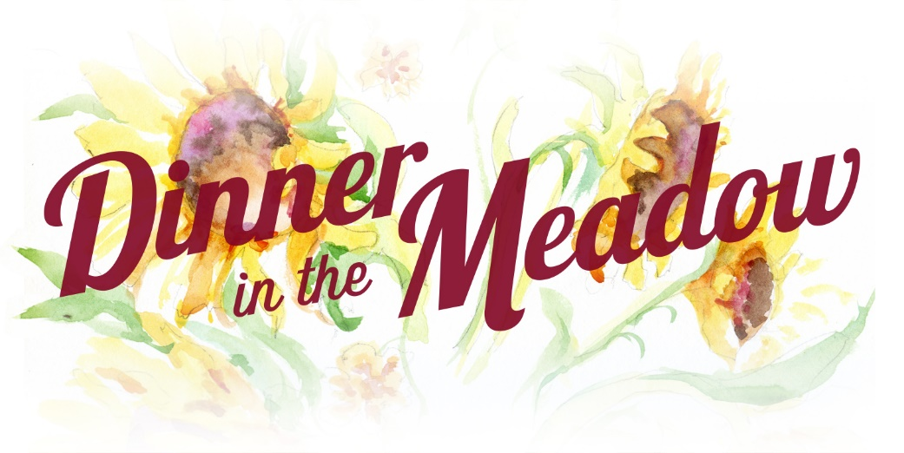
Grant
For Farmers in North Carolina
$5,000
Funding Opportunity for Equipment and Projects

2020 Grant Application DUE: April 1, 2020
APPLICATION
DEADLINE April 1, 2020
The Leonard-Mobley Small Farm Fund was established to support and cultivate small farms in 11 counties in North Carolina. Founded in 2014 in honor and in memory of Franklin County farmers Marjorie Leonard and Steve Mobley of Meadow Lane Farm in Louisburg, the fund aids in development and long-term sustainability of small farms through an annual grants program; with proceeds from a dinner at the farm and through community donations and sponsorships.
Is My Farm Eligible?
To apply, farms must be located in one of eleven NC counties: Franklin, Granville, Person, Durham, Vance, Warren, Wake, Nash, Halifax, Chatham, and Wilson.
Farms eligible for this grant can be the enterprise of one person or family or a small group of farmers. The farm business must have been operational for at least two years in North Carolina by July 1 of the year of the application. You may own or rent the land. Farmer’s who generate at least 50% of his/her personal income from the farm operation during the previous calendar year will be given preference. Previous winners are not eligible.
The Grant is up to $5,000. The grant should be spent within 1 year of the award.

The Grant is intended for agricultural equipment or infrastructure that will support continuation, growth and long-term success of the farm operation and small farm sustainability in the region. The LMSFF does not fund labor, wages, training or marketing.
The grant is awarded at the annual Dinner in the Meadow; at Meadow Lane Farm in Louisburg. This year the Dinner in the Meadow is scheduled for Sunday, September 13, 2020. Awardee’s are expected to attend this event to receive the grant. Awardee’s should be prepared to describe his/her project and progress at and for subsequent events.
Grant applications should be emailed to lmsmallfarmfund@gmail.com or mailed to LMSFF – Grant Application, 571 Leonard Farm Road, Louisburg NC, 27549. All grant applications must be received by April 1, 2020. The application must be completed and all information included or the application will be rejected. Qualifying farms will be scheduled for an interview and farm visit before June 1. The farm visit is required. Email any questions to lmsmallfarmfund@gmail.com. You may also call 919-495-1305 for more information.
Mailed applications must be postmarked on or before March 30, 2020.
All applicants will be notified of their status by August 1, 2020.

2020 LMSFF GRANT APPLICATION
(Early submissions are encouraged.)
Name of Farm:
Name of Farmer(s):
Address of Farm(s) (street, city, county):
Phone Number please give a home phone and two cell phone numbers for contacts:
Primary Contact Email:
Web Address (if existing):
Approximate date applicant(s) began market production on this farm(s):
Sources of Farm Income (crops, livestock, flowers etc.):
The Farm generates more than half the income for the farmer(s): (Y/N)
Total Gross Receipts from farm revenue in 2017:
Description of Project:
- Clearly define what you want to do with the grant funds if awarded.
- Tell us why this is important to the success and the benefit of the farm(s).
- Be as specific as possible with timeframe for implementation and how the project fits in with your operations now. Will it support operations? Will it help you diversify? Will it add to what exists?
- Tell us about your farm and who you are and why these funds can help you. If possible please tell us about the entire scope of the overall farming venture. Please tell us anything unique about your farm or team or situation that we should know as we consider your application.
Funding Requested:
- Clearly define the total cost of the project.
- Give a financial/budget breakdown of project costs to the best of your ability. List each item and cost.
- Indicate if your project is funded by any other outside sources or if you are using your money or if the LMSFF grant will fully fund your project.
- Define exactly how the grant funds are significant to achieve your project and farm goals. Describe any efficiencies/cost savings/economies of scale.
- Please share future expectations for growth and continuity of your farming operation. Describe your long term vision. Include how your farm community might develop and benefit as the result of your farm success. your abilities/skills or contacts to realize better or sharing of resources with other farmers.

Deadline: April 1, 2020.
All applicants and the awardee will be notified by August 1, 2020.

Applications are reviewed as they are received. Early applications encouraged.

Grant applications should be emailed to: lmsmallfarmfund@gmail.com
OR they may be mailed to:
LMSFF – Grant Application, 571 Leonard Farm Road, Louisburg NC, 27549

Thank you for your application. We value the efforts of every farmer. Your work in farming is a contribution to agriculture in our region.

Please visit our website https://www.dinnerinthemeadow.org/grant-application.html, and follow our efforts to assure the success of small farmers in North Carolina.

