Mars UP Church

Apostles’ Creed
I believe in God the Father Almighty, Maker of heaven and earth; and in Jesus Christ His only Son our Lord; who was conceived by the Holy Ghost, born of the Virgin Mary, suffered under Pontius Pilate, was crucified, dead and buried; He descended into hell; the third day He rose again from the dead; He ascended into heaven, and sitteth on the right hand of God the Father Almighty; from thence He shall come to judge the quick and the dead. I believe in the Holy Ghost, the holy catholic church; the communion of saints; the forgiveness of sins; the resurrection of the body; and the life everlasting. Amen.

Gloria Patri
Glory be to the Father, and to the Son, and to the Holy Ghost. As it was in the beginning, is now and ever shall be,
world without end.
Amen. Amen.

Come Holy Spirit, Come
Before the Service – Speak to God!
During the Service – Let God speak to you!
After the Service – Speak to each other!

(*Please stand, if able)
Welcome and Mars Messages

Prelude

Song
“Come Now is the time to Worship”

Call to Worship
Leader: Here, in this place,
People: God welcomes all the dreamers, as well as the
doubters:

Leader: Here, the worriers and wanderers can call on God
by name.

People: Here, in this time, we can remember all the ways
God has graced us:

Leader: Here, in these moments, we are reminded that God
is with us, always!

People: Here are gathered those daring enough to step
out of comfort into the unknown:

Leader: Here, in this faith space, we will find the courage to
Cry out, ‘God, save us!’ in every situation.

People: Here we are to worship.

Opening Prayer

*Hymn 3
“Holy, Holy, Holy, Lord God Almighty”

Scripture Romans 10:5-15

Children’s Chat
The
Lord’s Prayer

Our Father,
who art in heaven,

hallowed be Thy
name,

Thy kingdom come,
Thy will be done,
on earth
as it is in heaven.

Give us this day
our daily bread;

and forgive us
our debts,
as we forgive
our debtors;

and lead us not
into temptation,
but deliver us
from evil.

For Thine
is the kingdom,
and the power,
and the glory,
forever. Amen.

The Doxology

Praise God
from whom
all blessings flow;
praise Him
all creatures
here below;
praise Him above,
ye heavenly host;
praise Father, Son,
and Holy Ghost.
Amen.

Morning Message Rev. Brian Hauser
“Unless”

*Hymn 358
“Because He Lives”

Prayers of the People and Lord’s Prayer

Affirmation of Faith Apostles Creed

*Hymn 731
“Onward Christian Soldiers”

*Benediction

*Postlude

Flowers today are presented to the Glory of God and in celebration of our 21st wedding anniversary by Dominik and Missy Wells
We also praise and thank God for his blessings.
Flowers today in the Tarry N Talk are presented to the Glory of God and in memory of MaryEllen and our years together and our anniversary on August 9th by John Grau.

Mars United Presbyterian Church will also make a donation to the Angiosarcoma Awareness foundation in Memory of Douglas Hauser.

MUP Session
Church Staff
Rev. Brian Hauser
Pastor
pastor@mars-up.org
724-689-3412

Mrs. Shelly Bocheff
Administrative Assistant
marsup@mars-up.org

AV TEAM
Alma Staskiewicz, Lisa Barbour, Marie Matthews, Bill Guesman, John Ivory, Mike Bocheff, Herb Wellman

Mars United Presbyterian Church

232 Crowe Ave
PO Box 805
Mars, Pennsylvania 16046
724-625-1365
www.mars-up.org
marsup@mars-up.org

Church Office Hours:
Mon -Thurs from 9 a.m. -2:30 p.m.

Class of 2025 Class of 2024 Class of 2023
John Ivory Alma Staskiewicz Lisa Barbour
Susan Cox Louise Fox Mary Ann Croop
Jay Wilson Marie Matthews Don Lewis
Herb Wellman
Clerk of Session: Herb Wellman
MUP Deacons
Morning Worship:
10:00 am

11th Sunday after Pentecost

Prayer of Preparation
Lord, we come to you today with so many things on our hearts.

You call us to be in relationship of trust and love with you and you offer healing to us for those portions of our lives that are broken and injured.

Help us to be open to your mercy and healing love. For we ask this in Jesus’ Name.
AMEN.

Class of 2025 Class of 2024 Class of 2023
Jill Cooper Steve Martin Sharon Gibb
Robyn Beckwith Marge Nicklas Carol Kopar
Missy Wells Pat Auld Alice Leonberg

Moderator: Steve Martin
MUP Music Committee
Keith Nichols – Chair
Sally Olsen – Clerk
Alma Staskiewicz
John Ivory
Linda Lees
Karl Kennedy

Mars United Presbyterian Church
Welcome!

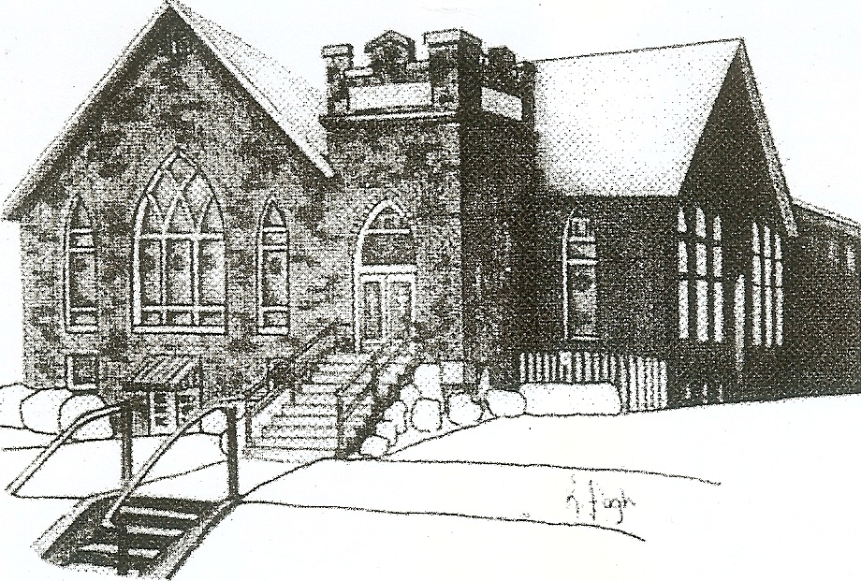
We are your hometown church: Faithful to Tradition, Loving in Fellowship, & Reaching for Tomorrow!

August 13, 2023

We welcome you and we are glad you’ve chosen to Worship with us today!

CALENDAR: August 13th – August 20th

Church Office Hours: Monday -Thursday from 9 a.m. – 2:30 p.m.

Today, August 13, 2023
VOLUNTEERS☺

LAST SUNDAY’S In-House ATTENDANCE: 51

LAST SUNDAY’S OFFERING:
Operating Funds: $1725.00
Kindness: $170.00
Mission: $50.00
Memorial: 200.00
Total: $2145.00

Tarry N Talk Hosts
Christian Ed/Mission and Outreach

10:00 a.m. THE MORNING WORSHIP SERVICE
11:00 am Congregational Meeting
1:00 pm VBS Reunion
Monday, August 14, 2023
Tuesday, August 15, 2023
8:30 am Mars Ministerium
9:00 am Ateam
7:00 pm AA Meeting
7:00 pm Stewardship Meeting
Wednesday, August 16, 2023
9:00 am Material Girls
Thursday, August 17, 2023
7:00 pm Session Meeting
Friday, August 18, 2023
Saturday, August 19, 2023
8:30 am Rafting
Sunday, August 20, 2023
10:00 am THE MORNING WORSHIP SERVICE
11:15 am Deacon Meeting

Welcome to all who are Worshiping with us today!

Guests
We sincerely hope our service is a blessing to you. We ask that our guests please take a few minutes to complete one of the Connect Cards found in the pew holder.

Should you have questions regarding any aspect of our church, including membership, please contact Pastor Brian or the church office during the week at 724-625-1365. Thank you for being with us today.

PRAYER – JOYS & CONCERNS
Lou Beckwith Paige Lauten
Paige Barbour (daughter of Andrew and Steph Barbour) Sandy Wahl
Reid Christopher Hall (June Stirling’s nephew)
Lindy McCartney (Lisa Barbour’s Sister)

ANNOUNCEMENTS
Bulletins are printed Thursday mornings; let us know if you have an announcement…

VBS REUNION We had so much fun at VBS, we can’t wait until next year! Join us for a VBS REUNION to have a bonus day of VBS! TODAY SUNDAY, AUGUST 13TH at Mars UP Church 1-3pm

CONGREGATIONAL MEETING There will be a congregational meeting immediately after worship TODAY Sunday, August 13th. The meeting will be to share information with the congregation about the proposed parking lot and to allow the Music committee to share information regarding the music director position.

MISSION PARTNER HOSANNA INDUSTRIES is hosting its annual golf benefit at Pittsburgh North Golf Club in Bakerstown on Monday, Sept. 11. This is a fun way to help raise funds for Hosanna. The day includes a light breakfast, golf, lunch and prizes. Please see the flyer on the Tarry ‘N Talk bulletin board for more info or see Mission committee member Lisa Barbour for info and/or questions. It would be great if MUP could put together a foursome or two to play in this event!
GRIEFSHARE SUMMER MEETINGS Griefshare will continue to hold one monthly meeting during the summer. Meetings will be held on August 21st. The fall session will resume on September 18th at 6:30 For more information, please contact Denise @ ddemarco5@yahoo.com

ANGIOSARCOMA AWARENESS MUP will be making a donation to this organization in Memory of Douglas Hauser. If you would like to contribute to this donation, please put your donation in the offering plate, marked “Memorial” and your contribution will be added to the church donation. Last Sunday to take donations will be TODAY, August 13th. If you would like to make your own donation, https://www.cureasc.org/.

