Before answering this question it must determined why is there a marriage
I. There will be Marriage
Jesus is called "the bridegroom". (Matt.9:15; Mark.2:19) The Church is to be "espoused as a chaste virgin"
(2Cor.11:1-3) As of this moment Christ is our head (as Joseph was over Mary - Matt:18-25) preparing us to be
His Bride sanctified and cleansed by the washing of water by the word, That he might present it to himself a glorious
church, not having spot, or wrinkle, or any such thing; but that it should be holy and without blemish…³¹ For this
cause shall a man leave his father and mother, and shall be joined unto his wife, and they two shall be one flesh.
(Marriage language) This is a great mystery: but I speak concerning Christ and the church. (Eph.5:26-33) John
saw the bride / Church making her self ready. (Rev.19:7-8) Then he turned to see her completed as a wife, and it
was the (heavenly) holy city of Jerusalem. (Rev.21:2, 9-27)
II. Why is there a Marriage of Christ and His Church?
The Marriage is not a "end of the season / year ending party" or some extravagant Banquet Dinner where
everyone is invited. There is a purpose for the Marriage as seen in the first marriage of Adam and Eve. In fact
the apostle Paul called Christ the last Adam and addressed the Church as Eve, to explain the ultimate purpose
of God's redemptive plan. (Note: 1Cor.15:45, 2Cor.11:1-3, Eph.5:21-33 / Eph.3:1-12)
A. The "first Adam" set the pattern
The "first man Adam (the figure Rom.5:14 / model) [3] was made a living soul; the last Adam (Jesus, the
reality) was made a quickening spirit. Howbeit that was not first which is spiritual, (Jesus) but that which is
natural; (Adam) and afterward that which is spiritual. The first man is of the earth, earthy: the second man
is the Lord from heaven." (1Cor.15:45-47)
1. The first Adam was to be married and to be one with Eve
Therefore shall a man leave his father and his mother, and shall cleave unto his wife: and they shall be
one flesh." (Gen.2:24-25, Eph.5:31-32)
2. After marriage they were to be fruitful, multiply, and replenish the earth..."
God "blessed them, and God said unto them, be fruitful, and multiply, and replenish the earth, and
subdue it: and have dominion over the fish of the sea, and over the fowl of the air, and over every living
thing that moveth upon the earth." (Gen.1:28-29)
3. Subdue...have dominion
After marriage they were to "have dominion (Gen.1:26) over the fish of the sea, and over the fowl of the
air, and over every living thing that moveth upon the earth." (Gen.1:28-29, Note: Heb.2:8-9)
They failed, and fell into sin and did not "subdue" or "have dominion!" (Gen.3:1-24,
Rom.5:12-21)
B. Jesus...the "last Adam" will complete this pattern
Jesus will be married (become "one"- unity / Day of Atonement / Feast of Tabernacles) with the Church.
(Foreshadowed by Eve. Gen.2:18-25, John.17:20-23, Eph.4:11-16; 5:21-33, 1Cor.15:45)
1. As of this minute (2017 AD) the Church (Eve) is "espoused" to Christ, the last Adam
This is similar to our modern understanding of being "engaged" which should carry the same seriousness
and commitment of the Biblical pattern.[17] (2Cor.11:1-3) Since the Cross, (during these last two days / 2,ooo
year engagement - 2Peter.3:8-9) Jesus has given Himself Eph.5:25 for (His Bride) the Church, to prepare
her for marriage just as (the first) Adam did (Gen.2:21-25) for Eve
III. When is the Marriage
Many think the Marriage and the Second Coming happen at the SAME time. Since the 1880's AD most Western Saints have been waiting for the Second Coming of Jesus to happen at
any moment and every saint up to that point in time, dead or alive will be married to Christ "in the twinkling of an
eye".(1Cor.15:51-52, 1Thes.4:13-18) This is called "The Pre-Tribulation Rapture
A. The "day of Christ is at hand"
This is what the apostle Paul had to correct in the Thessalonian Church with his second letter / epistle to
them. They were being shakened by spirit, by word by letter / epistle as from us. Paul, Silvanus, and Timothy.
(2Thes.1:1; 2:1-2)
1. Shaken
They were not searching the scriptures, (Acts.17:11)
2. In mind
3. Troubled
a. By spirit
b. By Word
c. By Letter / epistle
4. He there is an order of events
a. Let no man deceive you
b. A falling away first
c. That man sin be revealed (antichrist)
5. Don't you remember I told you these thing when I was with you

We will be "presented" during the 7th Seal and then appear (in the last day order of events) married and
with child (Rev.12:1-17) Review: Eschatology Two, Phase.12, Page 1-2 (Review: Phase 10 for how this chart was
built)
Questions
This depends on how you understand the Second Coming
1. What is the day of Atonement?
2. The last two days being the last two thousand years?
3. Our presentation as the Bride during the 7th. Seal?
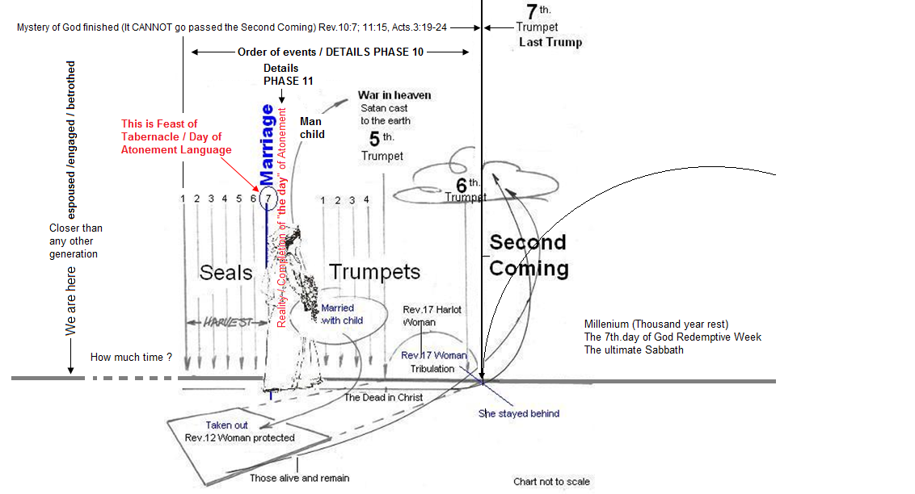

2. The fruit of this marriage (Not fulfilled yet)
From this union / unity (John.17:21-24, Eph.4:1-16) of Christ and His Church there will be the man child.[18]
(Rev.12:1-17) \Review: Phase.12 (Note: Rom.16:20)
3. Then (Christ / last Adam and His Church / Eve) will "subdue...(Not fulfilled yet)
After marriage (Gen.1:28) they will have dominion (Heb.2:8-9, Eph.1:20-23 / Eph.3:1-12, Phil.2:10,
Rev.11:15) over the fish of the sea, and over the fowl of the air, and over every living that moveth upon the
earth, "continuing on from where the "first Adam" and Eve fell from in the new earth (Rev.22:1) and the
new heaven. Obviously the Church is not married to Christ yet, and there is no dominion yet
A Summary to this point
a. There will be marriage between Christ and His Church. (Eph.5:21-33, Rev.21:1-2, 9-27)
b. Now that it is understood why there is a marriage of Christ and His Church. It is to restore us back to
where Adam and Eve fell from and complete what they failed to do. (Eph.3:1-12, Gen.1:26-31))
IV. Next: Will everyone be in the Bride?
The resurrection of the dead in Christ is a "pivotal" point
Only those who are Alive and remain can be in the Marriage, because the dead in Christ would have resurrect to be
in the marriage. (This is common sense)
It is not automatic and everybody is in
Unsaved
Dead in Christ
Those the make excuse not to come
The that fail to prepare

IV. There will two groups at the time of the marriage
The marriage takes place at the time of seventh seal (Review: B. V. 1.) which BEFORE the Tribulation. (the time
of the man of sin /antichrist -PHASE 10) During this time there will be two groups of Christians. The dead in
Christ and those that alive and remain. (1Thes.4:13-18)
A. The dead in Christ
Remember our topic: "Will every Christian be in the Bride?" The dead in Christ will not be in the Marriage
because they don't resurrect until the Second Coming. (Review: PHASE 10)
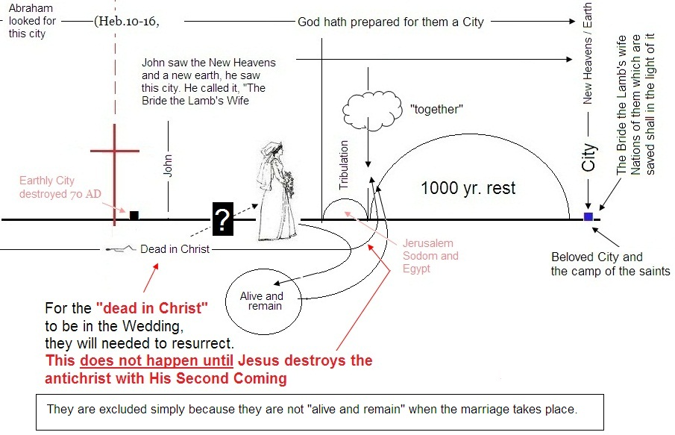

1. Note: The "apostles doctrine"
This the "doctrine of Christ" (Acts.2:42, Heb.6:1-3) because Jesus taught each one of the apostles.
(Luke.24:44-45, Gal.1:11-12, John.16:11-15)
a. The apostle Paul (Gal.1:11-12)
For this we say unto you by the word of the Lord, that we which are alive and remain unto the coming of
the Lord shall not prevent them which are asleep. For the Lord himself shall descend from heaven with a
shout, with the voice of the archangel, and with the trump of God: and the dead in Christ shall rise first:
Then we which are alive and remain shall be caught up together with them in the clouds, to meet the
Lord in the air: and so shall we ever be with the Lord." (1Thes.4:13-18) Note: the dead in Christ and the
alive and remain are connected. The rise at the SAME time.
(1) The Thessalonians were told the order of events, (2Thes.2:5) but were still think that the day of Christ
was at hand [27] (any moment) The Second Coming)
(2) That day (The Day of Christ) shall not come, except come
(a) Falling away
(b) Man of sin (antichrist) be revealed
(3) .Time is short / last days
b. The apostle John
(1) The antichrist shall come (same as Paul - same teacher Jesus
c. The apostle Peter - get your time clock in line with God's (2Peter,3:1-9)
d. The apostle James
Still waiting for the latter and early rain
There will be a group that is "alive and remain" (at the time of the 7th. Seal) and there will be the "dead in Christ."
which will remain dead until the Second Coming / 7th. Trumpet / Last Trump. (Review: PHASE 10)

A. Who are the "dead in Christ"
These are the Old and New Testament saints "together"[1] (Eph.4:1-10, 1Thes.4:4:13-18, Heb.11:13-16,
Dan.12:1-2) that have not lived long enough to be "alive and remain" when the Marriage takes place
during the 7th. Seal.[14] (Review: 7th. Seal
This conclusion is quite simple

1. No one is teaching that Marriage has taken place yet. (We are "espoused", but not married)
2. The Old and New Testaments from previous generations are dead

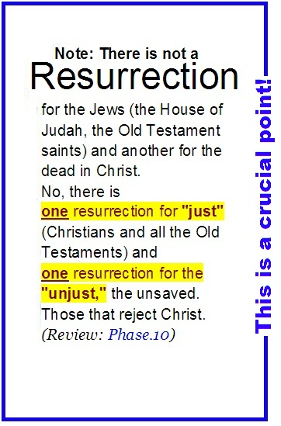
1. The Old Covenant dead (Testament)
They were to be "gathered unto their people." The first mention is when " Abraham gave up the ghost,
and died in a good old age, an old man, and full of years; and was gathered to his people." (Gen.25:8-9,
Gen.25:17; 35:29: 49:29-33; Num.20:24-26; Deut.32:50) When the beggar Lazarus died, he was
"gathered" to "Abraham's bosom" where Isaac, Jacob, Aaron and the others where kept before the Cross.
They were covered by the "animal sacrifices were "a figure" for the time then present, in which were
offered both gifts and sacrifices, that could not make him that did
the service perfect, as pertaining to the conscience; Which stood
only in meats and drinks, and divers washings, and carnal ordin
-ances, imposed on them until the time of reformation. (Heb 9:8-
11; 10:1-10) Until Christ! These are the ones that were in "captivity"
that Jesus lead "captivity captive" when He arose from the grave
(Eph.4:7-10) and took to paradise with Him. (Luke.23:43) They are
now waiting for the "resurrection at the last day." (John.11:24,
Dan.12:1-2)
NOTE: However God "has prepared for them a city" where all the
(Old Testament and New Testament) saints "shall ever be with the
Lord." (1Thes.4:17 / (Review: Phase.10) for explanation of chart
2. The New Covenant dead (Testament)
Once Christ came (Gal.3:24) "there remaineth no more sacrifice [12]
for sins," (Heb.10:26-39) because the reality is here. Under the
New Covenant we can have confidence (Heb.10:19) and say with the
apostle Paul, "absent from the body...present with the Lord."
(2Cor.5:8-9)
B. Have the "dead" in Christ been left out of the Bride?"
NOTE: The impression in our preaching left that the marriage will take place in our life time. We need to learn
from the great cloud of witnesses (The Old Testament saints and the 1st Cent. Church) They were looking for
this promise but died in faith. (Heb.11:1-) Every generation is had a part to play in the purpose / intent of God.
We will all be together in the Bride City. (The Pre-Trib. Doctrine has created a false hope in God's people by
teaching that the Second Coming / Marriage will happen at any moment which will include the dead in Christ
and those that are alive and remain.. (1Thes.4:13-18)
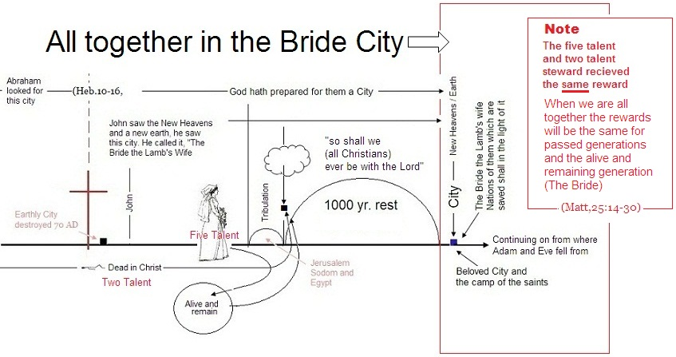
1. These saints simply did not live long enough
They will not be alive and remain when the Bride is presented as a Glorious Church / Bride. Their
resurrection is after the Marriage of the Lamb at the Second Coming. (Review: PHASE 10) God's
PURPOSE / INTENT is far greater than our life span. NOTE: God's PURPOSE (Eph.3:1-12) is not built
around our generation
2. Is this is unfair? Is God playing favorites? Absolutely NOT!
God is NO respecter of mans person. (Acts.10:34) There are NO Favorites! Peter, James and John were
not favorites when Jesus took them apart from the other disciples. () John, whom Jesus loved, was not
because He did not love the
other Disciples.(John.20:) Was Moses more important? Was he a favorite? He was rejected from entering
the Land after he had lead Israel from Egypt to the Land (Num.20:) Was the House of Judah more loved
than the House of Israel? No, it was only because of Covenant with David. The House of Israel was rejected
(2Kings.17, Amos.5:21) because they rejected God's Word / patterns. Judah was not a "favorite!" They
were preserved because of Covenant () Think of the natural body, If the ear shall say, because I am not the
eye, I am not of the body; is it therefore not of the body? (1Cor.12:16) Shall the ting formed (by the potter)
say WHY HAVE YOU MADE ME SO? (Rom.9:

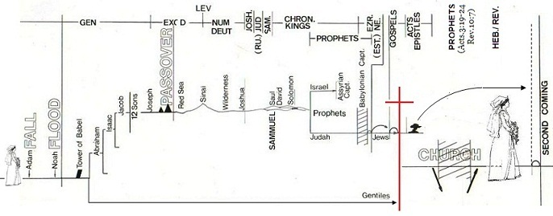
3. Look at the Old Testaments Heroes of faith (Heb.11)
Paul writes that God "made known unto me the mystery; (as I wrote afore in few words, Whereby, when
ye read, ye may understand my knowledge in the mystery of Christ) which in other ages (Generations /
Old Testament / Heb.11:1-40) was NOT made known unto the sons of men, as it is NOW revealed
(New Testament) unto his holy apostles and prophets by the Spirit." (Eph.3:3-5) Was this unfair????
Why didn't The Word become flesh and redeem man back at that moment??? Answer: That was not
God's purpose at that time. The "holy apostle" Paul goes back to Adam and interprets him to be "a
figure of Him that was to come." Rom.5:12-21, Gal.1:11-12, John.16:13-15) There was an "appointed
time" (1Peter.1:18-20) for The Word to become flesh.(John.1:1-14)
l
a. The example of Adam and Eve (Gen.3:15-16)
Adam did not understand this. All he knew that fig leaves were out, coats of skins were in and he
now was outside the garden looking in. Jesus was to be the "last Adam" and the
Church to be the last Eve. (1Cor.15:45, 2Cor.11:1-3 / Eph.5:21-33)
Adam and Eve did not see this promise come to pass simply because they "died in faith in faith" before it
came to pass. Their future was to be in the resurrection of the dead in Christ when Jesus returns

b. Next was Able
The Heroes of faith in Hebrews 11 "all died in faith, (born out of due[16] time) not having received the promises, (i.e. the reality of the "blueprint." All they saw was the model /
"ensample"[13] (1Cor.10:11) which "was not made known unto" them. Eph.3:5) All they could see was the
promise "afar off." (Heb.11:13)
Like king David who was
given the pattern for the Temple 1Chron.28:19) yet he would not live long enough to see it built. Neverthe
-less, the Old Testament generations "were persuaded of them, and embraced them, and confessed
that they were strangers and pilgrims on the earth." (Heb.11:1-40, Note:v.13)
This generation will have
a greater responsibility / accountability than
any other generation.

But we know in the New Covenant "as you see the day approaching." (Heb.10:25)
To much is given, much shall be required. (Better is the end of a thing, than the beginning (Eccl.)
Like king David who was given the pattern for the Temple 1Chron.28:19) yet he would not live long enough to see it built. Nevertheless, the Old Testament generations "were persuaded of them, and embraced them, and confessed
that they were strangers and pilgrims on the earth." (Heb.11:1-40, Note:v.13)
Keep in mind that "the mystery of Christ” which in other ages / generations was not made known unto the sons
of men, as it now revealed unto his holy apostles and prophets by the Spirit." (Eph.3:6) From Adam to Moses
"there was no law." (Rom.5:12-14) They were not accountable., "but when the commandment came, sin revived and I died. (Rom.7:9) This was to bring to Christ. (Gal.3:24) greater accountabvility
Paul says,[14] "who art thou that repliest (contradict or dispute) against God? (and His Redemptive Plan for His Bride) Shall the thing formed say to him that formed it, Why hast thou made me thus? (or why was I [Paul says] born at this time) Hath not the potter power over the clay." (Rom 9:20-21, Isa.64:8; 55:8-9)
1. The example of the Old Testament generations
These "all died in faith, (born out of due[16] time) not having received the promises, (i.e. the reality of
the "blueprint." All they saw was the model / "ensample"[13] (1Cor.10:11) which "was not made known
unto" them. Eph.3:5) All they could see was the promise "afar off." (Heb.11:13) Like king David who was
given the pattern for the Temple 1Chron.28:19) yet he would not live long enough to see it built. Neverthe
-less, the Old Testament generations "were persuaded of them, and embraced them, and confessed
that they were strangers and pilgrims on the earth." (Heb.11:1-40, Note:v.13)
They did not see this promise come to pass simply because they "died in faith in faith" before it came to
pass. Their future was to be in the resurrection of the dead in Christ when Jesus returns. Paul
writes that God "made known unto me the mystery; (as I wrote afore in few words, Whereby, when ye
read, ye may understand my knowledge in the mystery of Christ) Which in other ages
was not made known unto the sons of men, (i.e Adam and Eve) as it is now revealed (New Testament)
unto his holy apostles and prophets by the Spirit" (Eph 3:3-5)

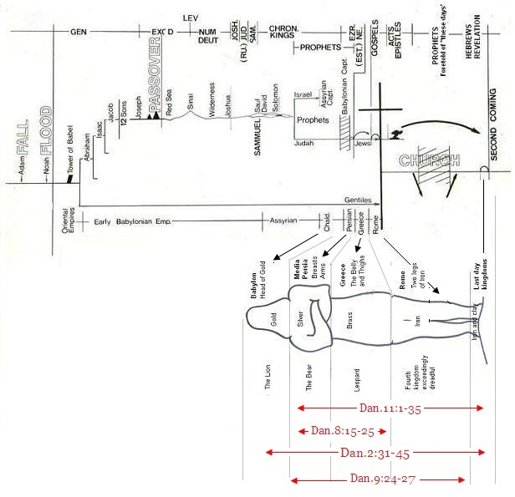

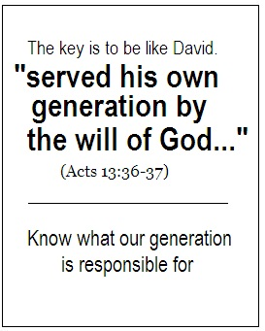
2. Paul realized that he was "born out of due time"
He said, "last of all He (Jesus) was seen of me also, as of one born out of due [16] time." (1Cor.15:7-9)
Brethren, "I count not myself to have apprehended: but this one thing I do, forgetting those things which
are behind, and reaching forth unto those things which are before, I press toward the mark for the prize
of the high calling of God in Christ Jesus." (Phil.3:13-15) The apostle knew there was more (Heb.5:11
-14, 2Cor.2:1-14) and knew he would not be in it. He realized
that he (Phil.3:13) and all the Church from the 1st. Cent. up to the
generation that will be "alive and remain" will be in the "dead in
Christ' which will not be resurrected until the Second Coming,
after the tribulation. (Review: Phase 10)
3. The 1st. Century, New Testament saints
They knew there was more in the future. The apostle Paul writes
that "He (Jesus) gave some, apostles; and some, prophets; and
some, evangelists; and some, pastors and teachers; For the
perfecting (the full maturity) of the saints, for the work of the ministry,
for the edifying of the body of Christ:
Till we all come (future) in the unity of the faith." (Eph.4:11-13 This is "the day" of Atonement language.
(Review: Bible Language)
a. They understood there was still "the day" coming
This "day" was not the day of Pentecost, because it had already come, (Acts.2:1) and the epistle to the
Hebrews was written many years after Pentecost. There is yet another "day approaching". (Heb.10:25)
NOTE: This day is NOT the Second Coming because
Jesus is NOT returning until the Mystery of God is finished.
Paul said, he was born out of due time. He would not see the unity of the faith (bride/ marriage) The
1st. Century Church had a "present truth." (a truth that was near / Acts.13:36) They were looking
towards being "fitly framed together groweth unto an holy temple in the Lord: In whom ye also are
builded together for an habitation of God through the Spirit." (Eph.2:21-22 - Foreshadowed by
Solomon's Temple. Review: Phase.2) They knew about the Mystery of God, (Eph.3:1-5) but lost
focus and declined into the dark ages.
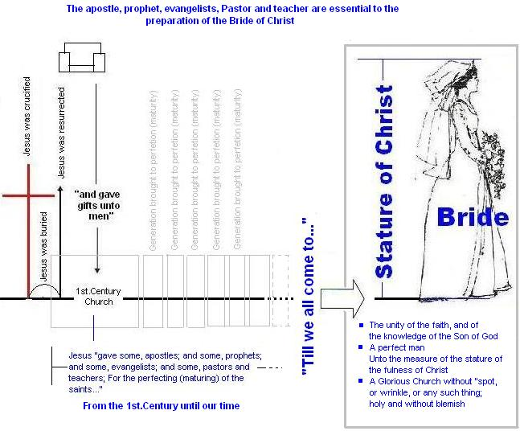

Note: They never attained the ultimate purpose of God. They came as far as the Tabernacle of
David (Review: Phase.2 and 7) and failed to press on "to the prize of the High Calling." (Phil.3:15)
They failed in their the stewardship of their "present truth."These all died and did not see the "Glorious
Church." A Church that had come to the "unity of the faith, and of the knowledge of the Son of God,
unto a perfect man, unto the measure of the stature of the fullness of Christ." (Eph.4:13-14)
b. They failed to keep the "vision" and declined into the "dark ages"
After the death of the apostle John (approx.100 AD.) the Church began to spiritually decline
towards the dark ages (500 AD approx.) which lasted until 1500 AD. (approx.) Those that remained
faithful to the Word of God (i.e. the truth that they understood) also have died and will be in the dead
in Christ.
(3) The Reformation (1571 AD) until our present day (2017 AD)
God began to restore truth back to His Church, however " These have also "died in faith not
having received the promise" of the Bride, the marriage. However we will be...

4. What should the motivation for those who will not be in the Bride of Christ
.
When you look at the blue print and see that the Marriage is for the last generation (those alive and remain)
this should not discourage you from pressing in / preparing to be the Bride. It should inspire
you to realize your responsibility (as ADULT / MATURE / PERFECTED SAINTS) to teach the NEXT
Generation what to look (watch and pray, listen) for. (NOTE: Heb.11:13-16)
a. Example of the Old Testament saints.
These all died in faith. (Review:
b. Example of David
David is very relevant to us TODAY because the pattern reveals that the Church has been restored up to
the time of the "Tabernacle of David". (Review: PHASE 2)When David was given the pattern
(1Chron.28:19) for the next and final step in God's Purpose for "the church in the wilderness" (Acts.7:37-
38), this did not "discourage" him, it inspired him to prepare in abundance for the NEXT generation to build
the Temple. (1Chron.22) David knew he would not see the completed Temple. David did not miss out, he
fulfilled his part. (some of us will live long enough to see the completion / perfection of the Church, like
Zadok. However some of us will not.
NOTE: We cannot predict the time, but we can look at the pattern and see what is about to happen.
Keep in mind "that one day with the Lord is as a thousand years" (2Peter.3:8, Psa.90:4, 84:10) A
generation (40-60 Yrs) is approx. 1-2 hours unto the Lord. [19]
(1) Right NOW you need to be someone that is after God's "own heart" (Acts.13:22) and serve your
generation by the will of God. (Acts.13:36) This applies to every generation, Old and New
Testaments. Think about two of the disciples that wanted to sit on the throne with Jesus. (Matt.20:20-
28) You don't need to be "top dog." Today some Christians get upset with those that desire to in the
Bride, thinking that they are better or special over other Christians.
NOTE: It is not a question if one group is better or favored more than another. It is one group is alive
and remain (1Thes.4:13-18) the other is dead in Christ. (See PHASE 10)
It is God that decides which generation you are born in. (Gen.4:1, Jer.1:5) It is God that sets every
member in the Body of Christ as it pleases Him. (1Cor.12) Can the thing that is formed say to the potter,
why have you made me thus (or why have I been born now and not in the alive and remain generation?
(Rom.9:19-20 / Isa.64:8, 1Thes.4:13-18)
(2) Right now you need to be after God's heart (He made mistakes that drove him into God's written
word. 1Chron.13-16) This actually open the revelation of the Temple / final move. (1Chron.17) After, is
to follow, have your intentions and goals / purpose / want to be around
(a) Do not mind (or be after) the flesh (Rom.8:
(b) Look not at the things which seen (1Cor.4:18) Seek those things that are above (heavenly places
Col.3:13
(3) Right now you need to serve your generation. Know where your generation is in God's unfolding
redemptive plan Phase.2, 3, 4 This means you must understand God's Redemptive plan
(4) Right now you need to served by the will of God as David did. (Rom.2:1-2)
Present yourself a "living sacrifice" (Old Testament language) That you may prove was is the will of
God. Offerings sacrifices is the Priests responsibility which foreshadows our responsibilities.
(1Peter.2:5) as a royal spiritual priesthood. The Priesthood was to serve / minister to the Tabernacle
(Num.1:47-54, 1Cor.9:13) Are we serving / ministering to our purposes? Are we staying on the Altar /
Brazen Altar when it gets to hot? (NOTE: David qualified as a "priests")
This is what's involved in present ourselves as a "living sacrifice"
(a) Only the Priest could offer a sacrifice (Lev.1-5, 1Peter.2:5)
(b) What qualified someone to be a Priest? (Num.1:47-54)
(c) Sacrifice was placed on the Altar The pattern requires an "Altar" which
requires a Tabernacle build according to the pattern. (The pattern of the heavens Heb.8:1-5;
9:1-29, Heb.13:10)
(d) There was only ONE Altar for blood sacrifice. (Lev.17:11) all others rejected!
(e) Not just any sacrifice (Mal,1:1-10; 2:1-8, Lev,21:21-23)
(f) The sacrifice is totally consumed, nothing less
c. Look at the example of the apostle Paul serving by the will of God
(1) Paul says, "reaching forth unto those "things" (1Cor.2:1-14, Col.2:16-17, Heb.10:1) which are
before…I press (pursue / Hunger and thirst) towards the mark…" (Phil.3:13-15) The 1st. Cent.
Church was told [20] press towards the mark…" This is why we "press" today. (Regardless of what
generation we are in)
NOTE: Paul knew that there was "a mark for the prize of the high calling of God in Christ Jesus."
To the Corinthians He said he was "born out of due time" (1Cor.15:8) To the Hebrews he said that he
was looking for "the day" Heb.10:25 / PHASE 11) Paul (who was taught by Jesus Gal.1:11-12) knew
"the day" (the day of atonement / Feast of Tabernacles) was still to come. (Col.2:16-17 - Review:
PHASE 8. 9, and 11) This did not stop him from pressing towards "the mark for the prize of the high
calling" To the Ephesians he said there is still a unity of the faith still to come and the Church
universal to become a perfect man. (Eph.4:11-16 / 1Cor.13:9-12)
(a) "The day" is NOT "the day" of Pentecost, because this feast had all ready been historically
fulfilled. (Acts.2:1) THE ONLY "day" that is ahead of the Church is the reality of "the day of
atonement". The context of Heb.10:25 is the day of Atonement, (the center piece of the Feast of
Tabernacles Lev.23:23-44)
(1) This is not "the day of the Lord" as some teach
(2) This is not "the day of Christ" as some teach
Besides, there is NO two stage Second Coming anyway, there is ONLY the day of The Lord Jesus
Christ. (Review: Phase 12 / Other Related subjects)
(3) This day must happen between our present time and the Second Coming because it is
part of the Mystery of God (Eph.5:32, Rom.16:25-26, 1Cor.2:1-7 / Col.2:16-17[26]) that MUST be
fulfilled BEFORE Jesus can return. (Acts.3:19-24, Rev.10:7; 11:15) REVIEW: PHASE 6, 10 / Note:
chart below. This places the Seals, Trumpets, Tribulation etc. between us and the Second Coming.
The Only "the day" (Heb.10:25) is the Seventh Seal because it matches "the day" of atonement.
(Review: PHASE 11 / Day of Atonement)
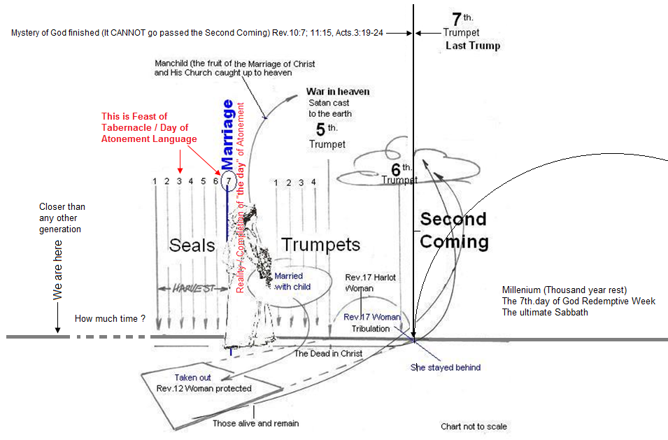

(b) This "day" of atonement was celebrated in the Tabernacles.
The third and final Feast of the year. (Lev.23:1-44) Passover was in the 1st. month, (fulfilled at the
Cross 1Cor.5:7-8) Pentecost was in the 3rd.month.
(fulfilled on the day of Pentecost Acts.2:1) The only New Testament reference to the Feast of
Tabernacles / day of atonement is in the Book of Hebrews and Revelation.
(1) The Book of Hebrews - The theme of the High Priest and the day of atonement
(2) The book of Revelation - The oil and the wine (Rev.6) is the harvest of the Feast of Tabernacles.
(3) The angel standing at the golden Altar (Rev.8:1-2, Lev.16:12-13) is the Day of Atonement.
(4) Most acknowledge the Feast of Tabernacles / "the day" of atonement has not been fulfilled yet.
We are still looking for the reality of this Feast

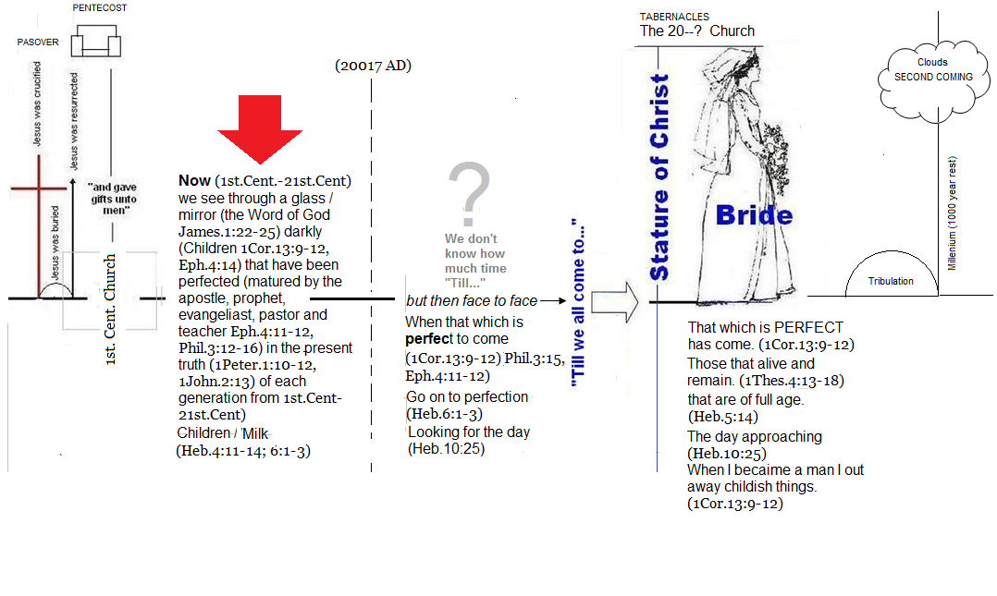
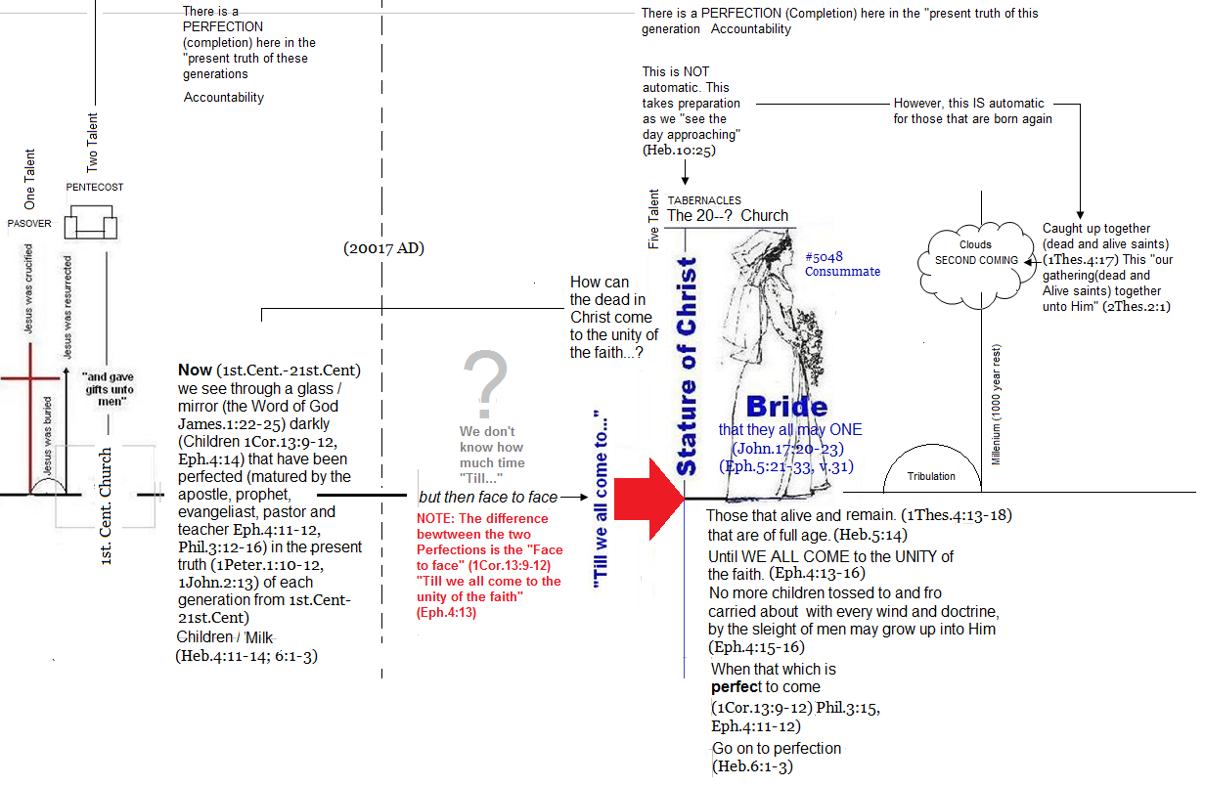
(c) The mark [24] for the prize of the high calling. This MARK / PRIZE is The Bride of Christ because
there is no other high prize. (Phil.3:15, 1Cor.9:24 / Heb.12:1) NOTE: Eph.5:21-33 Husband and wife
One in marriage. (John.17:21-24) / unity ("the day" atonement that is to come) / Glorious Church /
without spot or blemish / two made one / a Great Mystery).
NOTE: This "MARK / PRIZE" is ahead for those that are "PERECT." (Phil.3: This is FUTURE. The
antichrist (1John.2:18) will have a counterfeit "mark"[25] (Goal Rev.13:) "like"( a scratch or etching,
i.e. stamp (as a badge of servitude), or sculptured figure (statue):—graven, mark) the true.
(Isa.14:11-14, 2Thes.2:1-9) NOTE: "who is like beast / antichrist (Rev.13:4) What is he (the
antichrist) counterfeiting? It is just "like" - graven on my hand Isa. / the potter mounding the clay
(Rom.9) into a statue (Eph.4) / image (Rom.8:28-29, 2Cor.3:18)
(2) Note: Paul's letter to the Church at Ephesus (Eph.4:11-16) has two sections in it.
(a) First section. Paul wrote of being perfect Phil.3:(a) Apostle, Prophet, Evangelist, Pastor and
teacher are given to bring us to maturity / perfection / to be completed. (Eph.4:11-12) This was
directed to the body of Christ that was alive in Paul's generation in the 1st Cent. Church.
(d) While looking for the unity of the faith (day of atonement) full measure / stature of Christ
UNTO A PERFECT MAN. (Eph.4:13-14, 1Cor.13:9-12 / Phil.3:15) brought to its end,
finished / wanting nothing necessary to completeness / perfect / that which is perfect
consummate human integrity and virtue / of men / full grown, adult, of full age, mature
brought to its end. Finished wanting nothing necessary to completeness, consummate
human integrity and virtue of men. Strong's Con. 5046 / complete (in various applications of
labor, growth, mental and moral character, etc.);completeness:—of full age, man, perfect.

The difference between Eph.4:11-12 and Eph.4:13-16 is
isYou need to understand where you are in God's Redemptive Plan / Purpose
What's the point of pressing in I am not going to be in the Bride
Think of the natural body, If the ear shall say, because I am not the eye, I am not of the body; is it therefore not of the body? (1Cor.12:16)
Shall the ting formed (by the potter) saY WHY HAVE YOU MADE ME SO? (Rom.9:
First of all, you have not be left out! Your not excluded, or discriminated against

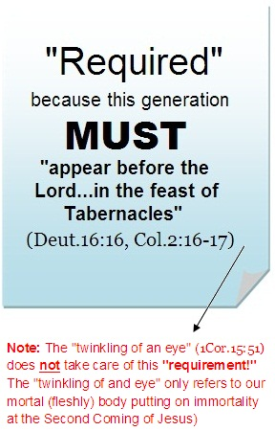
II. (Cont)There will be two groups at the time of the marriage
When the marriage takes places there will be two categories in the Church. There will be a group that is "alive
and remain" and there will be the "dead in Christ."
B. Those that "alive and remain" at the time of the Marriage
Obviously, this generation will be the Bride because they alive.(The dead in Christ did not resurrect until
Jesus returns at the end of the Tibulation / Review: Phase 10) Much shall be required of this generation!
(Luke.12:48 / Matt.25:14-30) The Church of this generation will be required to "come in to the unity of the
faith,(The Feast of Tabernacles and of the knowledge of the Son of God,unto a perfect (complete / mature)
man, (1Cor.13:9-12) unto the measure of the stature of the fulness of Christ." (Eph 4:13 Review: "Conclusion")
This is the "glorious church, not having spot, or wrinkle, or any such thing; but that it should be holy and
without blemish." (Eph.5:27-28) I say "required" because Jesus
cannot marry a Church that is not mature (i.e. perfect, without spot or
blemish) This would make Him unequally yoked in marriage which
would violation of His own Word. He cannot deny Himself.
(John.1:14, 2Tim.2:13)
1. These are things not as seen yet
As it was in the days of Noah, (Luke.17:26) these are "things
not as seen yet." (Heb.11:7, 1Cor.2:9) Nobody had ever seen an
ark, rain or a flood. (Gen.2:4-6) Nobody has ever seen a "Glorious
Church," without spot, or wrinkle, or any such thing...holy and
without blemish." (Eph.5:27) But it WILL happen! The only
question is where [9] and when?[10]
2. Requirement foreshadowed by the Feast of Israel
Three "times in a year shall all thy males appear before the Lord
thy God in the place which he shall choose." (Deut 16:16-17)
a. In "the feast of unleavened bread"
The 1st. Century Church appeared "before the Lord" in the
reality of Passover / Unleavened Bread when Jesus was
crucified as the true Passover Lamb. (1Cor.5:7-8, Col.2:16-17)
REQUIRED! (Deut.16:16)
b. In "the feast of weeks"(Pentecost Acts.2:1)
The 1st. Century Church appeared "before the Lord" in the
reality of the Feast of Pentecost / Weeks / Harvest. (Col.2:16-17) REQUIRED! (Deut.16:16)
c. In "the feast of tabernacles" REQUIRED! (Deut.16:16)
The 1st. Century Church never appeared "before the Lord" in the reality of the Feast of Tabernacles.
they let man spoil them "through philosophy and vain deceit, after the tradition of men, after the
rudiments of the world, and not after Christ." (Col 2:8) This resulted in the spiritual decline of the
Church down into the "Dark Ages." This continued for (approx.) 1000 years until Luther and the
Reformation in 1517 AD. Since that time God has been restoring the Church back to appearing before
Him in the Feast Passover (Reformation 1517 AD) and Pentecost (1900's AD) and soon the Church will
"appear before the Lord" in the reality of the Feast of Tabernacles. (i.e. "come in to the unity of the faith,
and of the knowledge of the Son of God,unto a perfect (complete / mature) man, (1Cor.13:9-12) unto
the measure of the stature of the fulness of Christ." (Eph 4:13 Review: "Conclusion") This is the
"glorious church, not having spot, or wrinkle, or any such thing; but that it should be holy and without
blemish." (Eph.5:27-28 "Things not as seen yet"- Heb.11:7, Luke.17:26)
Out of the "alive and remain" group there will be
(1) Those that refuse to come to the Marriage. (Luke.14:15-24)
(2) Those that are not properly prepared and are refused entrance to the Marriage. (Matt.22:11-14;
25:1-13) and
(3) Those that fall away defect, apostatize to the false Bride / marriage because they don't have a love
for the truth - 2Thes.2:10)
To be continued on Page 2 Coming Soon
______________________________________________________________________________
Note: This study will be on going.
Paul the wisemaster builder and apostle writes, "For we know (This study) in part, (because we are children Eph.4:14-15) and we
prophesy in part. But when that which is perfect (becoming a man, a perfect man Eph.4:11-16) is come, then that which is in part (being a
child Eph.4:14-15) shall be done away. When I was a child, (Eph.4:14-15) I spake (i.e. my preaching and teaching) as a child, I understood
as a child, I thought as a child: but when I became a man, (Eph.4:11-16) I put away childish things. For now (i.e. today) we (the Church) see
through a glass, (The written Word of God / The Bible) darkly; but then (when I become a perfect / complete man (Eph.4:11-16) face to face:
now (today) I know in part; but then (Becoming a perfect / complete man Eph.4:11-16) shall I know even as also I am known. And now (while
I am a child, knowing in part) abideth faith, hope, charity, these three; but the greatest of these is charity.
_______________________________________________________________________________________________
NOTES
1. Our "gathering together" - a complete collection; especially a Christian meeting (for worship): KJV - assembling (gathering) together. Strong's Con. NT # 1997
2. Saints - OT:2623 from OT:2616; properly, kind, i.e. (religiously) pious (a saint): KJV - godly (man), good, holy (one), merciful, saint, [ungodly.
3. Figure - NT:5179 a die (as struck), i.e. (by implication) a stamp or scar; by analogy, a shape, i.e. a statue, (figuratively) style or resemblance; specifically, a sampler ("type"), i.e. a model
(for imitation) or instance (for warning): KJV - en- ex-) ample, fashion, figure, form, manner, pattern, print.
4. Supper - NT:1173 a dinner, i.e. the chief meal (usually in the evening): KJV - feast, supper.
5. Falling Strong's NT:646 - defection from truth (properly, the state) ["apostasy"]: KJV - falling away, forsake.
6. Repliest - Strong's NT 470 -to contradict or dispute:KJV - answer again, reply against.(Biblesoft's New Exhaustive Strong's Numbers and Concordance with Expanded Greek-Hebrew
Dictionary. Copyright © 1994, 2003, 2006 Biblesoft, Inc. and International Bible Translators, Inc.)
7. Perfecting - Strong's Concordance NT #:2677 from NT #:2675; complete furnishing (objectively): KJV - perfecting.
8. Understanding season - Note those the sensed the first coming of Messiah. Woman at the well. the two on their way to Emmaus. The two that said we have found the Messiah (because
of Daniel's word. Dan.9:26)
9. Where - This is explained by the Rev.12 Woman. (Review: Phase 10 and 12) It is some time before the Tribulation
10. When - This is during the 7th. Seal
11. Rev.12-22 further explain the events of chapters 4-11. The reason for this conclusion is because Rev.12:1-17; 13:1-18; 14:11; 15:2; 16:1-15; 17:1-18; 18:1-24; 19:20--21; 20:1-15 are all
associated with the beast / antichrist who ONLY has 3½ years to continue. (Rev.13:5) Therefore all events must happen during this same 3½ year period of time. (Note: How the Rev.12
Woman is protected during this 3½ period of time)
12. No more sacrifice - This is why there will be NO animal "daily sacrifice" (Dan.8:11-13, 31; 12:11) during the time of the man of sin (Tribulation "so-called") because Jesus caused the
sacrifice and oblation to cease. (Dan.9:27)
13. Ensample - Strong's Concordance NT # 5179 / týpos, too'-pos; from G5180; a die (as struck), i.e. (by implication) a stamp or scar; by analogy, a shape, i.e. a statue, (figuratively)
style or resemblance; specially, a sampler ("type"), i.e. a model (for imitation) or instance (for warning):—en-(ex-)ample, fashion, figure, form, manner, pattern, print.
14. When the apostle was writing - He was writing under the inspiration of the Spirit of God (2Tim.3:16-17) and he was taught by Jesus. (Gal.1:11-12) This makes his doctrine the doctrine
of Christ
15. Repliest - Strong's Concordance #470 NT / from G473 and G611; to contradict or dispute:—answer again, reply against.
16. Due - Strong's Concordance #1626 NT / from a comparative of G1537 and τιτρώσκω titrṓskō (to wound); a miscarriage (abortion), i.e. (by analogy) untimely birth:—born out of due time.
Note: Paul's statement, "
17. Biblical pattern of being espoused - Mary and Joseph. (Matt.1:18-25) Strong's Concordance NT # 718 / Espoused: "to woo and win, to espouse or promise in marriage," is used in the
Passive Voice in Mat 1:18; Luk 1:27; 2:5, all with reference to the Virgin Mary, RV, "betrothed," for AV, "espoused," in each case. Joseph had to authority before the Lord to put Mary away
(Deut.24:1-4) because according to the pattern, from the time of betrothal the woman was regarded as the lawful wife of the man to whom she was betrothed (Deut. 28:30; Jdg 14:2,8; Mat
1:18-21). Jesus (who fulfills "the righteousness of this Law Matt.5:17-19, Rom.8:1-4) has authority over us today, (Eph.5:21-33) even though the marriage has not happened yet.
18. Man child - This is the fruit of the Marriage. (Review: Phase 12, Page 2)
19. This calculation is concluded because a thousands year = 24 hrs, 500 yrs = 6 hours, 250 yrs =3 hours, 125 yrs = 60+hrs, 60+ yrs = 30 yrs, 30+ yrs = 15 yrs, 15 yrs = 7+ hrs, 7+yrs = 3+ yrs, 3+ yrs = 1+ hrs. etc. This is speculation and opinion. One thing is for sure, we MUST see timweas God sees it. NOTE: 2 Peter.3:1-9
20. The Epistles (Corinthians, Galatians', Ephesians', Philipians, etc. were written to the Body of Christ, not just them. (2Tim.3:16-17, 2John.5:13,
Rom.15:4
21. Perfect - Greek #5046 τέλειος téleios, tel'-i-os; from G5056; complete (in various applications of labor, growth, mental and moral character, etc.); neuter (as noun, with G3588) completeness:—of full age, man, perfect. Eph.4:13-16
22. Perfecting - Greek #2005 ἐπιτελέω epiteléō, ep-ee-tel-eh'-o; from G1909 and G5055; to fulfill further (or completely), i.e. execute; by implication, to terminate, undergo:—accomplish, do, finish, (make) (perfect), perform(X -ance). Gal.3:3
23. Perfection - Greek #5047 / τελειότης teleiótēs, tel-i-ot'-ace; from G5046; (the state) completeness (mentally or morally):—perfection(-ness). Heb.6:1
24. Mark - Strong's Con. # 4649 σκοπός skopós, skop-os'; from σκέπτομαι sképtomai (to peer about ("skeptic"); perhaps akin to G4626 through the idea of concealment; compare G4629); a watch (sentry or scout), i.e. (by implication) a goal:—mark. Phil.3:15
25. Mark (antichrist) - Strong's Con. #5480 / χάραγμα cháragma, khar'-ag-mah; from the same as G5482; a scratch or etching, i.e. stamp (as a badge of servitude), or scupltured figure (statue):—graven, mark.
26. The Mystery of God - is the wisdom of God (1Cor.2:6-7 / Gal.1:11-12) which is to be made manifest by the Church according to His eternal purpose. (Eph.3:1-12; 5:21-33, Rom.16:25-26, Rev.10:7; 11:15 / Acts.3:19-24) The day of atonement is part of that mystery because it is part of the Feast of Tabernacles which is a shadow of things to come (Col.2:16-17) which is the third and final Feast that the church in the wilderness kept. (Deut.16:16-17, Lev.23, Acts.7:37-38, 1Cor.10:1-11, Rom.15:4) The other two Feasts are Passover and Pentecost.
27. Hand - Strong's Con. #NT 1764 to place on hand, i.e. (reflexively) impend, (participle) be instant:—come, be at hand, present.Thayer's Greek Lexicon [?] (Jump to Scripture

