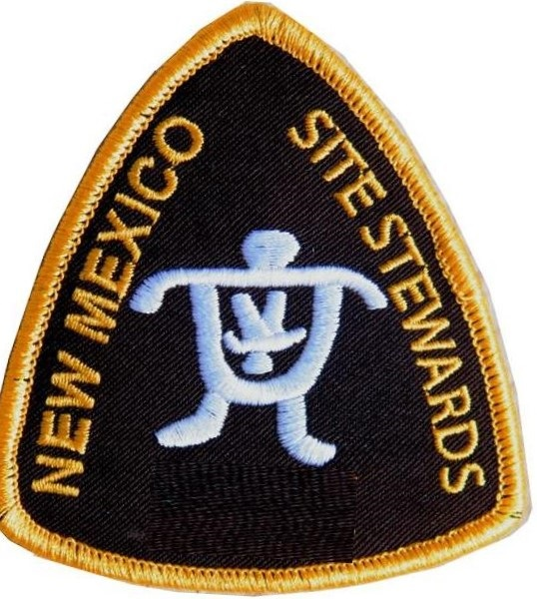Northwest New Mexico Site Stewards’ Program
Managed by the Salmon Ruins Museum
PO Box 125
Bloomfield, NM 87413
505-632-2013

Name:
Address:
Cell Phone:
Email:

Emergency Contact Name:
Emergency Contact Cell Phone:

Please fill out:
What distance would you like to walk to get to your site: Short Long
What does that mean to you? Quarter mile, half mile, mile or more, close to road, etc. explain below:

If you have to climb up and down a cliff, will that be a problem? Yes No Prefer Not
Do you have a high clearance vehicle AND 4 wheel drive? Yes No
Can you monitor your site at least once every 2 months? Yes No

Do you have interesting or useful skills? (writing, photography, GPS, orienteering, medical, giving presentations, offering training, drone pilot, etc.) explain below:

Describe your interests and/or background in archaeology:

