

2024
Liberation Singles Open

A welcome back to our usual annual Singles Open and the first major tournament of the year. 16 players took part in this years competition played in beautiful sunshine.

Round one saw current champion from 2022 Laurent Pellaton take on Seb Renuad from Guernsey, a tough draw for both players, but a great win for Seb and not the start the champion was looking for.

Nicky Maindonald almost beat Andrew Bellamy, with a miss fire giving Andrew a 13-12 win. Alan Oliveira played exceptionally well beating Toby 13 – 10.

Round two, saw Jake Romeril make it two from two just beating Neil Selby 13 – 12, the first of three such scores for Neil!

Andrew beat Geoffroy Buffetrille 13 – 11 and Alan made it two wins beating Ross Payne 13 – 7. Toby got back to winning ways 13 – 3 over Nicky and two 13 – 2 results as Laurent beat James Villalard and Branden De La Haye beat Daniel Villalard.

Seb lost to Brian Harris 13 – 5 and Wendy beat Mo 13 – 11.

Round three, saw a very close match between Jake and Alan with Jake just taking it 13 – 11. Brian also made it three wins in a row beating Andrew 13 – 11.

Wendy playing exceptionally well, beat Geoffroy 13 – 9 leaving Geoffroy just one win from three. Toby handed Neil his second 13 – 12 defeat with two perfect carreau to seal a great win.

Laurent got his tournament back on track beating Ross 13 – 11 and the first wins for Mo 13 – 12 over Daniel and James 13 – 10 over Nicky.

Round four, saw Brian suffer a heavy loss to Jake 13 – 2 and Alan beat Andrew 13 – 4 in two big results. With Toby also beating Seb 13 – 4.

Laurent though suffered his second loss 13 – 9 to Wendy who took her second big scalp of the tournament.

Daniel got his first win beating Nicky 13 – 9, whilst both Ross and Neil won their respective matches 13 – 6.

In the final Round to determine the top eight for the Main. Jake Romeril put in a great performance to beat Wendy and topped the rankings with five out of five wins. Wendy finishing an impressive fourth.

Alan Oliveira beat Brian Harris 13 – 0!! To finish second, but despite this big loss and finishing with minus points difference Brian finished third.

Despite Toby loss to Laurent, Toby had already qualified in sixth, but Laurent finishing with plus eight points lost out to Andrew who beat Ross 13 – 10 on BHN but with a points difference of minus five!

Neil also squeezed in with a 13 – 12 win over Nicky to take eighth place with plus 11 points beating Laurent by three.

Geoffroy and Seb played each other with the winner going through, Geoffroy just made it after Seb missed a fire for the win.

Final Swiss Rankings

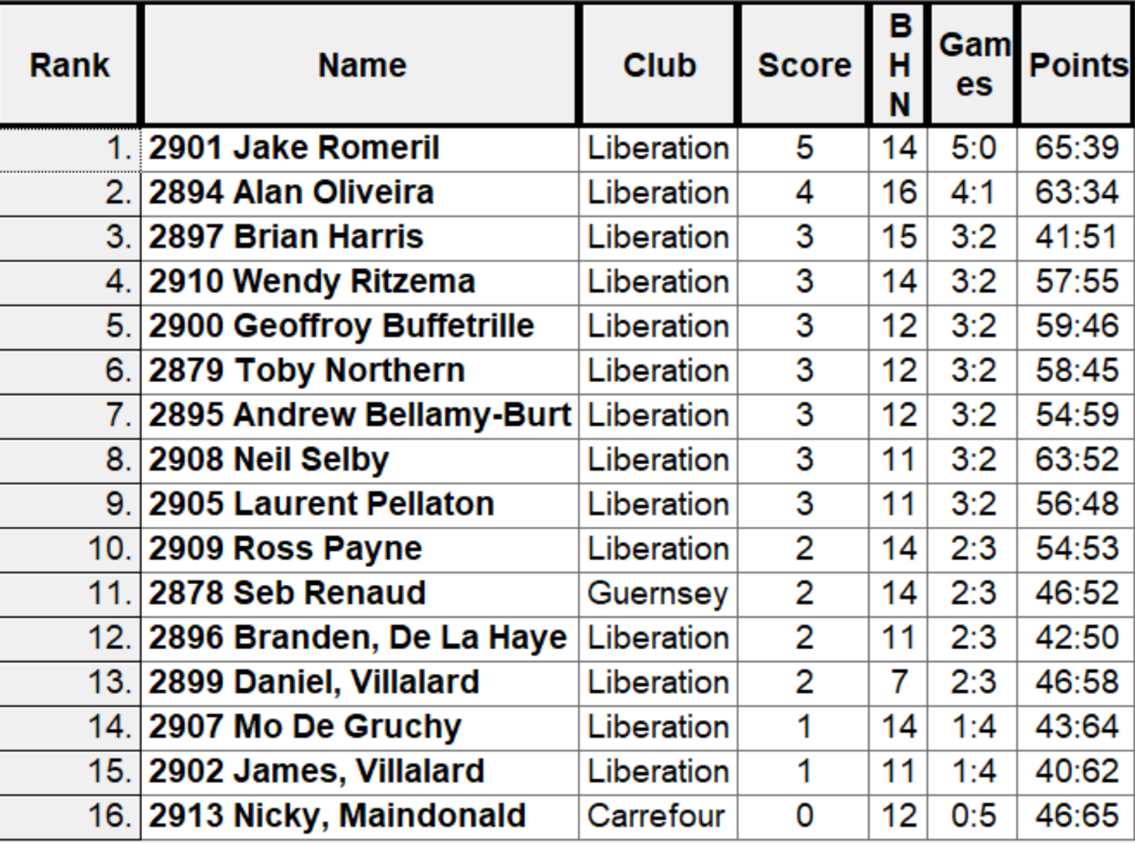

The Main Competition

Quarter Finals

A

Ranked 1st Jake Romeril v Neil Selby Ranked 8th

Ranked 2nd Alan Oliveira v Andrew Bellamy-Burt Ranked 7th

Ranked 3rd Brian Harris v Toby Northern Ranked 6th

Ranked 4th Wendy Ritzema v Geoffroy Buffetrille Ranked 5th

Three of the quarter finals saw repeat matches from the qualifying rounds, with Jake having beat Neil 13 – 12 in round two. Jake finished the match in style with a carreau leaving him holding three with Neil one boule left but little options, with Jake making it to the semi-finals.

Another match saw Alan having already beaten Andrew 13 – 4 in round play well again, but not quite a the level of the previous match with Andrew grinding out a 13 – 10 win to make the semi-finals.

Wendy had also beaten Geoffroy but despite a close match Geoffroy this time go the win he needed 13 – 9. In the last quarter-final Toby was in the lead the whole way taking a 13 – 7 win.

The Main Competition

Semi Finals

Ranked 1st Jake Romeril v Geoffroy Buffetrille Ranked 5th

Ranked 6th Toby Northern v Andrew Bellamy-Burt Ranked 7th

Jake was on exceptional form as he beat Geoffroy 13 – 5 to make his third Liberation Singles Open final! Previously in 2012 (the first one) and 2015.

Toby was equally impressive, hitting several carreau and if it wasn’t for one very unlucky shot would have won more comfortably than 13 – 10 over Andrew. This was Toby fourth final and having won in 10 years ago in 2014.

Geoffroy took third place beating Andrew 13 – 11 to finish the tournament on a high.

In the final Toby hit the ground running taking a 6 – 0 lead before Jake pulled it back to 6 – 6. Jake then took the lead albeit with a lucky shot carreau his own boule instead of the target boule to take appoint on one end. With Jake leading 10 -8 Toby then pulled in back to lead 11-10 and placed a good shot within 6inches of the Jack at 9m, Jake choosing to place but not one but two boules off the terrain! Jake composed himself placing a really good last boule, but Toby with his last boule placed in for the win.

10 years since his last win in this competition but fantastic play all day and need that extra bit to beat Jake who had won all his matches prior, but this means Jake has lost all three finals he has played in.

2024 – Winner –

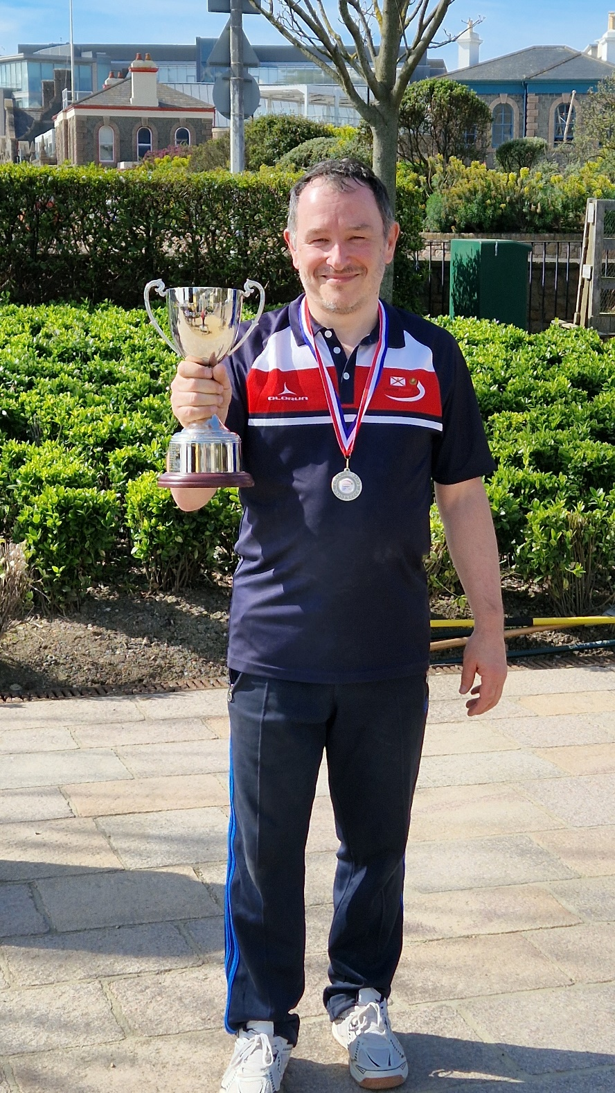

Thanks to all those who helped on the day to make it another great competition.

Club email address - liberationpc@gmail.com

Club Website - www.liberationpetanque.co.uk

Kind Regards

Toby Northern

Chairman

Liberation Petanque Club

