Saturday & Sunday,
December 6 & 7 2025
Second Sunday of Advent, Year A
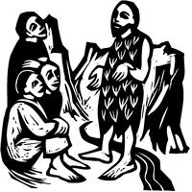
Christ Lutheran Church
“A Place Where You are Always Welcome”
Services: Saturday 5:30 pm and Sunday 10:00 am
Sunday School: 9:00 am (September- May)
600 North Main Street, Stockton, IL 61085 Office: 815-947-2033
Email: christlutheranchurch70@gmail.com http://www.christlutheranstockton.com
Ministers: ALL members of the congregation
Pastor: Rev. Chrissy Salser chrissytherev@att.net 815-988-9450
From Sundays and Seasons.com. Copyright 2017 Augsburg Fortress. All rights reserved. Reprinted by permission under Augsburg Fortress Liturgies Annual License #40643.New Revised Standard Version Bible, copyright 1989, Division of Christian Education of the National Council of the Churches of Christ in the United States of America. Used by permission. All rights reserved.
WELCOME: Thank you for joining us for worship today. We are glad you are with us. Communion will be served in the aisle or in your pew. All are welcome to share this meal. Jesus is our host and invites everyone. Those who would like to come forward, bread and wine will also be available in the front. When directed by the usher, come forward down the center aisle, Pr Chrissy will give you bread (she will be masked and wearing cloves) and then you will take a cup of wine (grape juice) from the tray. After taking communion, you will return to your seat by the side aisle. For those who are unable to come forward, communion elements can be found as you entered worship. At that part of the service, you are invited to take the bread and wine (or grape juice) when Pr. Chrissy leads. On Saturday’s offering is collected as you enter or leave worship. On Sunday we will pass the plate as a response to God’s grace. Online giving is available. Please see QR code on back of bulletin or visit our website.
INTRODUCTION At the heart of our Advent preparation stands John the Baptist, who calls us to repent and make a new beginning. As the darkness increases, we turn toward the approaching light of Christ. For Christians he is the root of Jesse, the righteous judge who welcomes all, especially the poor and meek of the earth. We wait with hope for that day when the wolf will dwell with the lamb, and there will be no more hurt or destruction. From the Lord’s table we are sent in the spirit of John the Baptist to proclaim that in Christ the kingdom of God has come near.

Gathering: The Holy Spirit calls us together as the people of God.
PRELUDE
WELCOME AND ANNOUNCEMENTS
CONFESSIONS AND FORGIVENESS
In those days John the Baptist appeared in the wilderness, proclaiming, “Repent, for the kingdom of heaven has come near.” The same voice cries out to us today, calling us to turn back, to prepare, to walk in God’s way.
Let us confess our sin and hear the promise of God’s mercy.
(Silence for reflection)
P: Merciful God,
C: We confess that our hearts are often far from you.
P: Our paths are crooked.
C: Straighten them, Lord.
P: Our words have been careless.
C: Purify them with your mercy.
P: Our hands have clung to selfishness.
C: Open them to serve in love.
P: We have relied on our strength.
C: Teach us to rely on your grace.
P: We have resisted change.
C: Transform our journey, O God.
P: We have grown weary of waiting.
C: Awaken us with your Spirit.
P: Forgive us, Lord.
C: Renew us in hope. Shape us into people who bear fruit worthy of repentance.
P: Hear the good news! John proclaimed, “I baptize you with water for repentance, but one who is more powerful than I is coming after me.” That One is Jesus Christ. He comes not to condemn but to save.
C: He comes with Spirit and fire.
P: The fire of judgment becomes the fire of mercy.
C: The Spirit that convicts also restores.
P: In Jesus Christ, your sins are forgiven. Your burden is lifted. Your path is made new. Walk now in the light of Christ. Bear fruit in every step. For God’s grace is not far away— it has come near, and it transforms the journey.
C: Amen. Come, Lord Jesus.

GATHERING HYMN Prepare the Royal Highway ELW 264
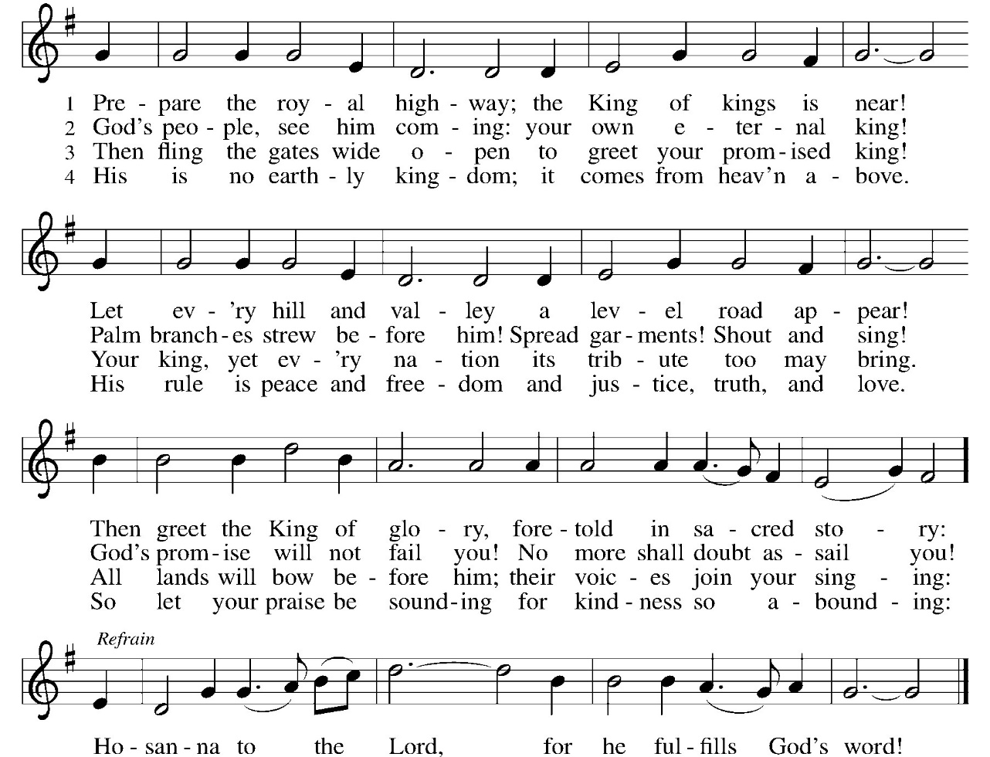
Greeting:
P: The grace of our Lord Jesus Christ, the love of God, and the communion of the Holy Spirit be with you all. C. And, with you.
PRAYER OF THE DAY:
P: Stir up our hearts, Lord God, to prepare the way of your only Son. By his coming nurture our growth as people of repentance and peace; through Jesus Christ, our Savior and Lord, who lives and reigns with you and the Holy Spirit, one God, now and forever. Amen.

THE ADVENT WREATH
One of the best-known customs for the season is the Advent wreath. The wreath and winter candle-lighting amid growing darkness strengthen some of the Advent images found in the Bible. The unbroken circle of greens is clearly an image of ever- lasting life, a victory wreath, the crown of Christ, or the wheel of time itself. Christians use the wreath as a sign that Christ reaches into our time to lead us to the light of everlasting life. The four candles mark the progress of the four weeks of Advent and the growth of light.

ADVENT WREATH HYMN: Light One Candle To Watch for Messiah ELW #240 v 2
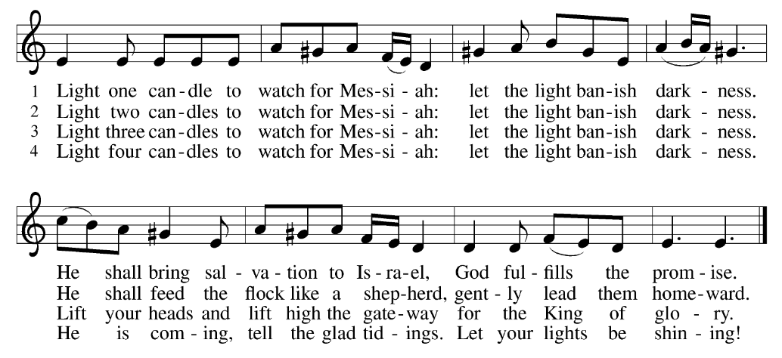
ADVENT WREATH PRAYER:
P: We praise you, O God, C: for this circle of light that marks our days of preparation for Christ’s advent. As we light the candles on this wreath,
kindle within us the fire of your Spirit, that we may be light shining in the darkness. Enlighten us with your grace, that we may welcome others as you have welcomed us. Grant this through Christ our Lord, whose coming is certain and whose day draws near. Amen.
Word: God speaks to us in scripture reading, preaching, and song.

First Reading: Isiah 11:1-10
Isaiah describes the coming of a future, ideal ruler who will renew David’s royal line (the stump of Jesse). Gifted by the spirit of God, this ruler will reign with perfect justice. Enmity and danger will be restored to harmony and peaceful coexistence.
¹ A shoot shall come out from the stump of Jesse, and a branch shall grow out of his roots. ² The spirit of the Lord shall rest on him, the spirit of wisdom and understanding, the spirit of counsel and might, the spirit of knowledge and the fear of the Lord ³ His delight shall be in the fear of the Lord.
He shall not judge by what his eyes see or decide by what his ears hear,
⁴ but with righteousness he shall judge for the poor and decide with equity for the oppressed of the earth; he shall strike the earth with the rod of his mouth, and with the breath of his lips he shall kill the wicked. ⁵ Righteousness shall be the belt around his waist and faithfulness the belt around his loins. ⁶ The wolf shall live with the lamb; the leopard shall lie down with the kid; the calf and the lion will feed together, and a little child shall lead them ⁷ The cow and the bear shall graze; their young shall lie down together; and the lion shall eat straw like the ox.⁸ The nursing child shall play over the hole of the asp, and the weaned child shall put its hand on the adder’s den. ⁹ They will not hurt or destroy on all my holy mountain,
for the earth will be full of the knowledge of the Lord as the waters cover the sea. ¹⁰ On that day the root of Jesse shall stand as a signal to the peoples; the nations shall inquire of him, and his dwelling shall be glorious.

R: The Word of the Lord. C: Thanks be to God.

Psalm: Psalm 72:1-7,18-19
¹ Give the king your justice, O God, and your righteousness to the king’s son;
² that he may rule your people righteously and the poor with justice;
³ that the mountains may bring prosperity to the people, and the hills, in righteousness.
⁴ Let him defend the needy among the people, rescue the poor, and crush the oppressor.
⁵ May he live as long as the sun and moon endure, from one generation to another.
⁶ Let him come down like rain upon the mown field, like showers that water the earth.
⁷ In his time may the righteous flourish; and let there be an abundance of peace till the moon shall be no more.
¹⁸ Blessed are you, Lord God, the God of Israel; you alone do wondrous deeds!
¹⁹ And blessed be your glorious name forever and may all the earth be filled with your glory. Amen. Amen.

Second Reading: Romans 15:4-13
God’s promise to include Gentiles within the circle of God’s blessed people has been fulfilled in Jesus Christ. Christians live out their unity by welcoming and encouraging each other just as Christ has welcomed them into God’s family.
⁴ Whatever was written in former days was written for our instruction, so that by steadfastness and by the encouragement of the scriptures we might have hope. ⁵ May the God of steadfastness and encouragement grant you to live in harmony with one another, in accordance with Christ Jesus, ⁶ so that together you may with one voice glorify the God and Father of our Lord Jesus Christ.
⁷ Welcome one another, therefore, just as Christ has welcomed you, for the glory of God. ⁸ For I tell you that Christ has become a servant of the circumcised on behalf of the truth of God in order that he might confirm the promises given to the ancestors ⁹ and that the gentiles might glorify God for his mercy. As it is written,
“Therefore I will confess you among the gentiles and sing praises to your name” ¹⁰ and again he says, “Rejoice, O gentiles, with his people”;
¹¹ and again. “Praise the Lord, all you gentiles, and let all the peoples praise him” ¹² and again Isaiah says, “The root of Jesse shall come, the one who rises to rule the gentiles; in him the gentiles shall hope.”
¹³ May the God of hope fill you with all joy and peace in believing, so that you may abound in hope by the power of the Holy Spirit.
R: The Word of the Lord. C: Thanks be to God.
GOSPEL ACCLAMATION Come Now O God ACS 902
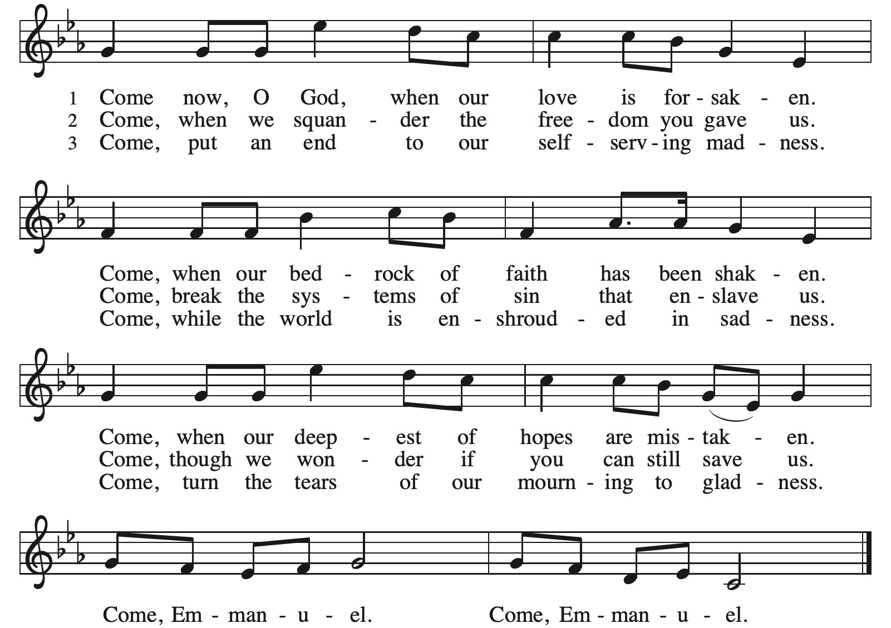

Gospel: Matthew 3:1-12

P: The Gospel according to Matthew C: Glory to you, O Lord
Just before Jesus begins his public ministry, John the Baptist appears, calling people to mend their ways and speaking of a powerful one who is to come.
¹ In those days John the Baptist appeared in the wilderness of Judea, proclaiming, ² “Repent, for the kingdom of heaven has come near.” ³ This is the one of whom the prophet Isaiah spoke when he said, “The voice of one crying out in the wilderness: ‘Prepare the way of the Lord; make his paths straight.’ ”
⁴ Now John wore clothing of camel’s hair with a leather belt around his waist, and his food was locusts and wild honey. ⁵ Then Jerusalem and all Judea and all the region around the Jordan were going out to him,
⁶ and they were baptized by him in the River Jordan, confessing their sins.
⁷ But when he saw many of the Pharisees and Sadducees coming for his baptism, he said to them, “You brood of vipers! Who warned you to flee from the coming wrath? ⁸ Therefore, bear fruit worthy of repentance, ⁹ and do not presume to say to yourselves, ‘We have Abraham as our ancestor,’ for I tell you, God is able from these stones to raise up children to Abraham. ¹⁰ Even now the ax is lying at the root of the trees; therefore every tree that does not bear good fruit will be cut down and thrown into the fire. ¹¹ “I baptize you with water for repentance, but the one who is coming after me is more powerful than I, and I am not worthy to carry his sandals. He will baptize you with the Holy Spirit and fire. ¹² His winnowing fork is in his hand, and he will clear his threshing floor and will gather his wheat into the granary, but the chaff he will burn with unquenchable fire.”
P: The Gospel of Our Lord. C. Praise to you, O Christ.
CHILDREN’S MESSAGE
MESSAGE
HYMN OF THE DAY Hark, The Glad Sound! ELW 239 (next page)
APOSTLES’ CREED:
I believe in God, the Father almighty, creator of heaven and earth.
I believe in Jesus Christ, God’s only Son, our Lord, who was conceived by the Holy Spirit, born of the virgin Mary, suffered under Pontius Pilate, was crucified, died, and was buried; he descended to the dead. On the third day he rose again; he ascended into heaven, he is seated at the right hand of the Father, and he will come to judge the living and the dead.
I believe in the Holy Spirit, the holy catholic church, the communion of saints, the forgiveness of sins, the resurrection of the body, and the life everlasting. Amen.

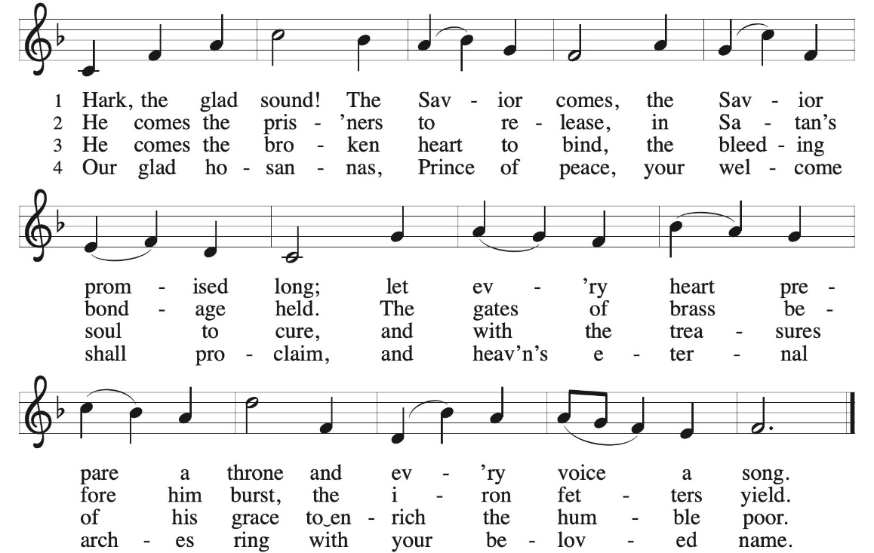

PRAYERS OF INTERCESSION:
P: God of grace C: hear our prayer
PEACE
P: The peace of Christ be with you always. C. And also with you.
OFFERING: Our offering is a significant act of worship; we worship God through our giving. The ministry of this congregation is completely dependent upon your partnership and generosity. Offering is collected as you enter worship on Saturday. We will pass the offering plate on Sundays. Online giving is available.
OFFERING HYMN Come Now O Prince of Peace ELW 247
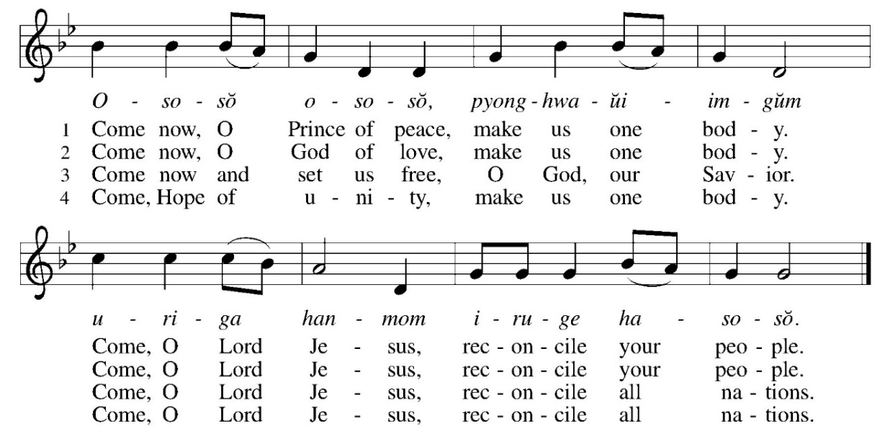
COMMUNION LITURGY:
In the night in which he was betrayed, our Lord Jesus took bread, and gave thanks, broke it and gave it to his disciples, saying: take and eat; this is my body, given for you. Do this for the remembrance of me. Again, after supper, he took the cup, gave thanks and gave it for all the drink, saying: this cup is the new covenant in my blood, shed for you and for all people for the forgiveness of sin. Do this for the remembrance of me.
THE LORD’S PRAYER:
Our Father, who art in heaven, hallowed be thy name, thy kingdom come, thy will be done on earth as it is in heaven. Give us this day our daily bread; and forgive us our trespasses, as we forgive those who trespass against us; and lead us not into temptation but deliver us from evil. For thine is the kingdom, and power, and the glory, forever and ever. Amen
INVITATION TO COMMUNION:
P: Here is life. God is with us. Come, receive what God has promised.
Please come down the center aisle, take the bread, then receive a cup (wine is dark, juice is light, return to your seats via side aisle.) Those who prefer to take communion in your pews, we will take all together after all are served.
DISTRIBUTION OF COMMUNION:
P: This is the body of Christ given for you. (All take bread).
P: This is the blood of Christ shed for you. (All take the wine).
COMMUNION HYMN: Let Justice Flow Like Streams ELW 717
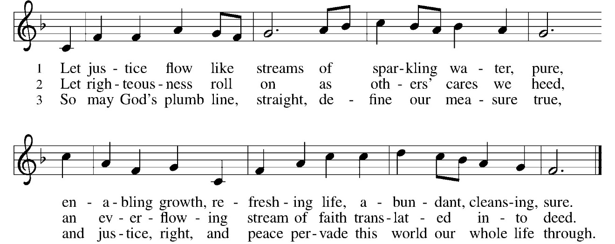
TABLE BLESSING:
P: May the blood of our Lord Jesus Christ strengthen and keep you in His grace. C: Amen
PRAYER AFTER COMMUNION:
P: God our host, C: at this table you have fed us with joy and gladness. Send us forth, eager to share the feast, welcome the stranger, and bear good fruit in the name of Jesus. Amen.
SENDING: God blesses us and sends us in mission to the world.
BLESSING:
P: May God who comes among us, Father, ☩ Son, and Holy Spirit, grant you patience in waiting, peace in the darkness, and good news to share today and always.
C: Amen.
SENDING HYMN Light Dawns on a Weary World ELW 726

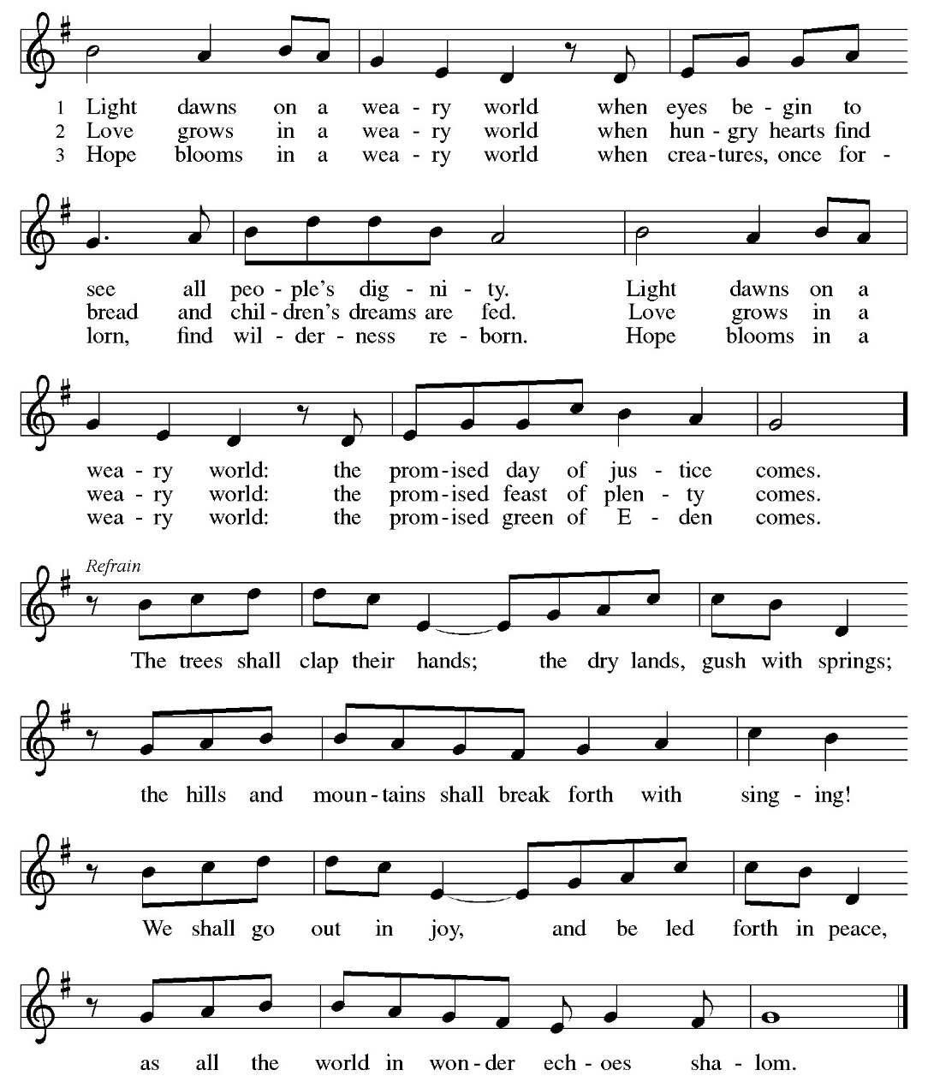
DISMISSAL:
P: Go in peace. Keep awake. C: Thanks be to God.
POSTLUDE
IN OUR PRAYERS TODAY: Teresa Hesselbacher, Elaine Schlicting, Darlene and Walt Steffes, Bob Schreck, Delores Wampfler, Marge and Gerald Arnold, Don & Judy Brudi, Diego Gonzalez, Grayson Raab, Dan Bonnet, James Dieter, Christine Happ, Kay Hesselbacher, Mary Lou Bunker, Lillian Sefford, Jeff Encheff, Judy Wilson, Russ Synder, Don Kunz, Johnny Blair, Jim Sullivan, Sally Duran Salser, Darrell Lindstrom, Chris Marek, Joe Karr, John Becker To add someone to the prayer list please contact Pastor Chrissy
CELEBRATING BIRTHDAYS / ANNIVERSARIES: Josie Bonjour, Derek Ertmer, Charles Feltmeyer, Julia Heilman, Stewart Baker, Lauryn Schubert, Emily Rowe, Brynlee Werner, Logan Aurand, Pat Lawfer, Jayden Dittmar
Next Week Readings: Isaiah 35:1-10, Psalm 146:5-10, James 5:7-10, Matthew 11:2-11
Thanks be to God for your gifts for the ministry of  Christ Lutheran Church *these numbers do not reflect online giving- only offering in worship |  |  |  | Offering/ Attendance  Sat Nov 29 & 30
Current Expense | $295.00 | Building Fund | $25.00 | Nov 29  (Snow) | 0
Benevolence | $5.00  $20.00 | Community Table | $100.00 | Nov 30  Sunday School | 26  9
 |  | Total |  | Community Dinner | 24
  $ 425.00

ONLINE GIVING: Your gift has a big impact on our ministries and those we serve. Scan this code or visit our website to give online today.
October Totals: As a way to improve communication around finances, we are sharing the following information: *these numbers reflect online giving contribution
2025
 | October | Year to date
Offerings: | $7,484 | $96,952
Expenses: | $9,104 | $102,444
Overall Gain / Loss | ($1,621) | ($5,492)

ANNOUNCEMENTS
POINSETTIA ORDERS: Order forms are available at the back of the church. All orders are due to Janet Haas by December 18, 2025. Cost is $15.00.
CHRISTMAS EVE CHOIR: Let us make a joyful noise to the Lord! The choir will practice on Sundays, December 7^{th,} 14th, 22st following worship, to prepare for Christmas eve service at 7 pm, Wednesday, December 24. No experience necessary. All are welcome. Questions- reach out to Peggy Harmston.
BLESSING BOX: the need is great. Consider making a special donation of money or bringing items for the blessing box. During this time of food insecurity, we would like to always keep the blessing box full. If blessing box is full, please put items in the narthex.
THE COMMUNITY TABLE: The Community Table is an opportunity for outreach to the local community. This is a twice a month meal on the first and third Tuesday of the month at 11:30, here at Christ to gather for food, fellowship and fun, if you are interested in volunteering please talk with Janet Haas or Debbie Goebel. Join us Tuesday, December 3rd and 16th. All are welcome.
ITEMS NEEDED FOR 2026 BIBLE SCHOOL: in the back of the church, we are collecting your plastic milk bottle lids, small plastic pop bottles and assorted plastic bottle lids. Plastic 8 oz pop bottles. Please collect and bring them in!
38TH ANNUAL STOCKTON COMMUNITY CHRISTMAS DINNER- Thursday, December 25, 2025, noon at Christ Lutheran Church. Sponsored by the churches and businesses in the Stockton Community. All people are invited, especially those who will not be with family on Christmas day. Deliveries will be made to shut ins in the immediate Stockton area. Pickups will also be available. Please let your church know if you need a delivery, giving your address and phone number, or call Shirley Toepfer at 815-947-3639.

AMAZON WISH LIST: did you know that everyday items used at the church are items you could contribute? Find our list here or on our Facebook page.

Upcoming Events
- December 6- 5:30 worship
- December 7- 9 am Sunday School
- December 7 10 am worship
- December 7- after worship- Christmas eve choir practice
- December 10- 9 am Bible Study (SMA Chapter 13) (Matthew 11:2-11)
- December 14- 8:30 am Confirmation Class
- December 14- 7 pm Advent/ Christmas Hymn Sing
- December 16- 11:30 Community Table
- December 17- 7 pm Church Council
- December 20- 5:30 Blue Christmas Worship
- December 21- 10 am Children’s Christmas Program
- December 24- 7 pm Christmas Eve Worship
- December 25- noon- Christmas Day Dinner at Christ Lutheran

