

SUMMER 2023 SEASON
2023
CLUB HANDY CAP CUP

The Annual fun cup saw 18 players take part, with the lower ranked players getting points head start who would the top players fair playing catch up.

2022 champion Neil Selby started off 2 – 0 behind in his first match against Jean Stewart but managed to win 13 – 8. 2022 runner up Callum Stewart didn’t fair as well losing 13 – 12 to Mo De Gruchy who started off + 3.

Top Swiss ranked player in 2022 Toby Northern started off 2 – 0 behind Lorna Limbrick but won 13 – 6, Lorna unfortunately had to withdraw after this match due to injury.

Keith White pushed Geoffroy all the way to 13 – 12 as did Cassie Stewart against Brian Harris.

Ross Payne avoided any shocks as he ran out 13 – 5 winner over last years third place Kat Stewart who started with +4.

Big shock though as Andrew Bellamy-Burt lost 13 – 6 to Jim Waddell who was helped with a +4 start.

Ross made it two in a row with a 12 – 10 win over Neil and Toby won big over Tim 13 – 4.

Jim just lost 13 – 12 to Mike Robinson and Callum just beat Branden 13 – 11. Kat provided another shock with a 13 – 12 win over Jean. A big win also for Keith 13 – 4 over Brian.

Round 3 of the Swiss system saw to Premier league giants play each other with Toby winning 13 – 5 over Geoffroy. Ross Payne also made it three wins with a 13 – 8 score over Mike.

Three 13 – 9 scores as Neil beat Paul, Andrew beat Callum and Jim beat Mo.

Keith just beat Kat 13 – 11.

In the final round Toby beat Ross to top the rankings for the second year running with Ross finishing 3rd. Brian Harris just beat Neil Selby 11 – 10 with both players going through in 5th and 7th respectively.

Keith beat Jim to finish 2nd with Jim squeezing in 8th place. Geoffroy beat Tim to go through in fourth and Andrew beat Mike to finish 6th.

Kat Stewart and Mike Robinson both just missed out on points difference.

Final Rankings

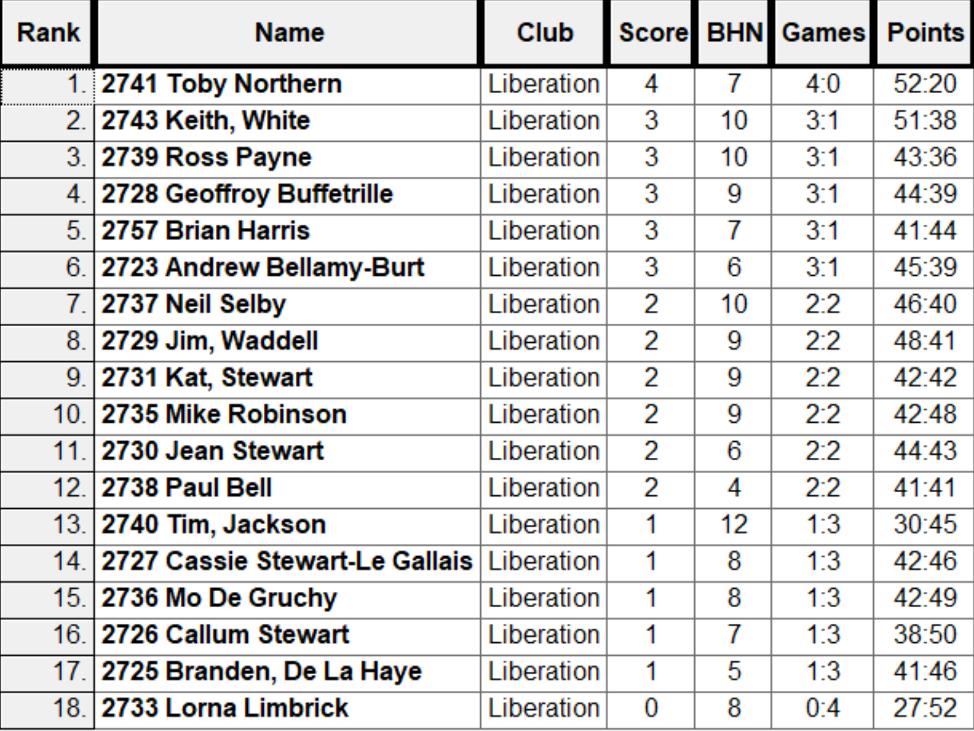

The Swiss curse struck again as a four point lead and three points of the first end saw Jim 7 – 0 up against Toby who fell 12 – 2 behind before fighting back to 12 – 10 only for a great shot by Jim take his through 13 – 10.

Keith White also had a big win knocking out holder Neil 13 – 11. Andrew beat Ross 13 – 9 and Geoffroy overcame Brian 13 – 10.

Incredibly close semi finals saw Jim repeat his quarter final start going 7 – 0 up before Geoffroy fought back and lead 12 – 11 but a coche move by Jim saw him holding two close boules and Geoffroy tried to fire to break the points but missed meaning Jim made the final 13 – 12.

Keith also started well against Andrew who was losing heavily before coming back but too little too late as Keith made his second successive club cup final winning 13 – 11.

The final saw Keith lead all the way taking the title 13 – 10 and Geoffroy beat Andrew 13 – 7 for third place.

Winner – 2023 – Keith White



Thank you to all those who helped out making another great competition.

NEXT WEEK - FREE WEEK

Club email address - liberationpc@gmail.com

Club Website - www.liberationpetanque.co.uk

Kind Regards

Toby Northern

Chairman

Liberation Petanque Club

