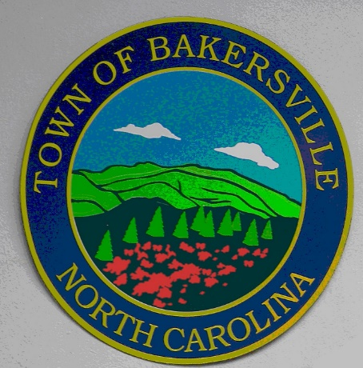
Due to COVID-19 There is not a 2021 Calendar of Events. If restrictions are eased and we are able to plan events later in the year, we will post an update.

