ANNUAL TOWN MEETING
March 12, 2019
Aurora, MN

IN ATTENDANCE: (18) Jon Skelton, Craig Anttila, Edward Kippley, Jodi Knaus, Amanda Gross, Michael Kearney, Clark Niemi, Wesley Peterson, Adam Heikkila, Lorna Kallio, Bob Kallio, Betty Stende, Mike Skinner, Micheal Skarken, George Brown, Ronald Anzelc, Ila Fodness, Dolores Helgeson

- The 2019 Annual Town Meeting of the Town of White was called to order by Chairman Skelton on Tuesday, March 12, 2019, at 6:00 P.M., at the Loon Lake Community Center.
- Pledge of Allegiance
- Skelton called for Nominations for Moderator
IT WAS MOVED BY KALLIO, SUPPORTED BY STENDE TO NOMINATE KIPPLEY AS MODERATOR. NO OTHER NOMINATIONS. MOTION CARRIED
IT WAS MOVED BY KALLIO, SUPPORTED BY STENDE THAT NOMINATIONS BE CLOSED. MOTION CARRIED
Edward Kippley took the chair as moderator.

4.) IT WAS MOVED BY STENDE, SUPPORTED BY SKINNER TO ADJOURN THE 2018 ANNUAL TOWN MEETING. MOTION CARRIED

5.) IT WAS MOVED BY ANZELC, SUPPORTED BY STENDE TO OPEN & CONDUCT THE 2019 ANNUAL TOWN MEETING. MOTION CARRIED IT WAS MOVED BY STENDE, SUPPORTED BY SKINNER TO ADOPT AND APPROVE THE AGENDA. MOTION CARRIED

6.) IT WAS MOVED BY STENDE, SUPPORTED BY SKINNER TO SUSPEND THE READING & APPROVE THE 2018 CONTINUATION OF THE ANNUAL TOWN MEETING MINUTES AS PRESENTED. MOTION CARRIED

7.) IT WAS MOVED BY HEIKKILA, SUPPORTED BY ANZELC TO SET THE DATE, TIME, AND PLACE FOR THE 2020 ANNUAL TOWN MEETING FOR TUESDAY, MARCH 10, 2020 AT THE LOON LAKE COMMUNITY CENTER AT 6:00 P.M. MOTION CARRIED

8.) Moderator Kippley read the PowerPoint Presentation outlining the Clerk’s Report including Strategic Plan Outcomes and the 2018-2019 Budget Discussion (slides included at end of minutes). Questions were answered about the East Mesabi Water Project, Gardendale, and Poplar Street. Anzelc inquired about the interest rates and the Township’s investments. Knaus responded monthly collateral and security reports are received to ensure the investments are insured and protected. The Township will look into investing and diversifying funds that offer higher interest rates. Kallio inquired about St. James Pit dewatering. Brown asked if a guardrail could be installed at Twin Lakes.
8a.) IT WAS MOVED BY HELGESON, SUPPORTED BY FODNESS APPROVING THE EMPLOYEE RECOGNITION POLICY ANNUAL AMOUNT OF $1,000.00 FOR 2019. MOTION CARRIED
8b.) IT WAS MOVED BY ANZELC, SUPPORTED BY KALLIO TO DELAY SETTING LEVY UNTIL THE CONTINUATION OF ANNUAL MEETING ON SEPTEMBER 10, 2019. MOTION CARRIED

8c.) IT WAS MOVED BY BROWN, SUPPORTED BY HELGESON TO ACCEPT THE CLERK’S REPORT. MOTION CARRIED
9.) Other Business – None was discussed.
10.) IT WAS MOVED BY STENDE, SUPPORTED BY ANZELDC TO KEEP THE 2019 ANNUAL MEETING OPEN UNTIL THE CONTINUATION OF ANNUAL TOWN MEETING ON SEPTEMBER 10, 2019. MOTION CARRIED AT 6:58 P.M.

POWERPOINT PRESENTATION SLIDES ARE ATTACHED.

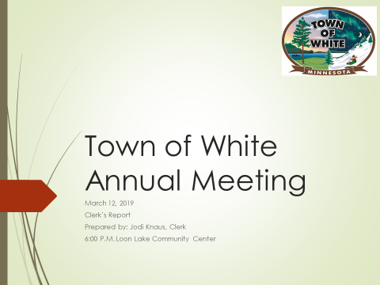

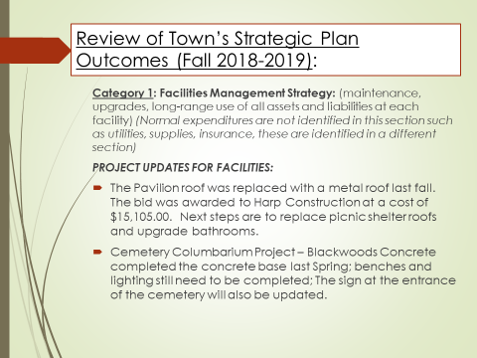

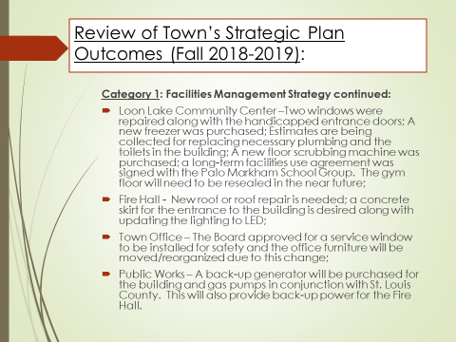

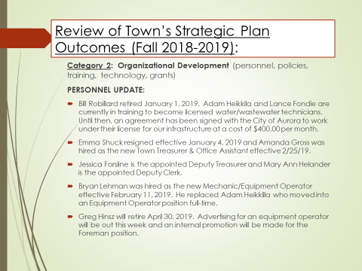

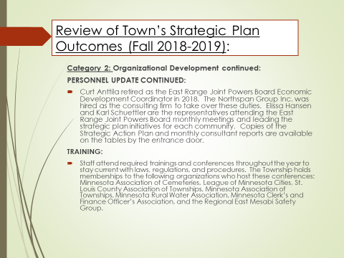

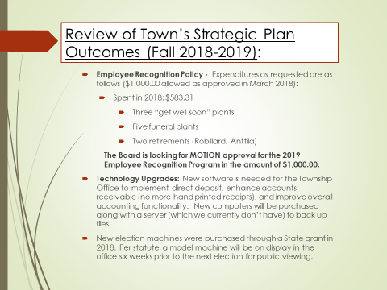

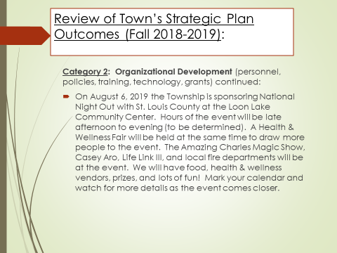

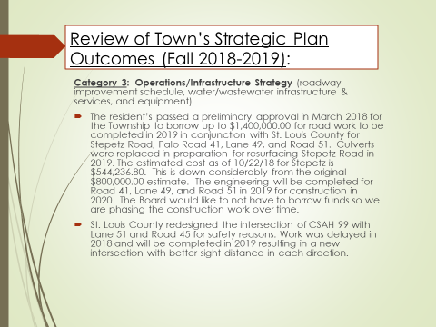

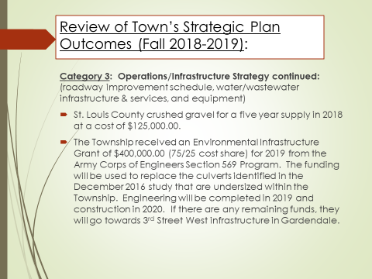

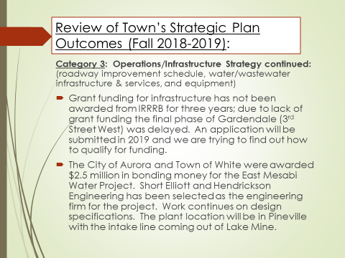

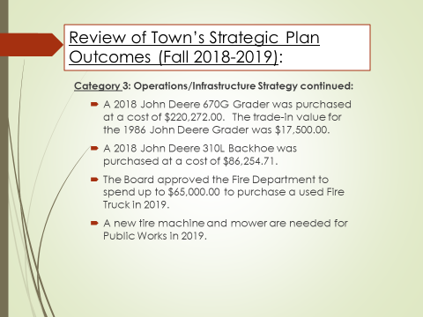

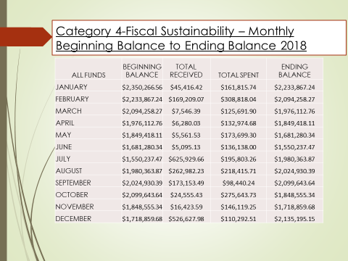

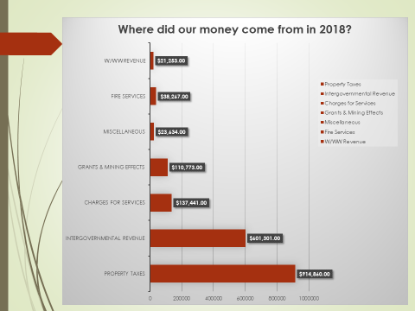

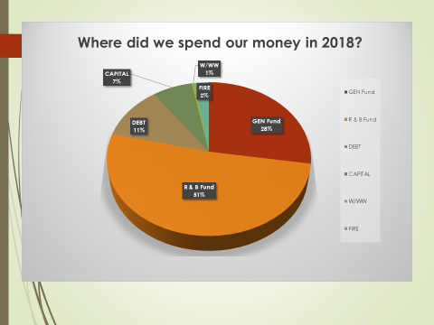

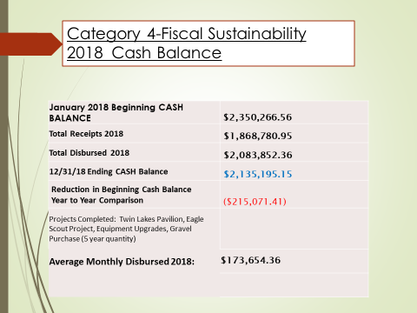

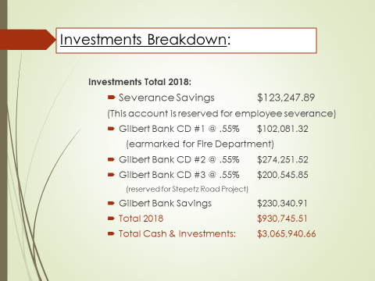

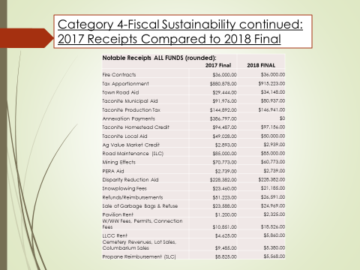

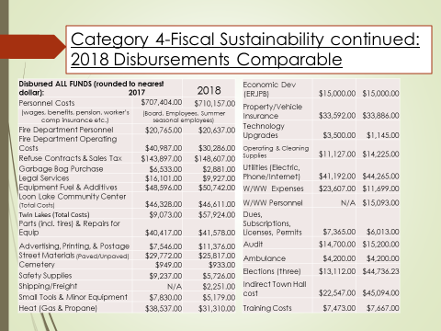

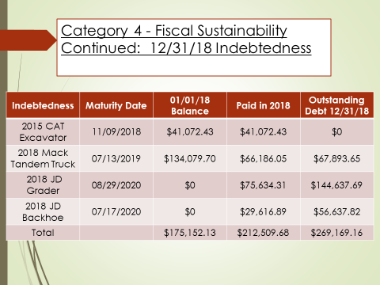

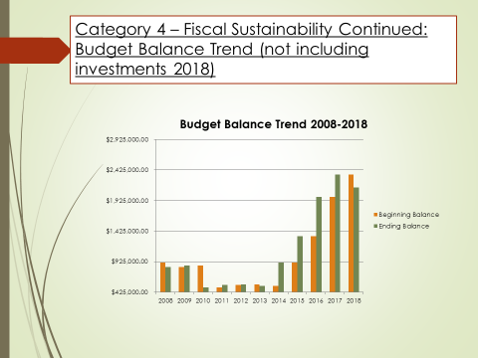

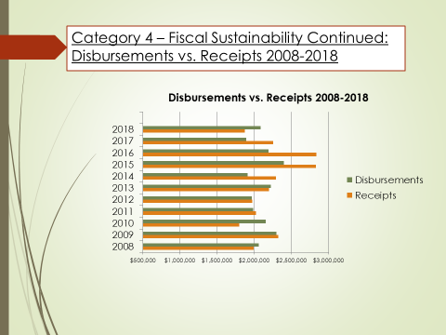

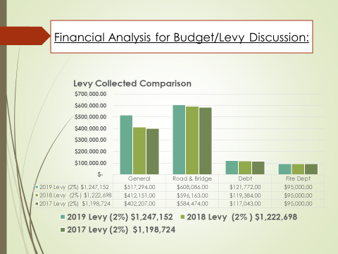

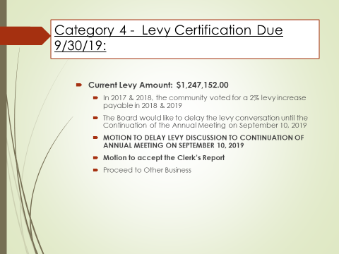

_____________________________________ _________________________________________
Jodi Knaus, Clerk Edward Kippley, Moderator

