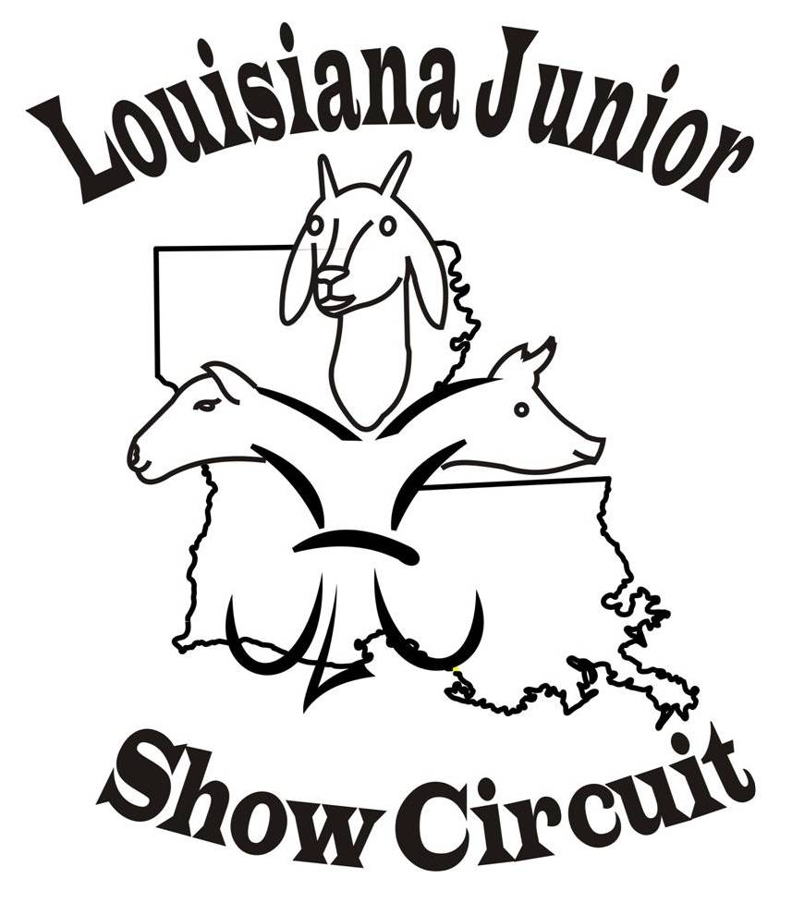

2018 Tentative LJSC SHOW Schedule

June 29th & June 30th Watermelon Festival Deridder, LA
July 6th & 7th Red River Showdown, Coushatta, LA
July 14th & July 15th Bayou Bash, Oberlin, LA
July 20th & 21st Claiborne Classic, Haynesville, LA
July 27th & 28th, Show pending
August 3rd & 4th Allen Parish Showdown, Oberlin, LA
August 10th & 11th Black & Gold Showdown, Winnfield, LA
August 18th Winn Sizzler, Winnfield, LA

Website (www.louisianajuniorshowcircuit.org.) and facebook Louisiana Junior Show
Circuit (page and group) for updates. If interested in hosted a sanctioned show
please contact Nancy Nettles.

LJSC Contact Information
For Comments or questions concerning Louisiana Junior Show Circuit (LJSC) ~~~ Contacts:
Nancy Nettles-President Allison Landry – Secretary
(318) 932-5435 Home (337) 276-4995
(318) 455-2905 Cell (337) 201-0431
Membynancy1@aol.com AllisonLandry@aol.com

Vice-President- Lauribeth Padgett Judy Latiolais – Treasurer

Board Members: Dana Broussard, Stephanie Chamberlin, Josh Johnson, Angie Baker, and Guy Sanders

