There is scientific evidence of pre-historic man, known as archaic humans, which date from about 12,000 to over 300,000 years ago. https://en.wikipedia.org/wiki/Archaic_humans

The bible doesn't seem to exhibit this time span, but the bible doesn't reveal everything on its surface. The casual reader won't gather the deeper truths hidden in scripture. These deeper truths are deliberately obscured by our Creator for a reason. The revelation of hidden truth is His reward to those who love Him enough to search His Word diligently.

When hidden truths are revealed to secular people and lukewarm saints, these truths are usually rejected as being essentially worthless. The Messiah Himself was judged as worth merely 30 shekels of silver by the Jerusalem Priesthood, rejected, and crucified.

Several years ago Harold Camping of Family Radio had predicted that the world would "end" on 5/21/2011. When that didn't happen, he moved the date to 10/21/2011. When that didn't happen he quit and many of his followers lost heart. The website promoting his teachings was removed from the internet. Almost everyone labeled Mr. Camping as a false prophet. Mr. Camping died on 12/15/2013 at the age of 92. https://en.wikipedia.org/wiki/Harold_Camping

There was something in Mr. Campings timeline calculations that wasn't really brought forward publically as far as I know. YaHuWaH Elohim had revealed a coded sequence to him that had been placed into the generations of the patriarchs in the book of Genesis. According to Mr. Camping's calculations, the creation of Adam at about 11,000 BC was exactly 7,000 years earlier than the bible indicates on the surface at about 4,000 BC.

Most people take the bible at a surface reading, which yields a date of creation at about 4004 BC, just over 6000 years ago. Mr. Camping was a diligent bible scholar and I believe that YaHuWaH Elohim may have rewarded his faithfulness with a fantastic truth that was hidden from all others. Mr. Camping knew what he had been allowed to understand, and how precious that knowledge was. Unfortunately, his date setting didn't seem to work out in 2011. Maybe it just didn't work out in the way he thought it would.

The keeping of the seven day Sabbath is of extreme importance to our heavenly Father, YaHuWaH Elohim. The seven day Sabbath points all the way back to Elohim creating the heavens and the earth in 6 days, and then YaHuWaH Elohim resting on the 7th Day. Our heavenly Father asks us to keep His 7th day Sabbath, and He says that the keeping of His Sabbath is a sign that we are set apart unto Him, that we belong to Him (Exodus 31:13). It's His mark of ownership on us. What we do marks us as belonging to Him!

Here's a graphic that show's the special gift of knowledge that YaHuWaH Elohim revealed to Harold Camping. It's a timeline of thousand year "days" indicating the 1,000 year Sabbath at the end of every 6,000 years (6 days).

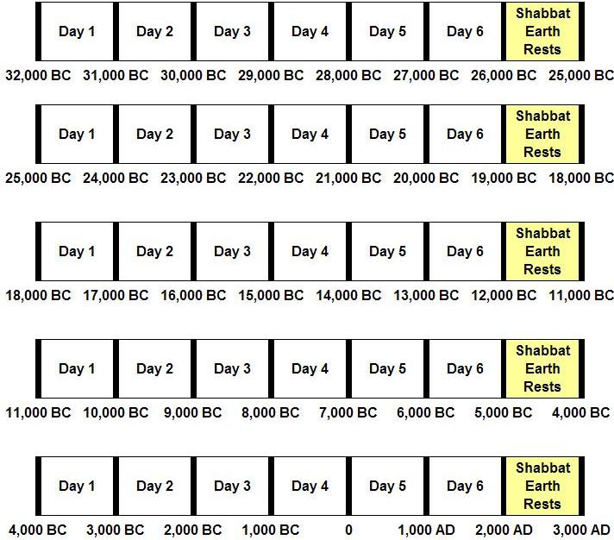

The graphic above may be extended far into the distant past, and will account for the existence of pre-historic humans and other pre-historic life.

Below is a timeline like the one above that shows the creation of Adam and the flood of Noah.

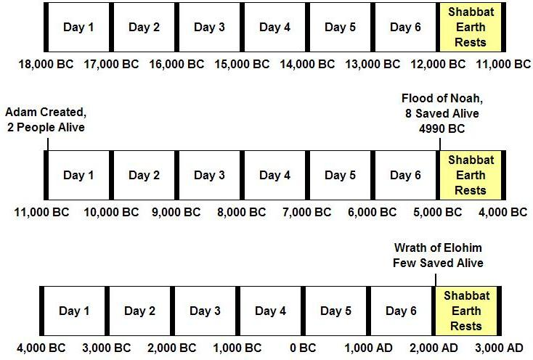

Notice that the flood of Noah was around 4990 BC, about 7,000 years ago, and that Adam was created about 6,000 years earlier at the end of a 1,000 year Sabbath.

If we look at Harold Camping’s way of extracting the biblical timeline, we see a familiar pattern, "7 day weeks" of 1,000 years per "day".

Scientist know that the most recent prehistoric man, the Red Deer Cave People, went extinct 11,500 to 14,500 years ago. Another ancient people 3.5 feet tall, Homo floresiensis, went extinct about 13,000 years ago.

The reason that Adam was created around 11,000 BC is that no human-like being may have lived through the 1,000 year Sabbath from 12,000 BC to 11,000 BC.

And that may be precisely why Adam had to be created by YaHuWaH Elohim around 11,000 BC at the end of a 1,000 year Sabbath. The other previous humanoids may have all been destroyed and sent to their graves to rest on the Sabbath. But we don't know because YaHuWaH Elohim doesn't tell us everything in the bible.

There is a space of indeterminate time between Genesis 1:1 and 1:2 that leaves room for the existence of prior eons of time, with the wording that the earth "came to be without form, and void" not that the earth "was without form, and void".

What this all comes down to is that we are right now at the beginning of a 1,000 year Sabbath. Because the keeping of Sabbaths is so important to YaHuWaH Elohim, we need to realize the immediate danger to all human lives. Dear reader, we are entirely in the hands, and at the mercy, of the extraterrestrial Being who created us. He is not human! He does not think like we think. Beware. As a matter of fact, we should be gripped with terror.

We need to voluntarily get on board with YaHuWaH Elohim and keep His Sabbaths. Those who refuse to keep His Sabbaths will also rest on the coming 1,000 year Sabbath. They will rest in death! One way or the other, we will keep this coming 1,000 year Sabbath period. Matthew chapter 24 tells us that most people will spend the coming Sabbath in death. Few will survive the wrath of YaHuWaH Elohim. The violent, lying, and wicked people will be selectively removed from the earth by the angels (Matthew 13:49).

This is the untold, and unpublicized, truth hidden in Harold Camping's time calculation method. Adam was created at the end of a 1,000 year Sabbath. 6,000 years later the flood of Noah came. That was 7,000 years ago at the beginning of a 1,000 year Sabbath. Noah and his family came off the Ark and began to repopulate the earth as it rested from all the violence and wickedness of the pre-flood society.

Mr. Camping may have gone to his grave in sorrow, thinking he had missed it. He and his timeline methodology were certainly rejected by society and Christian brothers. But maybe he didn't miss it. I believe He was given priceless truth and that it fits in with the pre-historic scientific model.

I saved all of Harold Camping’s no-copyright calculations several years ago. I'm now unable to find his information on the internet. If anyone would like them for educational purposes, please let me know.

