5/24/2018 Now Being Weighed in the Balances

There was a message in the "Handwriting on the Wall" episode on October 11, 539 BC that may pertain to the modern King of Babylon in 2018.

Here's the Handwriting on the Wall and the intrepretation that was revealed to Daniel by YaHuWaH Elohim:

Daniel 5:25 And this is the writing that was written, MENE, MENE, TEKEL, UPHARSIN.
26 This is the interpretation of the thing: MENE; Elohim hath numbered thy kingdom, and finished it.
27 TEKEL; Thou art weighed in the balances, and art found wanting.
28 PERES; Thy kingdom is divided, and given to the Medes and Persians.

There are 3 parts to the intrepretation in verses above.

1. Elohim hath numbered thy kingdom, and finished it.
2. Thou art weighed in the balances, and art found wanting.
3. Thy kingdom is divided, and given to the Medes and Persians.

The Numbering of the Kingdom

The Babylonian word Mene mentioned above is the ancient mina, having a value of 50 shekels. The Babylonian word Tekel is the shekel, having a value of 20 gerahs.

Encoded into the Handwriting on the Wall was a value of 126 shekels, which is also 2520 gerahs at 20 gerahs per shekel.

The Handwriting on the Wall incident occurred on 10/11/539 BC. If we add 2520 years to 10/11/539 BC by accurately counting days using a keisan day counter that corrects for passing through from BC to AD and also the Roman calendar change in 1582 AD, we arrive at 10/4/1982 AD.

The 2520th year from the Handwriting on the Wall was from 10/4/1981 to 10/4/1982. Be aware that President Donald Trump's 36th birthday was on 6/14/1982, during that 2520th year from 539 BC.

The number 36 was very special in ancient Babylon. The Babylonian people had 36 gods. To each god a number was assigned from 1 to 36. Note that all the numbers from 1 to 36 when added up consecutively (1+2+3...35+36) sum to 666. The Babylonians wore "lucky" amulets know as the Babylonian Magic Square with the numbers 1 to 36 on it in a special configuration.

It happens that President Donald Trump's 72nd birthday is 6/14/2018, 36 years from his 36th birthday on 6/14/1982 during the 2520th year from 539 BC. It also happens that the Muslim month of Ramadan will also end on Donald Trump's birthday at sunset on 6/14/2018. Therfore the chiastic center period of President Trump's life right now in 2018 is the year 1982, 2520 years from the Handwriting on the Wall incident in 539 BC.

Know that 70 x 36 = 2520. There were exactly seventy, 36 year periods, between 539 BC and 1982 AD. The 71st, 36 year period, is being completed right now in 2018. The 72nd, 36 year period, from the Handwriting on the Wall in 539 BC will be completed in the year 2054, 36 years from 2018. However, there was a 36 year period before 539 BC that we will investigate below, bringing 72, 36 year periods, from 575 BC to this present year, 2018 AD.

The King Weighed in the Balances

The 2nd component of the message encoded into the Handwriting on the Wall on 10/11/539 BC is that the King of ancient Babylon had been weighed in the balances.

The weighing of coins was common practice in ancient times as a check to be sure that the person being paid wasn't being shorted in his wages. Thus the minas and shekel were weighed in the balances to assure their accuracy.

We can understand that President Donald Trump is being weighed in the Babylonian balances because 36 years transpired between his birth in 1946 and 1982 and 36 more years will have transpired between 1982 and his 72nd birthday on 6/14/2018.

The year 1982, the 2520th year from the Handwriting on the Wall incident in ancient Babylon, is the fulcrum (center point) of the "balances" in the life of Donald Trump right now in 2018.

And, right now in the heavens, YaHuWaH Elohim our Creator is providing mankind with a sign.

There is a constellation in the heavens known as Libra, the balance scales.

The planet Jupiter, symbolic of Israel's King Messiah, passed into the constellation Libra on or shortly before December 5, 2017. The very next day, 12/6/2017, President Donald Trump announced publicly that the United Sates of America would be moving its Embassy from Tel Aviv, Israel, to Jerusalem.

Because of the orbital motions of the Earth and the planets, planets can sometimes appear to reverse direction as they traverse the heavens. They don't really reverse direction, it just looks like they do from time to time.

Jupiter entered the constellation of Libra, the balance scales, on about 12/5/2017 and travelled part way across the constellation and then appeared to reverse direction on about 3/8/2018. It then appeared to travel backward in the sky, moving from one balance scale to the other where it will appear stop again on about 7/10/2018, reversing direction again.

Below: On 12/5/2017 Jupiter enters the right side of the graphic and traverses the balances.

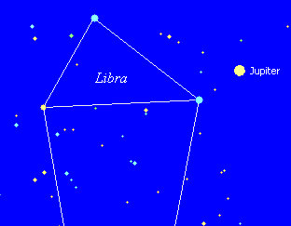

Below: On 3/8/2018 Jupiter appears to stop and reverse direction and return in the direction from which it originally came.

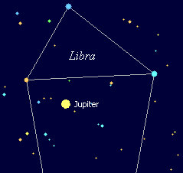

Below: On 7/10/2018 Jupiter appears to again stop and reverse direction and travel to exit the balances. The King of Babylon has been symbolically weighed in the balances.

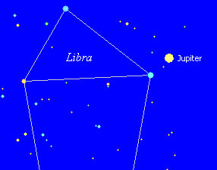

Below: On 11/3/2018 the Sun, the "great light" and symbolic of YaHuWaH Elohim, enters Libra and quickly follows Jupiter.

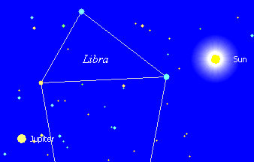

On 11/5/2018 Jupiter exits the balances at the left side of the graphic. Note that election day in the United States is the very next day, on 11/6/2018.

Below: On 11/26/2018, the Sun and Jupiter closely meet (conjunct) in the constellation of Scorpio. The constellations now known as Scorpio and Ophiuchus comprise the ancient constellation of the Eagle.

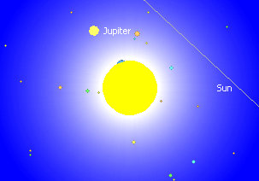

The Eagle was the symbol of ancient Rome, and is now also the symbol of the United States of America.

After the King of Babylon is weighed in the balances, YaHuWaH Elohim will decree him to be either righteous or wanting.

The Divided Kingdom

The Division of the Kingdom was the last part of the message encoded into the Handwriting on the Wall. The ancient Babylonian King had been found lacking in respect for the Almighty King of the Universe, YaHuWaH Elohim, in that the king and his officers had drunken from the golden vessels that had been taken from the Temple in Jerusalem. Note that when gold is mentioned in the bible, it's always a symbol of YaHuWaH Elohim's Set Apart Holy Spirit.

In today's modern Babylon the Great, the Set Apart Spirit of YaHuWaH Elohim dwells within His covenant people. It is those special people, who have the Holy Spirit of YaHuWaH Elohim dwelling within them, who are symbolic of golden vessels reserved for the use of YaHuWaH Elohim Himself.

We know that certain political organizations in modern Babylon have allied themselves with Holy Spirit filled followers of our heavenly Father. YaHuWaH Elohim, who knows all things, will make a decision regarding the use of His special golden vessels by the King of modern Babylon for his political purposes.

YaHuWaH Elohim has set a sign in the heavens (Genesis 1:14) from the creation of the heavens and the earth regarding this particular issue, as silently testified to by the movements of the planet Jupiter through the constellation Libra at this time in history.

The Ishtar Gate

The Ishtar Gate was the eighth gate to the inner city of ancient Babylon. It was located on the north side of the city.

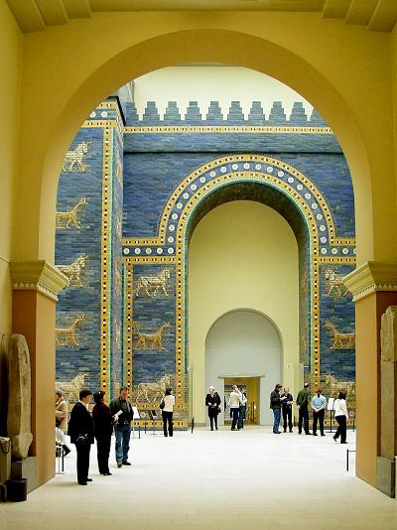

Above: Replica of the Ishtar Gate in the Pergamon Museum in Berlin

There were 36 years from the construction of the Ishtar Gate in 575 BC to the Handwriting on the Wall event in ancient Babylon in 539 BC.

Note that 575 BC (Ishtar Gate) + 36 Years = 539 BC + 2520 Years (numerical value encoded into the Handwriting on the Wall) = 1982 AD + 36 Years = 2018 AD.
The numbering of years that we have here is 36 + 2520 + 36 = 2018. Know that there are 70, 36 year periods in the 2520 year period. So from the construction of the Ishtar Gate to 2018 there are 72, 36 year periods. 72 is twice 36.

Ishtar is the name of a Babylonian goddess of fertility. Ishtar was also known as the Queen of Heaven.

You must know that there is only one entrance into the kingdom of YaHuWaH Elohim. That one and only entrance door is through YaHuShua, YaHuWaH 's only begotten Son. The blood of His chosen Lamb was applied to the lintel and doorposts of that door at the crucifixion of YaHuShua Messiah during Passover.

Today, another door to heaven is being espoused by Babylon the Great. That door is Mary, Queen of Heaven, also known as Ishtar.

Mary = Queen of Heaven, Ishtar = Queen of Heaven, logically therefore, Mary is equivalent to Ishtar, Mary = Ishtar.

Planned Parenthood and the Blood of Ishtar's Covenant

There was blood shed at the observance of the Feast of Ishtar. It was the blood of sacrificed infants. Being a fertility feast, eggs, a symbol of fertility, were dipped in the blood of sacrificed infants during the Feast of Ishtar in ancient times. The modern tradition handed down from this ancient bloody sacrificial practice is the coloring of Easter eggs by children.

Mary's followers continue to observe the day set apart in ancient Babylon to observe the fertlity Feast of Ishtar (Easter) instead of the day set apart by YaHuWaH Elohim for remembering and observing His Feast of Passover, a day having His appointed one time only blood sacrifice.

Mary, Queen of Heaven is an usurper and an anti-messiah.

President Donald Trump, the symbolic King of modern Babylon the Great, along with Babylon's Jesuit aligned government officials, refused to stop the slaughter of infants by the thousands by the Planned Parenthood organization by rapidly agreeing to a funding bill in 2018 that doled out $500,000,000 to the Planned Parenthood infant butchering organization.

But Charles, Catholics are anti-abortionists. Yes, and Shriners are nice clowns who run children's hospitals. The outside is white and clean, but death resides inside.
YaHuWaH Elohim is at odds with Ishtar, a.k.a. Mary, Queen of Heaven, and all of her allies, including the Jesuit Pope Francis. We know who wins the contest.

There was a small town by the name of Rome that is now Washington, District of Columbia. All the symbols of the Vatican are there. The domed Capitol building, the obelisk surrounded by a circle of flags (ancient fertility symbols of penis and vagina) (Parents, please don't let your children form a circle around the flagpole and pray. It's symbolically obscene, but delightful to those anti-god people who are secretly in control behind the scenes). And of course Washington, D.C. is situated on the borders of Virgin-ia and Mary-land. Sounds like someone had a plan centuries ago.

We know that the title "Pontifex Maximus" was first associated with the priests of ancient Babylon. The title was passed to the Roman Emperor after the Romans conquered ancient Babylon. The title "Pontifex Maximus" was passed from the Roman Emperors to the Pope of the Roman Catholic Church where it remains today, indicating another direct link between modern Rome and ancient Babylon, and Mary and Ishtar.

Summary

Revelation 18:1 And after these things I saw another angel come down from heaven, having great power; and the earth was lightened with his glory.
2 And he cried mightily with a strong voice, saying, Babylon the great is fallen, is fallen, and is become the habitation of devils, and the hold of every foul spirit, and a cage of every unclean and hateful bird.
3 For all nations have drunk of the wine of the wrath of her fornication, and the kings of the earth have committed fornication with her, and the merchants of the earth are waxed rich through the abundance of her delicacies.
4 And I heard another voice from heaven, saying, Come out of her, My people, that ye be not partakers of her sins, and that ye receive not of her plagues.
5 For her sins have reached unto heaven, and YaHuWaH hath remembered her iniquities.
6 Reward her even as she rewarded you, and double unto her double according to her works: in the cup which she hath filled fill to her double.
7 How much she hath glorified herself, and lived deliciously, so much torment and sorrow give her: for she saith in her heart, I sit a queen, and am no widow, and shall see no sorrow.
8 Therefore shall her plagues come in one day, death, and mourning, and famine; and she shall be utterly burned with fire: for strong is YaHuWaH Elohim who judgeth her.
9 And the kings of the earth, who have committed fornication and lived deliciously with her, shall bewail her, and lament for her, when they shall see the smoke of her burning,
10 Standing afar off for the fear of her torment, saying, Alas, alas, that great city Babylon, that mighty city! for in one hour is thy judgment come.

Jeremiah 25:9 Behold, I will send and take all the families of the north, saith YaHuWaH , and Nebuchadrezzar the king of Babylon, My servant, and will bring them against this land, and against the inhabitants thereof, and against all these nations round about, and will utterly destroy them, and make them an astonishment, and an hissing, and perpetual desolations.
10 Moreover I will take from them the voice of mirth, and the voice of gladness, the voice of the bridegroom, and the voice of the bride, the sound of the millstones, and the light of the candle.
11 And this whole land shall be a desolation, and an astonishment; and these nations shall serve the king of Babylon seventy years.
12 And it shall come to pass, when seventy years are accomplished, that I will punish the king of Babylon, and that nation, saith YaHuWaH , for their iniquity, and the land of the Chaldeans, and will make it perpetual desolations.
13 And I will bring upon that land all My words which I have pronounced against it, even all that is written in this book, which Jeremiah hath prophesied against all the nations.
14 For many nations and great kings shall serve themselves of them also: and I will recompense them according to their deeds, and according to the works of their own hands.

A seventy years relationship between modern Israel and Babylon the Great culminated on 5/14/2018.

The actions of President Donald Trump and the secret government of the United States of America in league with Rome are right now being weighed in the balances in the heavens as indicated by the apparent retrograde motions of Jupiter in the constellation Libra as ordained by our Creator, YaHuWaH Elohim. Whether yea or nay, His judgment will be righteous. So be it.

