 | F.A.E.T. Inc.  Go to FAET.org to pay for the conference fees | 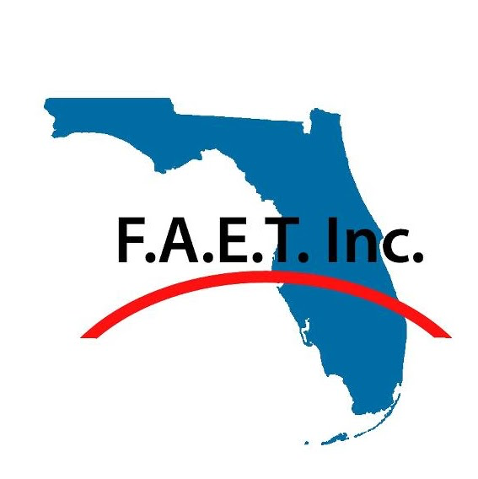  Hilton UF Conference Center  1714 SW 34th Street  Gainesville, Florida 32647 | - 41th Annual Florida Association of Enterostomal Therapists  Annual Conference
2019 Conference Pricing
​-Annual membership FAET: $ 20
​-Conference Fee Early Bird Member: $ 75
​-Conference Fee Regular Member: $95
-Pre-Conference workshop fee (3M): $ 30
-Nonmember Early Bird Conference fee: $ 100
​-Nonmember Regular Conference: $ 120
The Art of Science
Friday, May 31st  2-3PM Registration  3-4:30PM 3M Compression Workshop:  A hands-on workshop for lower extremity compression wrapping.  4:45-6:15PM Industry Sponsored Workshop: Fistula Funnel/Crown:  A hands-on workshop featuring the new fistula funnel/crown. It will address your fistula challenges.  6-9PM Exhibits with the Vendors: Paint the town red, or at least, paint the vendor hall. Come and explore the vendors latest products.  Saturday, June 1st  7-8:30AM Open Registration  Breakfast with the Vendors | 8:30-9:30AM Flaps, VACs, and Reconstructive Surgery: A Plastic Surgeon's Perspective  Dr. Noah Prince, MD  9:30-10:30AM Protection of a Surgical Flap During the Healing Process and the First Year  Nicole Ward, PT, Registered Kinesiotherapist  10:30-11AM Break  11-Noon Battling Biofilms – Winning the War in Wounds  Dr. Gregory Schultz, PhD  12-1:30PM Lunch/Membership Meeting  1:30-2:30PM Caring for the Older Adult  Charlene Demers, ARNP  2:30-3:30PM Lower Extremity Ulcers –An Integrative approach  Joyce Steichmiller PhD, ARNP, FAAN  3:30-3:45PM Coffee/Tea/Break | 3:45-4:45PM Ostomy Lecture  Jane Nichols, MSN, CWON  4:45-5PM Wrap Up (6.0 Contact Hours)  Bring your creativity and logic to:  Hilton UF Conference Center;  1714 SW 34th Street  Gainesville, Florida 32647  Hotel Rates $129/Night: Reserve rooms through the FAET website for the block of rooms https://www.hilton.com/en/hi/groups/personalized/G/GVNCCHF-FAE519-20190530/index.jhtml?WT.mc_id=POG

