Point of Distribution Staff
Training Series

POD 1: The Mechanics of a POD
POD 2: Facilitating Clients Through a POD



Contents

POD 1 & 2 - Curriculum 3

POD 1: The Mechanics of a POD
Trainer’s Resources 1
Trainer’s Guide – POD 1: The Mechanics of a POD 2
Training Materials 9

POD 2: Facilitating Clients Through a POD
Trainer’s Guide – POD 2: Facilitating Clients Through a POD 1
Training Materials 11

Training Evaluation Materials 32

Other Training Resources 1

Point of Distribution Staff Training Series

POD 1 & 2 - Curriculum

Preface
Any mass prophylaxis operation that targets a population at risk, either within or beyond a single jurisdiction’s boundaries, requires coordination to achieve the incident response objectives. This is a challenging endeavor. Procedures, policies, and managerial activities must be coordinated among response organizations. The workforce must be prepared to carry out the operation and have sound knowledge of the plan, policies, and procedures. Personnel must become familiar with requisite forms and necessary equipment in a limited period of time. And, critically important to the success of a mass prophylaxis operation, staff and volunteers must be able to work effectively as a team.

This training is designed to develop knowledge and skills by drawing upon participant experience and expertise. It employs a training technique where the trainer-to-trainee dynamic is a partnership, the learning setting is casual, and trainees actively identify their learning needs and methods under the guidance of a facilitator. This approach is well suited for an audience of local public health and MRC volunteers who are leaders either within their departments or in their communities.

This training series compliments other resources from the Cambridge Advanced Practice Center for Emergency Preparedness (Cambridge APC). The job action sheets and basic Point of Distribution (POD) design are consistent with the Massachusetts Emergency Planning Region 4b Emergency Dispensing Site (EDS) Action Plan Template, version 1.5. Station signs with large high contrast pictograms and the Pocket Communicator are utilized in these trainings as well. For more information on these and other Cambridge APC resources, go to http://www.cambridgepublichealth.org/services/emergency-preparedness.

This training series is the product of collaboration between the Cambridge Advanced Practice Center for Emergency Preparedness, the Massachusetts Department of Public Health, and Access Umbrella, Inc.

For questions, please contact: Garrett Simonsen, at gsimonsen@challiance.org



These materials were developed with support from Cooperative Agreement Number U50/CCU302718 from CDC to NACCHO. The contents are solely the responsibility of the Cambridge Public Health Department Advanced Practice Center for Emergency Preparedness and do not necessarily represent the official views of CDC or NACCHO.

Section 1: Overview
This section contains a summary of the POD Staff Training Series, POD 1: The Mechanics of a POD, and POD 2: Facilitating Clients Through a POD.

Goal
Participants will gain knowledge and skills to work at a Point of Distribution (POD) in order to increase the efficiency, effectiveness and speed of a universally accessible emergency mass prophylaxis operation. Participants will master fundamental concepts and terminology. They will also acquire experience with key operational resources (e.g., job action sheets and signage), the flow of a basic POD, and become familiar with communication methods and strategies for servicing all clients who may present at a POD.

Learning Objectives
POD 1: The Mechanics of a POD
At the completion of this training, participants will be able to:

- Describe the purpose of a POD operation.
- Describe client flow through a POD.
- Describe the functions of ten basic POD stations.
- Identify the order and interrelatedness of all POD stations.
- Identify resources necessary for operating the stations visited during the exercise.
- Identify critical POD staff roles and responsibilities.
- Explain how the chain of command is used to facilitate POD operations.
- Identify roles that best match their individual experiences, skills and expertise.
- Fulfill more than one POD staff role.

POD 2: Facilitating Clients through a POD
At the completion of this training, participants will be able to:

- Identify strategies to overcome common communication barriers associated with persons for whom English is not a primary language, are elderly, or have a physical or cognitive disability.
- Describe how pictogram-based signage can be used to support clients in navigating a POD.
- Demonstrate how the Pocket Communicator can be used to overcome communication barriers.
- Provide critical feedback to other participants regarding solutions intended to overcome a variety of physical, cognitive, language, and psychological barriers.
- Relate past training or field experiences to address the specific barriers presented in client case studies.

Content Overview
POD 1: The Mechanics of a POD
Randomly assign participants to one of six POD stations (i.e., Enter, Start, Registration, Screening, Treatment/Children, and Waiting/Exit). Provide a brief lecture on fundamental POD concepts and terms. Instruct participants on the 60 minute learning activity. In their groups and at your direction, groups have approximately 10 minutes at each station to answer activity questions using job action sheets, an incident command chart, a POD flow diagram, and station signage. Reconvene all participants for a large group debriefing session about the learning activity, their answers, and any other related questions.

POD 2: Facilitating clients through a POD
Randomly assign participants to one of six POD stations (i.e., Enter, Start, Registration, Screening, Treatment/Children, and Waiting/Exit), and direct participants to sit at their assigned station. Outline the lesson, explain the learning activity, and walk participants through the resource book and questions. In their groups and at your direction, groups have approximately 10 minutes at each station to read client case studies and answer four questions regarding at least two cases. Reconvene all participants for a large group debriefing session about the learning activity, their answers and any other related questions.

Learning Methods and Activities
POD 1: The Mechanics of a POD, and POD 2: Facilitating Clients Through a POD, include the following types of activities to aid in achieving training goals and objectives:
- Use of materials from the Emergency Dispensing Site Action Plan, Version 1.5 (or your agency plan), will provide participants with job action sheets, command chart, and other technical information.
- Use of mass and interpersonal communication materials (e.g., pictogram based signage and the Pocket Communicator), will provide participants an opportunity to work with resources that will assist them in serving clientele.
- Limited time to complete tasks at each station during the learning activities simulate the stress participants can expect to feel when preparing themselves to staff a POD during an emergency.
- In POD 1: The Mechanics of a POD, discussion questions regarding the function, tasks, and interrelatedness of stations to providing the medical prophylaxis focus participant learning on fundamental concepts.
- In POD 2: Facilitating Clients through a POD, four structured questions in combination with client case studies focus participant learning on physical, cognitive, language and cultural factors that can frustrate clients and staff.
- Small group discussions will allow participants to learn from each other by exchanging practices and collective problem solving.
- Large group discussions will provide participants with an opportunity to expand on knowledge acquired during small group discussions.
- Collective problem solving and peer-to-peer learning will build relationships among participants.

Section 2: Preparation
This section details preparation for the POD Staff Training Series, POD 1: The Mechanics of a POD, and POD 2: Facilitating Clients Through a POD.

Participants (Target Audience)
Participants for this training should be persons who may be assigned to any Point of Distribution staff position (e.g. local public health staff, MRC and community volunteers). These positions include and are not limited to: The POD Director, Clinical Unit Supervisor, Clerical Unit Leader, Greeter, Orientation staff, Registrar, Screener, Dispensing Staff, and Discharge/Exit Staff. Although the qualifications for these positions differ, the training is designed to teach all participants about each job and station. Previous experience in staffing or planning a POD is not a requirement.

A participant to trainer ratio of 24:1 is ideal for this training. This ratio will allow for 6 small groups of 4 participants each to form for the learning activities. Any more than 6 (or less than 3) participants per small group will detract from individual learning.

Training Calendar Descriptions
If you choose to produce these trainings as part of a quarterly or bi-annual training calendar, brief overview descriptions are provided in each Trainer’s Guide.

Breaks
Breaks are critical to maintaining participant involvement. Time permitting, we recommend short breaks between the learning activities and large group discussions.

Facilities and Equipment:
- Tables (6 plus a couple for refreshments and registration)
- Chairs (1 per participant, placed around each of the 6 tables)
- The room should have an open layout with few if any fixed pieces of furniture. This will make it easy for you to properly set-up the room for the learning activities. Since conversations can become animated during case study discussions, it is helpful to have a room that dampens noise with wall-to-wall carpeting and low ceilings.
- Complete set of Station Signage
- Pocket Communicators (POD II only)

Classroom supplies
- News print, flip chart, or white board (1)
- Easel (10), 1 for each station, 1 for the news print, and 3 extra for Aid, Support, and Process signage
- Markers (one set)

Print materials needed for training
- POD 1 – Teaching materials
  - Job Action Sheets for the individual station roles (placed at each station)
    - Greeter, Orientation, Registration, Screening, Dispensing, and Discharge – should be the JAS from your local plan
  - Participant Handout:
    - Outline of session including Goal and Objectives
    - POD CONCEPTS & TERMS
    - POD Flow Chart
    - Incident Command Structure (ICS) chart
  - Exercise questions for each station (one set per group)
  - Paper for notes on reports from other teams’ Exercise debrief
  - Pre and Post training assessments
  - Training Evaluation
- POD 2 - Station specific participant binders that include:
  - Pre and Post-training assessments (one per participant)
  - Training Evaluation (one per participant)
  - Training worksheet (one per group)
  - Training reference book (station specific, one per station):
    - Flow Control Job Action Sheet (in the front pocket)
    - Pocket Communicator (in the front pocket)
    - Job Action Sheets for the given station (e.g., if Greeting, then JAS is Greeter)
    - Description of “Quatro Regionosis Beta”
    - Medical Protocol Decision Tree
    - Mock-up of client information form
    - Client case studies for the given station (e.g., if Dispensing, the case study should be the Dispensing clients)

Section 3: Training Basics
This training uses a non-formal approach to adult education. Participants are given an activity which draws on their own personal and professional experience (e.g., staffing a flu clinic, participating in an exercise, or community volunteering), and the experience of their peers. In keeping with this approach, your role as the facilitator is to foster collaborative learning and conversation among the participants.

Section 4: Trainer’s guides and training materials
Guides and training materials have been provided at the end of this document to aid in facilitating POD 1 and POD 2. Each guide outlines the training with rough time allocation estimates. In addition, helpful training tips and points where the training can be customized are also indicated.
- Trainer’s Guide – POD 1: The Mechanics of a POD
- POD 1 Teaching Materials:
  - Activity Questions
  - Handout
- Trainer’s Guide – POD 2: Facilitating Clients through a POD
- POD 2 Teaching materials:
  - Training Worksheet
  - Disease Fact Sheet: Quatro Regionosis Beta”
  - Medical Protocol Decision Tree
  - Client information form
  - Client Case Studies
  - POD Task Flow Diagram
  - ICS Chart

Section 5: Evaluation Tools
Evaluating your training is essential to determine how successful the training was in achieving the objectives and to identify ways to improve future trainings. Pre and post tests for POD 1 and POD 2, and a template feedback survey have been provided in the trainer’s resources. The feedback survey collects information on the perceived usefulness of the training in teaching POD operational concepts, the degree to which the training activities were helpful in learning, and collects suggestions for improvement.

Trainer’s Resources
POD 1: The Mechanics of a POD

Point of Distribution Staff Training Series

Trainer’s Guide – POD 1: The Mechanics of a POD

Table of Contents
Materials/Equipment Checklist 2
Goal 3
Prerequisites 3
Overview 3
Objectives 3
Preparation 3
Presentation of Training Content – Guide 4
1. Pre-Test & Introduction . . . . . . . . . . . . . . . . . . . . . . . . . . . . . . . . . . . . . 5 minutes
2. Lecture . . . . . . . . . . . . . . . . . . . . . . . . . . . . . . . . . . . . . . . . . . . . . . . . . . 15 minutes
3. Exercise Instructions . . . . . . . . . . . . . . . . . . . . . . . . . . . . . . . . . . . . . . 10 minutes
4. Exercise . . . . . . . . . . . . . . . . . . . . . . . . . . . . . . . . . . . . . . . . . . . . . . . . . 60 minutes
5. Break . . . . . . . . . . . . . . . . . . . . . . . . . . . . . . . . . . . . . . . . . . . . . . . . . . . 10 minutes
6. Debriefing Session . . . . . . . . . . . . . . . . . . . . . . . . . . . . . . . . . . . . . . . . 45 minutes
7. Post-Test & Feedback Survey . . . . . . . . . . . . . . . . . .. . . . . . . . . . . . . 5 minutes

Materials/Equipment Checklist
- POD 1 – Participant Handout; one copy per participant

Handout Contents: Training outline
POD Key Terms and Concepts
POD task flow diagram
ICS Chart
Blank page for notes

- POD 1 – Pre/Post-Test; one copy per participant
- Feedback Survey; one copy per participant
- Job Action Sheets
- Exercise questions; one packet per team
- Station Signage
- Easels or reusable adhesive hooks to prominently display signs
- 6 Tables
- Chairs; one per participant
- White board or flip chart for assistant to keep notes during debrief
- Name tags
- Extra pens and pencils for participants

Goal
Prepare participants to work at a Point of Distribution (POD) by learning the operations and functions of the basic stations and jobs.

Prerequisites
None; however, strongly recommend ICS 100 and 700 due to references to incident command principles.

Overview
This is the first in a two-part training series that prepares participants to work at an emergency dispensing site. During this training, “POD 1: The Mechanics of a POD”, participants will work in teams to learn how a basic POD operates, basic station functions, staff roles and responsibilities, and gain an ability to work multiple jobs.

Objectives
At the completion of this training, participants will be able to:

- Describe the purpose of a POD operation
- Describe client flow through a POD
- Describe the functions of ten basic POD stations
- Identify the order and interrelatedness of all POD stations
- Identify resources necessary for operating the stations visited during the exercise
- Identify critical POD staff roles and responsibilities
- Explain how the chain of command is used to facilitate POD operations
- Identify roles that best match their individual experiences, skills and expertise
- Fulfill more than one POD staff role

Preparation
Arrange for a venue and time that is convenient for participants. Be sure to consult with a human resource or community volunteer coordinator. The venue should have an open layout with few if any fixed pieces of furniture. This will make it easy for you to properly set-up the room for the exercise. Since conversations can become animated during the exercise, it is helpful to have a room that dampens noise with wall-to-wall carpeting and low ceilings.

On the day of the training, show up at the venue at least an hour early. Arrange the tables to mimic a six station dispensing site where the first station, “Enter”, is located near the door that participants enter through and the final station, “Exit/Waiting”, is near the door that participants can leave the room. Place appropriate job action sheets at each station. Identify a central location in the room where you can best facilitate the debrief session and set down your reference and instruction materials. As participants arrive provide them with a name tag, Participant Handout, a team number (i.e., 1 thru 6), and a pre/post-test and feedback survey. Make sure that there are at least three participants in each team.

Presentation of Training Content – Guide

- Pre-Test & Introduction . . . . . . . . . . . . . . . . . . . . . . . . . . . . . . . . . . . 5 minutes

As participants arrive and sit at their assigned station, ask them to take the pre-test without referring to the handout materials. Emphasize that the purpose of the test is to measure the trainer’s performance. They do not need to write their names.

At the start time, welcome all the participants. Introduce yourself and any other trainers. Ask participants to introduce themselves and where they are from (e.g., city, town or neighborhood). Describe the purpose of the training. Outline how the training will proceed:
- Brief lecture about POD
- Instructions for the Training Exercise
- The Training Exercise
- Regroup to debrief on what you learned and discuss your questions.
- Post-test and feedback survey

Emphasize that a key element to the success of this training is team work. Also, that the bulk of the learning will take place during the exercise and very little will be explained up front. Participants will learn with and from one another.

Make sure participants know where exits, bathrooms and refreshments are located. Ask if they have any questions or concerns before proceeding further.

- Lecture . . . . . . . . . . . . . . . . . . . . . . . . . . . . . . . . . . . . . . . . . . . . . . . 15 minutes

Begin by mentioning that this training is based on an All-Hazards approach to emergency preparedness. That with this approach the focus is to develop knowledge and skills that are critical to an array of incident response scenarios, not any particular one.

Explain that:
- Emergency Dispensing Sites (POD) provide medications or vaccinations that protect people exposed to a biological hazard from becoming sick.
- Emergency dispensing is essentially a highly efficient, effective, safe and quick process that is set-up and run by a team of people, health department and community volunteers.
- The design, size, and location of any particular POD depend on the number of exposed people and many other factors (e.g., treatment/prophylaxis standard of care, point of exposure, or residency).
- There are critical functions and stations that we can study in order to prepare to work at a POD.

Describe the design of the POD used in this training. Move around the room from one station to the next, in sequence from start to finish, and describe roughly what happens at the station. Be sure to mention that at:

ENTER: Clients are welcomed to the POD
START: Clients receive their forms and complete them
REGISTRATION: Client forms are reviewed for completeness and some are directed to screening while others straight to treatment
SCREENING: Clients with special conditions are interviewed in more detail to identify the correct treatment
TREATMENT/CHILDREN: Where clients receive the treatment that is designated on their form
WAITING: In some POD operations, clients that get a shot may need to remain on site to make sure they are okay
EXIT: Clients leave the site and turn in their forms

Explain to participants that in this training, two functions and one job typical to a POD operation will not be studied. These are:

AID: Where clients in need of first aid or immediate medical care will be triaged
SUPPORT: A private, quiet area where clients will receive mental health care (e.g., psychological first aid)
Flow Control/Runner: Staff dedicated to support the operation of POD stations who can perform a variety of tasks

Briefly discuss signage. Mention that good signage designates the location and function of a particular station to clientele in a way that supports staff in operating a POD. These ought to have large, high contrast pictograms of station activities paired with simple one word descriptions (e.g., “Start”, “Treatment”, or “Exit”). Such descriptions should match with the conceptions of persons who are unfamiliar with medical terminology.

Ask participants if they have any questions before you proceed any further. Remember that the exercise will teach the participants in detail about each of the stations and the staff roles. Make sure they at least understand what emergency dispensing is and why it would happen.

- Exercise Instructions . . . . . . . . . . . . . . . . . . . . . . . . . . . . . . . . . . . . 10 minutes

Explain that during this exercise, participants will work in their assigned teams to do the following:
- Visit each of the six stations, rotating when instructed by the trainer.
- With approximately 10 minutes at each stations, each team will:
  - Answer as many of the station questions as possible
  - Answer these questions as a team, striving to reach consensus
- Once all six stations have been visited, we will reconvene as a large group and debrief this exercise. Each team will talk about one station. The trainer will tell the team what station they will report on shortly before the exercise is completed.

Explain that to answer the questions, everyone has the following resources:
  - Job Action Sheets (to be left at the stations)
  - POD flow chart (in the POD 1 Participant Handout)
  - Station Signs/Pictograms
  - ICS chart (in the POD 1 Participant Handout)
  - The trainers
  - Your team members

Ask participants if they have any questions before you proceed any further. Participants may feel overwhelmed at this point. It is important to make sure they understand the exercise directions. It may be helpful to reiterate that the focus is to understand the functions of the stations and to answer the questions. It may also be helpful to mention that this is similar to what would happen in a real situation; staff will be overwhelmed with new information, time will be tight, and tensions high.

Before they begin, each team must choose one team member to record the team’s responses, and another to report the team’s answers during the debriefing session.

- Exercise . . . . . . . . . . . . . . . . . . . . . . . . . . . . . . . . . . . . . . . . . . . . . . . 60 minutes

With participants seated at their stations, proceed as follows:
- Ask teams to select reporter and recorder.
- Once selected, each team sends one person to trainer to pick up their station’s sign and then place it properly near their station:

Team 1 at START
Team 2 at REGISTRATION
Team 3 at SCREENING
Team 4 at TREATMENT/CHILDREN
Team 5 at EXIT/WAITING
Team 6 at ENTER

- Teams then begin answering questions using Job Action sheets, flow chart and ICS chart as references.
- Circulate among the teams. Listen in on discussions, and answer questions or redirect participants back to the task of answering the questions when necessary.
- When time has elapsed, get the attention of all participants.
- Ask teams to move to their next station. Remind them to bring their questions and leave the job action sheets.
- Repeat 3 – 7 until all stations have been visited. End the exercise on time.
- As teams approach their last station, inform them that they will report on that last station.

Initially, teams will have difficulty determining what they are supposed to do and where to turn for answers. This will get better as the Exercise progresses and with your support. Utilize your position as time keeper to increase or decrease the actual time per station in order to provide time upfront for teams to master the Exercise tasks and then focus on learning. For example, although participants believe that they have 10 minutes per station, begin by actually allocating 15 minutes to the first station. Use the extra 5 minutes to ensure that all teams understand what they are supposed to do and where they can turn to for answers. Then allow 12 minutes at the second station, 10 minutes at the third, 8 minutes at the fourth, and continue to decrease actual time allotments to bring the exercise to an end after 60 minutes.

- Break . . . . . . . . . . . . . . . . . . . . . . . . . . . . . . . . . . . . . . . . . . . . . . . . . 10 minutes

During this time, ready a location where participants can place their pre/post-tests and feedback survey. If a training assistant is going to take notes, then set-up the easel or other necessary equipment.

- Debriefing Session . . . . . . . . . . . . . . . . . . . . . . . . . . . . . . . . . . . . . . 45 minutes

This is the part of the training where the learning objectives are reinforced. Focus the conversation on topics related to the objectives. Encourage questions and facilitate group conversation rather than immediately answering questions yourself. You may want to have an assistant to keep notes on a flip chart in order to track what has and has not been discussed.

With participants seated in their teams either at the last station or positioned in a circle, begin with the team assigned to the Entrance station and ask the reporter to address the following questions:

- What is the primary function of your station?
- What is most critical / important for the operation of your station?

Encourage other team members to add comments or thoughts following the reporter. As questions arise, redirect them to the group where appropriate. If time allows, turn to the larger group for additional comments about the station. Budget 7-8 minutes per team. When time is up or there are no more comments, move to the next team. Bring debriefing session to an end on time.

There will be a tendency for the conversation to delve into incident specific issues (e.g., pandemic flu vaccine availability, bioterrorism agents, or the shortcomings of the Hurricane Katrina response). This can derail the training and sink the debriefing session. There are many affective solutions to this problem. One solution is to remind the group that this training is about the fundamentals of emergency dispensing. That during this training, they are learning about things that will be applicable to all hazards regardless of their specific nature.

Participants may also ask questions about occupational health and safety, policy, and administrative issues. These too can stall the debriefing session. Be prepared to answer questions regarding personal liability, prophylaxis for families and response personnel, personal protective equipment, and how staff or volunteers may be called up.

- Post-Test & Feedback Survey . . . . . . . . . . . . . . . . . . . . . . . . . . . . 5 minutes

Thank the participants for their time and commitment. Make any other relevant concluding remarks. Instruct participants to take the post-test and ask them to complete the training feedback survey. Collect these as participants finish and leave.

Training Materials
POD 1: The Mechanics of a POD

POD Staff Training – Part I: POD Mechanics
Training Information

Date: | Time:
Location:
Instructors:

Training Goal: This is the first in a two-part training series that prepares participants to work at an emergency dispensing site. During this training, “POD 1: The Mechanics of a POD”, participants will work in teams to learn how a basic POD operates, basic station functions, staff roles and responsibilities, and gain an ability to work multiple jobs.
Training Objectives | At the completion of this training, participants will be able to:  - Describe the purpose of a POD operation  - Describe client flow through a POD  - Describe the functions of ten basic POD stations  - Identify the order and interrelatedness of all POD stations  - Identify resources necessary for operating the stations visited during the exercise  - Identify critical POD staff roles and responsibilities  - Explain how the chain of command is used to facilitate POD operations  - Identify roles that best match their individual experiences, skills and expertise  - Fulfill more than one POD staff role
Training Outline | Introductions & pre-assessment | 15 min.
Training Outline | Exercise: “Operations” Experience each station at a POD. Notice how the stations are connected, both by route and the interrelationships among the stations. Answer questions related to the functions of each station in a POD. | 60 min.
Training Outline | Exercise Debrief: Brief discussion about the experience. | 40 min.
Training Outline | Conclusions, post-assessment, and evaluation: | 5 min.
Point of Distribution Operations
Key Concept and Terms

Prophylaxis: Medication or vaccine that if administered appropriately can reduce the likelihood of illness due to exposure.

Population at Risk: The group of individuals who have been exposed to a disease causing agent.

Mass Prophylaxis Operation: An organized effort to provide medication or vaccine to a group that has been exposed to a disease causing agent in order to prevent illness.

Point of Distribution(POD): An operational unit tasked with delivering medication or vaccine to pre- or self-identified individuals at risk for illness.

Clinical Unit: POD staff responsible for providing the appropriate prophylaxis to individual consumers and on-site medical care when necessary.

Clerical Unit: POD staff responsible for supporting the clinical unit’s mission and managing consumer contact information.

Incident Management Team: Personnel responsible for the overall response to the incident.

POD Management Team: Personnel tasked with supervising and supporting POD staff.

Chain of Command: The line of authority and responsibility along which orders are passed.
Point of Distribution Operation
Basic Design and Flow Diagram
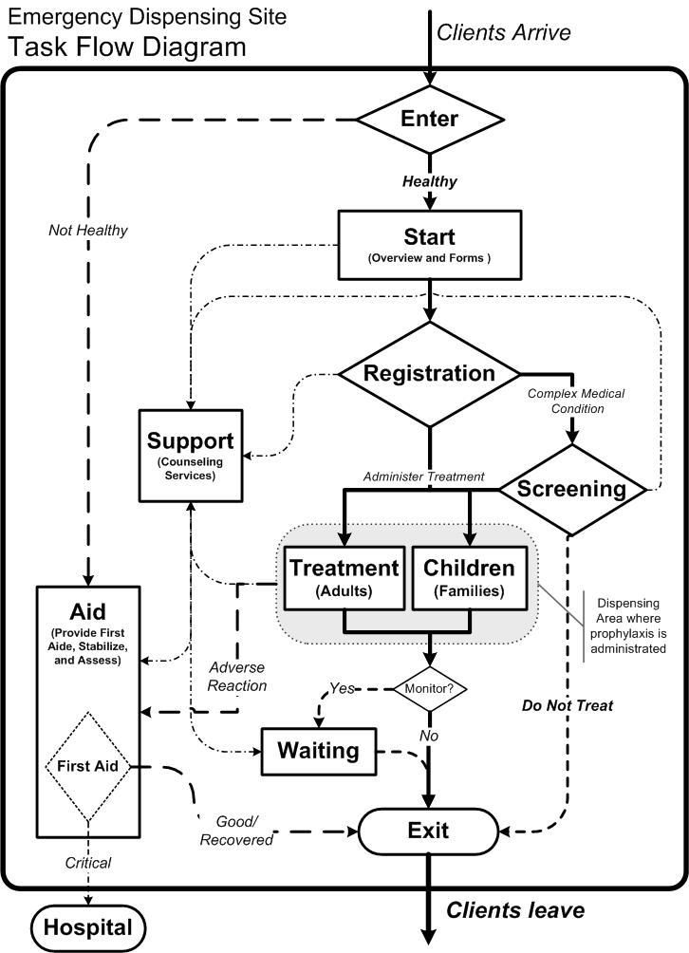
Point of Distribution Operations
Command Structure/Organizational Chart
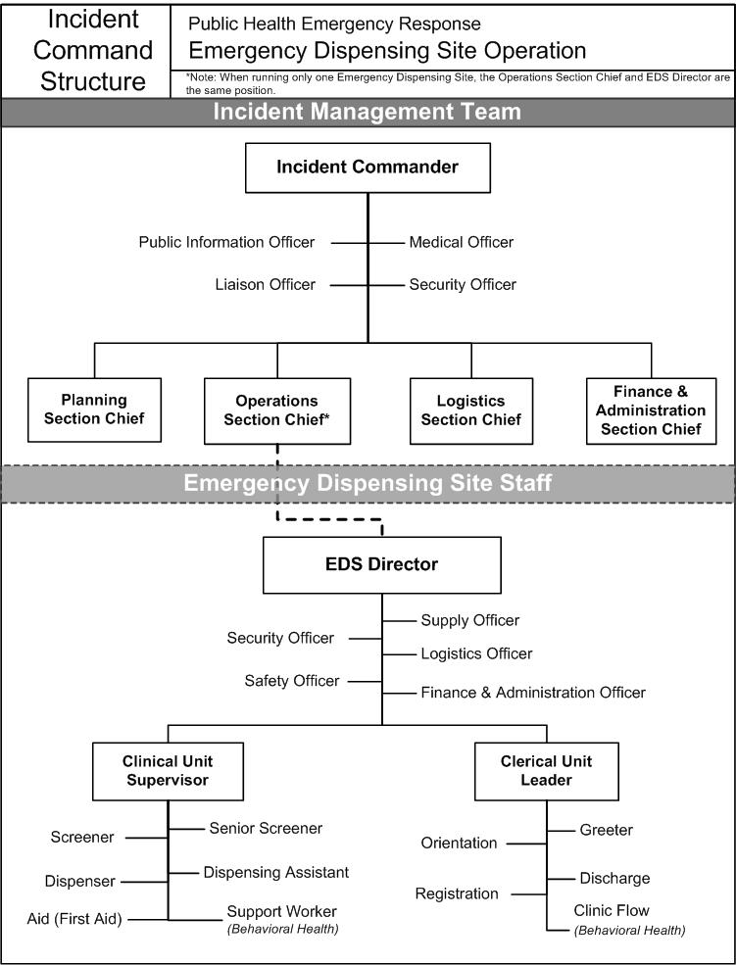
NOTES
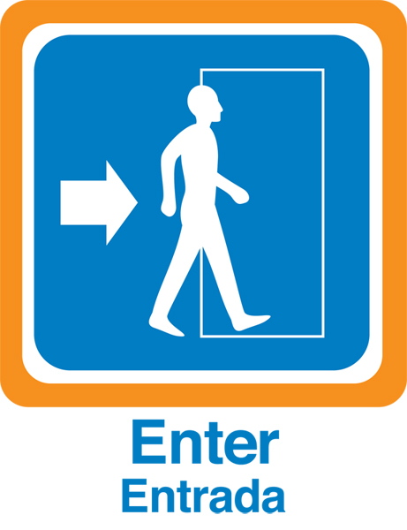 | Exercise Questions  Enter

- What occurs at this station? What are the primary functions?

- What is essential for this station to operate effectively (e.g., number of staff, materials, skills and/or personality traits of staff)?

- Who is the immediate supervisor for staff at the Entrance?

- Where will clients be coming from prior to this station?

- What will clients be receiving from you at this station?

- Where will a majority of clients go from this station?

- What other stations might you direct a client toward? Why?

- How could you direct clients to the appropriate next station?

- How could you control client flow through this station?

- Who must be notified if there is a bottleneck here?

- How would you notify them?

 | Exercise Questions  Start

- What happens at Orientation? What are the primary functions?

- What is essential for this station to operate effectively (e.g., number of staff, materials, skills and/or personality traits of staff)?

- Who is the immediate supervisor for Orientation staff?

- What might clients expect to happen at Orientation?

- What do you have to provide to clients at this station?

- How would you communicate this to them?

- How would you control client flow through this station?

- Who must be notified if there is a bottleneck here?

- How would you notify them?

 | Exercise Questions  Registration

- What happens at Registration? What is the primary function?

- What is essential for this station to operate effectively (e.g., number of staff, materials, skills and/or personality traits of staff)?

- Who is the immediate supervisor for staff at Registration?

- Where will clients be coming from prior to Registration?

- What must a client accomplish at Registration?

- Where will a majority of clients go from Registration?

- Where else might you send a client from Registration? Why?

- What kind of assistance might a client request or require?

- Who should you notify if you are unable to provide the required or requested assistance?

- Who must be notified if there is a bottleneck here?

- How would you notify them?

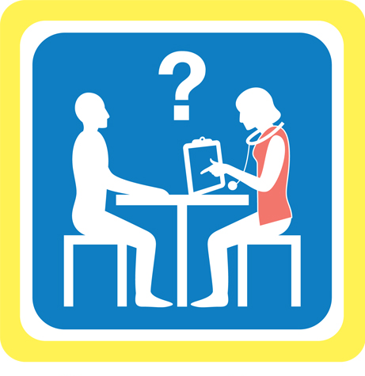 | Exercise Questions  Screening

- What happens at Screening? What are the primary functions?

- What is essential for this station to operate effectively (e.g., number of staff, materials, skills and/or personality traits of staff)?

- Who is the immediate supervisor for staff of Screening?

- Where could clients come from prior to Screening?

- What might clients expect to happen at Screening?

- What should you provide to clients at Screening?

- Who should be notified if a client becomes distressed by information provided at Screening?

- Where could a client be sent from Screening?

- How could you direct clients to the appropriate next station?

- How could you control client flow through this station?

- Who should you notify if there is a bottleneck here?

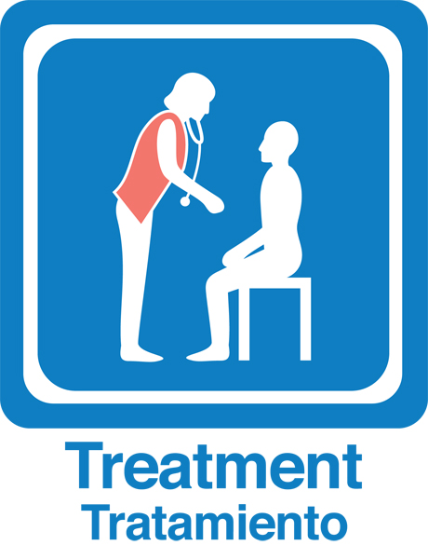 | Exercise Questions  Dispensing: Treatment & Children | 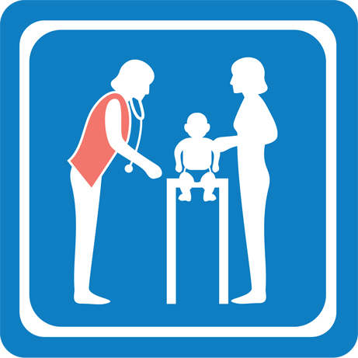

- What is the primary function of the Dispensing stations?

- If both station signs are used, who should be directed to Children?

- What is essential for this station to operate effectively (e.g., number of staff, materials, skills and/or personality traits of staff)?

- Who is the immediate supervisor for staff at this station?

- Where will most clients come from prior to Treatment?

- What must a client present before they, or their children receive treatment? What should clients know before they, or their children receive treatment?

- Where will most clients go after treatment? Where else might a client be directed from Treatment? Why?

- How could you control client flow through these stations?

- Who should be notified if clients or their children become combative, disorderly, physically ill, or refuse treatment?

- Who should be notified if there is a bottleneck here?

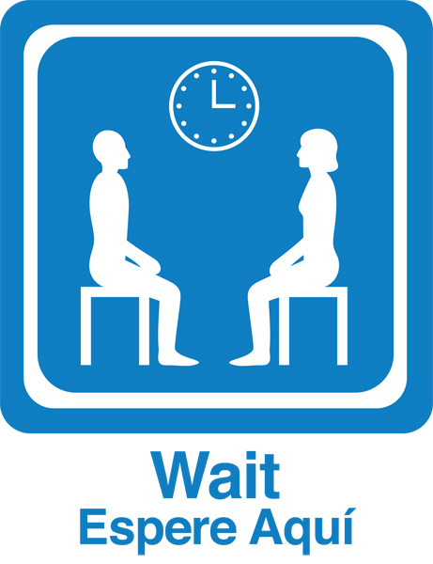 | Exercise Questions  Discharge: Wait & Exit | 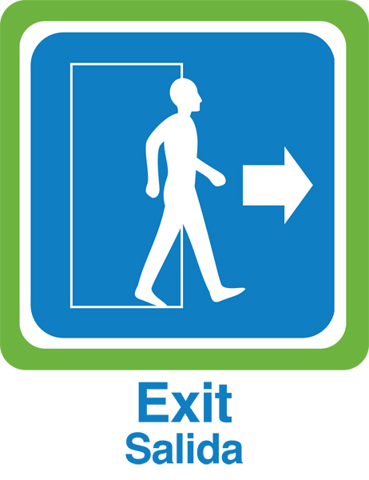

- What happens at these stations?

- What is your primary function at the Wait or Discharge stations?

- Who is the immediate supervisor for staff at these stations?

- Where will clients be coming from prior to Discharge?

- Will every client pass through Discharge?

- What will clients have to do at Discharge?

- Which clients will need to Wait?

- How will you manage clients who are looking for family members/friends who have not yet emerged or who are loitering at Discharge?

- Who should be notified if a client refuses to wait or is loitering?

- Who must be notified if a client is physically ill, or reports a negative reaction to treatment at either Discharge or the Exit?

Trainer’s Resources

POD 2: Facilitating Clients Through a POD
Point of Distribution Staff Training Series

Trainer’s Guide – POD 2: Facilitating Clients Through a POD

Table of Contents
Materials/Equipment Checklist 1
Goal 2
Prerequisites 2
Overview 2
Preparation 3
Presentation of Training Content – Guide 4
1. Pre-Test & Introduction . . . . . . . . . . . . . . . . . . . . . . . . . . . . . . . . . . . . . 5 minutes 4
2. The Scenario . . . . . . . . . . . . . . . . . . . . . . . . . . . . . . . . . . . . . . . . . . . . . 20 minutes 5
3. Exercise Instructions . . . . . . . . . . . . . . . . . . . . . . . . . . . . . . . . . . . . . . 10 minutes 7
4. Exercise . . . . . . . . . . . . . . . . . . . . . . . . . . . . . . . . . . . . . . . . . . . . . . . . . 60 minutes 8
5. Break . . . . . . . . . . . . . . . . . . . . . . . . . . . . . . . . . . . . . . . . . . . . . . . . . . . 10 minutes 8
6. Debriefing Session . . . . . . . . . . . . . . . . . . . . . . . . . . . . . . . . . . . . . . . . 45 minutes 9
7. Post-Test & Feedback Survey . . . . . . . . . . . . . . . . . .. . . . . . . . . . . . . 5 minutes 10

Materials/Equipment Checklist
- POD 2 Pre/Post-Test; one copy per participant
- Feedback Survey; one copy per participant
- POD 2 Station Reference Books; one per station
Bound and Tabbed Contents:
Cover – Station sign(s)
Tab 1 – Job action sheets for the station
Tab 2 – Client case studies for the station
Tab 3 – Disease Fact Sheet: Quatro Regionosis Beta
Tab 4 – Client Information Form & Medical Protocol Decision Tree
Tab 5 – POD task flow diagram & ICS Chart
Unbound Inserts:
2 Pocket Communicators
1 Stapled client case study set for the station
1 copy of flow control job action sheet
- Training worksheet; one packet per team
- Station Signage
- Easels and/or reusable adhesive hooks to prominently display signs
- 6 Tables
- Chairs; one per participant
- White board or flip chart for assistant to keep notes during debrief
- Name tags
- Extra pens and pencils for participants

Goal
Prepare participants to maintain a universally accessible, effective, efficient, and safe Point of Distribution(POD) operation by familiarizing them with communication methods and strategies for servicing all clients who may present at a POD.

Prerequisites
POD 1; Recommend ICS 100 and 700 due to references to incident command principles.

Overview
This is the second in a two part training series that prepares participants to work at an emergency dispensing site. During this training, “POD 2: Facilitating Clients Through a POD”, participants examine client case studies that depict people with a variety of barriers to receiving the service. In teams, participants identify the service barriers and develop solutions to address client needs without obstructing or disrupting POD flow.

Objectives
At the completion of this training, participants will be able to:

- Identify strategies to overcome common communication barriers associated with persons for whom English is not a primary language, are elderly, or have a physical or cognitive disability.
- Describe how pictogram-based signage can be used to support clients in navigating a POD.
- Demonstrate how the Pocket Communicator can be used to overcome communication barriers.
- Provide critical feedback to other participants regarding solutions intended to overcome a variety of physical, cognitive, language, and psychological barriers.
- Relate past training or field experiences to address the specific barriers presented in client case studies.

Preparation
Arrange for a venue and time that is convenient for participants. Be sure to consult with a human resource or community volunteer coordinator. The venue should have an open layout with few if any fixed pieces of furniture. This will make it easy for you to properly set-up the room for the exercise. Since conversations can become animated during the exercise, it is helpful to have a room that dampens noise with wall-to-wall carpeting and low ceilings.

On the day of the training, show up at the venue at least an hour early. Arrange the tables to mimic a six-station dispensing site where the first station, “Enter”, is located near the door that participants enter through and the final station, “Exit/Waiting”, is near the door that participants can leave the room. Place station reference books at corresponding stations. Identify a central location in the room where you can best facilitate the debriefing session and set down your references and instruction materials. As participants arrive provide them with a name tag, Participant Handout, a team number (i.e., 1 thru 6), and a pre/post-test and feedback survey. Make sure that there are at least three participants in each team.

The client case studies used in this training depict people who may present at a POD with issues related to language, differing cultural attitudes, impairments related to aging, and other physical, cognitive or sensory functions. They are rich in opportunities for participants to learn from personal experience and the experiences of other participants. Familiarize yourself with the case studies in detail. From training to training keep track of issues that participants raise, questions they ask, solutions they develop, and stories that they share. This will help you and other trainers to facilitate better trainings in the future.

Position the teams as follows:
Team 1 – Start, ends at Enter
Team 2 – Registration, ends at Start
Team 3 – Screening, ends at Registration
Team 4 – Children/Treatment, ends at Screening
Team 5 – Exit/Waiting, ends at Children/Treatment
Team 6 – Enter, ends at Exit/Waiting

Presentation of Training Content – Guide

- Pre-Test & Introduction . . . . . . . . . . . . . . . . . . . . . . . . . . . . . . . . . . . . . 5 minutes

As participants arrive and sit at their assigned station, ask them to take the pre-test without referring to the handout materials. Emphasize that the purpose of the test is to measure the trainer’s performance. They do not need to write their names.

At the start time, welcome all the participants. Introduce yourself and any other trainers. Ask participants to introduce themselves and where they are from (e.g., city, town or neighborhood).

Describe that this training will build on the lessons of POD 1. Where POD 1 focused on the basic functions of a POD, this training will focus on how to move people through the process. In particular, people whose primary language is not English, elders, and people with physical or cognitive disabilities. Mention to participants that these make up the majority of people in many communities; that in a way they are not “special”, but rather typical. Describe to participants that during this training, they will work in teams to identify strategies for understanding and coping with the dynamics of such clients.

Outline how the training will proceed:
- Scenario & POD Operations for Exercise
- Exercise instructions
- Exercise
- Break
- Debriefing Session
- Post-test and feedback survey

Emphasize the importance of the following to ensuring success during this training:
  - While there will be lots of information at first, all of it can be found in the station reference books located at each station. They do not need to get everything right away.
  - Try not to feel inhibited about a lack of knowledge or understanding related to issues presented in the case studies. These are intended to teach and create opportunities for participants to learn.
  - Team work
  - REMEMBER: The scenario and the disease are fictional.

Make sure participants know where exits, bathrooms and refreshments are located. Ask if they have any questions or concerns before proceeding further.

- The Scenario . . . . . . . . . . . . . . . . . . . . . . . . . . . . . . . . . . . . . . . . . . . . . 20 minutes

Explain to the participants that during the exercise they will be staff at a POD that has been set-up to deal with a fictitious incident and made-up disease. Proceed to describe the incident and the response:

- Several food handlers at a popular cafeteria in town grew ill with a disease called Quatro Regionosis Beta, (QRB). Everyone who recently worked or ate at the cafeteria and their household members are at risk of getting sick with QRB.
- The public health department has contacted everyone who recently worked or ate at the cafeteria. These people have been informed that they been exposed to QRB. And they have been instructed that a POD will be set-up to provide them and their household members with medical prophylaxis.

Explain that the participants need to know a little bit about QRB and how it is treated. Remind them that this is a fictitious disease with a completely made-up treatment. As you go over the following, refer to the appropriate tab in the station reference book where the information is located.

Tab 3 – Disease Fact Sheet:
- Disease Etiology and Mode of Transmission: QRB is a waterborne pathogen and is contracted through ingestion of contaminated water or unwashed produce irrigated with contaminated water. Person-to-person transmission is limited to intimate physical contact with infected individuals, and caretakers of infected individuals through the fecal-oral route.
- Attack Rate: Thirty percent of directly exposed individuals become infected. QRB is fatal in 50% of untreated, infected individuals. Emphasize the importance of the 50% fatality rate; it is what makes receiving the treatment such an imperative for clients.
- Signs and Symptoms: Initial infections result in a rapid immune response – 12 to 36 hours. This presents as a common infection with fevers, nausea, and diarrhea. QRB is easily distinguished from other infections by the presence of multiple ulcerations on the tongue and mouth. Bloody stools and vomiting are common and are a concern for individuals with secondary exposure.

Tab 4 – Medical Protocol Decision Tree
- Primary Treatment: A pre-measured dose, IM injection of MedX. Children under 10 years of age will receive a pre-measured half dose IM injection of MedX (note: Treatment is based on age, not weight).
- Contra-Indications To Primary Treatment: A SINGLE INJECTED DOSE OF MEDX COULD BE FATAL TO:
  - Women who are or think they might be pregnant
  - People who are immune compromised (Clients who are: undergoing chemo therapy, HIV positive/have AIDS, or have had organ transplants)
- Alternative Treatment: Two MedX tablets to be taken WITH FOOD twice a day, for three consecutive days. Due to the medication’s course of action, clients who are immune compromised and showing symptoms will likely experience painful gastrointestinal symptoms such as nausea, vomiting, or diarrhea during the three-day treatment period.

Explain how the POD is set-up. Move around the room from one station to the next, in sequence from start to finish, and describe roughly what happens at the station. Refer participants to the client information form (Tab 4) and the POD task flow diagram (Tab 5) as you do this. Be sure to mention that at:

ENTER: Clients are welcomed to the POD.
START: Clients receive their forms and complete them.
REGISTRATION: Client forms are reviewed for completeness and some are directed to screening while others straight to treatment.
SCREENING: Clients with special conditions are interviewed in more detail to identify the correct treatment.
TREATMENT/CHILDREN: Where clients receive the treatment that is designated on their form.
WAITING: In some POD operations, clients that get a shot may need to remain on site to make sure they are okay.
EXIT: Clients leave the site and turn in their forms.
AID: Clients and their family will be directed here if anyone presents with a critical health issue or has symptoms of the disease.
SUPPORT: Clients and their families will be directed here when there is a demonstrated need for stress management or treatment of acute behavioral health issues. Stress and panic can be contagious in large groups, so removing people who are exhibiting negative behaviors is critical.

Explain to the participants that in this POD there are policies and guidelines to follow while working with clients. These are:

  - Keep families together regardless of where a specific client is sent. If there are children, all family members are treated in the “Children” area.
  - Children should never translate for family members. The client may not want to share certain information with their child, or the child may feel that translating the information to a person of authority could be harmful.
  - Ask if a person needs assistance, never assume.
  - Prophylaxis will occur at both Aid and Support.
  - “Clients” have come to us as consumers.
  - If you do not know the most appropriate way to deal with a situation, ask colleagues for input.
  - Do not overwhelm clients; give them the information they need to get through the process.
  - Be reassuring when possible, in order to alleviate stress or panic.

Ask if participants have any questions or concerns before proceeding further. Although many may be overwhelmed, reassure them that they have all of this information in the station reference books and they can ask you during the exercise. Answer questions[Who does this refer too?]

- Exercise Instructions . . . . . . . . . . . . . . . . . . . . . . . . . . . . . . . . . . . . . . 10 minutes

Explain that during this exercise, participants will work in their assigned teams to do the following:

- Visit each of the six stations, rotating when instructed by the trainer
- With approximately 10 minutes at each stations, each team will:
  - Read their three assigned client case studies found in the station reference book, Tab 2.
  - As a team and striving for consensus, complete four questions for each case study found on the training worksheet.
    - What service will we provide to Client X at this station?
    - Where will we direct Client X from this station and why?
    - What is/are the barriers to servicing Client X?
    - How can we overcome the service barriers and facilitate Client X to the next station?
- Once all six stations have been visited, we will reconvene as a large group and debrief this exercise. Each team will talk about one station. The trainer will tell the team what station they will report on shortly before the exercise is completed.

Explain that to answer the questions, everyone has the following resources:
- Station Reference Book – Must leave these at the station
- Training Worksheet – Take this with you from station to station
- The Trainers
- Team members
- Your team members

Encourage teams to discuss the client case studies by considering issues of language, behavior, disability, aging, and presenting symptoms. How might these affect the client’s ability to progress through the POD process? How might these issues affect the way we guide them through the process? Suggest that participants write down their questions, note the client case studies that presented an issue that seemed to stump the team, and concerns. Be sure to mention these things during the debriefing session.

Remind participants that everyone is at a different place of learning and experience. There are delicate issues presented in the client case studies. In many cases there is not a single right answer. People are encouraged to ask questions of one another, share past experiences, and disagree.

Ask participants if they have any questions before proceeding. Before they begin, each team must choose one team member to record the team’s responses, and another to report the team’s answers during the debriefing session.

- Exercise . . . . . . . . . . . . . . . . . . . . . . . . . . . . . . . . . . . . . . . . . . . . . . . . . 60 minutes

With participants seated at their stations, proceed as follows:
- Ask teams to select reporter and recorder.
- Once selected, provide each team with their client case study assignments. These are the case numbers they will study at each station, found behind Tab 2:

Team 1 (Start) – 1, 2, 3
Team 2 (Registration) – 3, 4, 5
Team 3 (Screening) – 5, 6, 7
Team 4 (Treatment/Children) – 7, 8, 9
Team 5 (Exit/Waiting) – 9, 10, 1
Team 6 (Enter) – 2, 3, 4

- Teams read client cases and answer questions using the station reference book and working together. Circulate among the teams. Listen in on discussions, and answer questions or redirect participants back to the task of answering the questions when necessary.
- When time has elapsed, get the attention of all participants.
- Ask teams to move to their next station. Remind them to bring their questions and leave the job action sheets.
- Repeat 3 – 7 until all stations have been visited. End the exercise on time.
- As teams approach their last station, inform them that they will report on that last station.

Initially, teams will have difficulty determining what they are supposed to do and where to turn for answers. This will get better as the Exercise progresses and with your support. Utilize your position as time keeper to increase or decrease the actual time per station in order to provide time upfront for teams to master the Exercise tasks and then focus on learning. For example, although participants believe that they have 10 minutes per station, begin by actually allocating 15 minutes to the first station. Use the extra 5 minutes to ensure that all teams understand what they are supposed to do and where they can turn to for answers. Then allow 12 minutes at the second station, 10 minutes at the third, 8 minutes at the fourth, and continue to decrease actual time allotments to bring the exercise to an end after 60 minutes.

- Break . . . . . . . . . . . . . . . . . . . . . . . . . . . . . . . . . . . . . . . . . . . . . . . . . . . 10 minutes

During this time, ready a location where participants can place their pre/post-tests and feedback survey. If a training assistant is going to take notes, then set-up the easel or other necessary equipment.
- Debriefing Session . . . . . . . . . . . . . . . . . . . . . . . . . . . . . . . . . . . . . . . . 45 minutes

This is the part of the training where the learning objectives are reinforced. Focus the conversation on topics related to the objectives. Encourage questions and facilitate group conversation rather than immediately answering questions yourself. You may want to have an assistant to keep notes on a flip chart in order to track what has and has not been discussed.

With participants seated in their teams either at the last station or positioned in a circle, remind them that some lack knowledge and experience with other cultures, relating to people who are disabled, and how to deal with differences. Emphasize that everyone has something to learn.

Begin with the team assigned to the Entrance station (i.e., Team 1) and ask the reporter to describe the most difficult client group(s) at the station.
- What were the barriers?
- What were the solutions?
- Does anyone have personal or professional experiences that might address these issues?
- Did other groups experience different barriers at this station?
- Any situations that we have not touched on?

Encourage other team members to add comments or thoughts following the reporter. As questions arise, redirect them to the group where appropriate. If time allows, turn to the larger group for additional comments about the station. Budget 7-8 minutes per team. When time is up or there are no more comments, move to the next team. Bring debriefing session to an end on time.

There will be a tendency for the conversation to delve into incident specific issues (e.g., pandemic flu vaccine availability, bioterrorism agents, or the shortcomings of the Hurricane Katrina response). This can derail the training and sink the debriefing session. There are many effective solutions to this problem. One solution is to remind the group that this training is about the fundamentals of emergency dispensing, that what they are learning will be applicable to many types of hazards.

Participants may also ask questions about occupational health and safety, policy, and administrative issues. These too can stall the debriefing session. Be prepared to answer questions regarding personal liability, prophylaxis for families and response personnel, personal protective equipment, and how staff or volunteers may be called up.

- Post-Test & Feedback Survey . . . . . . . . . . . . . . . . . .. . . . . . . . . . . . . 5 minutes

Thank the participants for their time and commitment. Make any other relevant concluding remarks. Instruct participants to take the post-test and ask them to complete the training feedback survey. Collect these as participants finish and leave.

Training Materials
POD 2: Facilitating Clients Through a POD

REFERENCE BOOK ASSEMBLY INSTRUCTIONS

Materials
- 6 – Report Covers with clear front (e.g., Avery Oversized Clear Front Report Covers)
- 6 – 5 Tab Dividers (e.g., Avery Ready Index® Reference Dividers)
- 1 – Color copy of each of the following station signs (8.5” x 11”):
  - Enter
  - Start
  - Registration
  - Screening
  - Treatment / Children
  - Waiting / Exit
- 6 – POD task flow diagram
- 1 – Job Action Sheets for each of the following stations:
  - Enter (e.g., Greeter JAS)
  - Start (e.g., Orientation JAS)
  - Registration (e.g., Registrar JAS)
  - Screening (e.g., Senior and Junior Screener JAS)
  - Treatment / Children (e.g., Dispenser and Dispenser Assistant JAS)
  - Waiting / Exit (e.g., Discharge JAS)
- 1 – Color copy of each of the following client case studies:
  - Enter
  - Start
  - Registration
  - Screening
  - Treatment / Children
  - Waiting / Exit
- 6 – Quatro Regionosis Beta Fact Sheet
- 6 – Medical protocol decision tree
- 6 – Client Information Form
- 6 – POD ICS chart

Instructions
- Gather all the above materials in the specified quantities

- Assemble reference books per station name, arranging the contents as follows:
Tab 1 – Job action sheets for the station
Tab 2 – Client case studies for the station
Tab 3 – Disease Fact Sheet: Quatro Regionosis Beta
Tab 4 – Client Information Form & Medical Protocol Decision Tree
Tab 5 – POD task flow diagram & ICS Chart

- Unbound Inserts:
  - 2 Pocket Communicators
  - 1 Stapled client case study set for the station
  - 1 copy of flow control job action sheet Cover – Station sign(s)

Client Case Studies

Enter

- A nicely dressed Asian couple arrives with two children who look to be about 6 – 10 years old. They all wait patiently in line, have no questions, and move along with the other clients. The two children look sweaty and uncomfortable. As you watch, one of the children leans against the wall and slides to the floor.

- A family with four children, ages 2, 4, 7 and 10, asks for help with their youngest son. The mother is pushing the 2 year-old daughter in a stroller while telling you that the four year-old fell when they were on their way to the POD, and is complaining that his head hurts. The father is trying to calm the two older boys who are fighting with one another.

- A middle aged white woman enters alone. She appears to be perspiring and nervous. She states that she feels nauseous and that her chest hurts.
- A group of 8 adults arrive together. They are very talkative, but their conversations seem to be somewhat disjointed and unrelated to the situation. When you approach them, they collectively ask similar questions over and over without appearing to understand the answers, and seem confused when given directions. Three of them, who are unrelated, say that they “don’t feel good.”

- A couple from the neighborhood arrives and recognizes you. They ask you pointedly if this was a terrorist attack, who from the neighborhood has shown up, and how many people here are sick.

- An older gentleman comes in using a cane. He walks very unsteadily on his feet. When you approach him to ask if you can be of assistance, he has a great deal of difficulty hearing you, and incessantly asks you to speak up and repeat what you said.

- A family comprised of a father, a mother, an adolescent son and an older teenaged daughter arrive. The father acts very domineering and is sharp with his directions to the family. He states definitively that none of them are sick.

- An older Russian woman and her daughter arrive. The daughter states in fairly clear English that her mother has many health issues. The mother holds out a plastic shopping bag full of pill bottles, and in broken English asks to “Speak with doctor?”

- A disheveled-looking couple asks you about what they should expect during their visit and how much this is going to cost. They very anxiously ask what will happen to them if they can’t afford to pay. They talk nervously to each other then turn around to leave through the Entrance.

- A young man says that he lives in the neighborhood and came because he wants to help. He asks many questions about what is happening, what kind of medicine is being handed out, and wonders who is in charge. He also asks if he can take some home to his mother who has become very sick in the last two days.

Client Case Studies
Start

- While you are attempting to convey basic information to people standing in line, two couples in line are carrying-on a conversation, and apparently paying no attention to what you are saying. You notice that the man standing behind them in line has had to ask them to move forward when the line has progressed, but is becoming increasingly frustrated because he can’t hear what you’re saying due to their talking.

- A young Latino man looks very nervous and sweaty. When you ask him questions he either says “Yes” or nods affirmatively. He indicates that he speaks Portuguese and is continually rubbing his left arm while grimacing.

- After giving your orientation presentation, a man and woman, who appear to be middle-aged, approach you and say they don’t know where to go or what to do. You inquire as to whether they heard the information you just presented. They say that they heard it but couldn’t understand what you meant. They say you seem nice, and ask if you would take them where they need to go.

- A family consisting of a middle-aged father and mother, and a young teenaged girl approach speaking in a foreign language. You ask if you can be of assistance. The girl replies with a very thick accent that the family has just come from Senegal and her parents do not speak any English, but states “I can interpret for them.”

- A young man in an electric wheelchair is trying to navigate through the line. A woman comes up to you and is insistent that, “That man wants to ask you a question. He needs you right away!” You are already addressing questions from an elderly couple who are quite concerned about how the treatment may interact with the medications they are already taking.

- You see a man and his elderly father standing in line. The older gentleman is using a walker. The next time you look over you see that the older man has fallen on the floor and his son is trying to pick him up. Other people in line are trying to help, but the man appears to be in a great deal of pain.

- A couple, who has just arrived from Denmark and speak little English, express that they do not understand what you are talking about. They appear concerned and have questions. Suddenly, the man turns his head and vomits blood.

- After providing information to a group of people, a woman approaches you to say that the man who was standing next to her is deaf and was trying to sign to her. She points to identify the man who is moving along in the line but by himself

- As you explain about the disease and the treatment, a woman in the group becomes increasingly anxious. She fidgets in her chair, balls her hands into fists, and begins crying. Suddenly, another woman with three children pushes her way through the line and demands that you immediately treat her and her children because her husband is a Selectman. Other people in line become very agitated.

- A man with two young children pushes through the line and yells that he wants his family protected quickly. “Why don’t you hurry up?” Other people start muttering about how slowly the line is moving.

Client Case Studies
Registration

- A man asks if he can get more of the medicine to take home to his sick mother and sister who is caring for her. He asks, “How much of this can I get, because I also have some friends who asked me, since you’re going, get us some too.”

- A young woman with a Russian accent hands you two registration forms. She tells you that one is for her and the other is for her mother who is standing next to her. The daughter has some questions related to her mother’s medication regimen. She asks if the treatment will react with some of the medications her mother is taking. The mother does not speak with you directly.

- A Latino man is standing with his form looking very anxious. When you look closer you see that he is sweating profusely. When you ask if he speaks English, he nods affirmatively. When you ask how you can help him he answers “Yes.” When you ask if he needs help filling out his form, he grabs at his left arm, and while gritting his teeth answers “Yes.”

- A man and a woman, both using white canes, tell you that they cannot fill out the forms because they can’t see them. The woman does tell you that she has had a kidney transplant.

- An elderly couple approaches your table. They are moving fairly slowly. The woman is trembling and seems very concerned. She hands you both her and her husband’s forms. They have been filled-out in the same handwriting and are illegible. As you begin to ask questions the woman tells you she can’t hear well, but her husband is “a little confused about things.” She asks you repeatedly, “How much will this cost because we are on a fixed income.”

- A man with a beard and wearing a turban is with a woman who is also wearing head covering. As they walk toward you, the man states that his form will be identification for both of them. He also tells you that you must speak only to him.

- A couple comes to the table with their adult child who appears very agitated. The mother tells you that their son has severe developmental disabilities. She begins to give you very detailed descriptions of his daily routine, a list of his medications, and is emphatic about all of the things you must do before interacting with him or giving him the treatment.

- An Asian couple with two children present, and the father hands you all of the family’s forms. The mother’s form indicates that she is allergic to some kind of medication, but has not indicated what kind. When asked, she does not respond but the father states that he is not sure which one is the one she cannot take. He also tells you that she is very allergic to many things and “She sometimes has trouble breathing and the doctors have not told us why.”

- An African-American couple hand you their forms. The wife’s form indicates that she is undergoing chemo therapy for lymphoma. The wife becomes concerned when they are told that they must speak with someone else. The husband looks angry.

- A very nervous man who does not speak English looks at his form with a very concerned expression. He continually looks around as though he is watching for someone. He indicates that he does not want to provide any personal information but just wants the medication.

Client Case Studies
Screening
- A middle-aged man with no hair and his woman companion seem confused. As they speak with you it becomes apparent that they are both having some cognitive difficulties. As you try to ascertain if they are there alone they tell you that they live in a group home together and were told to “Come here for the medicine.” The woman tells you “He has cancer but the doctor is giving him medicine for that.”

- A family of a father, a mother, an adolescent boy and an older teenaged daughter is standing in front of you. They are olive skinned with black hair, but all indicate that they speak English well. The father seems very disturbed, and states that they have been directed by “someone in Registration who told us we must talk to you.” After reviewing their individual forms, you discover that the daughter thinks she might be pregnant. She raises her finger to her lips and glances toward her father.

- An African-American couple seem very agitated as they approach the screening station. When the wife is told that she may not receive the medication, the couple’s anxiety markedly increases. The husband becomes furious by the volunteer’s explanation that his wife shouldn’t have the medication. He angrily asks, “Who are you to decide to not treat Blacks?”

- A distraught man with two children approaches the table. He states that the younger of his two sons, ages 4 and 6, has become increasingly ill over the past 24 hours with severe nausea and bloody diarrhea. He explains that his youngest son has great difficulty taking pills. The older boy has not been sick, but cannot tolerate shots. The father denies feeling sick himself.

- A Latino mother has come to screening with her autistic son. The son, age 13, is becoming increasingly agitated to the point that the mother cannot attend to her discussion with the screener.

- A very thin man tells you he was directed to this station by someone in Registration. You ask him about his health history and what medications he’s taking. He berates you by stating “You can’t ask me that! It’s illegal.

- An elderly Black man, using a walker, very slowly sits in the chair. He explains that he takes many pills, but he doesn’t know what they are for. He believes some are related to his arthritis, but is unsure of the others. He can tell you what colors they are, though he doesn’t know their names. “My daughter picks up my prescriptions, but she is on vacation this week.”

- A Haitian family consisting of a young father, a young mother and 3 small children presents at your table. The father, speaking broken English, is unable to give a clear family history. He does say that he works in a restaurant and many of his co-workers have been out sick for the last few days. His wife’s form indicates that she has been HIV positive for eight years.

- A very large man sits down before you and you notice that he looks puffy. He explains that he takes large doses of steroids for his asthma and has concerns about how the treatment will react with medications he is already taking. He becomes increasingly agitated and insists that you guarantee that he’ll be able to breathe and “Be alright” if he takes the medicine

- A Caucasian woman has written on her form that she thinks she might be pregnant. She has been presented with the pros and cons of taking the treatment based on the medical information she wrote on her form. She seems completely immobilized about making the decision of whether or not to take the treatment. She stops talking and will not leave the chair in which she is sitting.

Client Case Studies
Dispensing: Treatment & Children

- A Black family that consists of a father, a mother and 3 very small children is next in line for treatment. An interpreter explains that they are Haitian, speak almost no English, and have just come from Screening because the mother has been HIV positive for eight years. According to the interpreter, the father has been exposed at work and understands that this is the only treatment that will protect his family. He defiantly insists that you give him and his entire family the treatment.

- A morbidly obese woman in a wheelchair presents for treatment. She states that she “Can’t take pills,” but you don’t have a needle long enough to reach a muscle.

- A Latino mother and her young autistic son are next in line for treatment. The son is extremely agitated and the mother has difficulty controlling him. As you and the mother attempt to control the child in order to give his treatment, the mother begins to have a reaction and stops breathing.

- A middle-aged woman is acting very nervous as she approaches the table for treatment. She asks many questions about the sanitation procedures related to receiving treatment. She requests extra alcohol swabs and proceeds to repeatedly wipe her arm and all of the areas adjacent to where she would be receiving her injection. She will not allow you to give her the injection because she states that the area is not sterile.

- A very frail woman in her early 90s enters the dispensing area. She is next in line and explains, “I desperately need to visit the lady’s room. I’m sorry but I just can’t wait.” She further explains that she is unable to get there by herself.

- Two women standing together hand you their paperwork. The forms are complete, and there do not appear to be any contraindications for giving them the treatment. You administer treatment to the first woman and then to the second. By the time you put the second woman’s syringe in the sharps box you notice that the first woman is beginning to swell up and is having difficulty breathing.

- A family of six is next in line for treatment. The mother tells you that the children are 2, 4, 7 and 10 years-old. The two year-old girl is in a stroller, and the four year-old boy is being carried by his father and looks like he is asleep. When the 7 year-old realizes that the treatment involves getting a shot he begins crying loudly. Consequently, the two year-old begins screaming. The boy being held by his father does not wake up. The father declares, “He’s tired because he bumped his head earlier.”

- A distraught man with two children approaches the table. He states that the younger of his two sons, aged 4, has been increasingly ill over the past 24 hours with severe nausea and bloody diarrhea. He explains that his youngest son has great difficulty taking pills. The older boy, 6 years old, has not been sick, but cannot tolerate shots. The father denies feeling sick himself.

- A woman with her infant son approaches to be treated. The woman tells you that she is breast-feeding her baby and has just begun to notice sores in her mouth.

- You have just treated a father and his adolescent son who look as though they are of Middle Eastern descent with injections of the medication. The mother and older daughter are to be treated next. Based on the paperwork you’ve been handed, the daughter should receive the treatment orally. The father grabs the form when he realizes you are preparing to give his daughter something different. After reading the form he becomes furious because he has discovered she might be pregnant. The man pushes you out of the way, knocks over the table that contains prepared doses, and begins hitting his daughter.

Client Case Studies
Discharge: Wait & Exit

- A family of five has been directed to tell you that two of them, an elderly mother and an aunt, have just emigrated from India and have never received treatment like this before and have been told to wait. The two older women do not speak English, but the rest of the family does not want to stay when told that they must wait for 15 minutes to determine if the women have an adverse reaction to the treatment.

- A Latino man walks very hurriedly past you toward the exit. He has no form, does not look at you, and does not respond when you ask to speak with him. When you finally stop him, he indicates that he does not speak English. As you are trying to determine if he has received treatment, another Latino man hurries past you without stopping. As the second man passes you notice that he does not have a form as well, but is carrying a heavy plastic bag.

- Members of a large Vietnamese family are looking over the directions for continuing the treatment after they leave. They appear confused by the instructions.

- A man and two teenaged girls hand you their forms. You check them and see that the paperwork is complete so you direct them toward the Exit. The father declines and says “We have to wait here because my wife and son were directed to a different station than we were.”

- Two women are standing near the exit, very agitated, and arguing in what you have been told is Russian. When you inquire as to whether you might be of some assistance, the younger woman says in fairly clear English that her mother has lost her medications. The women speak with each other some more, then the younger one tells you that her mother said that “One of the doctors took her bag of medicine and she needs to have it back.”

- An African-American couple rushes up to you and thrust their forms into your hands. The forms indicate that the man received treatment, but the wife did not. The man asks for your name and the name of your supervisor shouting, “I’m going to sue you and the Health Department for discrimination!”

- A Caucasian couple hands you their forms. The forms were filled out by the same person, but the handwriting is mostly illegible. The treatment portion of the forms indicates that the two people received the medication differently. When you ask them which of them is taking the pills, they both say they don’t speak English but also don’t appear to have any pills.

- Six people are standing near the exit having a very friendly conversation. You approach them and ask politely if they would visit outside. One woman declares that, “We haven’t seen each other for so long.” She continues,” We’ll just be a few minutes,” then returns to her conversation.

- A well-dressed Black man begins to walk past you without handing you his form. When you ask him for it he points behind him and responds in very broken English, “They have it.” When you turn around from looking where he pointed the man has walked out.

- Four very talkative, cognitively disabled adults are walking toward the Exit. As they pass, you ask them for their paperwork and notice that none of them have the forms. When you inquire as to what happened, they all appear confused and say at once that the, “People who gave us the shots kept them.”

- A woman using a wheelchair tells you that her ride left her at the front of the POD. She says that she has no way of contacting the driver, but “He is supposed to wait for me where he left me off. Can you help me get there?”
Incident Profile: This POD has been stood up due to an outbreak of Quatro Regionosis Beta, (QRB). A popular cafeteria was found to have produce contaminated with QRB.
People At Risk: ALL & ONLY CLIENTS AT RISK AND HAVE BEEN DIRECTED TO THIS POD.
- People who ate at the cafeteria (directly exposed)
- People who live with people who ate at the cafeteria (close contact with people directly exposed)

Disease Etiology and Mode of Transmission: QRB is a waterborne pathogen and is contracted through ingestion of contaminated water or unwashed produce irrigated with contaminated water. Person-to-person transmission is limited to intimate physical contact with infected individuals, and caretakers of infected individuals through the fecal-oral route.
Attack Rate: Thirty percent of directly exposed individuals become infected. QRB is fatal in 50% of untreated, infected individuals.
Signs and Symptoms: Initial infections result in a rapid immune response – 12 to 36 hours. This presents as a common infection with fevers, nausea, and diarrhea. QRB is easily distinguished from other infections by the presence of multiple ulcerations on the tongue and mouth. Bloody stools and vomiting are common and are a concern for individuals with secondary exposure.

Primary Treatment: A pre-measured IM injection dose of MedX. Children under 10 years of age will receive a pre-measured half dose IM injection of MedX.
Alternative Treatment: Two MedX tablets to be taken WITH FOOD twice a day, for three consecutive days. Due to the medication’s course of action, clients who are immune compromised and showing symptoms will likely experience painful gastrointestinal symptoms such as nausea, vomiting, or diarrhea during the three-day treatment period.

Contra-Indications To Primary Treatment:
A SINGLE INJECTED DOSE OF MEDX COULD BE FATAL TO:
- Women who are pregnant, or think they might be pregnant.
- People who are immune compromised; i.e., Clients who are: undergoing chemo therapy, HIV positive/have AIDS, or have had organ transplants.
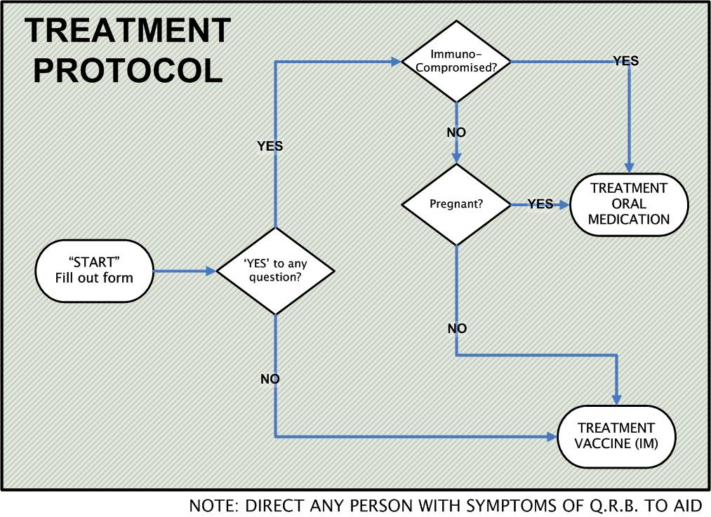
Registration Form: Post-Exposure Prophylaxis |  |  |  |  |  |  |  |  |  |  |  | Date:
City/Town: |  |  |  |  |  |  |  |  | POD Location:
Last Name: |  |  |  |  |  | First Name: |  |  |  |  |  |  |  | Middle Initial:
Phone Number: |  | Home Street Address: |  |  |  |  |  |  |  |  |  |  |  | Zip Code:
Please check ‘Yes’ or ‘No’ |  |  | YES |  | NO |  |  |  |  | NOTES
1. Are you pregnant?
2. Are you immuno-suppressed?
FOR STAFF USE ONLY
Screened By: |  |  |  |  |  |  | Med Recommendation:
Dispensed By: |  |  |  | Lot#: |  |  |  |  |  |  |  |  | Date:

Client Description:
What service will we provide to client x at this station?
Where will we direct client x from this station and why?
What is/are the barrier(s) to serving client x?
How can we overcome the service barriers and direct client x to the next station?
Client Description:
What service will we provide to client x at this station?
Where will we direct client x from this station and why?
What is/are the barrier(s) to serving client x?
How can we overcome the service barriers and direct client x to the next station?
Client Description:
What service will we provide to client x at this station?
Where will we direct client x from this station and why?
What is/are the barrier(s) to serving client x?
How can we overcome the service barriers and direct client x to the next station?
Client Description:
What service will we provide to client x at this station?
Where will we direct client x from this station and why?
What is/are the barrier(s) to serving client x?
How can we overcome the service barriers and direct client x to the next station?
Client Description:
What service will we provide to client x at this station?
Where will we direct client x from this station and why?
What is/are the barrier(s) to serving client x?
How can we overcome the service barriers and direct client x to the next station?
Client Description:
What service will we provide to client x at this station?
Where will we direct client x from this station and why?
What is/are the barrier(s) to serving client x?
How can we overcome the service barriers and direct client x to the next station?

POD Staff Training Series – POD 1 & 2

Training Evaluation Materials

1. | A Point of Distribution(POD) is an operational unit tasked with delivering medication or vaccine to pre- or self-identified people at risk for illness.
 | □ True |  |  | □ False |  | □ Not Sure
2. | “Bottlenecks” may occur in a POD when:
 | A. | Clients are confused about what station to move to next
 | B. | Client forms are illegible
 | C. | Stations are uncoordinated
 | D. | All of the above
3. | Match the station with its function.
 |  |  | Station |  |  |  | Function
 |  |  | Greeting |  |  |  | A. |  | Provide registration forms to clients
 |  |  | Orientation |  |  |  | B. |  | Determine appropriate prophylaxis for clients with complex medical conditions
 |  |  | Registration |  |  |  | C. |  | Direct clients to the exit
 |  |  | Screening |  |  |  | D. |  | Ensure that forms are complete and legible
 |  |  | Dispensing |  |  |  | E. |  | Explain the POD process to arriving clients
 |  |  | Discharge |  |  |  | F. |  | Provide the correct prophylaxis to the client
4. | All POD staff report directly to the POD Director.
 | □ True |  |  | □ False | □ Not Sure
5. | How confident are you in your ability to fulfill the following POD staff positions? (Circle one)
 | Staff Position |  |  |  |  |  |  | Not Confident |  |  |  | Some What Confident |  | Very Confident
 | Greeter |  |  |  |  |  |  | 1 |  |  | 2 | 3 | 4 | 5
 | Orientation |  |  |  |  |  |  | 1 |  |  | 2 | 3 | 4 | 5
 | Registration |  |  |  |  |  |  | 1 |  |  | 2 | 3 | 4 | 5
 | Screener |  |  |  |  |  |  | 1 |  |  | 2 | 3 | 4 | 5
 | Senior Screener |  |  |  |  |  |  | 1 |  |  | 2 | 3 | 4 | 5
 | Dispensing Assistant |  |  |  |  |  |  | 1 |  |  | 2 | 3 | 4 | 5
 | Dispenser |  |  |  |  |  |  | 1 |  |  | 2 | 3 | 4 | 5
 | Discharge |  |  |  |  |  |  | 1 |  |  | 2 | 3 | 4 | 5

At the beginning of the training you were asked to answer the following questions based on the knowledge and experience you had at that time. Now that the training is complete, please answer these questions again based on the experience you have had with us in the last 2 hours.
1. | A Point of Distribution(POD) is an operational unit tasked with delivering medication or vaccine to pre- or self-identified people at risk for illness.
 | □ True |  |  | □ False |  | □ Not Sure
2. | “Bottlenecks” may occur in a POD when:
 | A. | Clients are confused about what station to move to next
 | B. | Client forms are illegible
 | C. | Stations are uncoordinated
 | D. | All of the above
3. | Match the station with its function.
 |  |  | Station |  |  |  | Function
 |  |  | Greeting |  |  |  | A. |  | Provide registration forms to clients
 |  |  | Orientation |  |  |  | B. |  | Determine appropriate prophylaxis for clients with complex medical conditions
 |  |  | Registration |  |  |  | C. |  | Direct clients to the exit
 |  |  | Screening |  |  |  | D. |  | Ensure that forms are complete and legible
 |  |  | Dispensing |  |  |  | E. |  | Explain the POD process to arriving clients
 |  |  | Discharge |  |  |  | F. |  | Provide the correct prophylaxis to the client
4. | All POD staff report directly to the POD Director.
 | □ True |  |  | □ False | □ Not Sure
5. | How confident are you in your ability to fulfill the following POD staff positions? (Circle one)
 | Staff Position |  |  |  |  |  |  | Not Confident |  |  |  | Some What Confident |  | Very Confident
 | Greeter |  |  |  |  |  |  | 1 |  |  | 2 | 3 | 4 | 5
 | Orientation |  |  |  |  |  |  | 1 |  |  | 2 | 3 | 4 | 5
 | Registration |  |  |  |  |  |  | 1 |  |  | 2 | 3 | 4 | 5
 | Screener |  |  |  |  |  |  | 1 |  |  | 2 | 3 | 4 | 5
 | Senior Screener |  |  |  |  |  |  | 1 |  |  | 2 | 3 | 4 | 5
 | Dispensing Assistant |  |  |  |  |  |  | 1 |  |  | 2 | 3 | 4 | 5
 | Dispenser |  |  |  |  |  |  | 1 |  |  | 2 | 3 | 4 | 5
 | Discharge |  |  |  |  |  |  | 1 |  |  | 2 | 3 | 4 | 5

1. | “Special” or “vulnerable” populations represent only a small fraction of the total number of clients that will be served at a Point of Distribution(POD).
 | □ True |  | □ False | □ Not Sure
2. | Match the tool with its function.
 |  | Tool |  |  | Function
 |  | Station signs |  |  | A. | Pictorial description of the management and reporting structure of an emergency operation
 |  | Pocket communicator |  |  | B. | Pictorial description of the relationship between POD stations
 |  | Incident Command System (ICS) Chart |  |  | C. | Assist clients in understanding the location and what will happen at POD stations
 |  | POD Flow Chart |  |  | D. | Brief description of a particular staff positions job responsibilities and critical tasks
 |  | Job action sheets |  |  | E. | Assists staff and clients in communicating with one another
3. | If parents do not speak or understand English, it is ok to use children to translate information accurately.
 | □ True |  | □ False | □ Not Sure
4. | If a POD is experiencing a large surge of clients, families with children should be separated and sent to different stations in order to speed up clinic flow.
 | □ True |  | □ False | □ Not Sure
5. | How comfortable are you in your ability to provide treatment to the following individuals? (Circle one)
 | Group |  |  | Not confident |  |  |  | Somewhat confident |  | Very confident
 | Non-English speaking |  |  | 1 |  |  | 2 | 3 | 4 | 5
 | Elderly |  |  | 1 |  |  | 2 | 3 | 4 | 5
 | Disabled (cognitive) |  |  | 1 |  |  | 2 | 3 | 4 | 5
 | Disabled (physical) |  |  | 1 |  |  | 2 | 3 | 4 | 5
 | Hearing impaired |  |  | 1 |  |  | 2 | 3 | 4 | 5
 | Visually impaired |  |  | 1 |  |  | 2 | 3 | 4 | 5

At the beginning of the training you were asked to answer the following questions based on the knowledge and experience you had at that time. Now that the training is complete, please answer these questions again based on the experience you have had with us in the last 2 hours.

1. | “Special” or “vulnerable” populations represent only a small fraction of the total number of clients that will be served at a Point of Distribution(POD).
 | □ True |  | □ False | □ Not Sure
2. | Match the tool with its function.
 |  | Tool |  |  | Function
 |  | Station signs |  |  | A. | Pictorial description of the management and reporting structure of an emergency operation
 |  | Pocket communicator |  |  | B. | Pictorial description of the relationship between POD stations
 |  | Incident Command System (ICS) Chart |  |  | C. | Assist clients in understanding the location and what will happen at POD stations
 |  | POD Flow Chart |  |  | D. | Brief description of a particular staff positions job responsibilities and critical tasks
 |  | Job action sheets |  |  | E. | Assists staff and clients in communicating with one another
3. | If parents do not speak or understand English, it is ok to use children to translate information accurately.
 | □ True |  | □ False | □ Not Sure
4. | If a POD is experiencing a large surge of clients, families with children should be separated and sent to different stations in order to speed up clinic flow.
 | □ True |  | □ False | □ Not Sure
5. | How comfortable are you in your ability to provide treatment to the following individuals? (Circle one)
 | Group |  |  | Not confident |  |  |  | Somewhat confident |  | Very confident
 | Non-English speaking |  |  | 1 |  |  | 2 | 3 | 4 | 5
 | Elderly |  |  | 1 |  |  | 2 | 3 | 4 | 5
 | Disabled (cognitive) |  |  | 1 |  |  | 2 | 3 | 4 | 5
 | Disabled (physical) |  |  | 1 |  |  | 2 | 3 | 4 | 5
 | Hearing impaired |  |  | 1 |  |  | 2 | 3 | 4 | 5
 | Visually impaired |  |  | 1 |  |  | 2 | 3 | 4 | 5

We would like to take a few minutes more of your time to get some feedback on the training today. The information you provide will be used to help us improve the training program. We are sincerely open to positive and critical feedback. Your honesty is greatly appreciated.

- Have you received basic ICS training (e.g., ICS 100 or ICS 700)?

- Overall, how useful did you find the training? (Circle one)

1 | 2 | 3 | 4 | 5
Not Useful |  | Somewhat Useful |  | Very Useful

1a. What did you find most useful about the training?

1b. What did you find least useful about the training?

- How useful did you find the training exercise (Circle one)

1 | 2 | 3 | 4 | 5
Not Useful |  | Somewhat Useful |  | Very Useful

3a. What did you find most useful about the exercise?

3b. What did you find least useful about the exercise?

- Are there any topics or issues you think are missing from this training?
No
Yes. If yes, tell us what topics should be included:

- For me, the information in this training was: (Mark one)
All new
Some new
None/Little New

6. Do you have any additional recommendations for improvement or other comments regarding the training?

7. What additional training or experience would increase your ability to work at a POD?

POD Staff Training Series – POD 1 & 2

Other Training Resources

Greeter
Supervisor: Clerical Unit Leader
Mission: | To greet clients as they arrive/assemble, maintain order and clam in the queue, and direct clients in need of immediate medical attention to Triage/First Aid Station.
Activation (Phase I & II)
- Report to Clerical Unit Supervisor and obtain identification
- Attend staff briefing
- Receive assignments from Clerical Unit Supervisor
- Set up Greeting area
- Identify additional supply needs and communicate to Clerical Unit Leader
- Review educational materials on health threat and medications to be dispensed or administered
- Familiarize self with POD layout and personnel
Operation (Phase III)
- Greet clients as they arrive/assemble, and answer their initial questions
- Let clients know that all of their technical questions will be answered in the briefings and/or clinical screening process.
- Provide or direct assistance to persons with special needs (i.e., disability or language).
- Identify disruptive persons and notify security
- Direct clients to the appropriate first station in clinic flow
Deactivation (Phase IV)
- Clean-up Greeting area
- Pack and return unused supplies to Logistics Officer
- Assist in the clean-up of the POD
- Complete all required documentation
- Submit all required documentation to Clerical Unit Leader
- Participate in recovery activities as directed by the Clerical Unit Leader
(Rev. 7/28/2026

Orientation
Supervisor: Clerical Unit Leader
Mission: | To inform incoming clients about the POD process, provide necessary paper work, and assist clientele in completing paper work.
Activation (Phase I & II)
- Report to Clerical Unit Leader and obtain identification
- Attend staff briefing
- Receive assignment from Clerical Unit Leader
- Set up orientation area
- Review educational materials on medications to be dispensed or administered
- Review key messages about the nature of the health threat
- Identify additional supply needs and communicate to Clerical Unit Leader
- Familiarize self with POD layout and personnel
Operation (Phase III)
- Distribute POD forms (i.e., record, consent, etc.)
- Instruct clients on how to complete forms
- Briefly review forms for legibility, accuracy, and completeness
- Notify Triage staff if clients appear unhealthy or distressed
- Notify Clinic Flow staff if clients appear to have special needs that have not been addressed
- Coordinate with Registration, Screening, and Dispensing areas to reduce congestion
- Direct clients to next station or area
Deactivation (Phase IV)
- Clean-up Orientation area
- Repackage and return unused supplies to Logistics Officer
- Complete all required documentation
- Submit all documentation to Clerical Unit Leader
- Participate in recovery activities as directed by the Clerical Unit Leader
(Rev. 7/28/2026)

Registration
Supervisor: Clerical Unit Leader
Mission: | To assure collection of clear, complete, and accurate client information.
Activation (Phase I & II)
- Report to Clerical Unit Leader and obtain identification
- Attend staff briefing
- Receive assignment from Clerical Unit Leader
- Set up Registration area
- Establish and maintain registration log and registration procedures
- Identify additional supply needs and communicate to Clerical Unit Leader
- Familiarize self with POD layout and personnel
Operation (Phase III)
- Review client paper work for legibility and completeness
- Assist clients to correct errors or omissions in paperwork
- Notify Clinic Flow staff if clients appear to have special needs that have not been addressed
- Direct clients to the appropriate next station or area
Deactivation (Phase IV)
- Clean-up Registration area
- Repackage and return unused supplies to Logistics Officer
- Complete all required documentation
- Submit all documentation to Clerical Unit Leader
- Participate in recovery activities as directed by the Clerical Unit Leader
(Rev. 7/28/2026

Screener
Supervisor: Clinical Unit Supervisor
Mission: | To assess clients for contraindications to the medication or vaccine, determine risk of disease or infection, identify clients with complex medical conditions, and review risks and benefits of treatment with clients.
Activation (Phase I & II)
- Report to Clinical Unit Supervisor and obtain identification
- Attend staff briefing
- Receive assignment from Clinical Unit Supervisor
- Set up screening area
- Review screening forms
- Identify additional supply needs and communicate to Clinical Unit Supervisor
- Familiarize self with clinic layout and personnel
- Review educational materials on health threat and medications to be dispensed or administered

Operation (Phase III)
- Review client record
  - Verify the risk category
  - Verify that the form is legible, accurate, and complete
- Review key messages with client
- Provide fact sheets for contraindications and explain the risks and benefits
- Answer client’s questions
- Ensure that the client has signed necessary consent form
- Sign and date the medication order
- Refer clients with complex medical conditions or questions to Senior Screener
- Direct clients to appropriate area depending on whether they will be receiving medication or vaccine.
Deactivation (Phase IV)
- Clean-up workstation
- Pack and return unused supplies to Logistics Officer
- Assist in the Clean-up of the POD
- Complete all required documentation
- Submit all required documentation to Clinical Unit Supervisor
- Participate in recovery activities as designated by the Clinical Unit Supervisor
(Rev. 7/28/2026)

Senior Screener
Supervisor: Clinical Unit Supervisor
Mission: | To assess clients with complex medical conditions for contraindications to the medication or vaccine and for risk of disease or infection, and to review treatment risks and benefits with clients.
Activation (Phase I & II)
- Report to Clinical Unit Supervisor and obtain identification
- Attend staff briefing
- Receive assignment from Clinical Unit Supervisor
- Set up private screening area for clients with complex medical conditions
- Review screening forms
- Review educational materials on health threat and medications to be dispensed or administered
- Identify additional supply needs and communicate to Clinical Unit Supervisor
- Familiarize self with clinic layout and personnel
Operation (Phase III)
- Interview clients with complex questions or contraindications
  - Review medical record
  - Make a recommendation concerning prophylaxis or treatment
  - Clarify and confirm client’s decision regarding prophylaxis or treatment
- Provide fact sheets for contraindications and ensure client understands the risks and benefits
- Ensure that the client has signed necessary consent form
- Sign and date the medication order
- Direct clients to area depending on whether they will be receiving medication or vaccine.
Deactivation (Phase IV)
- Clean-up workstation
- Pack and return unused supplies to Logistics Officer
- Assist in the clean-up of the POD
- Complete all required documentation
- Submit all required documentation to Clinical Unit Supervisor
- Participate in recovery activities as designated by the Clinical Unit Supervisor
(Rev. 7/28/2026)

Dispensing Assistant
Supervisor: Clinical Unit Supervisor
Mission: | To assist the dispensing provider in dispensing or administering medication according to existing protocols in medical standing order(s).
Qualifications: |  | Licensed health care provider (e.g., RN, NP, PA, DVM, DDS, or MD).
Activation (Phase I & II)
- Report to Clinical Unit Supervisor and obtain identification
- Attend staff briefing
- Receive assignments from Clinical Unit Supervisor
- Review educational materials on medications to be dispensed or administered
- Review the medical standing order
- Set up dispensing station
- Identify additional supply needs and communicate to Clinical Unit Supervisor
- Review clinic layout and flow
Operation (Phase III)
- Obtain additional medication or vaccine as needed
- Fill syringes with appropriate vaccine dose (if necessary)
- Maintain organization of medication or vaccine lots
- Practice universal precautions
Deactivation (Phase IV)
- Clean-up service area
- Dispose of waste properly and in coordination with Logistics Officer
- Pack unused supplies and return to Logistics Officer
- Complete all required documentation
- Submit all required documentation to Clinical Unit Supervisor
- Participate in recovery activities as directed by the Clinical Unit Supervisor
(Rev. 7/28/2026)

Dispensing Provider
Supervisor: Clinical Unit Supervisor
Mission: | To dispense or administer appropriate medication/vaccine according to existing protocols in the medical standing order(s).
Qualifications: |  | Must be a licensed health care provider (e.g., RN, NP, PA, DVM, DDS, Pharm. D., or MD).
Activation (Phase I & II)
- Report to Clinical Unit Supervisor and obtain identification
- Attend staff briefing
- Receive assignments from Clinical Unit Supervisor
- Review educational materials on medications to be dispensed or administered
- Review the medical standing order
- Set up dispensing station
- Identify additional supply needs and communicate to Clinical Unit Supervisor
- Review clinic layout and flow
Operation (Phase III)
- Ensure that the client understands why they are receiving the medication/vaccine
- Confirm that the client is not contraindicated for the medication/vaccine
- Ensure that the client understands how to use the medication
- Confirm client’s informed consent
- Properly dispense or administer medication or vaccine
- Log the lot and dose administered to each client on the appropriate form
- Sign and date client’s form
- Practice universal precautions
- Maintain medication logs
Deactivation (Phase IV)
- Clean-up service area
- Dispose of waste properly and in coordination with Logistics Officer
- Pack unused supplies and return to Logistics Officer
- Complete all required documentation
- Submit all required documentation to Clinical Unit Supervisor
- Participate in recovery activities as directed by the Clinical Unit Supervisor
(Rev. 7/28/2026)

Discharge
Supervisor: Clerical Unit Leader
Mission: | To assure that forms are accurate, complete, and legible.
Activation (Phase I & II)
- Report to Clerical Unit Leader and obtain identification
- Attend staff briefing
- Receive assignment from Clerical Unit Leader
- Set up Discharge area
- Identify additional supply needs and communicate to Clerical Unit Leader
- Review educational materials on health threat and medications to be dispensed or administered
- Familiarize self with POD layout and personnel
Operation (Phase III)
- Ensure that all forms are accurate, complete, and legible
- Instruct clients to keep the informational materials and forms they have received
- Address any remaining questions from clients
Deactivation (Phase IV)
- Clean-up Discharge area
- Pack and return unused supplies to Logistics Officer
- Complete all required documentation
- Submit all required documentation to Clerical Unit Leader
- Assist in clean-up of the POD
- Participate in recovery activities as directed by the Clerical Unit Leader
(Rev. 7/28/2026)

Clinic Flow
Supervisor: Clerical Unit Leader
Mission: | To assure smooth and continuous client movement through POD stations, and provide support in areas that need additional or replacement personnel.
Activation (Phase I & II)
- Report to Clerical Unit Leader and obtain identification
- Attend staff briefing
- Receive assignments from Clerical Unit Leader
- Familiarize self with POD layout and personnel
- Support POD staff in setting up workstations and areas
- Review educational materials on health threat and medications to be dispensed or administered
Operation (Phase III)
- Monitor and facilitate the flow of clients throughout the clinic, addressing any interruptions
- Maintain client lines throughout the POD
- Report activities and recommendations to Clerical Unit Leader
- Identify and refer clients to Security or Support Area when necessary to respond to client flow disruption
- Facilitate assistance for clients with special needs (e.g., elderly, disabled or non-English speaking) to reduce flow disruption
- Ensure that family members remain together
- Accompany clients as directed by station staff
Deactivation (Phase IV)
- Assist in clean-up
- Assist in packing and returning unused supplies to Logistics Officer
- Complete all required documentation
- Submit all required documentation to Clerical Unit Leader
- Participate in recovery activities as directed by the Clerical Unit Leader
(Rev. 7/28/2026

