**St. Luke’s Episcopal Church**

**The Second Sunday after the Epiphany**

**17 January 2021  10:00 A.M.**

**Holy Eucharist**

The Reverend Allison Caudill, *Celebrant*

Mr. Ben Cowgill, *Preacher*

**THE WORD OF GOD**

**Prelude “Prelude sur l’Introit de l’Epiphanie, Op. 13” Maurice Durufle**

**First Hymn “Christ whose glory fills the skies” Hymnal, 7**

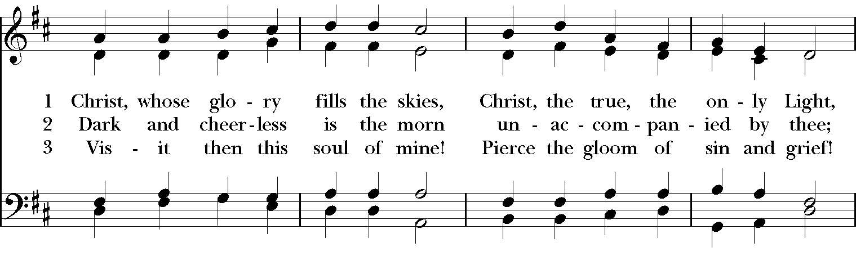

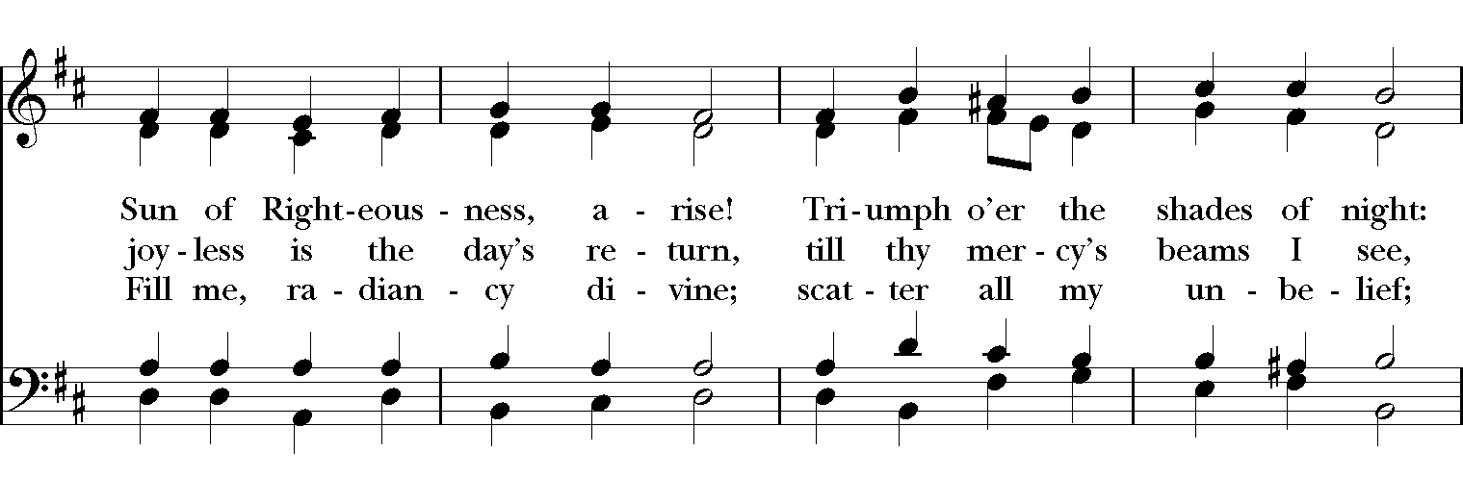

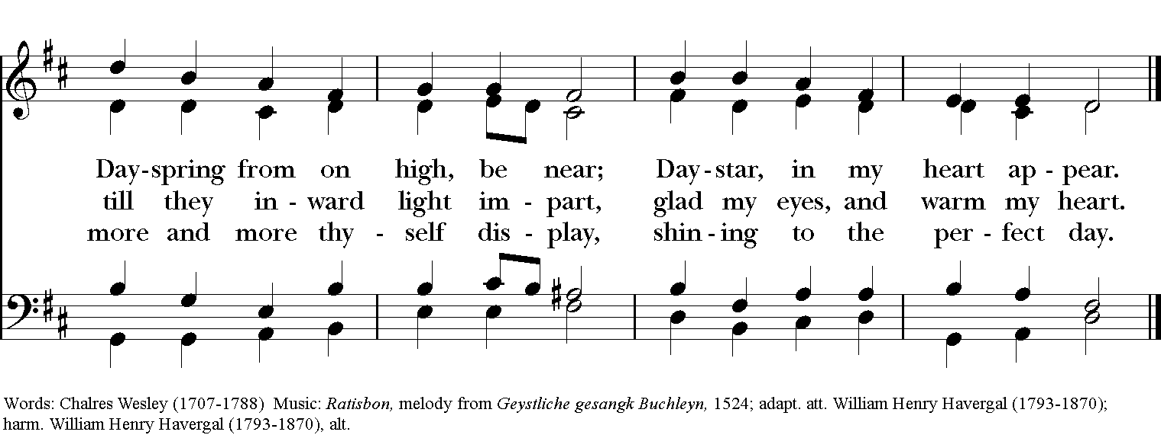

**The Opening Acclamation Page 355**

***Celebrant*** Blessed be God: Father, Son, and Holy Spirit.

***People* And blessed be his kingdom, now and for ever. Amen.**

**The Collect of Purity Page 355**

**The Gloria: S-280 in the Hymnal 1982**

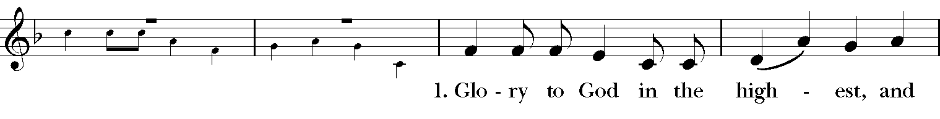

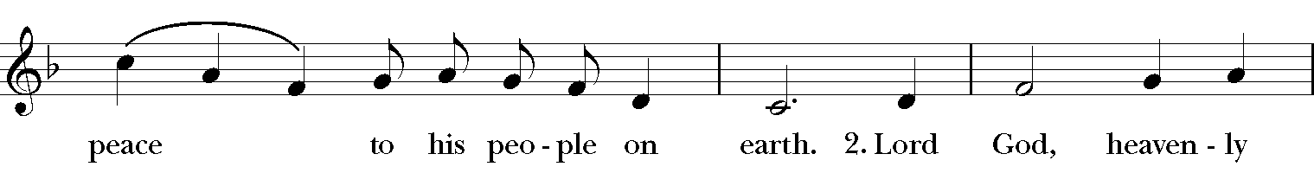

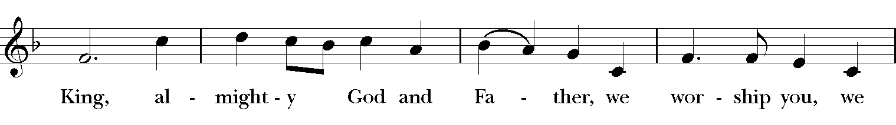

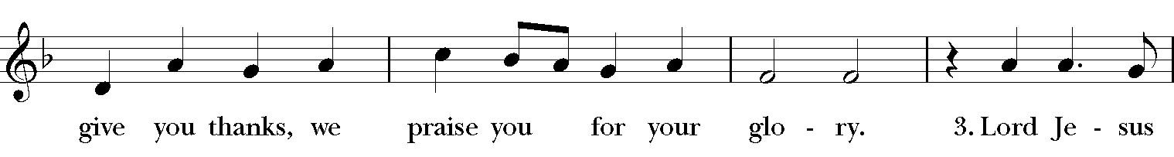

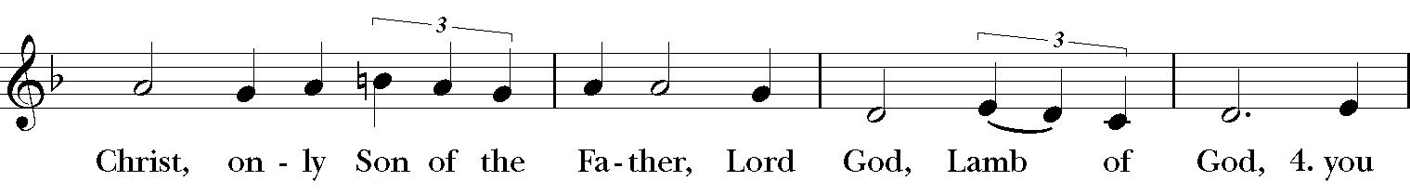

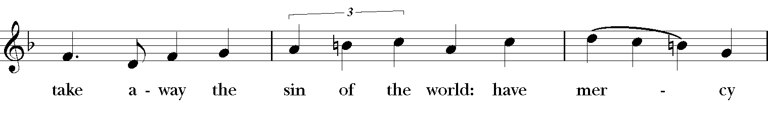

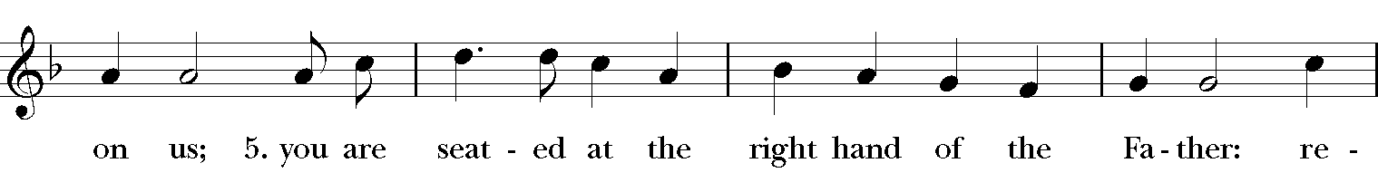

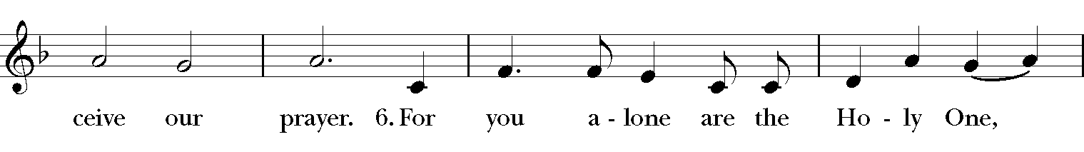

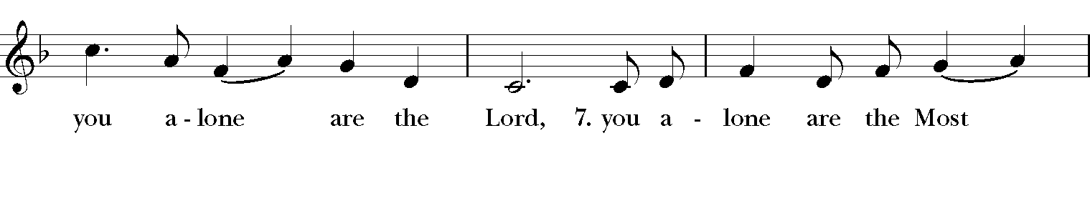

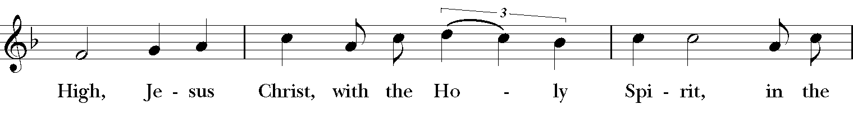

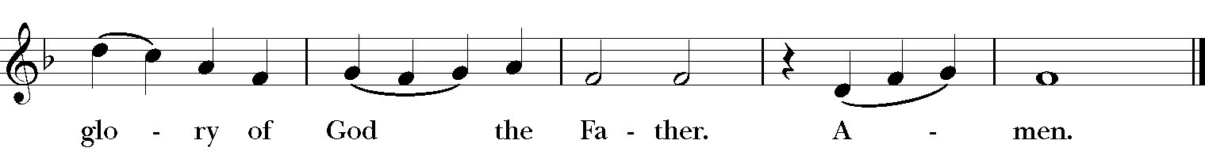

**The Salutation & Collect of the Day Page 357**

***Celebrant*** The Lord be with you.

***People* And also with you.**

***Celebrant*** Let us pray.

Almighty God, whose Son our Savior Jesus Christ is the light of the world: Grant that your people, illumined by your Word and Sacraments, may shine with the radiance of Christ's glory, that he may be known, worshiped, and obeyed to the ends of the earth; through Jesus Christ our Lord, who with you and the Holy Spirit lives and reigns, one God, now and for ever. ***Amen.***

**The Lesson I Samuel 3:1-10**

Now the boy Samuel was ministering to the LORD under Eli. The word of the LORD was rare in those days; visions were not widespread. At that time Eli, whose eyesight had begun to grow dim so that he could not see, was lying down in his room; the lamp of God had not yet gone out, and Samuel was lying down in the temple of the LORD, where the ark of God was. Then the LORD called, "Samuel! Samuel!" and he said, "Here I am!" and ran to Eli, and said, "Here I am, for you called me." But he said, "I did not call; lie down again." So he went and lay down. The LORD called again, "Samuel!" Samuel got up and went to Eli, and said, "Here I am, for you called me." But he said, "I did not call, my son; lie down again." Now Samuel did not yet know the LORD, and the word of the LORD had not yet been revealed to him. The LORD called Samuel again, a third time. And he got up and went to Eli, and said, "Here I am, for you called me." Then Eli perceived that the LORD was calling the boy. Therefore Eli said to Samuel, "Go, lie down; and if he calls you, you shall say, 'Speak, LORD, for your servant is listening.'" So Samuel went and lay down in his place. Now the LORD came and stood there, calling as before, "Samuel! Samuel!" And Samuel said, "Speak, for your servant is listening."

The Word of the Lord.

***People* Thanks be to God.**

**Psalm 139:1-5, 12-17 Plainsong**

1 LORD, you have searched me out and known me;  *  
      you know my sitting down and my rising up; you discern my thoughts from afar.

2 You trace my journeys and my resting-places  *  
      and are acquainted with all my ways.

3 Indeed, there is not a word on my lips,  *  
      but you, O LORD, know it altogether.

4 You press upon me behind and before  *  
      and lay your hand upon me.

5 Such knowledge is too wonderful for me;  *  
      it is so high that I cannot attain to it.

12 For you yourself created my inmost parts;  *  
      you knit me together in my mother's womb.

13 I will thank you because I am marvelously made;  *  
      your works are wonderful, and I know it well.

14 My body was not hidden from you,  *  
      while I was being made in secret and woven in the depths of the earth.

15 Your eyes beheld my limbs, yet unfinished in the womb; all of them were written

in your book;  *  
      they were fashioned day by day, when as yet there was none of them.

16 How deep I find your thoughts, O God!  *  
      how great is the sum of them!

17 If I were to count them, they would be more in number than the sand;  *  
      to count them all, my life span would need to be like yours.

**The Lesson I Corinthians 6:12-20**

"All things are lawful for me," but not all things are beneficial. "All things are lawful for me," but I will not be dominated by anything. "Food is meant for the stomach and the stomach for food," and God will destroy both one and the other. The body is meant not for fornication but for the Lord, and the Lord for the body. And God raised the Lord and will also raise us by his power. Do you not know that your bodies are members of Christ? Should I therefore take the members of Christ and make them members of a prostitute? Never! Do you not know that whoever is united to a prostitute becomes one body with her? For it is said, "The two shall be one flesh." But anyone united to the Lord becomes one spirit with him. Shun fornication! Every sin that a person commits is outside the body; but the fornicator sins against the body itself. Or do you not know that your body is a temple of the Holy Spirit within you, which you have from God, and that you are not your own? For you were bought with a price; therefore glorify God in your body.

The Word of the Lord.

***People* Thanks be to God.**

**The Sequence “Blest are the pure in heart” Hymnal, 656**

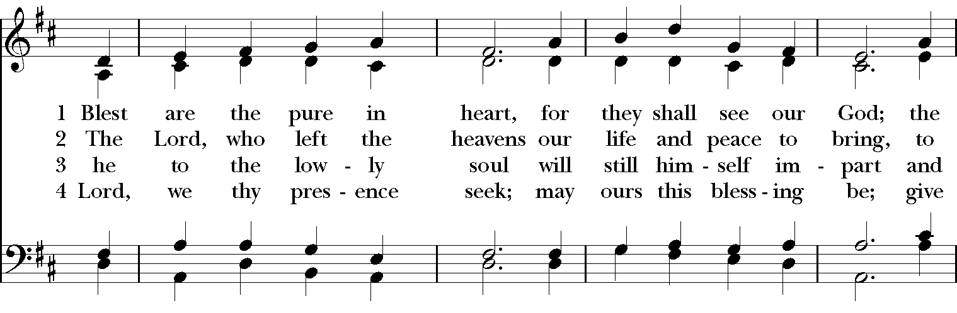

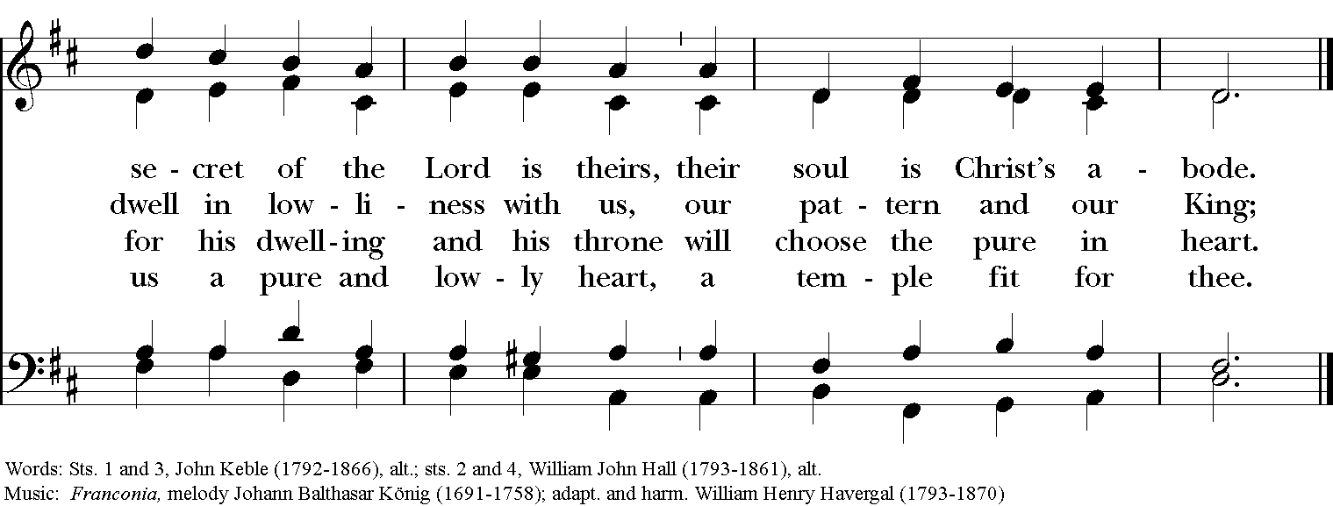

**The Holy Gospel John 1:43-51**

***The people remain standing. The Celebrant says***

The Holy Gospel of our Lord Jesus Christ according to John.

***People* Glory to you, Lord Christ.**

The next day Jesus decided to go to Galilee. He found Philip and said to him, "Follow me." Now Philip was from Bethsaida, the city of Andrew and Peter. Philip found Nathanael and said to him, "We have found him about whom Moses in the law and also the prophets wrote, Jesus son of Joseph from Nazareth." Nathanael said to him, "Can anything good come out of Nazareth?" Philip said to him, "Come and see." When Jesus saw Nathanael coming toward him, he said of him, "Here is truly an Israelite in whom there is no deceit!" Nathanael asked him, "Where did you get to know me?" Jesus answered, "I saw you under the fig tree before Philip called you." Nathanael replied, "Rabbi, you are the Son of God! You are the King of Israel!" Jesus answered, "Do you believe because I told you that I saw you under the fig tree? You will see greater things than these." And he said to him, "Very truly, I tell you, you will see heaven opened and the angels of God ascending and descending upon the Son of Man."

***After the reading, the Celebrant says***

The Gospel of the Lord.

***People* Praise to you, Lord Christ.**

**The Sermon**

**The Nicene Creed**

*Said by all, standing*

**We believe in one God, the Father, the Almighty, maker of heaven and earth, of all that is, seen and unseen.**

**We believe in one Lord, Jesus Christ, the only Son of God, eternally begotten of the Father, God from God, Light from Light, true God from true God, begotten, not made, of one Being with the Father. Through him all things were made. For us and for our salvation he came down from heaven: by the power of the Holy Spirit he became Incarnate from the Virgin Mary, and was made man. For our sake he was crucified under Pontius Pilate; he suffered death and was buried. On the third day he rose again in accordance with the Scriptures; He ascended into heaven and is seated at the right hand of the Father. He will come again in glory to judge the living and the dead, and his kingdom will have no end.**

**We believe in the Holy Spirit, the Lord, the giver of life, who proceeds from the Father and the Son. With the Father and the Son he is worshiped and glorified. He has spoken through the Prophets. We believe in one holy catholic and apostolic Church. We acknowledge one baptism for the forgiveness of sins. We look for the resurrection of the dead, and the life of the world to come. Amen.**

**The Prayers of the People, Form I Page 383**

With all our heart and with all our mind, let us pray to the Lord, saying "Lord, have mercy."

For the peace from above, for the loving-kindness of God, and for the salvation of our souls, let us pray to the Lord**.**

***Lord, have mercy.***

For the peace of the world, for the welfare of the Holy Church of God, and for the unity of all peoples, let us pray to the Lord.

***Lord, have mercy.***

For Justin, the Archbishop of Canterbury; Michael, our Presiding Bishop, Terry, our Bishop, for Michael, Allison, Anne, Art, and Jim, our clergy, for all clergy, and people, let us pray to the Lord**.**

***Lord, have mercy.***

For Donald our President, Joe our President-Elect, Andy our Governor, and Neil & Greg our Mayors, for the leaders of the Nations, and let us pray to the Lord.

***Lord, have mercy.***

For this village of Anchorage, for every city and community, and for those who live in them, let us pray to the Lord.

***Lord, have mercy.***

For seasonable weather, and for an abundance of the fruits of the earth, let us pray to the Lord.

***Lord, have mercy.***

For the good earth which God has given us, and for the wisdom and will to conserve it, let us pray to the Lord**.**

***Lord, have mercy****.*

For those who travel on land, on water, in the air, or through outer space, let us pray to the Lord.

***Lord, have mercy.***

For the aged and infirm, for the widowed and orphans, and for the sick and the suffering especially: **Al, Allen, Amy, Ann, Annie, Beecher, Bethann, Bill, Braxton, Bud, Calvin Riley, Carol, Charles, Christy, Dave, David, Diana, Doug, E.J., Eleanor, Elizabeth, Erma, Gene, Hugh, Ira, Jackie, Jen, Jenni, Jerry, Jewell, Jim, Joan, Joe, John, Joyce, Karen, Kelly, Ken, Lauren, Lee, Linda, Lisette, Liz, London, Lynn, Martha, Marty, Mary, Matt, Meg, Mike, Milo, Monica, Morgan, Nancy, Nina (Nine-ah), Patricia, Phil, Rob, Ronald, Rueben, Sandy, Stefanie, Steve, Sue, Susan, Susie, Terry, Tim, Tracy, Trent, Trish, Ursula, Vicki, Walt, Whitney, Wynn; for the men and women of our armed forces, especially Alex, Bianca, Casey, Christian, Griffin, Pat, Seth, Sinclair, Steve**, let us pray to the Lord.

***Lord, have mercy.***

For the poor and the oppressed, for the unemployed and the destitute, for prisoners and captives, and for all who remember and care for them, let us pray to the Lord.

***Lord, have mercy.***

For all who have died in the hope of the resurrection,.. , and for all the departed, let us pray to the Lord.

***Lord, have mercy.***

For deliverance from all danger, violence, oppression, and degradation, let us pray to the Lord.

***Lord, have mercy.***

That we may end our lives in faith and hope, without suffering and without reproach, let us pray to the Lord.

***Lord, have mercy.***

Defend us, deliver us, and in thy compassion protect us, O Lord, by thy grace.

***Lord, have mercy.***

In the communion of Luke and of all the saints, let us commend ourselves, and one another, and all our life, to Christ our God.

***To thee, O Lord our God.***

***Silence.***

***The Celebrant adds a concluding Collect.***

**Confession of Sin Page 360**

Celebrant Let us confess our sins against God and our neighbor.

**All Most merciful God, we confess that we have sinned against you in thought, word, and deed, by what we have done, and by what we have left undone. We have not loved you with our whole heart; we have not loved our neighbors as ourselves. We are truly sorry and we humbly repent. For the sake of your Son Jesus Christ, have mercy on us and forgive us; that we may delight in your will, and walk in your ways, to the glory of your Name. Amen.**

**The Absolution**

**The Peace**

***Celebrant*** The peace of the Lord be always with you.

***People* And also with you.**

**THE HOLY COMMUNION**

**Offertory Anthem “Lord, thou hast searched me out” Healey Willan**

**The Great Thanksgiving: Eucharistic Prayer B Page 367**

*S120a*

*Celebrant* It is right, and a good and joyful thing, always and everywhere to give thanks to you, Father Almighty, Creator of heaven and earth, because in the mystery of the Word made flesh, you have caused a new light to shine in our hearts, to give the knowledge of your glory in the face of your son Jesus Christ our Lord; so that we might be delivered from the bondage of sin, and receive power to become your children.   
Therefore we praise you, joining our voices with Angels and Archangels and with all the company of heaven, who for ever sing this hymn to proclaim the glory of your Name:

*Celebrant and people*

**Sanctus: S-129 in the Hymnal 1982**

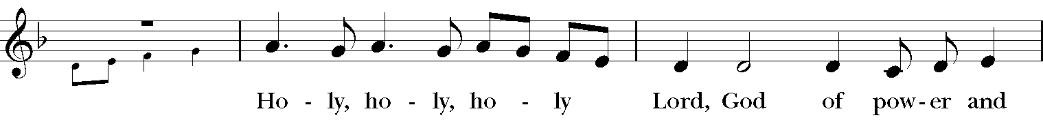

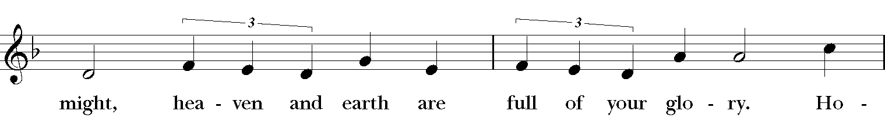

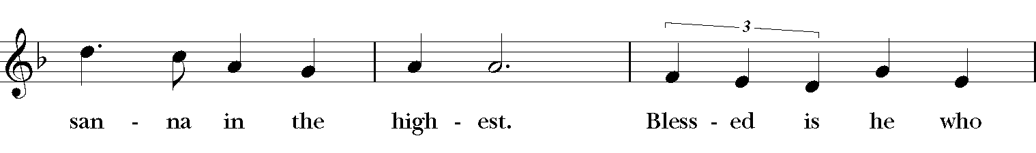

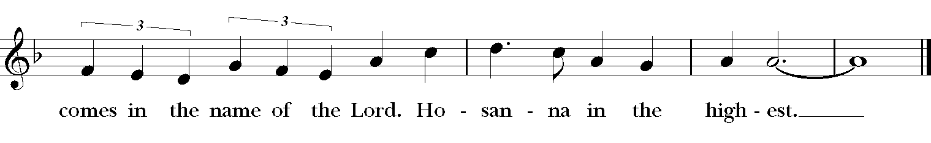

*The people stand or kneel.*

*Then the Celebrant continues*

We give thanks to you, O God, for the goodness and love which you have made known to us in creation; in the calling of Israel to be your people; in your Word spoken through the prophets; and above all in the Word made flesh, Jesus, your Son. For in these last days you sent him to be incarnate from the Virgin Mary, to be the Savior and Redeemer of the world. In him, you have delivered us from evil, and made us worthy to stand before you. In him, you have brought us out of error into truth, out of sin into righteousness, out of death into life.

On the night before he died for us, our Lord Jesus Christ took bread; and when he had given thanks to you, he broke it, and gave it to his disciples, and said, "Take, eat: This is my Body, which is given for you. Do this for the remembrance of me."

After supper he took the cup of wine; and when he had given thanks, he gave it to them, and said, "Drink this, all of you: This is my Blood of the new Covenant, which is shed for you and for many for the forgiveness of sins. Whenever you drink it, do this for the remembrance of me."

Therefore, according to his command, O Father,

*Celebrant and People*

**We remember his death.**

**We proclaim his resurrection.**

**We await his coming in glory.**

*The Celebrant continues*

And we offer our sacrifice of praise and thanksgiving to you, O Lord of all; presenting to you, from your creation, this bread and this wine.

We pray you, gracious God, to send your Holy Spirit upon these gifts that they may be the Sacrament of the Body of Christ and his Blood of the new Covenant. Unite us to your Son in his sacrifice, that we may be acceptable through him, being sanctified by the Holy Spirit. In the fullness of time, put all things in subjection under your Christ, and bring us to that heavenly country where, with Mary the Mother of God, St. Luke, and all your saints, we may enter the everlasting heritage of your sons and daughters; through Jesus Christ our Lord, the firstborn of all creation, the head of the Church, and the author of our salvation.  
  
(sung) By him, and with him, and in him, in the unity of the Holy Spirit all honor and glory is yours, Almighty Father, now and forever. ***Amen.***

And now, as our Savior Christ has taught us, we are bold to say,

**The Lord’s Prayer**

**Our Father, who art in heaven, hallowed be Thy Name. Thy kingdom come, Thy will be done, on Earth as it is in heaven. Give us this day our daily bread, and forgive us our trespasses, as we forgive those who trespass against us, and lead us not into temptation, but deliver us from evil, for thine is the kingdom and the power and the glory, for ever and ever. Amen.**

**Fraction Anthem: S-155 in the Hymnal 1982**

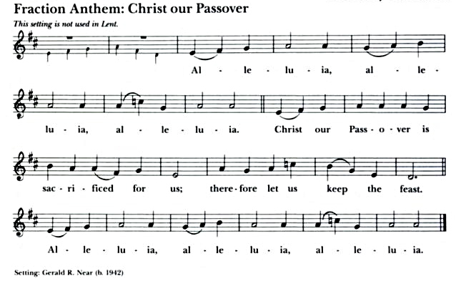

*A spiritual communion is a personal devotional that anyone can pray at any time to express their desire to receive Holy Communion at that moment, but in which circumstances impede them from actually receiving Holy Communion. We invite you to join us in this prayer wherever you are.*

**A Prayer from the St. Augustine Prayer Book**

*As the celebrant receives the elements of Communion, the congregation says aloud this prayer*

***All*     Jesus, my Savior, I ask you to come into my heart and fill me with your love.  Although I cannot physically join with others to celebrate the Eucharist today, I desire to offer my thanksgivings and prayers in union with all who worship you, wherever they may be. And although I cannot receive you now sacramentally in the bread and wine of Holy Communion, still I desire to receive your body and blood spiritually and feed on your love, that I may be united with you and with all your people in one communion and fellowship, your mystical body the church, now and ever more.  Amen.**

**Communion Hymn “Strengthen for service” Hymnal, 312**

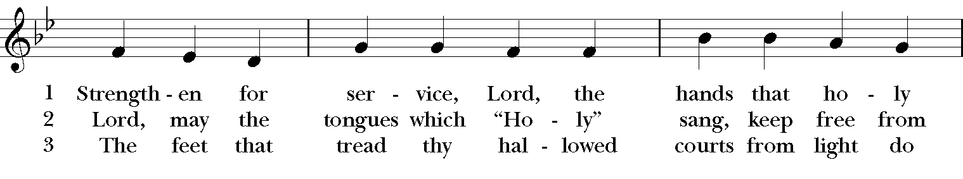

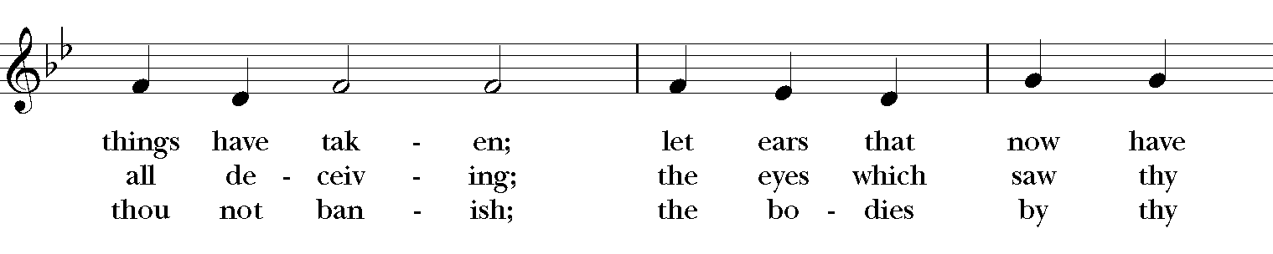

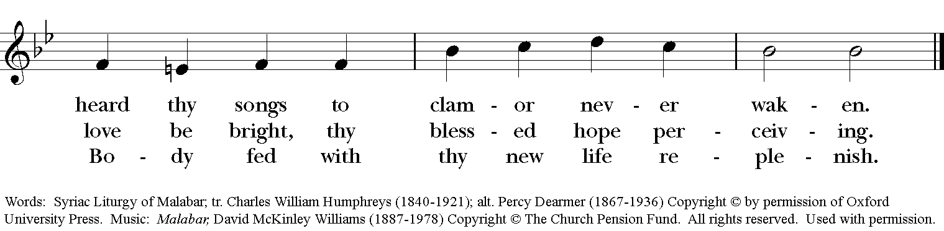

**The Blessing**

**The Final Hymn “Ye servants of God, your Master proclaim” Hymnal, 535**

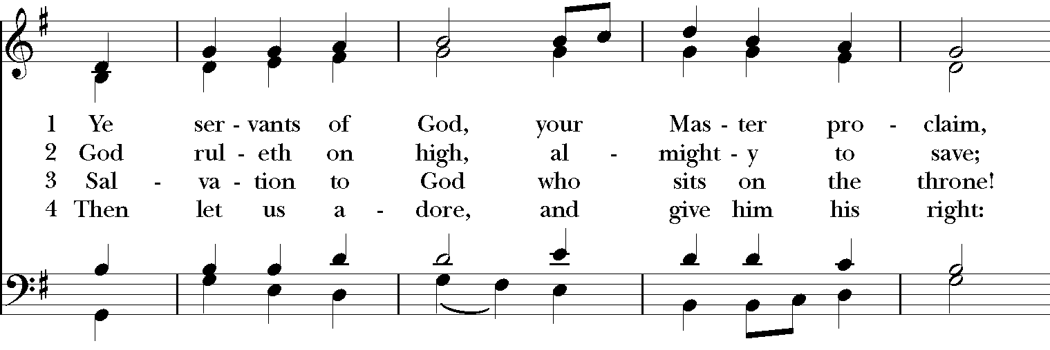

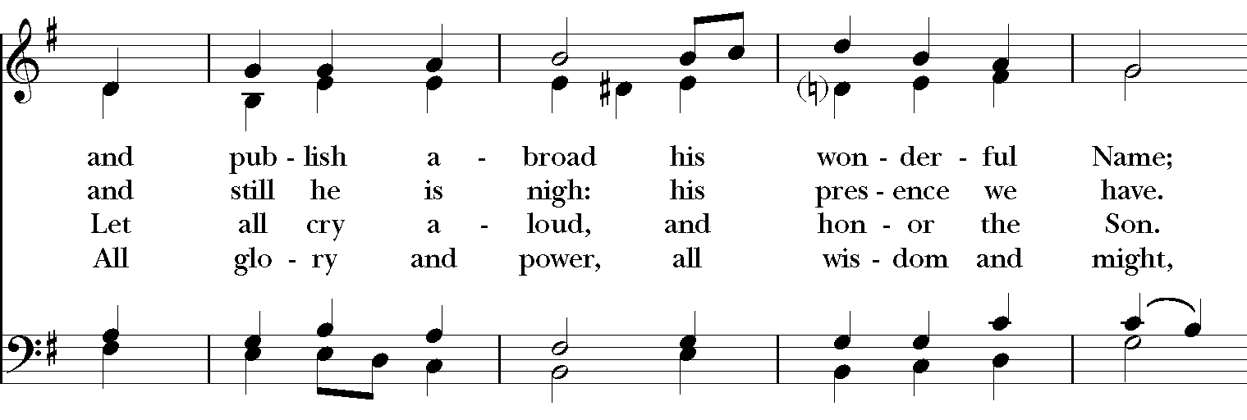

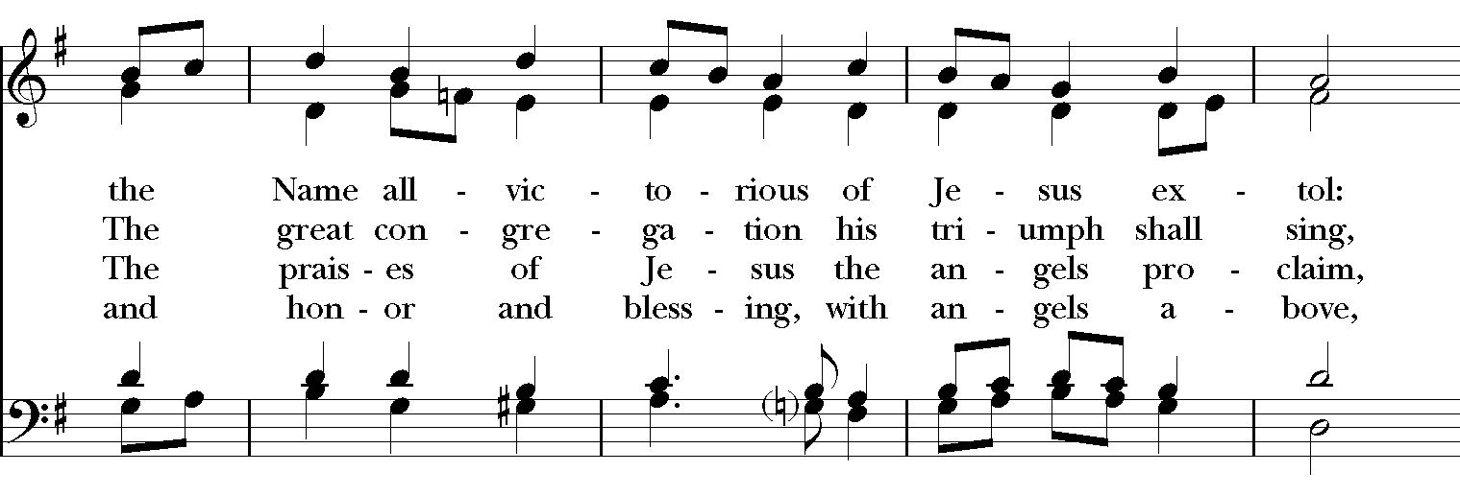

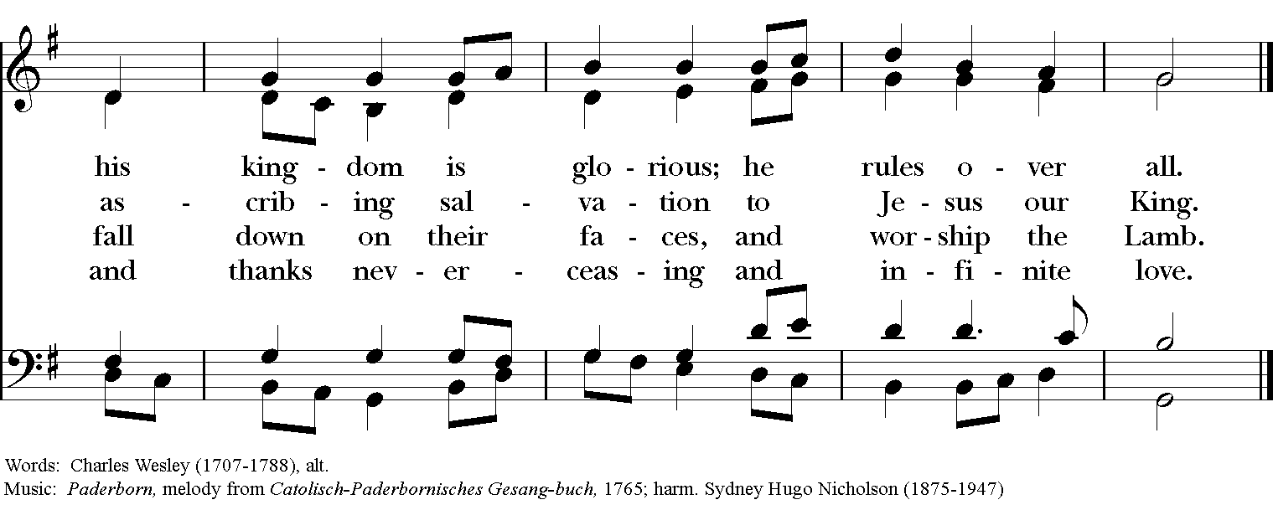

**The Dismissal**

***People* Thanks be to God.**

**Postlude “How brightly shines the Morningstar” Mark Sedio**

Permission to reprint, podcast, and/or stream the music in the service obtained from ONE LICENSE # A-736775. All rights reserved.

Hold Control and hover Left Mouse button

over green button to activate link.

**ANNOUNCEMENTS**

**2021 Stewardship & Offering Envelopes**It is not too late to submit your pledge (a commitment to a specified amount of financial giving) to the ministry of St Luke’s for 2021! You will hear at our Annual Parish meeting **tonight at 5 pm on Zoom** that we still have not heard from everyone who usually pledges an offering each year, and the impacts that reality has had on our budget for this new year. Please be in touch with our bookkeeper, Judy, at [**bookkeeper@stlukesanchorage.org**](mailto:bookkeeper@stlukesanchorage.org) to make or update your pledge for 2021. You have many options for giving, including by mail, by automatic draft from your preferred bank account, and by our online giving portal.  
  
If you would like to make your financial gifts by mail, we need to mail Offering Envelopes out to those who want them.  Please let Dawn know at [**admin@stlukesanchorage.org**](mailto:admin@stlukesanchorage.org), should you want a pack of envelopes for 2021.

**Day By Day Quarterly Devotionals**

If you would like a Day by Day devotion for this next quarter, contact Dawn at [**admin@stlukesanchorage.org**](mailto:admin@stlukesanchorage.org). Let her know if you would like either a **Large** or **Small** booklet or you can stop by when she's in the office on Thursday mornings. If you've not used them for daily devotion before, and are interested, let Dawn know. We usually have more than plenty.

**Sunday Altar Flower Memorials for 2021**

It’s time to schedule 2021 altar flower memorials. Last year donors have been contacted. Please respond promptly since renewals are honored first. **New donors are also welcome and encouraged to respond with a date!** Please contact Dawn at the church office at [admin@stlukesanchorage.org](mailto:admin@stlukesanchorage.org).

**Thursday Night Bible Study**

Mother Allison will be taking some vacation time this week, and so our weekly study will not meet on Thursday January 21st. She looks forward to being back with you on January 28th at 6:45!

**The Return of our Wednesday Study!**

Please join Mother Allison on Wednesday, January 27th at 9:45 am for a conversation about our options for this study going forward. This weekly gathering for prayer, fellowship, and scripture study has been a vital part of our community life and we look forward to bringing everyone back together!

**Contemporary Anglican Theologians – Sunday 9am Class**

Please join us Sunday mornings, 9:00, as we have begun a new series.

There are several Anglican (including many Episcopalian) theologians who have written during our lifetime, most of them are still working.  They have written some fascinating ideas that enrich our understanding of God, Jesus, the Church and spirituality. Their work has added clarity, insight and depth to Anglican Christianity. We will be spending the next couple of months discussing these theologians and their ideas.

For more information, email Dave Kirchinger at [**episcopaliandave@gmail.com**](mailto:episcopaliandave@gmail.com).

The link to the class is: [**https://us02web.zoom.us/j/85144530030**](https://us02web.zoom.us/j/85144530030) / Meeting ID: **851 4453 0030**

If prompted to enter a password, please enter our parish office phone number - 2458827

**Centering Prayer**

Centering Prayer is TWICE a month, every 2nd and 4th Tuesday. Join us on **January 26th from 6 – 7pm** on ZOOM until we can all join back in the Lyman Office.

Link to Centering Prayer Group: <https://zoom.us/j/85280543522>

Meeting ID: 852 8054 3522

If prompted to enter a password, please enter our parish office phone number – 2458827

**St. Luke’s Connections**

St Luke’s Connections is our latest media production, that happens right before our Sunday 10:00 AM live stream. In St Luke’s Connections we get to know members of our community here at St Luke’s. Currently we are in need of our community of faith to volunteer about 10-15 minutes of their time to be interviewed as part of St Luke’s Connections. If you are interested in being interviewed please contact either Ira Creasman or Mitch Wilson.

Ira: 205-382-4800 or [ibcreasman@gmail.com](mailto:ibcreasman@gmail.com) / Mitch: [mitchelldalewilson@hotmail.com](mailto:mitchelldalewilson@hotmail.com)

**Birthdays & Anniversaries**

**If you've had a birthday or anniversary over the past several weeks, or have one coming up in the weeks ahead,** please let Dawn know, [admin@stlukesanchorage.org](mailto:admin@stlukesanchorage.org).  Let her know your birthday, or the date of your wedding anniversary and how many years you've been married, and we will offer a blessing over you during our recorded worship.

**In our prayers** ... **for Al, Allen, Amy, Ann, Annie, Beecher, Bethann, Bill, Braxton, Bud, Calvin Riley, Carol, Charles, Christy, Dave, David, Diana, Doug, E.J., Eleanor, Elizabeth, Erma, Gene, Hugh, Ira, Jackie, Jen, Jenni, Jerry, Jewell, Jim, Joan, Joe, John, Joyce, Karen, Kelly, Ken, Lauren, Lee, Linda, Lisette, Liz, London, Lynn, Martha, Marty, Mary, Matt, Meg, Mike, Milo, Monica, Morgan, Nancy, Nina (Nine-ah), Patricia, Phil, Rob, Ronald, Rueben, Sandy, Stefanie, Steve, Sue, Susan, Susie, Terry, Tim, Tracy, Trent, Trish, Ursula, Vicki, Walt, Whitney, Wynn**; and our men and women serving in our armed forces and their families. We offer prayers of blessing and thanksgiving for all men and women serving in the armed services, especially these persons known to us: **Alex, Bianca, Casey, Christian, Griffin, Pat, Seth, Sinclair, Steve**. We pray that they have safe journeys and know the loving concern of friends and family. May God watch over them and grant them strength and courage to face perils which beset them.

**Readings for:**

**January 24: Jonah 3:1-5, 10; Psalm 62:6-14;**

**Epiphany 3**  **I Corinthians 7:29-31; Mark 1:14-20.**