Mars UP Church

Apostles’ Creed
I believe in God the Father Almighty, Maker of heaven and earth; and in Jesus Christ His only Son our Lord; who was conceived by the Holy Ghost, born of the Virgin Mary, suffered under Pontius Pilate, was crucified, dead and buried; He descended into hell; the third day He rose again from the dead; He ascended into heaven, and sitteth on the right hand of God the Father Almighty; from thence He shall come to judge the quick and the dead. I believe in the Holy Ghost, the holy catholic church; the communion of saints; the forgiveness of sins; the resurrection of the body; and the life everlasting. Amen.

Gloria Patri
Glory be to the Father, and to the Son, and to the Holy Ghost. As it was in the beginning, is now and ever shall be,
world without end.
Amen. Amen.

Come Holy Spirit, Come
Before the Service – Speak to God!
During the Service – Let God speak to you!
After the Service – Speak to each other!

(*Please stand, if able)
Welcome and Mars Messages

Prelude

The Day of Pentecost Reading: Acts 2:1-21

Song
“Holy Spirit”

*Litany of Welcome
Leader: A wind breathes among us, calling us to gather in
the name of God.
People: A fire burns within us, calling us to service,
calling us to prayer.
Leader: A spirit moves around us, calling us to turn in joy
toward the sorrows of the world.
People: Burning, breathing, Spirit of Compassion, we
bring our lives to you.

Opening Prayer

Old Testament Reading: Numbers 11:24-30

*Hymn 389 “Spirit of the Living God”

New Testament Reading I Corinthians 12:3b-13
The
Lord’s Prayer

Our Father,
who art in heaven,

hallowed be Thy
name,

Thy kingdom come,
Thy will be done,
on earth
as it is in heaven.

Give us this day
our daily bread;

and forgive us
our debts,
as we forgive
our debtors;

and lead us not
into temptation,
but deliver us
from evil.

For Thine
is the kingdom,
and the power,
and the glory,
forever. Amen.

The Doxology

Praise God
from whom
all blessings flow;
praise Him
all creatures
here below;
praise Him above,
ye heavenly host;
praise Father, Son,
and Holy Ghost.
Amen.

Children’s Chat

Morning Message Rev. Brian Hauser
“The Quarter Prophet Report”

*Hymn 431
“Shine, Jesus, Shine”

Prayers of the People and Lord’s Prayer

Affirmation of Faith (A Brief Statement of Faith PCUSA)
In life and in death we belong to God. Through the grace of our Lord Jesus Christ, the love of God, and the communion of the Holy Spirit, we trust in the one triune God, the Holy One of Israel, whom alone we worship and serve. We trust in God the Holy Spirit, everywhere the giver and renewer of life. The Spirit justifies us by grace through faith, sets us free to accept ourselves and to love God and neighbor, and binds us together with all believers in the one body of Christ, the Church. The same Spirit who inspired the prophets and apostles rules our faith and life in Christ through Scripture, engages us through the Word proclaimed, claims us in the waters of baptism, feeds us with the bread of life and the cup of salvation, and calls women and men to all ministries of the Church. In a broken and fearful world the Spirit gives us courage to pray without ceasing, to witness among all peoples to Christ as Lord and Savior, to unmask idolatries in Church and culture, to hear the voices of peoples long silenced, and to work with others for justice, freedom, and peace. In gratitude to God, empowered by the Spirit, we strive to serve Christ in our daily tasks and to live holy and joyful lives, even as we watch for God’s new heaven and new earth, praying, “Come, Lord Jesus!” With believers in every time and place, we rejoice that nothing in life or in death can separate us from the love of God in Christ Jesus our Lord. Glory be to the Father, and to the Son, and to the Holy Spirit. Amen.*

*Hymn 393
“Breathe on Me, Breath of God”

*Benediction

*Postlude

Flowers are presented to the Glory of God and in loving memory of my mother, Elizabeth Goetz and my sister, Karen Goetz on the first anniversary of their deaths by Ruth Pfeifer.
Church Staff
Rev. Brian Hauser
Pastor
pastor@mars-up.org
724-689-3412

Mrs. Shelly Bocheff
Administrative Assistant
marsup@mars-up.org

AV TEAM
Alma Staskiewicz, Lisa Barbour, Marie Matthews, Bill Guesman, John Ivory, Mike Bocheff, Herb Wellman

Mars United Presbyterian Church

232 Crowe Ave
PO Box 805
Mars, Pennsylvania 16046
724-625-1365
www.mars-up.org
marsup@mars-up.org

Church Office Hours:
Mon -Thurs from 9 a.m. -2:30 p.m.
MUP Session

Class of 2025 Class of 2024 Class of 2023
John Ivory Alma Staskiewicz Lisa Barbour
Susan Cox Louise Fox Mary Ann Croop
Jay Wilson Marie Matthews Don Lewis
Herb Wellman

Clerk of Session: Herb Wellman
Morning Worship:
10:00 am

Day of Pentecost

Prayer of Preparation
Lord, we come to you today with so many things on our hearts.

You call us to be in relationship of trust and love with you and you offer healing to us for those portions of our lives that are broken and injured.

Help us to be open to your mercy and healing love. For we ask this in Jesus’ Name.
AMEN.

MUP Deacons

Class of 2025 Class of 2024 Class of 2023
Jill Cooper Steve Martin Sharon Gibb
Robyn Beckwith Marge Nicklas Carol Kopar
Missy Wells Pat Auld Alice Leonberg

Moderator: Steve Martin

Mars United Presbyterian Church
Welcome!

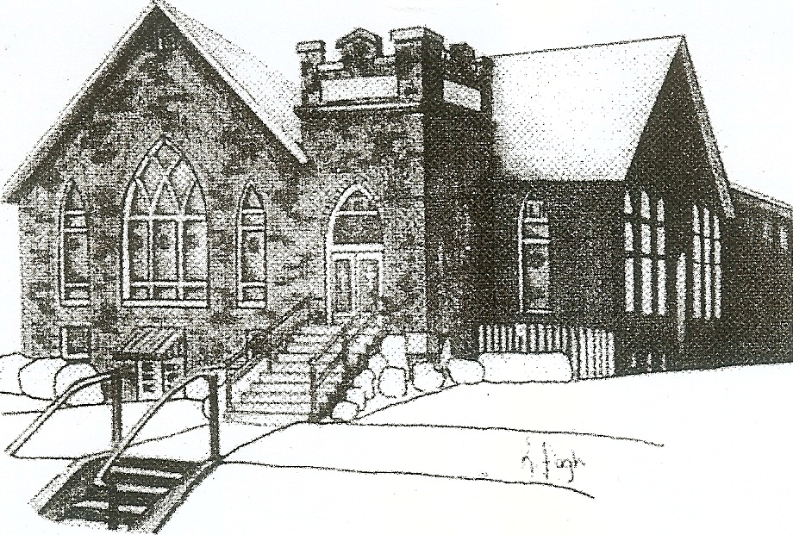
We are your hometown church: Faithful to Tradition, Loving in Fellowship, & Reaching for Tomorrow!

May 28, 2023

We welcome you and we are glad you’ve chosen to Worship with us today!

CALENDAR: May 28th – June 4th

Church Office Hours: Monday -Thursday from 9 a.m. – 2:30 p.m.

Today, May 28, 2023 PENTECOST SUNDAY
VOLUNTEERS☺

LAST SUNDAY’S In-House ATTENDANCE: 85

LAST SUNDAY’S OFFERING:
Operating Funds: $3105.00
Kindness: $100.00
Mission: $50.00
Total: $3255.00

Tarry N Talk Hosts
Stewardship Committee

10:00 a.m. THE MORNING WORSHIP SERVICE
Monday, May 29, 2023
OFFICE CLOSED – MEMORIAL DAY
Tuesday, May 30, 2023
9:00 am A team
7:00 pm AA
Wednesday, May 31, 2023
9:00 am Material Girls
Thursday, June 1, 2023
Friday, June 2, 2023
Saturday, June 3, 2023
8:00 am New to You Sale
Sunday, June 4, 2023
10:00 am THE MORNING WORSHIP SERVICE

Welcome to all who are Worshiping with us today!

Guests
We sincerely hope our service is a blessing to you. We ask that our guests please take a few minutes to complete one of the Connect Cards found in the pew holder.

Should you have questions regarding any aspect of our church, including membership, please contact Pastor Brian or the church office during the week at 724-625-1365. Thank you for being with us today.

PRAYER – JOYS & CONCERNS
Lou Beckwith Paige Lauten
Paige Barbour (daughter of Andrew and Steph Barbour) Sandy Wahl
Reid Christopher Hall (June Stirling’s nephew) Sue Morris
Lindy McCartney (Lisa Barbour’s Sister)

ANNOUNCEMENTS
Bulletins are printed Thursday mornings; let us know if you have an announcement…

SAVE THE DATE- New To You Sale – June 3rd We are accepting donations!!!!
Donations can be dropped off on Tuesday and Thursdays from 9am until 2pm or contact the office for additional needs.
Items not accepted: Televisions, Couches, Mattresses, Large Appliances, Computers, Clothing, Exercise Equipment and please no Junk!

VACATION BIBLE SCHOOL “STELLAR” Registration for VBS is available now online at www.mars-up.org. July 9th thru July 13th 6:00 to 8:30 pm. SPECIAL OPENING SUNDAY AFTERNOON- Families join us for a HOT DOG BEAN kickoff at 5:00 pm in MUP Fellowship Hall

THE QUIET HOUR DEVOTIONAL is available in Tarry N Talk. Please feel free to take one for your summer devotional.

SAVE THE DATE Mars UP church annual picnic will be held Sunday, September 10th at Adams Township Park. More Details to Follow

