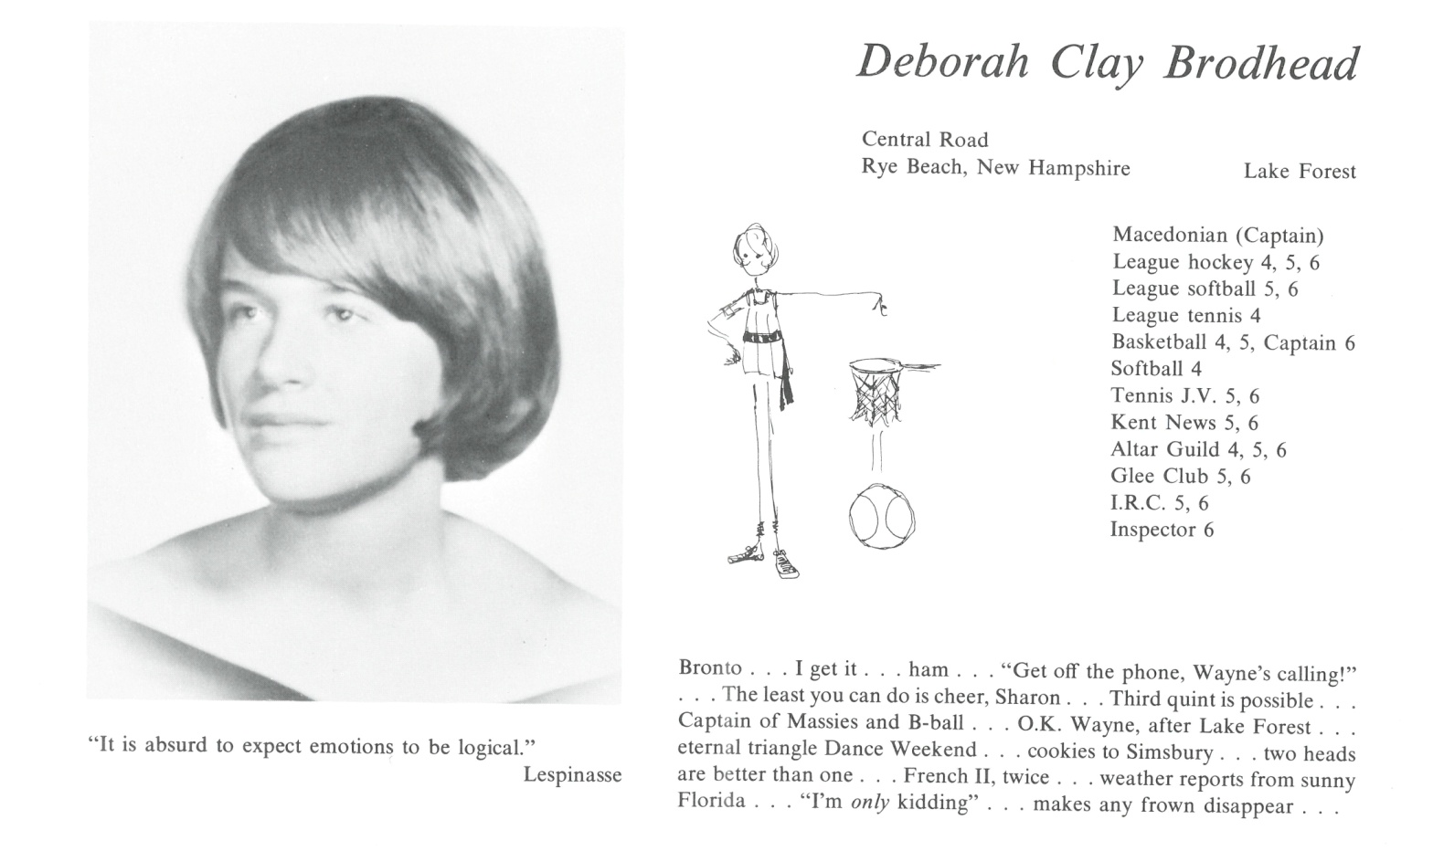

Deborah C. Brodhead

After Kent, I attended Lake Forest College. I received a B.A. in Sociology and then an M.A. in Social Work from Boston University. I worked in my field for several years until I was diagnosed with bipolar disease. It has been a challenge for over 20 years. I have been in and out of care. For the past few years, I have lived at Glencliff Home in Benton, New Hampshire.

I have survived. Even though I can no longer play, I enjoy watching golf.

I wish I could be with you and will be thinking of you all on June 9.



______________________________________________________________

______________________________________________________________ ______________________________________________________________ ______________________________________________________________ ______________________________________________________________ ______________________________________________________________ ______________________________________________________________ ______________________________________________________________ ______________________________________________________________

Attach Picture in .jpg Format

______________________________________________________________

______________________________________________________________

___________________________________________________________________________________ _________________________________________________________________________________________________________________________________________________________________________________________________________________________________________________________________________________________________________________________________________________________________________________________________________________________________________________________________________________________________________________________________________________________________________________________________________________________________________________________________________________________________________________________________________________________________________________________________________________________________________________________________________________________________________________________________________________________________________________________________________________________________________________________________________________________________________________________________________________________________________________________________________________________________________________________________________________________________________________________________________________________________________________________________________________________________________________________________________________________________________________________________________________________________________________________________________________________________________

___________________________________________________________________________________