
2019
SUPER 7’s CUP
21st August 2019

The last club cup of the year saw a 50% increase in entries with 24 players taking part compared to 16 in 2018.
So, 7 Rounds, of matches played and in each round players played just 7 ends. This meant there were some close scores as well as some very small points scored.
Round 1 saw some big matches as Ross Payne took on doubles partner Neil Selby with the latter running out comfortable winner 10 – 3. The Premier Leagues Laurent Pellaton took on Division 1 but double Island Triples Winner in 2019 Callum Stewart. It was the Premier League player though taking the match 7 – 4.
There were big wins for Paul Bell, 10 – 1 over Jean Stewart and Toby Northern 9 – 1 over Tom Le Sueur.
Andrew Bellamy-Burt just beat newcomer Branden De La Haye 7 – 6 and Brian Harris beat Gary Cowburn 5 – 4.
Round 2 saw Andrew Limbrick beat Geoffroy Buffetrille (2018 champion) 5 – 3. Last year’s 4th place finisher Richard Williams beat Laurent 7 – 5 to get revenge over his 3rd place play off opponent in 2018.
Paul Bell made in back to back 10 – 1 wins this time over Toby. Ross Payne recovered from his round 1 defeat to beat Tom Le Sueur 10 – 2. David Le Gresley beat Brian Harris and Neil beat Wendy Ritzema but two shocks from doubles pair Branden and Tim who beat James Rondel and Gary Cowburn respectively.
Round 3 saw Lorna Limbrick make it 2 wins from 3 over Toby. Neil beat Andrew 7 – 6 to make it 3 from 3. Callum beat European Triples partner Ross 8 – 2. Cassie Stewart made it back to back wins beating Wendy Ritzema.

Round 4
Lorna won big against Brian Harris 10 – 3 and Richard and Neil made it 4 from 4 with wins over Andrew Limbrick and David Le Gresley respectively.
Toby pulled off a great win over Gary Cowburn losing 4 -2 after six ends placed three perfect shots for a three to win 5 – 4 and move back into contention.
Andrew Bellamy-B won by one point for the second time, this time against Cassie 5 – 4. Mo De Gruchy won big against James V 8 – 1.
Round 5
Richard Williams topped the rankings after round 5 as the only player to win all his matches by beating Neil Selby 6 – 5. Another set of close matches saw
Geoffroy beat Callum 5 – 4 Wendy beat Paul Bell 5 – 4 Brian beat Jean 6 -5 James Rondel beat Daniel 6 – 5 James V beat Tom 7 – 6
Round 5 also saw Lorna make it 4 wins from 5 and comfortably sitting in the top 8 qualifying positions after a win over David Le Gresley 9 – 5.
Round 6
Richard Williams was certainly on a roll making it 6 from 6 this time with a 7 – 5 win over Andrew Bellamy-Burt. Neil won his 5th from 6 against Lorna and Callum made it 4 wins with a 9 – 1 win over David. Toby beat Laurent 6 – 3 to also move on to 4 wins as did Brian with a win over Andrew L.
Good wins also for James Rondel, 6 – 1 over Cassie, James V 5 – 4 over Branden, Mo 6 – 3 over Tim. This round also saw a rare double figure score as Geoffroy beat Wendy 11 – 2.
The final Round (7) saw a number of players still in with a chance of making the top 8 and qualifying for the Quarter Finals.
Richard Williams finally lost, to Geoffroy with the latter topping the rankings as a result with Richard finishing second.
Toby Northern beat Neil Selby 8 – 3 from 3 – 0 down to finish 5th with Neil retaining his third place despite the defeat.
Despite the third lowest BHN score of 20 Brian Harris beat Andrew Bellamy-B to finish on 5 wins and 6th place. This meant Andrew was one of three players on 4 wins to miss out on the top 8 finishing 10th by 1 BHN point.
Lorna Limbrick lost heavily to Callum Stewart 12 – 3 and this was ultimately her downfall as missed out on 8th place on points difference by 5 points and to make it worse it was to husband Andrew whose 6 – 4 win over Wendy meant he finished 8th. Callum though finished with the best points difference of +32!!!
Paul Bell beat doubles partner David 6 – 2 to also finish on 4 wins but missed out with a BHN of 26, in fact David’s loss also meant he missed out on the top 8 losing his last 4 matches after winning the first 3!
Tom Le Sueur won his last match against Jean Stewart to see who finished bottom. Mo De Gruchy gave Laurent a scare just losing 5 – 3 but ended with 3 wins which was a good performance in a very strong field.

FINAL RANKINGS
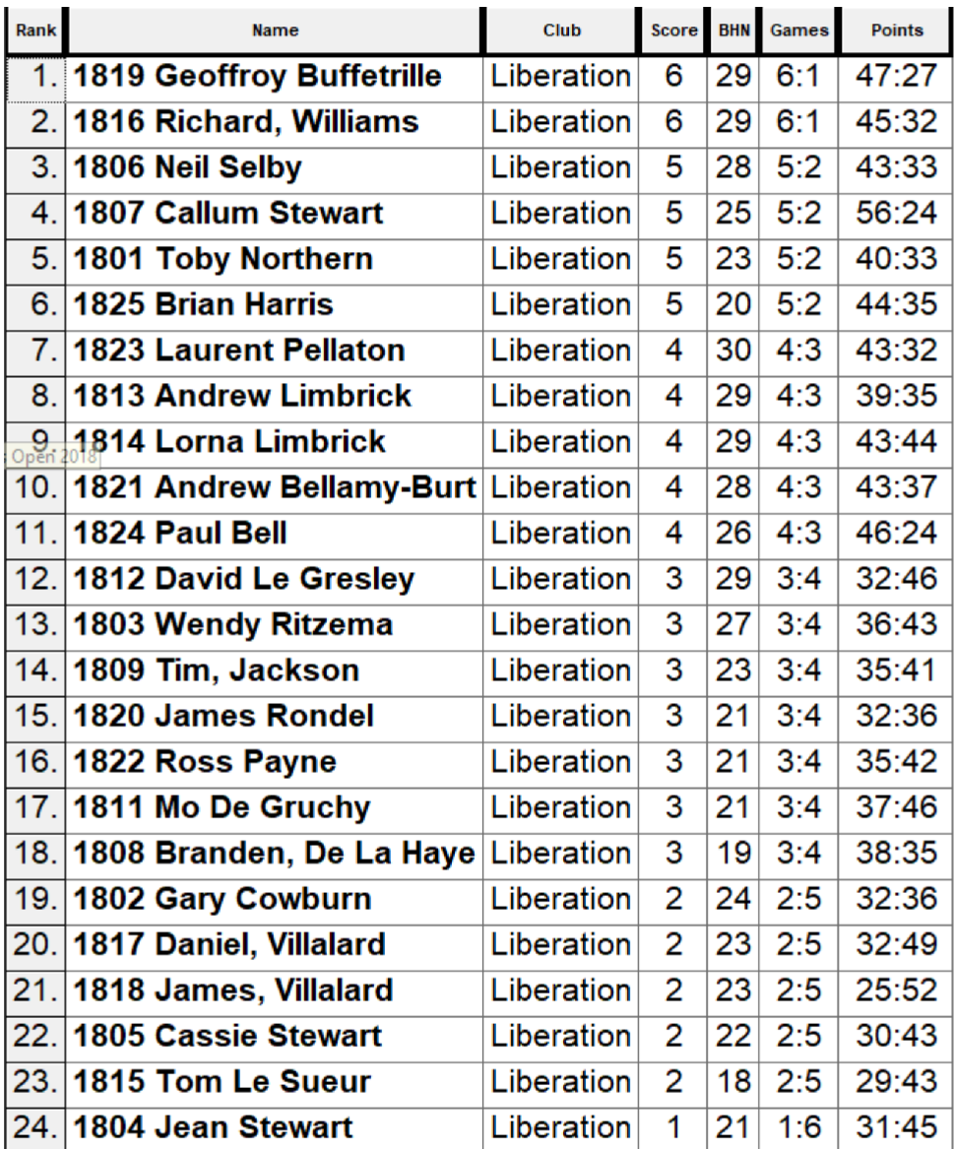

QUARTER FINALS
Ranked 1st Geoffroy Buffetrille v Andrew Limbrick Ranked 8th
Ranked 2nd Richard Williams v Laurent Pellaton Ranked 7th
Ranked 3rd Neil Selby v Brian Harris Ranked 6th
Ranked 4th Callum Stewart v Toby Northern Ranked 5th

Geoffroy versus Andrew was a repeat of Round 2 which saw Andrew win 5 – 3, Geoffroy’s only loss. However, experience knockout stage player Geoffroy won this time 6 – 2. Geoffroy was the only top four finisher to go through though as Richard Williams lost 6 – 5 to Laurent a player he beat in Round 2.
Neil Selby got out done by the terrains on one end as his boule rolled back past Brian’s boule into a whole on his way to defeat in another close one 6 – 5 to Brian. Toby though never looked in doubt taking a 5 nil lead and leading 6 – 1 after 6 ends resulting in Callum conceding defeat.

SEMI FINALS
Ranked 1st Geoffroy Buffetrille v Toby Northern Ranked 5th
Ranked 6th Brian Harris v Laurent Pellaton Ranked 7th
Toby again looked assured taking an early lead with some good shooting and placing and just with the result against Callum had an unassailable lead after 6 ends leading 6 – 2, but Toby and Geoffroy played the last end with Toby picking up another three points to win 9 – 2.
The second semi-final was much closer with Brian and Laurent tied 4 – 4 after 5 ends. The next end saw some great play from Brian as he fired all three of Laurent’s boules including two carreaux to pick up two points and lead 6 – 4 with one end to go. In the final end Laurent took Brian’s boule out to be holding 2 with Brian having one boule to play. Brian though placed through Laurent’s boule to get the final point for a 7 – 4 win.
In the Third Place Play-Off Geoffroy beat Laurent for the second time in the competition, this time 7 – 2 for another top three finish with Laurent having a third place in 2018 and a fourth place in 2019.
The final saw two top Premier League players take part, with the crowd shouting for Brian to win a determined Toby, never let up picking up 2 points of each of the first three ends with some excellent placing and shooting and in fact was 9 – 0 after 5 ends picking up another two points to win the title with 2nd ends to play.
The pair continued though with Toby making it 10 – 0 before Brian got 1 point on the last end as Toby cruised through the knockout stages conceding just 4 points against three of the Islands top players over his Quarter, Semi and Final matches.
Very well done also to Lorna Limbrick who finished 9th with 4 wins including wins over the two finalists!!
Well done to everyone taking partner we hope you enjoyed the club’s unique competition created by club chairman Toby Northern.
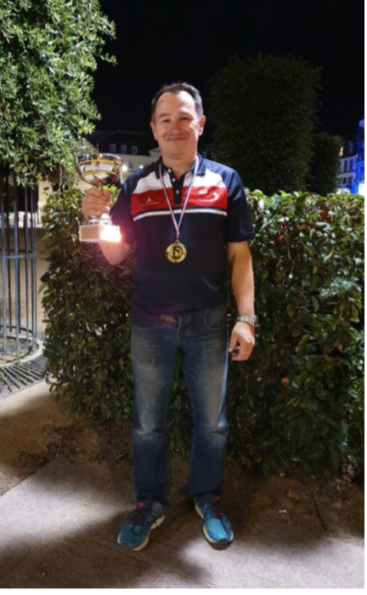
Thank you to everyone for supporting the competitions this year your support has been amazing.

NEXT WEEK – Doubles League
Club email address - liberationpc@gmail.com Club
Website - www.liberationpetanque.co.uk

Kind Regards
Toby Northern
Chairman
Liberation Petanque Club

SPONSORED BY
