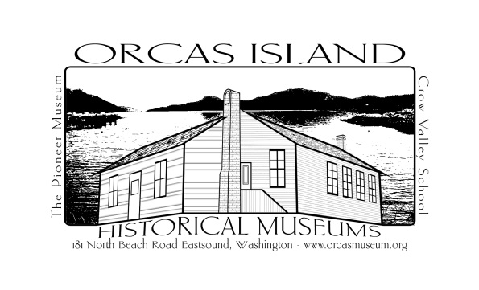
Employment
Application
Contact Information
Name: _______________________________________________________ Date: ___________
Address: _____________________________________________________________________
City: ___________________________ State: _______ Zip Code: _________________________
Phone: _______________________ Email Address: ___________________________________
Employment History
Please list in order, beginning with the most recent or present employer
1. Employer: _______________________________ Address: ___________________________
Supervisor’s name and title: ______________________________ Phone: _________________
Dates of employment: __________________________________________________________
Position(s) held ________________________________________________________________
Responsibilities: _______________________________________________________________ _____________________________________________________________________________ _____________________________________________________________________________
Reason for leaving:_____________________________________________________________ _____________________________________________________________________________
May we contact this employer? ___________________________________________________

2. Employer: _______________________________ Address: ___________________________
Supervisor’s name and title: ______________________________ Phone: _________________
Dates of employment: __________________________________________________________
Position(s) held ________________________________________________________________
Responsibilities: _______________________________________________________________ _____________________________________________________________________________ _____________________________________________________________________________
Reason for leaving:_____________________________________________________________ _____________________________________________________________________________
May we contact this employer? ___________________________________________________

3. Employer: _______________________________ Address: ___________________________
Supervisor’s name and title: ______________________________ Phone: _________________
Dates of employment: __________________________________________________________
Position(s) held ________________________________________________________________
Responsibilities: _______________________________________________________________ _____________________________________________________________________________ _____________________________________________________________________________
Reason for leaving:_____________________________________________________________ _____________________________________________________________________________
May we contact this employer? ___________________________________________________

Education/Training & Computer Proficiency:
Institution Dates Major Degree ____________________________________________________________________________________________________________________________________________________________________________________________________________________________________________________________________________________________________________________
Computer Proficiency: Please list the programs and systems you are proficient in. _______________________________________________________________________________________________________________________________________________________________________________________________________________________________________

A completed application file consists of:
- A letter of interest
- A completed application form
- A current resume
- Letters of reference, if available.

Schedule of Hiring:
- Closing date: April 30, 2018 or until filled
- Interviews: May 1-4, 2018
- Start Date: May 16, 2018 or earlier if possible

Mail or return applications:
Orcas Island Historical Museums, PO Box 134 Eastsound, WA 98245
Physical:
181 North Beach Rd
E-mail: director@orcasmuseums.org

