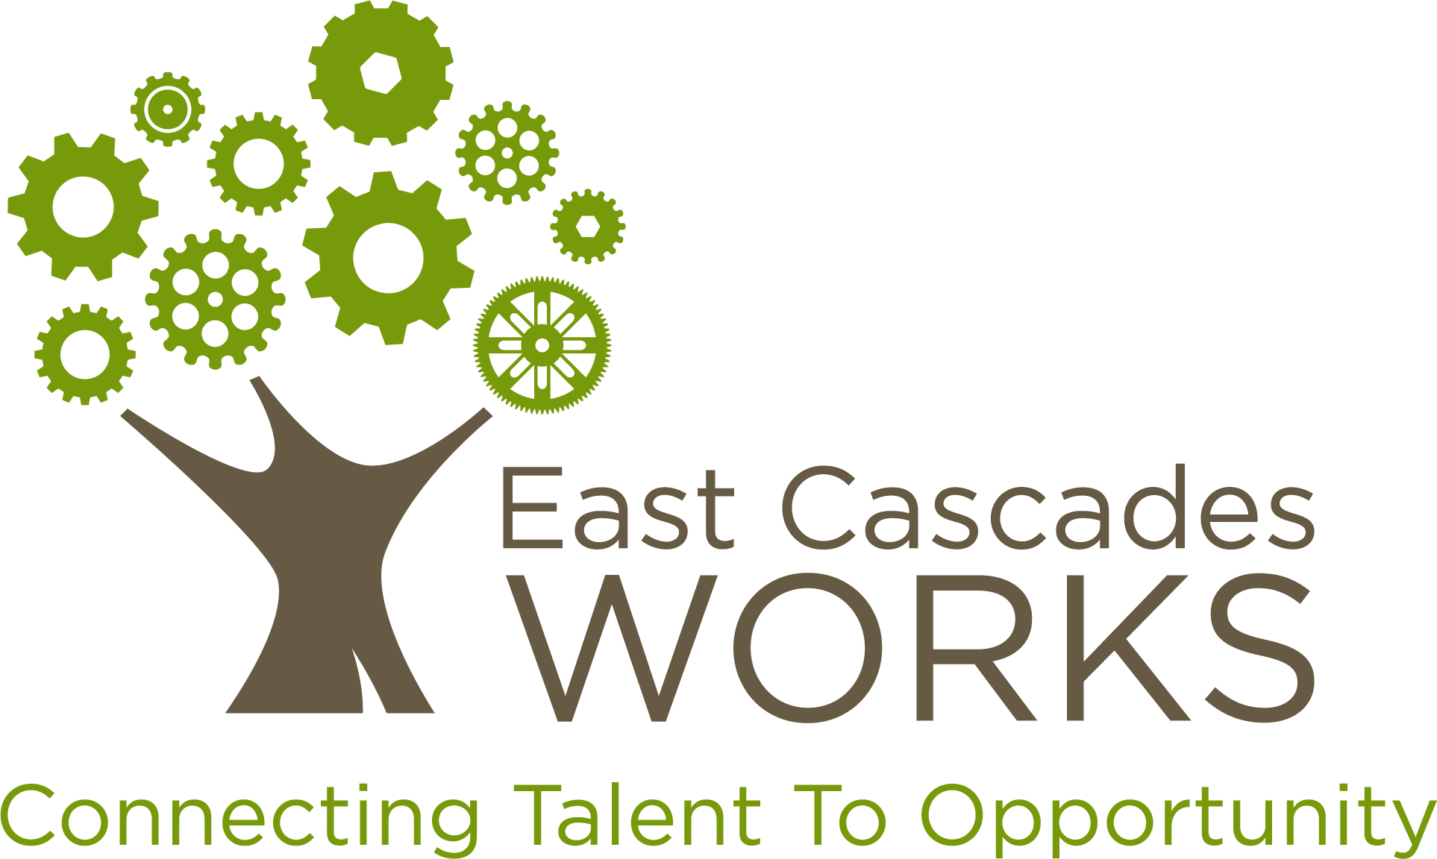

Proposal Narrative

Employer Training Funds

Incumbent Worker Training Grant
Applicant Information
Lead Applicant (Name, Company, Phone, Email)
Primary Contact (Name, Company, Phone, Email)
Fiscal Contact (Name, Company, Phone, Email)
Partner Applicant, if applicable (Name, Company, Phone, Email)
Partner Applicant, if applicable (Name, Company, Phone, Email)
Partner Applicant, if applicable (Name, Company, Phone, Email)
Has your company been awarded an Incumbent Worker Training Grant from EC Works before?
Request Information
Training Program Title
Training Period
Total Amount Requested
Total Employer Match
Minimum Criteria Certification
In submitting this application, we certify that we have read, understand and meet all “Application Criteria”, as described in Section VI. of the Request for Proposal. |  | YES/NO (Circle)

General Training Information (30 total points)

1. Briefly describe the training opportunity identified, the number of employees that will be trained and the benefit this opportunity provides to your company(ies).
2. What is the method for delivery of training? (example: in-class room, on-line, on-site) Where is the training held?
3. What are the beginning and end dates of the training(s)?
Consortia Training (10 total points)

4. Will multiple companies be participating together, in the same training opportunity? If so, please list the names of each company as well as the number of employees from each company.
Expression of Need (10 total points)

5. Please describe how this award will help your business and your employees become more competitive as a result of receiving training.
Sector/Industry Information (10 points)

6. Which industy or sector is your company a part of?
Employee Information (40 total points)

7. Please list the positions employees accessing training currently hold and indicate the current average wage range of these employees. (Example: Production Associate $10-14/hr; Production Supervisor $14-19/hr; $19-24/hr; Production Manager $25+/hr). Employee wages must meet Median Wage Standards for the sub-region where the funds will be utilized. Click here to verify your wages.
8. How does training directly benefit the individuals to be trained?
9. If training will result in an industry recognized certificate or credential, please list them here.

10. What employee wage growth and/or promotions for participating employees are expected as a result of training?

WorkSource Partnership (Bonus)
Please describe how your company currently utlizes WorkSource in identifying potential new hires.

