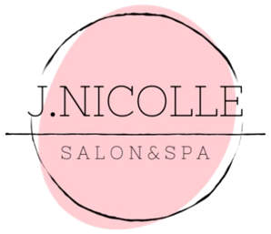
Summary of Bridal Services
Makeup Services:
Bridal Makeup Trial $65+ Timing: 60 minutes
Thorough consultation recommended 4 weeks prior to wedding day.

Bridal Makeup Day Of $65+ Timing: 60 minutes
Choice between traditional or airbrush application. False lashes included if desired. Complimentary lipstick provided for touch-ups throughout the day.

Makeup Application $55+ Timing: 45 minutes
Choice between traditional or airbrush application. False lashes included if desired.

Eye Makeup Application 25+ Timing: 30 minutes
Includes eye shadow, eyeliner, & mascara. False lashes included if desired.
Hair Services:
Bridal Hair Trial $65+ Timing: 60 minutes
Thorough consultation recommended 4 weeks prior to big day. Please arrive with clean, dry hair.

Bridal Hair Day Of $65+ Timing: 60 minutes
Please arrive with clean, dry hair.

Special Occasion Style $50+ Timing: 45 minutes
Please arrive with clean, dry hair. Hair can be styled up, down, half-up/half-down.

