**St. Luke’s Episcopal Church**

**The Feast of St. Luke**

**17 October 2021  10:00 A.M.**

**Holy Eucharist**

The Reverend Michael L Delk, *Celebrant*

The Reverend Anne Harris, *Preacher*

***Thank you for abiding by our social distancing policies, and for wearing a mask over nose and mouth for the entirety of the time you are on St. Luke’s campus.***

**THE WORD OF GOD**

**Prelude “Blagoslovi Dushe Moya” Sergei Rachmaninoff**

**(from: “All Night Vigil: Bless the Lord, (1595-1663)**

**O my Soul”, Psalm 104) arr. James Layton**

James Layton, *organ*

**Processional Hymn “What thanks and praise to thee we owe” Hymnal, 285**

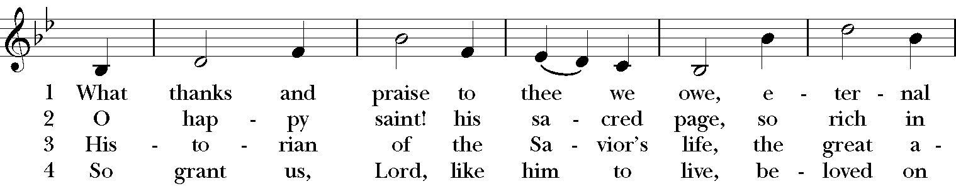

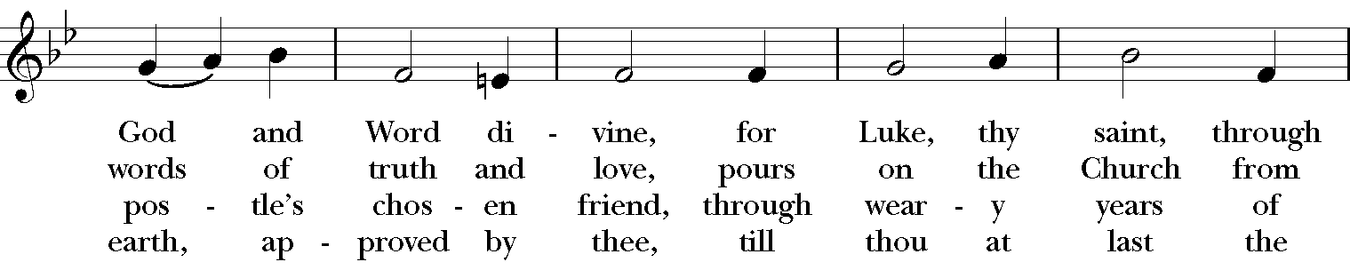

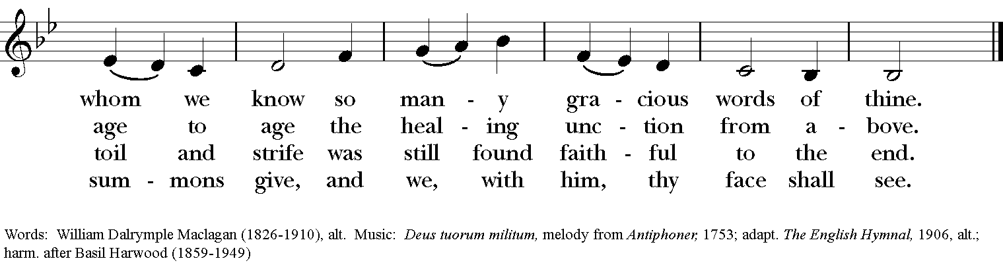

**The Opening Acclamation Page 355**

***Celebrant*** Blessed be God: Father, Son, and Holy Spirit.

***People* And blessed be his kingdom, now and forever. Amen.**

**The Collect for Purity**

**The Gloria “Mass in E” Jeffrey Smith**

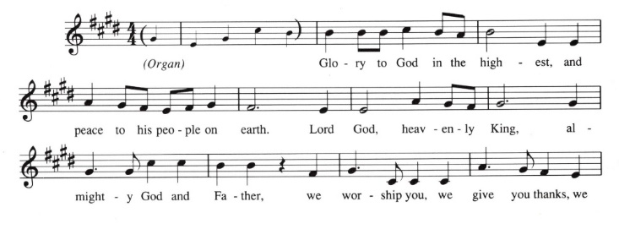

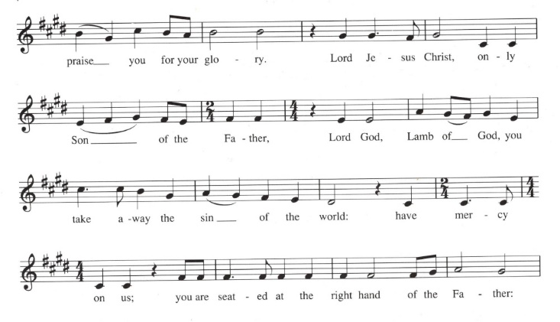

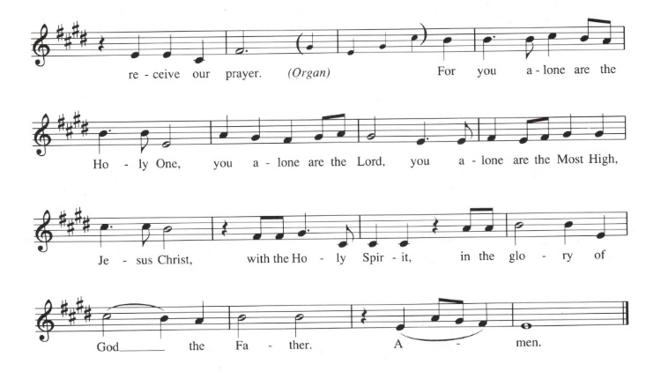

**The Salutation & Collect of the Day Page 357**

***Celebrant*** The Lord be with you.

***People* And also with you.**

***Celebrant*** Let us pray.

Almighty God, who inspired your servant Luke the physician to set forth in the Gospel the love and healing power of your Son: Graciously continue in your Church this love and power to heal, to the praise and glory of your Name; through Jesus Christ our Lord, who lives and reigns with you, in the unity of the Holy Spirit, one God, now and for ever. ***Amen***

**The Lesson Ecclesiasticus 38:1-4, 6-10, 12-14**

Honour physicians for their services, for the Lord created them; for their gift of healing comes from the Most High, and they are rewarded by the king. The skill of physicians makes them distinguished, and in the presence of the great they are admired. The Lord created medicines out of the earth, and the sensible will not despise them. And he gave skill to human beings that he might be glorified in his marvellous works. By them the physician heals and takes away pain; the pharmacist makes a mixture from them. God’s works will never be finished; and from him health spreads over all the earth. My child, when you are ill, do not delay, but pray to the Lord, and he will heal you. Give up your faults and direct your hands rightly, and cleanse your heart from all sin. Then give the physician his place, for the Lord created him; do not let him leave you, for you need him. There may come a time when recovery lies in the hands of physicians, for they too pray to the Lord that he will grant them success in diagnosis and in healing, for the sake of preserving life.

The Word of the Lord.

***People* Thanks be to God.**

**Psalm 147:1-7 Anglican Chant**

1 Hallelujah!

How good it is to sing praises to our God! *

how pleasant it is to honor him with praise!

2 The LORD rebuilds Jerusalem; *

he gathers the exiles of Israel.

3 He heals the brokenhearted, *

and binds up their wounds.

4 He counts the number of the stars; *

and calls them all by their names.

5 Great is our Lord and mighty in power; *

there is no limit to his wisdom.

6 The LORD lifts up the lowly; *

but casts the wicked to the ground.

7 Sing to the LORD with thanksgiving; *

make music to our God upon the harp.

**The Second Lesson II Timothy 4:5-13**

As for you, always be sober, endure suffering, do the work of an evangelist, carry out your ministry fully. As for me, I am already being poured out as a libation, and the time of my departure has come. I have fought the good fight, I have finished the race, I have kept the faith. From now on there is reserved for me the crown of righteousness, which the Lord, the righteous judge, will give to me on that day, and not only to me but also to all who have longed for his appearing. Do your best to come to me soon, for Demas, in love with this present world, has deserted me and gone to Thessalonica; Crescens has gone to Galatia, Titus to Dalmatia. Only Luke is with me. Get Mark and bring him with you, for he is useful in my ministry. I have sent Tychicus to Ephesus. When you come, bring the cloak that I left with Carpus at Troas, also the books, and above all the parchments.

The Word of the Lord.

***People* Thanks be to God.**

**The Sequence “By all your saints still striving” Hymnal, 232**

Verse 2: For Luke, beloved physician,

All praise, whose Gospel shows,

The healer of the nations,

The one who shares our woes

Your wine and oil, O Savior,

Upon our spirits pour,

And with true balm of Gilead

Anoint us evermore.

**The Holy Gospel Luke 4:14-21**

***The people remain standing. The Celebrant says***

The Holy Gospel of our Lord Jesus Christ according to Luke.

***People* Glory to you, Lord Christ.**

Then Jesus, filled with the power of the Spirit, returned to Galilee, and a report about him spread through all the surrounding country. He began to teach in their synagogues and was praised by everyone. When he came to Nazareth, where he had been brought up, he went to the synagogue on the sabbath day, as was his custom. He stood up to read, and the scroll of the prophet Isaiah was given to him. He unrolled the scroll and found the place where it was written: "The Spirit of the Lord is upon me, because he has anointed me to bring good news to the poor. He has sent me to proclaim release to the captives and recovery of sight to the blind, to let the oppressed go free, to proclaim the year of the Lord's favor." And he rolled up the scroll, gave it back to the attendant, and sat down. The eyes of all in the synagogue were fixed on him. Then he began to say to them, "Today this scripture has been fulfilled in your hearing.”

***After the reading, the Celebrant says***

The Gospel of the Lord.

***People* Praise to you, Lord Christ.**

**The Sermon**

**The Nicene Creed**

*Said by all, standing*

**We believe in one God, the Father, the Almighty, maker of heaven and earth, of all that is, seen and unseen.**

**We believe in one Lord, Jesus Christ, the only Son of God, eternally begotten of the Father, God from God, Light from Light, true God from true God, begotten, not made, of one Being with the Father. Through him all things were made. For us and for our salvation he came down from heaven: by the power of the Holy Spirit he became Incarnate from the Virgin Mary, and was made man. For our sake he was crucified under Pontius Pilate; he suffered death and was buried. On the third day he rose again in accordance with the Scriptures; He ascended into heaven and is seated at the right hand of the Father. He will come again in glory to judge the living and the dead, and his kingdom will have no end.**

**We believe in the Holy Spirit, the Lord, the giver of life, who proceeds from the Father and the Son. With the Father and the Son he is worshiped and glorified. He has spoken through the Prophets. We believe in one holy catholic and apostolic Church. We acknowledge one baptism for the forgiveness of sins. We look for the resurrection of the dead, and the life of the world to come. Amen.**

**The Prayers of the People, Form V Page 389**

*Deacon or other leader*

In peace, let us pray to the Lord, saying, “Lord, have mercy”

For the holy Church of God, that it may be filled with truth and love, and be found without fault at the day of your coming, we pray to you, O Lord.

*Here and after every petition the People respond*

***Lord, have mercy****.*

For *Justin*, the Archbishop of Canterbury, For *Michael,* our Presiding Bishop, for *Terry,* our own Bishop, for all bishops, for Michael, Anne, Art, and Jim***,***and other clergy, and for all the holy people of God, we pray to you, O Lord.

For all who fear God and believe in you, Lord Christ, that our divisions may cease, and that all may be one as you and the Father are one, we pray to you, O Lord.

For the mission of the Church, that in faithful witness it may preach the Gospel to the ends of the earth, we pray to you, O Lord.

For those who do not yet believe, and for those who have lost their faith, that they may receive the light of the Gospel, we pray to you, O Lord.

For the peace of the world, that a spirit of respect and forbearance may grow among nations and peoples, we pray to you, O Lord.

For those in positions of public trust especially Joe our President, Andy our Governor, and Neil & Greg our Mayors, that they may serve justice, and promote the dignity and freedom of every person, we pray to you, O Lord.

For all who live and work in this community, we pray to you, O Lord.

For a blessing upon all human labor, and for the right use of the riches of creation, that the world may be freed from poverty, famine, and disaster, we pray to you, O Lord.

For the poor, the persecuted, the sick, and all who suffer; for refugees, prisoners, and all who are in danger; that they may be relieved and protected, we pray to you, O Lord.

For this *congregation,* for those who are present, and for those who are absent, that we may be delivered from hardness of heart, and show forth your glory in all that we do, we pray to you, O Lord.

For our enemies and those who wish us harm; and for all whom we have injured or offended, we pray to you, O Lord.

For all who have commended themselves to our prayers; for our families, friends, and neighbors; that being freed from anxiety, they may live in joy, peace, and health, we pray to you, O Lord.

For **Allen, Amy, Ann, Annie, Barbara, Beecher, Bethann, Beverly, Bill, Carol, Christy, Dan, Danny, Darla, Dave, David, Diana, Dorothy, Doug, Gene, Helga, Herb, Hugh, Ira, Janice, Jenni, Jerry, Jewell, Joan, Joe, John, Kathy, Ken, Kirk, Lee, Linda, Lisette, Lynn, Mark, Martha, MaryBeth, Maureen, Monica, Nancy, Nelson, Nick, Nina (Nine-ah), Phillip, Sharon, Steve, Sue, Susie, Terry, Tracy, Walt; for the men and women of our armed forces, especially Alex, Casey, Christian, Griffin, Pat, Seth, Trey***,* we pray to you, O Lord.

For all who have died in the communion of your Church, **especially Joe Willis**  and those whose faith is known to you alone, that, with all the saints, they may have rest in that place where there is no pain or grief, but life eternal, we pray to you, O Lord.

Rejoicing in the fellowship of the ever‑blessed Virgin Mary, (*blessed Luke*) and all the saints, let us commend ourselves, and one another, and all our life to Christ our God.

*To you, O Lord our God.*

*Silence*

*The Celebrant adds a concluding Collect, or the following Doxology*

For yours is the majesty, O Father, Son, and Holy Spirit; yours is the kingdom and the power and the glory, now and for ever. *Amen.*

**Confession of Sin**

Celebrant Let us confess our sins against God and our neighbor.

**All Most merciful God, we confess that we have sinned against you in thought, word, and deed, by what we have done, and by what we have left undone. We have not loved you with our whole heart; we have not loved our neighbors as ourselves. We are truly sorry and we humbly repent. For the sake of your Son Jesus Christ, have mercy on us and forgive us; that we may delight in your will, and walk in your ways, to the glory of your Name. Amen.**

**The Absolution**

**The Peace**

***Celebrant*** The peace of the Lord be always with you.

***People* And also with you.**

**Prayers for Healing**

**Birthday and Anniversary Prayers**

**THE HOLY COMMUNION**

**Offertory Sentence**

**Offertory Anthem “Strengthen ye, the weak hands” David Buckley**

Strengthen ye, the weak hands and confirm the feeble knees,

Say to them that are of a faint heart, be strong.

Even God with a recompense, he will come and save you.

St. Luke, Evangelist, pray for us.

**Presentation Anthem “All things come of thee, O Lord” Jeffrey Smith**

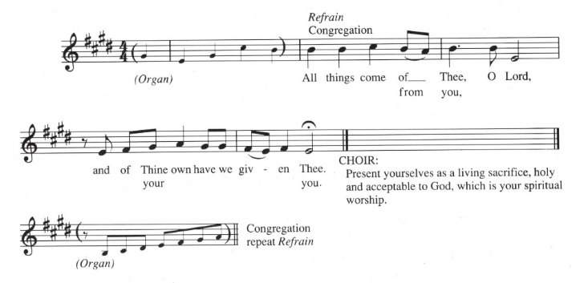

**The Great Thanksgiving: Eucharistic Prayer B Page 367**

*S120a*

*Celebrant* It is right, and a good and joyful thing, always and everywhere to give thanks to you, Father Almighty, Creator of heaven and earth.

*Here the Celebrant adds a Proper Preface*

Therefore we praise you, joining our voices with Angels and Archangels and with all the company of heaven, who for ever sing this hymn to proclaim the glory of your Name:

*Celebrant and People*

**Sanctus “Mass in E” Jeffrey Smith**

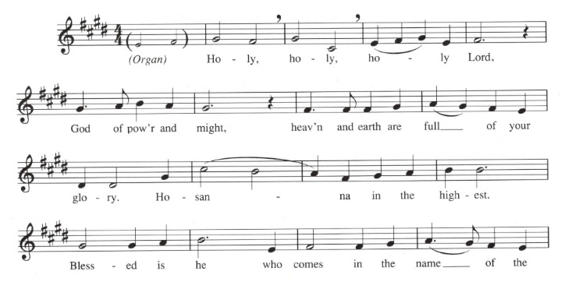

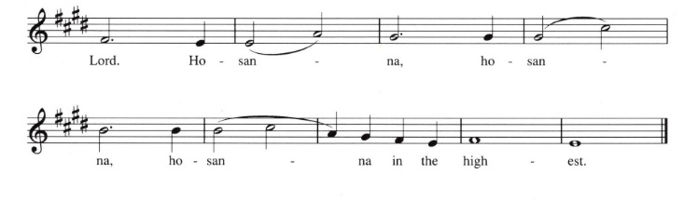

*The people stand or kneel.*

*Then the Celebrant continues*

We give thanks to you, O God, for the goodness and love which you have made known to us in creation; in the calling of Israel to be your people; in your Word spoken through the prophets; and above all in the Word made flesh, Jesus, your Son. For in these last days you sent him to be incarnate from the Virgin Mary, to be the Savior and Redeemer of the world. In him, you have delivered us from evil, and made us worthy to stand before you. In him, you have brought us out of error into truth, out of sin into righteousness, out of death into life.

On the night before he died for us, our Lord Jesus Christ took bread; and when he had given thanks to you, he broke it, and gave it to his disciples, and said, "Take, eat: This is my Body, which is given for you. Do this for the remembrance of me."

After supper he took the cup of wine; and when he had given thanks, he gave it to them, and said, "Drink this, all of you: This is my Blood of the new Covenant, which is shed for you and for many for the forgiveness of sins. Whenever you drink it, do this for the remembrance of me."

Therefore, according to his command, O Father,

*Celebrant and People*

**We remember his death,**

**We proclaim his resurrection,**

**We await his coming in glory;**

*The Celebrant continues*

And we offer our sacrifice of praise and thanksgiving to you, O Lord of all; presenting to you, from your creation, this bread and this wine.

We pray you, gracious God, to send your Holy Spirit upon these gifts that they may be the Sacrament of the Body of Christ and his Blood of the new Covenant. Unite us to your Son in his sacrifice, that we may be acceptable through him, being sanctified by the Holy Spirit. In the fullness of time, put all things in subjection under your Christ, and bring us to that heavenly country where, with [St. Luke, __________ and] all your saints, we may enter the everlasting heritage of your sons and daughters; through Jesus Christ our Lord, the firstborn of all creation, the head of the Church, and the author of our salvation.

By him, and with him, and in him, in the unity of the Holy Spirit all honor and glory is yours, Almighty Father, now and forever. ***Amen****.*

And now, as our Savior Christ has taught us, we are bold to say,

**The Lord’s Prayer**

**Our Father, who art in heaven, hallowed be Thy Name. Thy kingdom come, Thy will be done, on Earth as it is in heaven. Give us this day our daily bread, and forgive us our trespasses, as we forgive those who trespass against us, and lead us not into temptation, but deliver us from evil, for thine is the kingdom and the power and the glory, for ever and ever. Amen.**

**The Breaking of the Bread**

A period of silence is kept.

**The Fraction Anthem “Mass in E” Jeffrey Smith**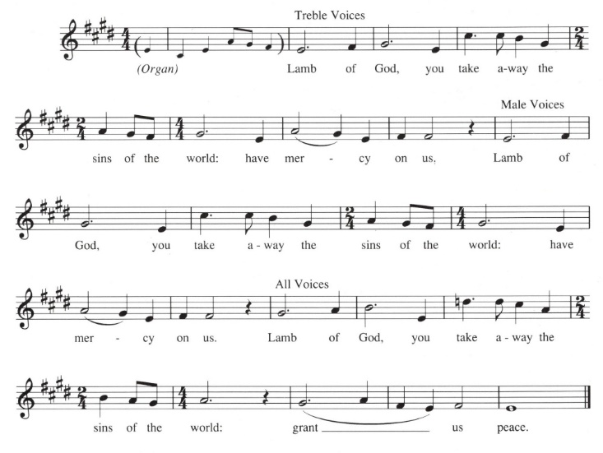

***Hand sanitizer can be found in each pew and is recommended***

***before and after receiving communion.***

**Communion Anthem “Matthew, Mark, Luke and John” Simon Lindley**

Matthew, Mark, Luke and John,

Bless the bed that I lie on,

Four corners to my bed, four angels round my head,

One to watch and one to pray, and two to bear my soul away.

Text: 1656: Thomas John Ady

*After Communion, the Celebrant says*

Let us pray.

*Celebrant and People*

**Eternal God, heavenly Father, you have graciously accepted us as living members of your Son our Savior Jesus Christ, and you have fed us with spiritual food in the Sacrament of his Body and Blood. Send us now into the world in peace, and grant us strength and courage to love and serve you with gladness and singleness of heart; through Christ our Lord. Amen.**

**Sending Forth of Lay Eucharistic Ministers**

***Celebrant*** In the name of God and of St. Luke’s, we send you forth bearing these holy gifts, that those to whom you go may share with us in the communion of Christ’s Body and Blood.

***People* We who are many are one body, because we all share one bread, one cup.**

**The Blessing**

**Recessional Hymn “O day of radiant gladness” Hymnal, 48**

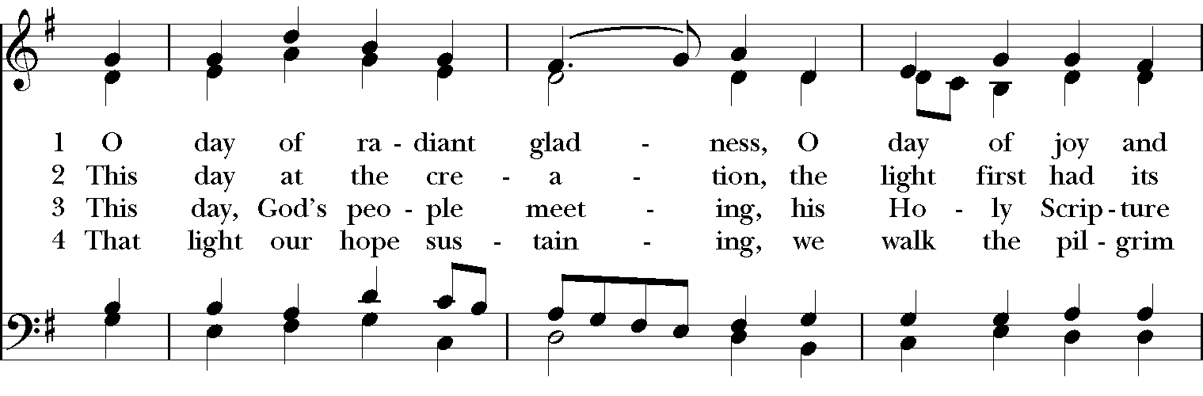

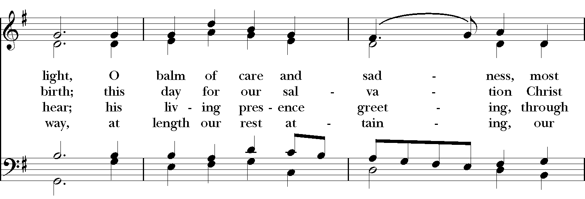

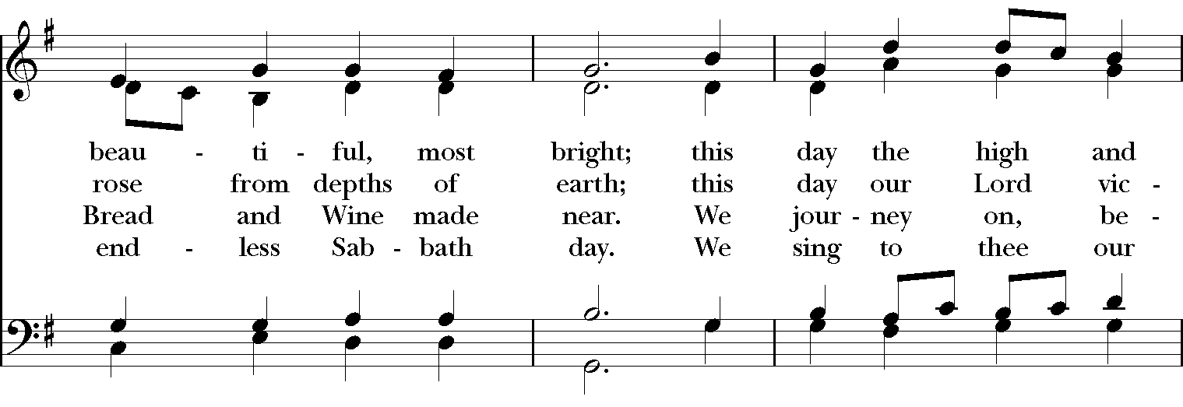

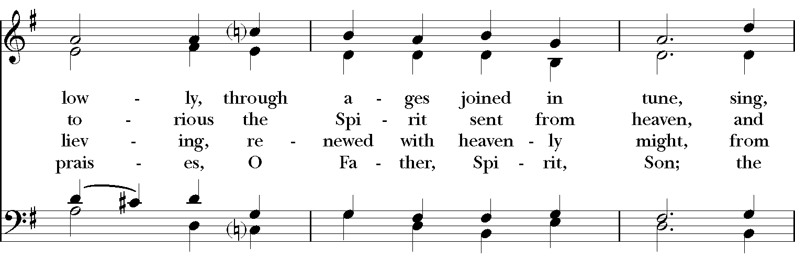

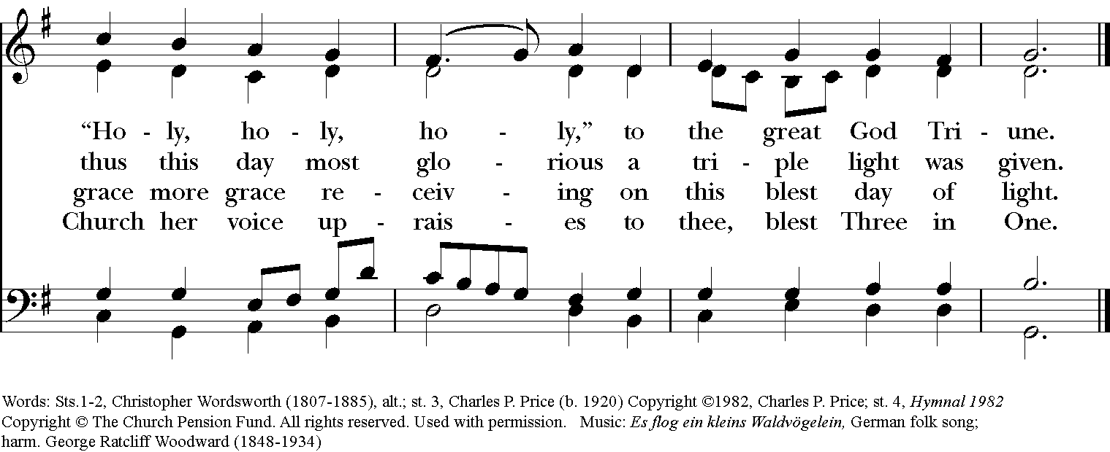

***Feel free to quietly leave worship or remain in your pew to enjoy the Postlude.***

***We are so grateful you have joined us today and look forward***

***to gathering again very soon.***

**The Dismissal**

***People* Thanks be to God.**

**Postlude “Prelude and fugue in e minor”**

**Arnold Matthias Brunckhorst**

**(1670?-1725?)**

Permission to reprint, podcast, and/or stream the music in the service obtained from ONE LICENSE # A-736775. All rights reserved.

**ST. LUKE’S GUEST CLERGY**

St. Luke’s is excited to welcome our guest preacher, the Rev. Anne Harris. Reverend Anne is a familiar face at St. Luke’s as she and her husband, Marc have been members of our parish for a couple of years. She is a native of New Zealand and was raised by a family of devout Anglicans. After 20 years of teaching and raising children, she went to seminary and received her Master of Divinity from the Virginia Theological Seminary. Rev. Anne served in the priesthood in Florida and Mississippi for eleven years. Rev. Anne retired from the priesthood and moved to Louisville to be close to her three grandchildren.

**WELCOME REVEREND ANNE**!

To Give, go to

**https://www.stlukesanchorage.org/giving.html**

**ANNOUNCEMENTS**

*Here at St. Luke’s, we welcome everyone to participate in everything freely, member or non-member. If you are a visitor, please fill out one of the visitor cards and place it in the offering plate. If you would like to become an official member of our parish family, please call our office, 245-8827, or speak with Father Michael.*

**Necrology Sign Up’s**

At all three services on the weekend of **Oct. 30 & 31**, we will be celebrating All Saints Day.  If you would like the name of a departed loved one read aloud during worship, please see the email sent out on October 9 for the link, or use the paper sign up sheets at both main entrances to the church. Be sure to write legibly and leave your name and contact information. **The last day to add names is Monday, October 25, 2021**.

**Music Gala Rescheduled!**

October 17, 5:00 – 7:00 pm at the home of Mason and Rick Rummel.  We’ll have music provided by singer, Emily Albrink and Robert Lee at the piano.  Cocktails and hors d’oeuvres will be served.  The Rummel’s address: 407 Wynfield Close Court, 40206. Please park along Madelle Avenue or spots available in the Wynfield Close Court circle.

Please join us for a fun event that will support the exciting upcoming year of concerts in St. Luke’s Music Series.

**Wednesday AM Bible Study**

The Wednesday morning 9:45 am bible study meets in person in the **church**. You can join this lay-led discussion of the core stories of our faith **in person** every Wednesday at 9:45. We are currently using The Path, a Bible Study published by Forward Movement, as a guide among other sources. It is not necessary to have a copy of The Path to participate. Just bring your Bible.

**Roots in our Liturgy**

**On Sunday, the 24th,** Lisa Lewis will be teaching us about music in liturgy. Class will meet in the sanctuary at 9:00am (This Day Only). We will then resume back at the Lyman Office. We will not be doing Zoom or recording on the 24th.

Our liturgy is rich with meaning, symbolism and history. Many parts of our liturgy are as old as Christianity itself. Have you ever wondered why we say and do the things we do during the Sunday morning church service? Have you wondered about the origins, reasons, and meanings of the components of our worship? For more information, email Dave Kirchinger at [**episcopaliandave@gmail.com**](mailto:episcopaliandave@gmail.com).

The link to the class is: [**https://us02web.zoom.us/j/85144530030**](https://us02web.zoom.us/j/85144530030) / Meeting ID: **851 4453 0030**

If prompted to enter a password, please enter our parish office phone number - 2458827

**Centering Prayer**

Centering Prayer has changed to every **FIRST** and **THIRD** Tuesday. Join us on **October 19 from 6 – 7pm** in the Lyman Office.

**Birthdays & Anniversaries**

**If you've had a birthday or anniversary over the past several weeks, or have one coming up in the weeks ahead,** please let Dawn know, [admin@stlukesanchorage.org](mailto:admin@stlukesanchorage.org).  Let her know your birthday, or the date of your wedding anniversary and how many years you've been married, and we will offer a blessing over you during our recorded worship.

**LAY PASTORAL CARE MINISTRY**

Pastoral care is a ministry provided by volunteer parishioners to individuals needing home, hospital, nursing home or rehabilitation facility visitations. Arrangements can be made for communion and meals as requested. All information is confidential unless you give permission to share with others.

**CALL THE CHURCH OFFICE TO LET US KNOW YOUR NEEDS**.

Reminder, if you do go to the hospital, let the hospital know your church affiliation or try to have your caregiver do so. Our ministry is here for you in time of need so remember to call the church office at 245-8827 or e-mail at [admin@stlukesanchorage.org](mailto:admin@stlukesanchorage.org)

VPOD: Bob LaMontagne / Lay Readers: Lydia Lewis, Rod Neaveill / POP: Chris Wilcox / USHERS: Joshua Anderson, Bob LaMontagne / Audio: Peter Finnis.

***The Flowers on the Altar*** are given by the Wessel daughters and grandchildren in loving memory of George & Mary Butler Wessel.

In our prayers ... for **Allen, Amy, Ann, Annie, Barbara, Beecher, Bethann, Beverly, Bill, Carol, Christy, Dan, Danny, Darla, Dave, David, Diana, Dorothy, Doug, Gene, Helga, Herb, Hugh, Ira, Janice, Jenni, Jerry, Jewell, Joan, Joe, John, Kathy, Ken, Kirk, Lee, Linda, Lisette, Lynn, Mark, Martha, MaryBeth, Maureen, Monica, Nancy, Nelson, Nick, Nina (Nine-ah), Phillip, Sharon, Steve, Sue, Susie, Terry, Tracy, Walt;** and our men and women serving in our armed forces and their families. We offer prayers of blessing and thanksgiving for all men and women serving in the armed services, especially these persons known to us: **Alex, Casey, Christian, Griffin, Pat, Seth, Trey**. We pray that they have safe journeys and know the loving concern of friends and family. May God watch over them and grant them strength and courage to face perils which beset them.

**Readings : October 24: Job 42:1-6, 10-17; Psalm 34:1-8;**

**Pentecost 22 Hebrews 7:23-28; Mark 10:46-52.**

**ST. LUKE’S EPISCOPAL CHURCH**

**DIOCESE OF KENTUCKY**

The Right Reverend Terry Allen White, *Bishop*

STAFF

The Reverend Michael L. Delk, *Rector*

Lisa Lewis, *Minister of Music*

Brench Boden, *Parish Composer*

Judy Chard*, Bookkeeper*

Dawn White, *Parish Administrator*

William Tsueda, *Sexton*

**St. Luke’s Vestry Members**

Term Expires 2022 Term Expires 2023 Term Expires 2024

Walt Anderson Fofo Johnson Jane Casada

Priscilla Bond* John F. Ridoux** Caroline Eddleman

Lynn Cline Barbara Staats Bob LaMontagne

Shaun McEntire Nelson Toebbe Doug Sanders

**\*** Senior Warden; **\*\*** Junior Warden

The Vestry Person On Duty (**VPOD**) has the responsibility for assisting the Rector with

welcoming newcomers and closing the church after worship has concluded.

St. Luke’s Episcopal Church

1206 Maple Lane

Anchorage, KY 40223

SERVICE TIMES

Saturday: 5:30pm (Rite II); Sunday: 8am (Rite I) & Sunday: 10am (Rite II)

OFFICE HOURS

M-Th : 9:30 to 2:30; F : 9:30 to 1:30.

Call to arrange an appointment / Please wear a mask.

Phone: 502-245-8827 Fax: 502-245-5595

Email: [admin@stlukesanchorage.org](mailto:admin@stlukesanchorage.org)

[www.stlukesanchorage.org](http://www.stlukesanchorage.org)