HIGH PINES OWNERS’ ASSOCIATION, INC.
SPECIAL BOARD MEETING
January 11, 2012

- Meeting Called to Order

Jim Hadley called the meeting to order at 10:00 AM at his home. Members present included
- Jim Hadley, Director and President
- Chris Taylor, Vice President and Treasurer
- Mary Scott, Director and Secretary
- Joseph Berube, Bylaws Task Force Member and Nominating Committee Member
- Ron Scott, Bylaws Task Force Member and Nominating Committee Member
- Carrie Johnson, HOA Property Manager
  - Agenda

    - Discuss 2010 and 2011 Treasurer’s Reports and proposed 2012 Annual Operating Budget
    - Conduct a review of business manager performance against Board expectations

  - Treasurer’s Reports and 2012 Operating Budget

Treasurer Chris Taylor discussed his approach and progress on the Treasurer’s Reports and the Board’s proposed budget to be presented to the General Membership for approval. When complete, he will circulate both documents to the Board Directors prior to release to the General Membership. The Treasurer’s Reports and proposed 2012 Operating Budget were completed and circulated to the Board Directors on January 20, 2012. The Directors approved the Treasurer’s report and proposed Budget. Treasurer Taylor’s reports and budget are attached.
  - Review of Business Manager Performance

President Jim Hadley recommended that the High Pines HOA retain Carrie Johnson as the business manager for the calendar year 2012. This action was supported by the entire Board of Directors. There was discussion and agreement that Carrie will transfer all Treasury functions and responsibilities to the Treasurer of the High Pines HOA, currently Chris Taylor. The Treasurer will have responsibility for all funds of the High Pines HOA, including deposits and disbursements. Carrie will continue to prepare checks for any approved expenditures, which checks will require the signature of the Treasurer.
Respectfully submitted,
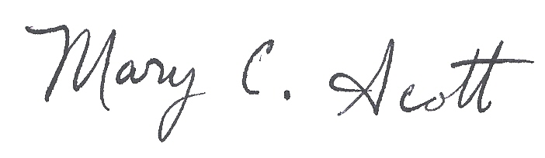
Mary C. Scott
Secretary

Attachment: Treasurer Chris Taylor’s Treasurer’s Report and Proposed 2012 Operating Budget

