7/1/2017 A Curious Culmination of 23’s, etc.

There are some timelines involving the number 23 just ahead of us. One of the timelines involves the arrival of Nephilim 120 years before the flood of Noah.

Human DNA is arranged in 23 pairs of chromosomes in each living cell in the human body. The Nephilim weren't completely human. They were comprised of partly angelic DNA and partly human DNA from human women. The difference between Nephilim (giants) and normal adamic Humans has to do with the 23 pairs of chromosomes residing in each cell of their bodies.

Two 23 Year Destructive Timelines

A rare astronomical event began to happen on 7/16/1994. Comet Shoemaker-Levy 9 had broken apart into 21 large pieces and it began striking the planet Jupiter. The 21 pieces of the comet continued to strike Jupiter for 7 consecutive days from 7/16 to 7/22/1994.

Below: A graphic showing that 23 years have expired since the beginning of the comet-Jupiter event on 7/16/1994.

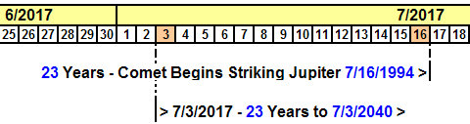

Above: Also noted in the graphic above is a 23 years period that is programmed into a public countdown clock in Tehran, Iran, that announces the annihilation of the State of Israel by 7/3/2040. Note that there are 8400.57 days in a 23 year period.

Information will added to the above graphic a little at a time in order to try to avoid overwhelming the reader.

Below: The midpoint of the two overlapping 23 year periods, 7/3/2017 to 7/16/2017, is at midnight on 7/9/2017.

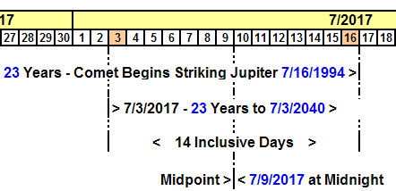

Above: 7/9/2017 is the midpoint of the overlap of the two 23 year periods. That means that we can fold the timeline graphic on itself at 7/9/2017. Both 23 year periods have a common theme, destruction.

When we fold the graphic above at 7/9/2017, the date 7/3/2040 set for the total destruction of Israel will then coincide with 7/16/1994 when the comet Shoemaker-Levy began striking Jupiter 21 times. Each fragment of the comet released enough energy to annihilate all life on earth if it had struck the earth.

Below: Additional information is added concerning 72 year anniversaries that coincide with some of the dates arrived at above.

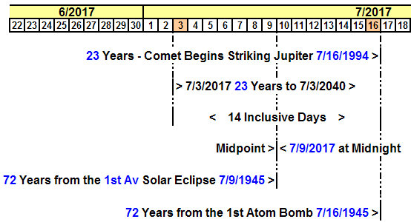

Above: By folding the graphic at its midpoint of 7/9/2017, the 72nd anniversary of the first atomic Trinity Test will then coincide with 7/3/2017 and the beginning of the 23 years count to 7/3/2040. YaHuWaH Elohim declares the end from the beginning.

Note that 7 days before the 1st atomic test on 7/16/1945, there was a total solar eclipse that denoted the astronomical beginning of the Hebrew month of Av. According to Hebrew scholars, 1st Av total solar eclipses denote woe for the nations. The very first test of an atomic device 7 days after the 1st Av eclipse tends to verify the belief of the Hebrew scholars.

Below: The 1st Av solar eclipse of 7/9/1945 was the first of three 1st Av solar eclipses that set boundaries on the sides of the North, the symbolic location of the throne of YaHuWaH Elohim.


Above: 1st Av solar eclipses symbolically set apart the location of YaHuWaH 's throne.

7/9/2017 is the 72nd (2 x 36 and the Babylonian Magic Square that adds up to 666) anniversary of the first 1st Av solar eclipse on 7/9/1945, and the fold date midpoint of the two overlapping 23 year periods mentioned above.

The 23 Days and the 23 Years

Below: The Iran countdown clock was inaugurated on 6/23/2017, 23 days before the 23rd anniversary of comet Shoemaker-Levy 9 beginning to strike Jupiter on 7/16/1994.

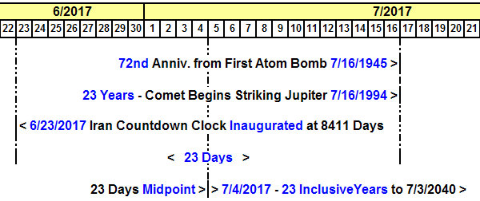

Below: The countdown clock to Israel's destruction by 7/3/2040 unveiled in Tehran on 6/23/2017.



Above: Note that the countdown clock in Tehran might be a deliberate ruse in order to try to cause someone to look far into the future for Israel's attempted destruction.

The Arrival of the Nephilim Before the Flood

Below: Nephilim arrived in Noah's day 120 years before the flood. (Genesis 6:3)

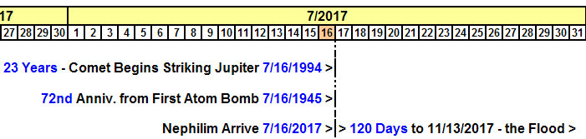

Above: Previous articles have been able to derive a timeline that indicates some sort of flood event will begin on 11/13/2017. That date, 11/13/2017, is the exact midpoint of Israel's 70th year of existence as a sovereign nation since 5/14/1948.

The arrival of Nephilim associated with the pair of 23 year timelines mentioned above indicates that a different kind of human will arrive, a human having DNA integrated into 23 pairs of chromosomes that has been modified.

Because Nephilim are the descendants of fallen angels, they aren't YaHuWaH Elohim's created type of human. They are "artificial" genetic hybrid human beings. In Noah's day the Nephilim filled the earth with violence, and genetically contaminated most of the human race. The flood was sent by YaHuWaH Elohim in order to purge the earth of the genetically transmitted violent behavior.

Daniel 2:43 tells us that in the last days "...they shall mingle themselves with the seed of men...".

We can be certain that various nations are secretly experimenting with mixing human, animal, and other forms of DNA with the intent of producing programmable superbeings for use as weapons of war.

