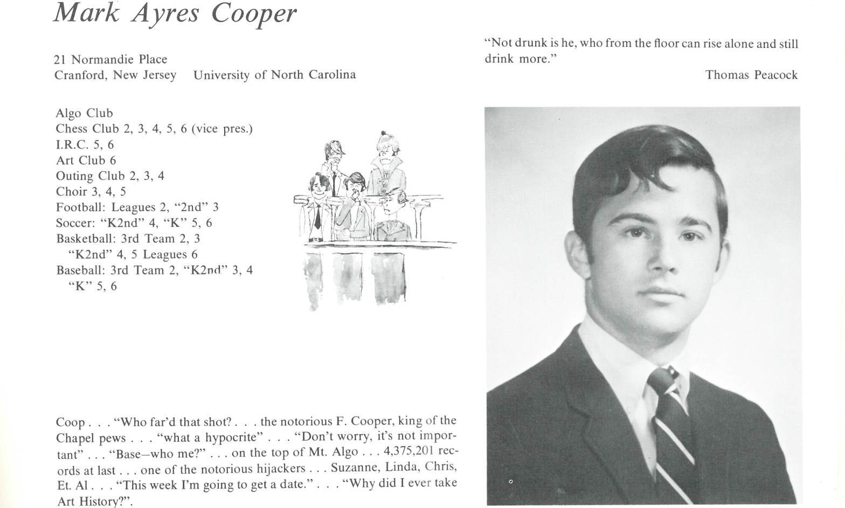

Mark A. Cooper

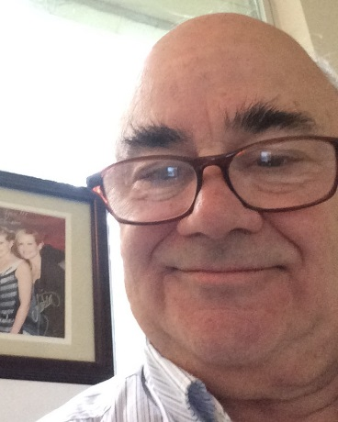I went to U.N.C. Chapel Hill for three years before moving back to New Jersey to start 3-4 years of dead-end jobs. The summer after graduation I spent in San Francisco after hitchhiking across the country. I was a hippie until around 1975 and did all the usual hippie stuff. I came back for a couple of reunions, one with my daughter Jennie. My son Nick wanted to come to my 50th but his real estate business in San Francisco and Marin County will keep him too busy. After hitchhiking around the country for a year, I finally landed back in San Francisco in October of 1973.

The next April 1st I met my wife to be in a laundromat. We were married in 1976 and soon had our two children. Our marriage lasted 13 years but we are friends currently. We also are grandparents to Jennie's two kids, Maddie and Riley. They are the joy of my life.

I have been an accountant and tax preparer most of my life. I am semi-retired and currently live in Marin County. My favorite music group is the Dixie Chicks. I know them personally and have seen them 40 times. My license plate is DXE CHIX. I am a friend of Bill W's and currently have 5-6 years of sobriety. When I write a gratitude list, God is always at the top and my family is always second. I am quiet and mellow but enjoy talking to people. I'm looking forward to our 50th Reunion.

My email is Kent67b@aol.com and my cell is 415-686-3332.



______________________________________________________________

______________________________________________________________ ______________________________________________________________ ______________________________________________________________ ______________________________________________________________ ______________________________________________________________ ______________________________________________________________ ______________________________________________________________ ______________________________________________________________

Attach Picture in .jpg Format

______________________________________________________________

______________________________________________________________

___________________________________________________________________________________ _________________________________________________________________________________________________________________________________________________________________________________________________________________________________________________________________________________________________________________________________________________________________________________________________________________________________________________________________________________________________________________________________________________________________________________________________________________________________________________________________________________________________________________________________________________________________________________________________________________________________________________________________________________________________________________________________________________________________________________________________________________________________________________________________________________________________________________________________________________________________________________________________________________________________________________________________________________________________________________________________________________________________________________________________________________________________________________________________________________________________________________________________________________________________________________________________________________________________________

___________________________________________________________________________________