***Pleasant Township Board of Trustees Meeting Highlights***

**Date _July 9, 2024______________ Next Resolution No._ 55—7-9-2024_ _**

* **Call to Order -- The meeting tonight will also be on WebEx.**
* **Please stand for moment of silence. --Pledge of Allegiance--Roll Call**
* **Visitors –**
* ***Hanna Poling*** with the Southwest Messenger via WebEx.
* **Minutes to approve**- No minutes
* **Financial Reports** – Resolution __55___ to accept the “Then & Now” certificate for the purchase of exercise equipment for $58,557.00 with grant money. Motion to pay expenditures.
* ***Department Reports***
* **Franklin County Sheriff’s Report- Community Liaison, Deputy Adkins- (Cell: 614-809-5843)**
  + Absent
* **Road Department****- Robert Bausch, Superintendent**
* Drive tile install Denton rd.
* Tile repair Timberlake.
* Trim cemeteries.
* Road mowing arm mower.
* Executive session wages.
* *Any updates on Gay Rd. about repairs due to heavy rains washing the roadway and gravel away. (meeting on 8-8-23 we said we’d keep it on the agenda till resolved in some way.)* Mr. Daniels present to discuss Gay Rd. washing away. Robert said it is on their agenda to start repairs in about 2 weeks.
* **Fire Dept. – Lt. Johnson in for Chief Whiting on vacation**
* MARCS grant
* -Grove City Hydrants
* -T 231 issue
* 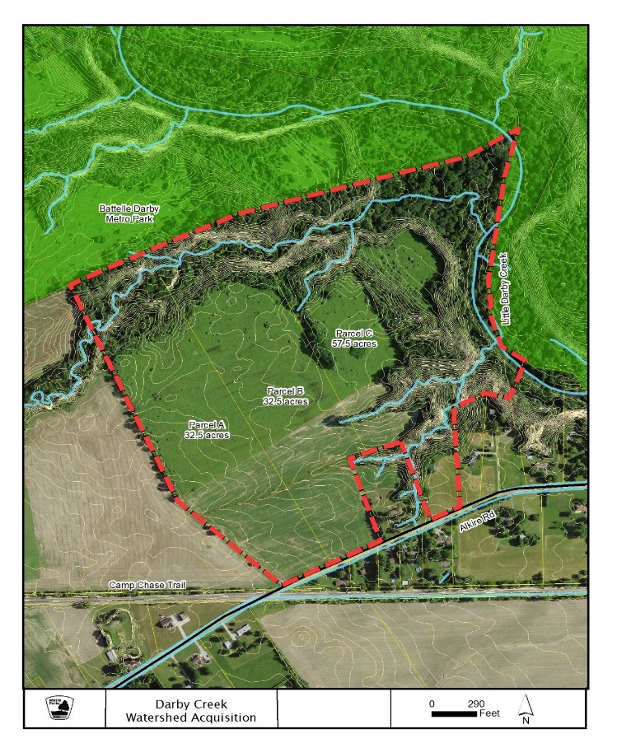Discussion about the payroll problems? I suggest with so many problems that a second person should review before turning it in to Paula for payment. Lt. Johnson said that already happens.
* **New Business –**
  + Received an email from Haley Ingram, Planning & Design Project Coordinator, Columbus & Franklin County Metro Parks to request a Letter of Support from the Pleasant Township Board of Trustees regarding Metro Parks' upcoming application to the Clean Ohio Greenspace Conservation Fund. We are seeking to acquire approximately 122 acres of land in Pleasant Township, Franklin County that is adjacent to Little Darby Creek. (This is on Alkire Rd. west of Gardner Rd.)
* **Announcements-**
* The Franklin County Fair starts on Monday, July 15, 2024 at 10:00 am.
* 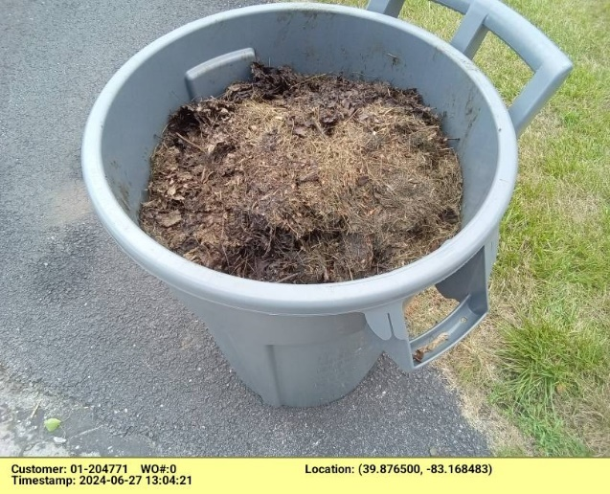This is notifications and reminders from local waste from last pickup----

Rolling Hills Ln. The can will need to be offloaded for service. The dirt will need to be put split up into another can or yard waste bags weighing 50lbs or less per bag or can.

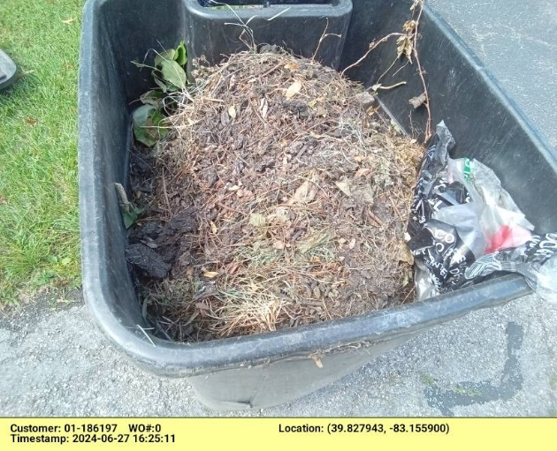

Pheasant Dr - The can will need to be offloaded for service. The dirt will need to be put into biodegradable bags or another can weighing 50lbs or less per bag or can.

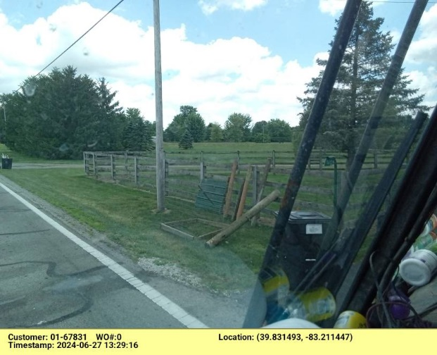

Opossum Run Rd – Upon further review these posts will need different means of disposal as they are not items, we would be able to service.

* Announcing a Special Meeting for the purpose of an executive session with township legal council and a mediator for contract negotiations on July 25, 2024 at 9:00 a.m.
* **Clerk Updates- Paula**
* Miscellaneous correspondence
* Resolution___56__ to enroll in Sedgewick program for 2025.
* OTARMA survey done, it was overdue since April 2024.
* HRA funds are still coming in. Paula will call Burnahm & Flowers about them allowing employees to go over.
* The only budget adjustment needed was moving the money for the trench box to the correct
* Paula has the grievance response prepared, the deadline to respond is July 23, so she will give it to us after the meeting so we can review and respond on the deadline date at our next Trustee meeting, July 23.
* Paula looked up the figures to pay off the Engine. The balance at the end of this year will be $238,404.26. If we pay it off we could save about $22,000 in interest. She will call and get details and specifics.
* **Executive Session** – requested by Robert Bausch

“I move to go into Executive Session according to Ohio Revised Code Section 121.22 (G)( 1 ) for the purpose of _*discussing compensation for Road Department_.* Do I have a second?” ROLL CALL VOTE

Reconvene

Under the Ohio Revised Code Section 121.22(G), I move to come out of Executive Session, do I have a second? ROLL CALL VOTE

Resolution__57_ to increase the Road Department wages by 3% for 2024 retro active back to January 1, 2024. And to add hoodies to their uniform list.

* **Adjourn**