April 20, 2025
Resurrection of Our Lord: Easter Day
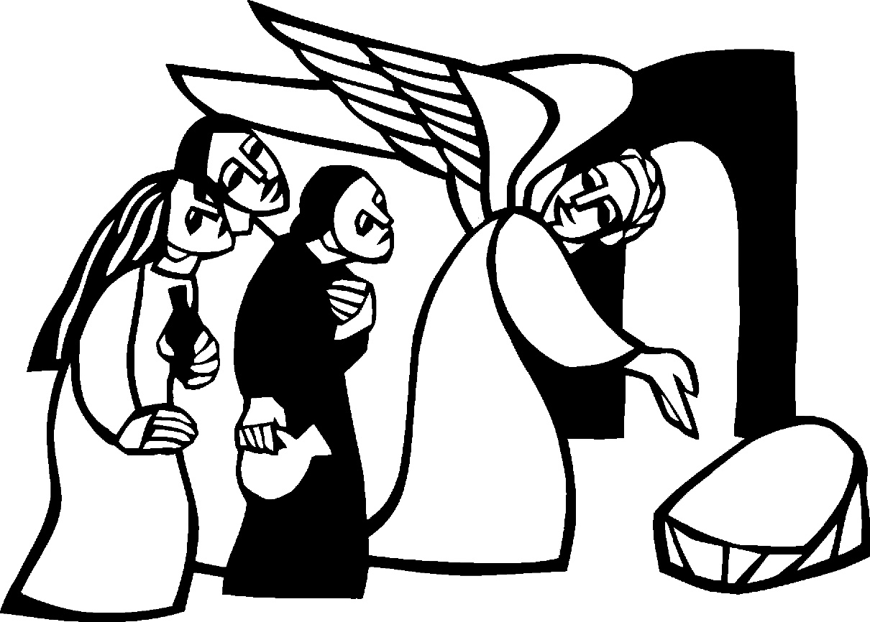

Christ Lutheran Church
“A Place Where You are Always Welcome”
Services: Saturday 5:30 pm and Sunday 10:00 am
Sunday School: 9:00 am
600 North Main Street, Stockton, IL 61085 Office: 815-947-2033
Email:christlutheranchurch70@gmail.com http://www.christlutheranstockton.com
Ministers: ALL members of the congregation
Pastor: Rev. Chrissy Salser chrissytherev@att.net 815-988-9450
From Sundays and Seasons.com. Copyright 2017 Augsburg Fortress. All rights reserved. Reprinted by permission under Augsburg Fortress Liturgies Annual License #40643.New Revised Standard Version Bible, copyright 1989, Division of Christian Education of the National Council of the Churches of Christ in the United States of America. Used by permission. All rights reserved.
WELCOME: Thank you for joining us for worship today. We are glad you are with us. Communion will be served in the aisle or in your pew. All are welcome to share this meal. Jesus is our host and invites everyone. Those who would like to come forward, bread and wine will also be available in the front. When directed by the usher, come forward down the center aisle, Pr Chrissy will give you bread (she will be masked and wearing gloves) and then you will take a cup of wine (grape juice) from the tray. After taking communion, you will return to your seat by the side aisle. For those who are unable to come forward, communion elements can be found as you entered worship. At that part of the service, you are invited to take the bread and wine (or grape juice) when Pr. Chrissy leads. On Saturday’s offering is collected as you enter or leave worship. On Sunday we will pass the plate as a response to God’s grace. Online giving is available. Please see QR code on back of bulletin or visit our website.
Introduction: “The last enemy to be destroyed is death,” Paul writes. Today Christ is risen, and we gather together with astonishment and joy. Christ is risen, and we have been set free from the bonds of death. Christ is risen, and we are forgiven. Christ is risen, and with the women at the tomb and Peter, we are amazed. Let us rejoice: Christ is risen indeed! Alleluia!
PRELUDE
WELCOME AND ANNOUNCEMENTS
EASTER THANKSGIVING FOR BAPTISM (please stand if you are able)
P: Christ is risen. C: Christ is risen indeed. Alleluia! (repeat)
P: Blessed be God, the one who promises salvation, Blessed be Jesus the Christ, the one who provides salvation, Blessed be the Holy Spirit, the one who inspires salvation.
Blessed be the Holy Trinity, + One God, who saves us all. C: Amen.
P: People of God, in the baptismal waters we travel with Christ from death to life. Our past, our sin, our failure, our doubt, and our shame are drowned and gone here.
C: You, O God, wash us clean.
P: Our fear, our confusion, our self-righteousness, our despair—ALL are washed away by grace. C: You, O God, wash us clean.
P: Our pride, our hypocrisy, and other people’s opinions of us no longer have the power to define us. C: You, O God, give us new life.
P: The Spirit lives and moves through us now, a great and joyful mystery, so we may bring love and mercy into the world as the body of Christ.
C: You, O God, give us new life.
P: Rejoice that God has claimed us in this baptismal grace, not by our own doing or believing but by God’s mercy alone. C: You, O God, give us new life.
P: And so, as we worship, we give thanks to God for the gracious gift of baptism that joins us together in Christ by the Spirit’s power. C: Amen
GATHERING HYMN: Arise your Light Has Come ELW #314

1 Arise, your light has come!
The Spirit's call obey;
show forth the glory of your God
which shines on you today.
2 Arise, your light has come!
Fling wide the prison door;
proclaim the captive's liberty,
good tidings to the poor.
3 Arise, your light has come!
All you in sorrow born,
bind up the brokenhearted ones
and comfort those who mourn.
4 Arise, your light has come!
The mountains burst in song!
Rise up like eagles on the wing,
God's pow'r will make us strong.

Greeting:
P. The grace of our Lord Jesus Christ, the love of God, and the communion of the Holy Spirit be with you all.
C. And also with you.
PRAYER OF THE DAY
P. Let us pray together: Risen Lord, we sing and remember your resurrection. We long for the vision of your glory in the ordinary moments of our lives. Surprise us with your resurrection day, encounter us on the road, and call us forth to lives that delight in your way of peace and love. Amen.
WORD: God speaks to us in scripture reading, preaching, and song.
FIRST READING: Acts 10:34-43
³⁴Peter began to speak to [the people]: “I truly understand that God shows no partiality, ³⁵but in every nation anyone who fears him and does what is right is acceptable to him. ³⁶You know the message he sent to the people of Israel, preaching peace by Jesus Christ—he is Lord of all. ³⁷That message spread throughout Judea, beginning in Galilee after the baptism that John announced: ³⁸how God anointed Jesus of Nazareth with the Holy Spirit and with power; how he went about doing good and healing all who were oppressed by the devil, for God was with him. ³⁹We are witnesses to all that he did both in Judea and in Jerusalem. They put him to death by hanging him on a tree; ⁴⁰but God raised him on the third day and allowed him to appear, ⁴¹not to all the people but to us who were chosen by God as witnesses, and who ate and drank with him after he rose from the dead. ⁴²He commanded us to preach to the people and to testify that he is the one ordained by God as judge of the living and the dead. ⁴³All the prophets testify about him that everyone who believes in him receives forgiveness of sins through his name.”
The word of the Lord C. Thanks be to God.

Psalm: Psalm 118:1-2, 14-24
This is the day that the Lord has made; let us rejoice and be glad in it. (Ps. 118:24)
¹ Give thanks to the Lord, for the Lord is good; God’s mercy endures forever.
² Let Israel now declare, “God’s mercy endures forever.”
¹⁴ The Lord is my strength and my song,and has become my salvation.
¹⁵ Shouts of rejoicing and salvation echo in the tents of the righteous:
“The right hand of the Lord acts valiantly!
¹⁶ The right hand of the Lord is exalted! The right hand of the Lord acts valiantly!”
¹⁷ I shall not die, but live, and declare the works of the Lord.
¹⁸ The Lord indeed punished me sorely, but did not hand me over to death.
¹⁹ Open for me the gates of righteousness; I will enter them and give thanks to the Lord.
²⁰ “This is the gate of the Lord; here the righteous may enter.”
²¹ I give thanks to you, for you have answered me and you have become my salvation.
²² The stone that the builders rejected has become the chief cornerstone.
²³ By the Lord has this been done; it is marvelous in our eyes.
²⁴ This is the day that the Lord has made; let us rejoice and be glad in it.

SECOND READING: 1 Corinthians 15:19-26
¹⁹ If for this life only we have hoped in Christ, we are of all people most to be pitied.
²⁰ But in fact Christ has been raised from the dead, the first fruits of those who have died. ²¹ For since death came through a human being, the resurrection of the dead has also come through a human being; ²² for as all die in Adam, so all will be made alive in Christ. ²³ But each in his own order: Christ the first fruits, then at his coming those who belong to Christ. ²⁴ Then comes the end, when he hands over the kingdom to God the Father, after he has destroyed every ruler and every authority and power. ²⁵ For he must reign until he has put all his enemies under his feet. ²⁶ The last enemy to be destroyed is death.
The word of the Lord C. Thanks be to God.

GOSPEL ACCLAMATION Thine is the Glory ELW # 376
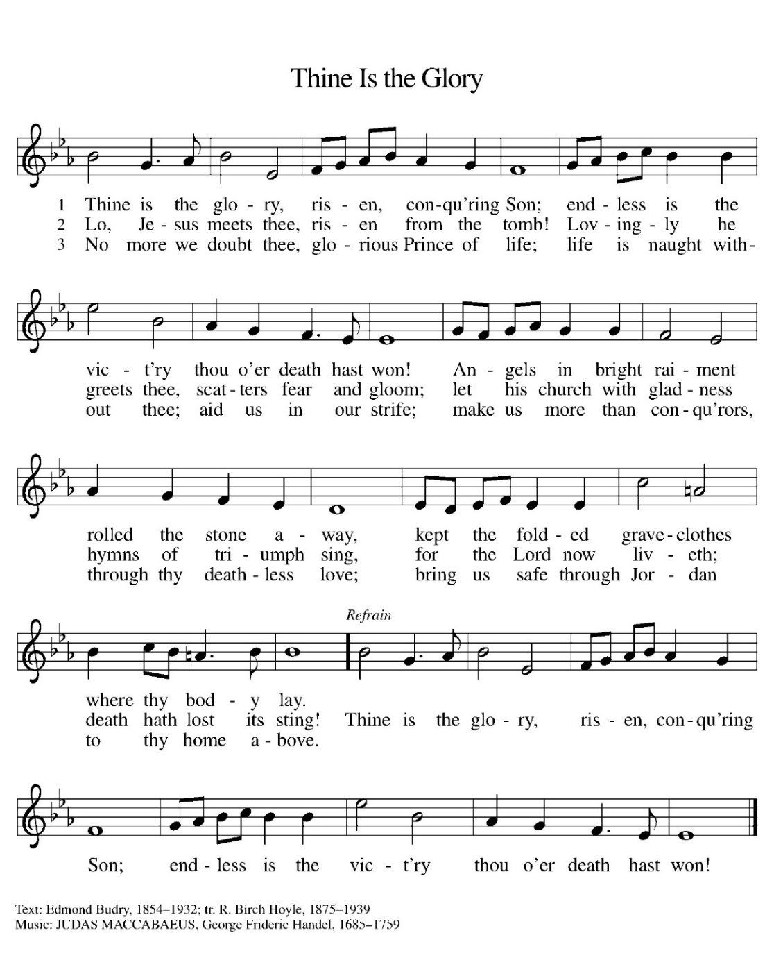
GOSPEL READING: Luke 24:1-12
P. The holy Gospel According to Luke. C. Glory to you, O Lord
On the first day of the week, at early dawn, [the women] came to the tomb, taking the spices that they had prepared. ² They found the stone rolled away from the tomb, ³ but when they went in, they did not find the body. ⁴ While they were perplexed about this, suddenly two men in dazzling clothes stood beside them. ⁵ The women were terrified and bowed their faces to the ground, but the men said to them, “Why do you look for the living among the dead? He is not here, but has risen.
⁶ Remember how he told you, while he was still in Galilee, ⁷ that the Son of Man must be handed over to sinners, and be crucified, and on the third day rise again.” ⁸ Then they remembered his words, ⁹ and returning from the tomb, they told all this to the eleven and to all the rest. ¹⁰ Now it was Mary Magdalene, Joanna, Mary the mother of James, and the other women with them who told this to the apostles. ¹¹ But these words seemed to them an idle tale, and they did not believe them. ¹² But Peter got up and ran to the tomb; stooping and looking in, he saw the linen cloths by themselves; then he went home, amazed at what had happened.
P. The gospel of the Lord. C. Praise to you, O Christ.
CHILDREN’S MESSAGE
MESSAGE
HYMN OF THE DAY : Good Christian Friends, Rejoice & Sing! ELW #385

1 Good Christian friends, rejoice and sing!
Now is the triumph of our king!
To all the world glad news we bring:
Alleluia, alleluia, alleluia!

2 The Lord of life is ris'n this day;
death's mighty stone is rolled away;
let all the world rejoice and say:
Alleluia, alleluia, alleluia!
3 Praise we in songs of victory
that love, that life, which cannot die,
and sing with hearts uplifted high:
Alleluia, alleluia, alleluia!

4 Your name we bless, O risen Lord,
and sing today with one accord,
the life laid down, the life restored:
Alleluia, alleluia, alleluia!

APOSTLES’ CREED:
I believe in God, the Father almighty, creator of heaven and earth.
I believe in Jesus Christ, God’s only Son, our Lord, who was conceived by the Holy Spirit, born of the virgin Mary, suffered under Pontius Pilate, was crucified, died, and was buried; he descended to the dead. On the third day he rose again; he ascended into heaven, he is seated at the right hand of the Father, and he will come to judge the living and the dead.
I believe in the Holy Spirit, the holy catholic church, the communion of saints, the forgiveness of sins, the resurrection of the body, and the life everlasting. Amen.
PRAYERS OF INTERCESSION:
P. God of Grace, C. Hear our prayer

PEACE
P: The peace of Christ be with you always. C: And also with you.
Meal: God feeds us with the presence of Jesus Christ.
OFFERING Our offering is a significant act of worship; we worship God through our giving. The ministry of this congregation is completely dependent upon your partnership and generosity. Offering is collected during this song. Online giving is available.

OFFERING SONG: We Come to the Hungry Feast ELW #479
OFFERING PRAYER:
P: Let us pray together: Risen One, you have gathered us around your table of grace along with these gifts we bring. Come among us again, breathe your life into us,
and enliven us with this meal, that we may live as your risen body in the world. Amen.

THANKSGIVING AT THE TABLE
Holy, living, and loving God, we praise you for creating the heavens and the earth.
We bless you for bringing Noah and his family through the waters of the flood, for freeing your people Israel from the bonds of slavery, and for sending your Son to be our Redeemer. We give you thanks for Jesus who, living among us, healed the sick, fed the hungry, and with a love stronger than death, gave his life for others.
In the night in which he was betrayed, our Lord Jesus took bread, and gave thanks; broke it, and gave it to his disciples, saying: Take and eat; this is my body, given for you.
Do this for the remembrance of me.
Again, after supper, he took the cup, gave thanks, and gave it for all to drink, saying: This cup is the new covenant in my blood, shed for you and for all people for the forgiveness of sin. Do this for the remembrance of me.
Remembering, therefore, his life-giving death and glorious resurrection, we await your promised life for all this dying world. Breathe your Spirit on us and on this bread and cup: carry us in your arms from death to life, that we may live as your chosen ones, clothed in the righteousness of Christ. Through him all glory and honor is yours, Almighty Father, with the Holy Spirit, in your holy Church, both now and forever.
Amen
THE LORD’S PRAYER:
Our Father, who art in heaven, hallowed be thy name, thy kingdom come, thy will be done on earth as it is in heaven. Give us this day our daily bread; and forgive us our trespasses, as we forgive those who trespass against us; and lead us not into temptation, but deliver us from evil. For thine is the kingdom, and the power, and the glory, forever and ever. Amen
INVITATION TO COMMUNION:
P. The risen Christ dwells with us here. All who are hungry, all who are thirsty, come. So come to this table, You who have much faith and you who would like to have more. You who have been to this sacrament often, And you who have not been for a long time. You who have tried to follow Jesus, and you who have failed. Come. It is Christ who invites us to meet him here. Communion is served by intinction. Please come down the center aisle, take the bread, then receive a cup (wine is dark, juice is light, return to your seats via side aisle.) Those who prefer to take communion in your pews, we will take all together after all is served.

DISTRIBUTION OF COMMUNION
P: This is the body of Christ given for you. (All take bread).
P: This is the blood of Christ shed for you. (All take the wine).

COMMUNION SONG Christ the Lord is Risen Today; Alleluia! ELW# 369

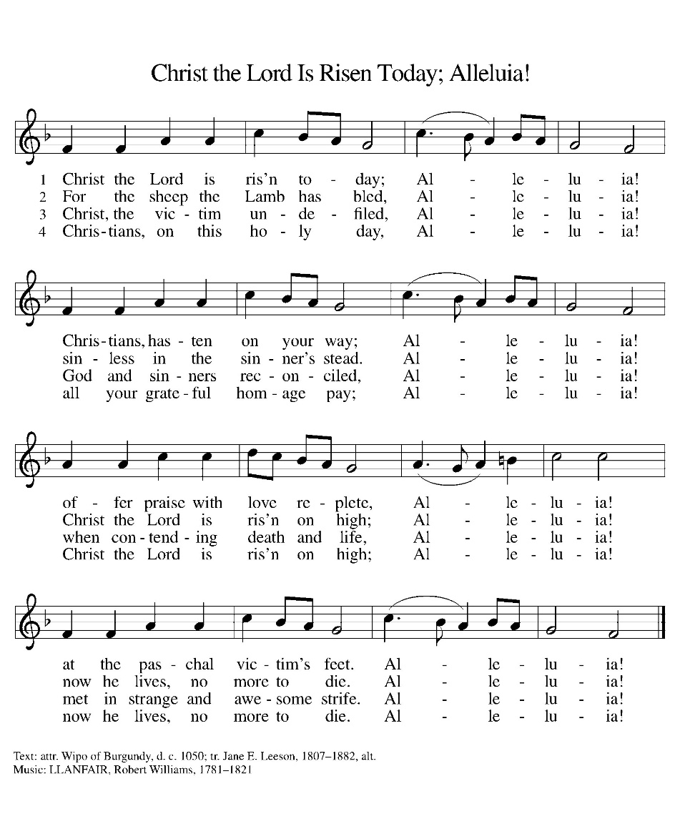
TABLE BLESSING:
P. May the body and blood of our Lord Jesus Christ strengthen you and keep you in his grace. C. Amen.
PRAYER AFTER COMMUNION:
P. Living One, in this feast you have made yourself known to us. Send us now to tell of your wonders, sing of your glory, and proclaim your risen life to a wounded and weary world. Amen.
SENDING: God blesses us and sends us in mission to the world.
BLESSING: P: God, the Author of life, Christ, the living Cornerstone, and the life-giving Spirit of adoption, ☩ bless you now and forever. Amen.
SENDING HYMN : Jesus Christ is Risen Today ELW #365

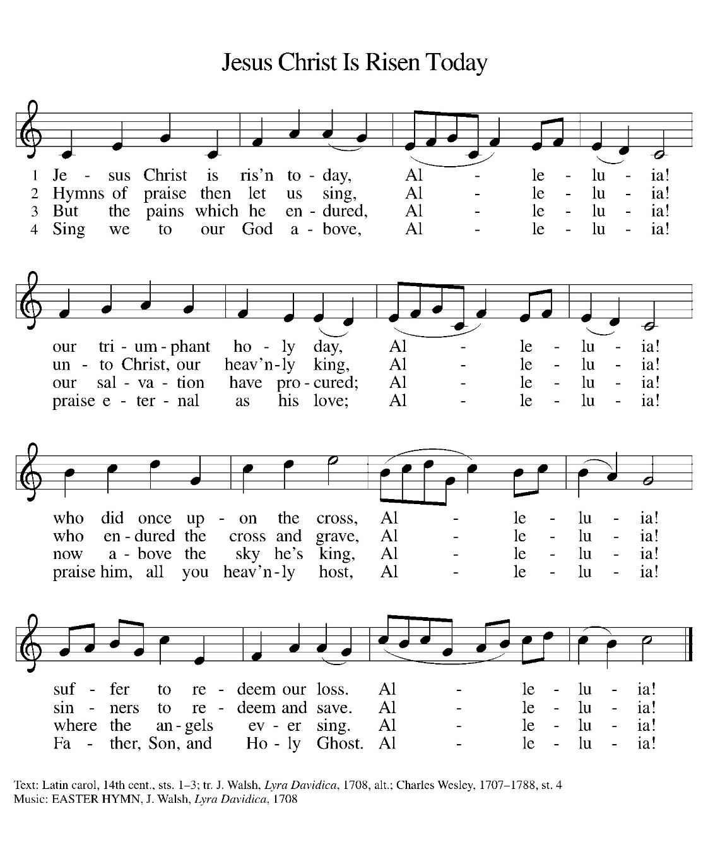
DISMISSAL:
P. Alleluia! Christ is risen. C. Christ is risen indeed. Alleluia!
P. Go in peace. In Christ you are made new. Alleluia . Alleluia.
C. Thanks be to God. Alleluia . Alleluia.

POSTLUDE

IN OUR PRAYERS TODAY: IN OUR PRAYERS TODAY: Gunnar Stich, Teresa Hesselbacher, Darlene and Walt Steffes, Bob Schreck, Delores Wampfler, Marge and Gerald Arnold, Josie Bonjour, Elaine Schlichting, Don Brudi, James Dieter, Christine Happ, Kay Hesselbacher, Mary Lou Bunker, Lillian Sefford, Judy Wilson, Jody Dascher, Russ Synder, To add someone to the prayer list please contact Pastor Chrissy
CELEBRATING BIRTHDAYS/ANNIVERSARIES THIS WEEK: Cecilia Staver, Leslie Coppas, Joseph Brudi, Tessa Tucker, Matt Harmston, Joe Dittmar, Bob Kehl
Anderson Birthdays
Christine | F | May 22 | 71 | Children cat books/color books/ puzzle’s/dolls
Rebecca | F | May 29 | 53 | Craft kits/ stuffed animals/word searches
Please send Birthday cards to Anderson House 200 East King Avenue Stockton Il 61085
Thanks be to God for your gifts for the ministry of  Christ Lutheran Church |  |  |  | Offering/ Attendance  Report
Current Expense | $1,494.75 | Lent 4/9/2025 | $10.00 | April 12  April 13 | 14  50
Benevolence | $10.00 | Building Fund  Youth | $30.00 | Sunday School | 16
 |  | Lent | $10.00 | April 9 | 20
 |  | Total | $ 1,544.75


2025
 | March | Year to date
Offerings: | $14,697 | $30,431
Expenses: | $10,979 | $31,490
Overall Gain / Loss | $3,718 | ($1,060)
March TOTALS: As a way to improve communication around finances, we are sharing the information above:
ANNOUNCEMENTS
ONLINE GIVING: Your gift has a big impact on our ministries and those we serve. Scan this code or visit our website to give online today.
THE COMMUNITY TABLE: The Community Table is an opportunity for outreach to the local community. This is a bi-weekly meal on the first and third Tuesday of the month at 11:30, here at Christ to gather for food, fellowship and fun. This is an outreach that will begin in May 6th at 11:30. If you are interested in volunteering please talk with Janet Haas or Debbie Goebel.
NW CONFERENCE WELCA SPRING GATHERING: Thursday May 15th at Lord of Love Lutheran Church 219 Summit St Galena Il 61036 Registration 9:30 Cost $15 Brunch & Program is Lord of Love Giving and Charitable Missions in the Community Forms Available in Narthex. They are due by May 8th.
BIBLE STUDY: Wednesday morning bible study will take one more week off. We will gather together again on Wednesday, April 31st at 9 am. We look at the gospel for the coming Sunday. All are welcome to join us.
SUNDAY SCHOOL: April 27th will be the last day of Sunday School for this school year. Don’t miss you. We would love to see your kids as we finish out the year. Don’t forget to mark Vacation Bible School on your calendar June 2-6 from 9-11:30.
SAVE THE DATE: WELCA is coordinating a fellowship event for Thursday, May 22 in Dubuque, a lunch boat ride on the Mississippi. More info to come.
AMAZON WISH LIST: did you know that everyday items used at the church are items you could contribute? Find our list here or on our Facebook page. Thank you! https://www.amazon.com/hz/wishlist/ls/TWP5U0RAGGAY?ref_=wl_share
COWORKERS IN THE GOSPEL: Consider being a part of one our leadership teams. As of this month, three teams will be helping connect the council and congregation as we work together to do ministry together. Three teams have formed; Worship Team, Building Team and Education Team. If you are interested in being a part of one of the teams, please see Pr Chrissy or someone on the team.
- Worship team leader is Janet Haas -anyone who is interested in serving in any area of worship, especially baking communion bread, communion set up, serving or clean up.
- The Property team will access, and address issues related to the building. Please see Cory Haas, team leader, if you would like to help with the building. We are also looking for people interested in helping with mowing the lawn come spring.
- The Education Team over sees Confirmation, Sunday School and Vacation Bible School. Vacation Bible School is going to happen June 2-6. from 9-11:30. If you would like to be a part of the education team or help with VBS Campfire Adventure please see Leisa Hubb (team leader).
Upcoming Events
- April 20- 7 am EASTER Worship
- April 20- 8 am Easter Breakfast
- April 20- 9 am Sunday School
- April 20- 10 am Easter Worship
- April 23- no bible study
- April 26- 5:30 pm Worship
- April 27- 9 am last Sunday School of the year
- April 27- 10 am

- May 4- 10 am Confirmation Sunday
- May 4- 2 pm Stockton Baccalaureate
- May 15 – 9:30 am WELCA Northwest Conference at Lord of Love Galena, IL
- May 25- LSSI Good Shepherd Sunday
- June 2-6 Vacation Bible School

