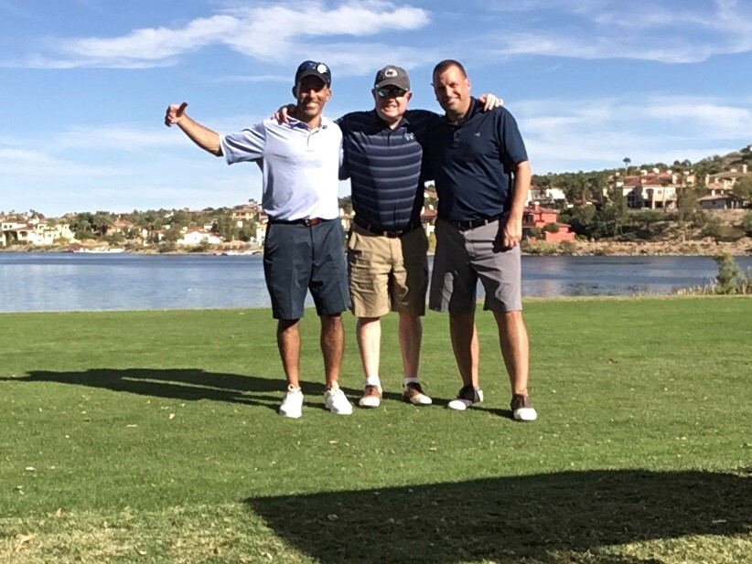
This sucks…
MBBC XXV – LAS VEGAS
(THE ONE WITHOUT DROZ)
TRIP REPORT

There was a lot of excitement for the silver anniversary of the Myrtle Beach Birdie Championship, especially since we were returning to Las Vegas for the first time since 2019 after the Covid-19 pandemic had forced us to go to Williamsburg, Virginia. Out of an abundance of caution, the trip was pushed back to October 22-26, 2021. In plans for the previous year (that had to be cancelled) we had agreed to move from New York/New York to The Mirage. Dan (a.k.a. Mr. Vegas) booked the rooms at The Mirage. Scott and Dan booked their flights on Southwest (through points) and Droz and Paul booked their flights on American. Scott got back in touch with old friend, Jason, from VIP Golf Services and put together another stellar lineup of Reflection Bay, South Shore Country Club, Royal Links, Anthem Country Club and Wolf Creek.

At first, it looked like this would be another awesome trip, especially when the NFL announced its schedule, which included the Eagles playing in Las Vegas against the Raiders on the Sunday of our trip. Flights, hotel rooms and rental cars subsequently skyrocketed, which made the fact the Danny “Mr. Vegas” Hoelke had already booked our trip all the better. There was some discussion about whether we might go to the game, but since the NFL had gone without fans the season before, and since all of Philadelphia was going to the game, ticket prices were sky high, and Paul claimed he wasn’t really that interested in going.

However, in the weeks before the trip, things took a turn for the worse. Weeks before, Haley tested positive for Covid-19. Droz did not. However, about month before the trip, Droz hurt his ankle practicing volleyball with Haley. He claimed he heard something “pop” and there was very real concern that he was dealing with a career threatening Achilles injury. After consulting with a doctor, it was determined that it was just a bad sprain. He was on crutches for a while, but he vowed to follow through on physical therapy and be ready for the start of the MBBC. The death knell came just 2 days before the trip while everyone’s excitement at its usual high. There had been some mention that Sam was not feeling well after having attended a wedding a few days before, but not much more was made of it. An odd and rare FaceTime call was initiated by Droz. Scott answered wondering if this was just a group call to talk about how pumped we were for the trip but was quickly told it was not a fun call. Dan was in the office and answered with a confused look on his face as well. Droz informed us that Sam had officially tested positive for Covid-19 and that unless she made a miraculous recovery, he was likely backing out of the MBBC. With everything already booked and everyone’s schedules full, there were no other options but to push forward with the hope that Droz might still be able to come. As has become habit now, Scott wrote the 2020 trip report a few days before. With Droz’s news that he likely would not be coming, Scott did not follow through on the prop bets and odds email. Paul played a warm up round the day before we left and made 2 birdies, which (also in hindsight) probably was a sign of things to come. Packing the night before was not nearly as fun with Droz out.

Friday, October 22, 2021
Again, things were much more subdued as we all woke up and headed to the airport and exchanged the usual “see you in Charlotte” texts. Scott was the first to leave out of BWI at 6:15 a.m. Dan left Pittsburgh shortly after him at 7:00 a.m. and Paul, flying solo, was the last to leave Philadelphia at 9:00 a.m. Things seemed to get even more bleak on Scott’s flight. Scott fell asleep before the plane even got in the air and was about 90 minutes into his flight, when he woke to the screams of a woman 2 rows in front Scott asking for help from a flight attendant because her husband was having a seizure. The flight attendants asked for any doctors on board to help and several responded. The man was conscious, but they decided it would be best to lay him down in the aisle right next to Scott and put him on oxygen. They tried to sit him up a couple of times, but his blood pressure would shoot up when they did, so they decided to keep on the floor. Since he was on oxygen, the oxygen tank was actually leaning against Scott’s legs. The flight attendants were in contact with Southwest medical personnel and there was some question as to whether the flight might be diverted, but apparently that’s only done if something is life-threatening. As the MBBC historian, Scott debated whether or not he should take photographs of this situation, but it seemed somewhat tacky or rude (something that’s never really stopped before), so he didn’t take any pictures. This is something that he now very much regrets. Scott’s flight landed safely (and on time) in Vegas and the man was actually quickly and efficiently taken off the plane. Scott headed directly to the duty-free shop to buy a bottle of Fireball for the newly minted tradition of group fireball shots after every birdie.
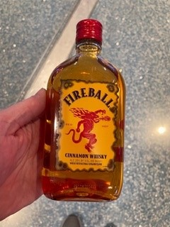
Scott’s bag and clubs arrived without incident and Dan landed shortly after that. Scott and Dan headed to the rental car center (a place that I don’t believe Paul and Droz have ever had to go or deal with… weird) and got the rental car Dan had reserved relatively pain-free. Dan drove to The Mirage, where we checked in. We debated whether or not to gamble but decided not to and just grabbed a beer at the bar next to the sportsbook (possibly the most expensive beers ever). While we were having a beer, Paul texted that he was landing, so we headed back to the airport to pick him up. Scott called VIP Golf and told them about Droz’s situation and they advised they would contact all of the courses and do what they good to get Droz a refund. After a successful airport pick up we head to our opening round at group-favorite, Reflection Bay.
We made it to Reflection Bay well ahead of our tee time. We checked in and they were already aware that we were down a man and said they had refunded the money. We decided to have lunch at the bar, where things got even better.
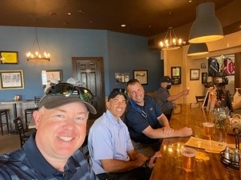
Still sucks…
Lunch was pretty good but highlighted by our server Sierra (who is from Hawaii). There was another server there, Brittany, who is Sierra’s roommate, but she didn’t really talk to us.
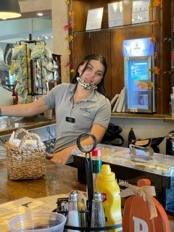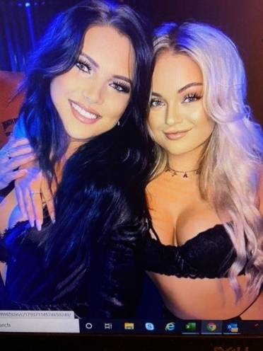
Scott got caught taking this picture Dan Facebook stalked them and discovered this picture
We loaded up on over-priced beers and headed to the shitty driving “range” and practice green before teeing off on number 1. Tee flippy was no fun without our honorary tee flipper. (I’m sure Paul has it written down somewhere, but I didn’t even bother writing down who won tee-flippy at this course or any other for that matter.) As is usually the case, the opening birdie came much sooner than expected. Paul hit his tee shot on the 193-yard Par 3 3rd to about 10 feet and confidently drained the birdie to jump out to the lead and trigger the first fireball shot of the trip.
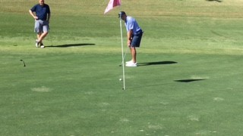
Paul drains this putt on #3 to take the lead
Dan responded on the 406-yard, Par 4 5th hole when he stuffed his approach to 2 feet and buried the putt for his opening birdie of the trip.
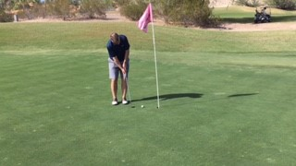
Dan cleans up this birdie on #5
There were no more birdies on the front nine, but Dan was playing lights out, as he shot 37. Fireworks followed on the first 3 holes of the back 9. Paul got things started on the 379-yard, Par 4 10th hole, when he hit his approach to about 12 feet, and again confidently sank the putt.
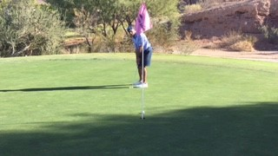
Paul strokes it home on #10
But Paul was not done, as he decided to go back-to-back on the 318-yard, Par 4 11th hole. This time his approach was not tight, as he left himself about 30 feet. But feeling good (likely from the fireball shots), Paul struck an absolutely brilliant putt and made his 3rd birdie of the day.
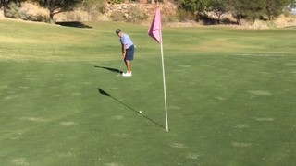
Paul stalks his 3rd birdie of the day on #11
Finding himself suddenly in a deep hole, Scott got on the board on the 519 yard, Par 5 12th hole, hitting his approach to 15 feet and actually managing to make a putt.
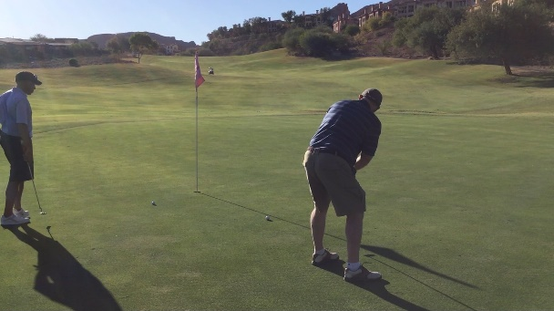
Scott makes it 3 birdies and 3 fireball shots in a row for the group on 12.
Things quieted down a bit after the barrage of birdies and also likely because of the barrage of fireball shots.
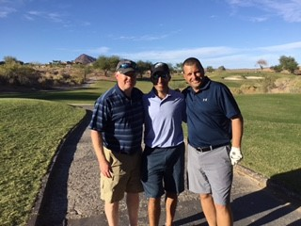
Still sucks but we're feeling pretty good after 5 fireball shots
We loaded up beers and more fireball from the cart girl on the 13th hole, even though we would not make any more birdies on the day.
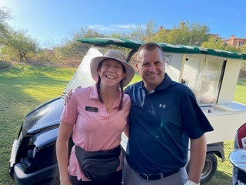
Traditional Dan and cart girl picture - 5 Fireball shots in full effect
There would not be any more birdies in the round although Dan continued to hit greens and have decent chances that he simply couldn’t convert. 2 double bogeys and a bogey in the last 3 holes left Dan with a 78, which was impressive but could have been even more so. With his 3 birdies, Paul fired an impressive 85, while Scott shot a not-so-impressive 99. Dan had 12 pars to go with his birdie. Scott and Paul combined for 6 pars and 4 birdies.
We headed back to the hotel, got squared away and cleaned up. Our rooms were nowhere close to each other. Paul got his own room (which he reportedly enjoyed VERY much) and Scott and Dan stayed together in the second room. We headed to The Cromwell for our reservation at Giada.
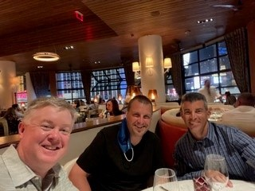
Continued sucking…
Giada was not nearly as good as we remembered. The food was fine, but the service was fair, the portions were small and it generally wasn’t worth the money. We agreed that we will likely not return.
We headed to our familiar stomping grounds at The Flamingo to do a little gambling. Things did not really go very well for any of us.
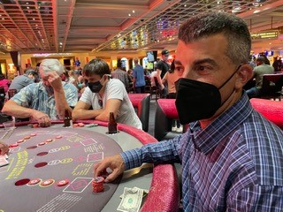
Paul losing at 3-card poker (in honor of Droz)
We walked back to The Mirage. On the walk back, Paul stopped at store to buy another bottle of Fireball. He decided on the larger bottle, which made sense, since we’d had such a barrage at Reflection Bay.
We did some gambling at The Mirage before Paul and Dan decided to call it a night. Scott stayed up a little longer at a $25 black jack table and made a small run to get back into the black for the trip.
Saturday, October 23, 2020
Despite a long day on Friday, Scott made MBBC history on Saturday morning by becoming the first player to work out during an MBBC. Scott headed to Orange Theory about 20 minutes from the strip for an hour class. After working out, he headed back to The Mirage to meet up with Paul and Dan in the sportsbook. In booking the round for Saturday, Scott had made a point of booking it for after 12:00, so that we could watch most of the Penn State-Illinois game, which started at 9:00 a.m., Vegas time. After taking their first loss of the season to Iowa the game before, a beat-up Penn State team struggled mightily with an awful Illinois team at home. We sat in the sportsbook, and Paul and several other Penn Staters had to convince the sportsbook to put the game on one of the screens. Paul had been in the sportsbook for a little while and had been convinced by a “hostess” named Danielle to register for an online MGM sportsbook account. Paul took the bait, but made sure that he still got free drink tickets from her even though he was using the app. Gregg Sterling and his friend, Heath, who were in town for Eagles came to hang out during the first half of the game. Shortly after halftime, we had to leave to head to South Shore Country Club for the second round. Service was spotty at the course, so we could only follow the game through text messages from Nicole and Sandy, which were confusing since we didn’t realize that overtime involved dueling 2-point conversions. Penn State ultimately lost the game putting yet another damper on the trip.
South Shore is a difficult course to start with, but being tired, a bit hungover, and angry about a Penn State did not lend itself to quality golf. The wind also started to pick up a bit (a sign of things to come). Scott and Paul struggled on the front 9. Dan played only slightly better and something good finally happened on the 177-yard, Par 3 8th hole. Dan hit his tee shot to about 15 feet and coaxed a slippery putt into the cup for his second birdie of the trip and to pull within 1 of Paul, who was showing no signs of adding to his lead.
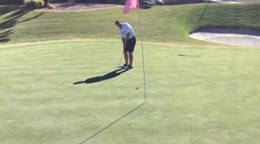
Dan makes it 2 for the trip on #8.
Things did not get much better on the back 9 for any of us. Scott did have a golden opportunity to get a second birdie on the difficult, Par 3 16th hole as he found the green with a 5-wood dead into the wind, but he hit an absolutely horrible putt. Dan shot 47’s on both sides to end with respectable 94 on a difficult course in difficult conditions, although disappointing after his blistering round at Reflection Bay. Scott shot 104 with a 9 and 10 in the card and Paul shot 102 but, most importantly, remained at the top of the MBBC leaderboard.
We headed back to The Mirage. After a frustrating day and since we didn’t have a reservation anywhere, we decided to try and get into a restaurant at The Mirage called The Still. The hostess was dumb as a box of rocks and spoke limited English, so it was unclear how long the wait was and/or how exactly she was managing the wait list. We waited for about 30 minutes before finally getting decent table which extended into the casino. At The Still, the waitress brings you drinks, but you have to walk to the back of the restaurant to order food from the “foodtruck” set up. We ordered way too much. The food was good but it was clear that if we didn’t leave soon we would fall asleep on the couches.
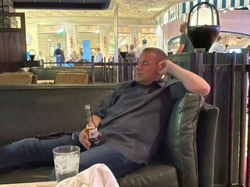
He's not really asleep. I think I just caught him with his eyes closed.
After dinner, we decided we would stay at The Mirage to gamble rather than walk somewhere else. Dan and Paul immediately found their home and played for hours.
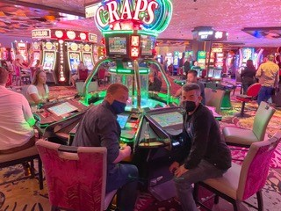
The people around them have no idea what they're in for...
Scott played some blackjack and some pai gow but basically treaded water for most of the night. Dan and Paul played bubble craps for 3 hours and seemed to do pretty well. We headed to bed pretty early, as we were set to play 36 holes the next day.
(It was unclear if he was serious, but Droz had suggested that if Sam started feeling better he could potentially catch a flight on Saturday and get in late Saturday night and join us for at least 3 rounds on Sunday and Monday. While Sam was doing okay, she was not well enough for this plan to actually come to fruition and any hope of Droz making it to Vegas officially ended.)

Sunday, October 25, 2020
We had planned to play 36 holes on Sunday long before we found out that the Eagles would be playing in Vegas against the Raiders. Paul insisted that he didn’t care about going to the game, and would be fine just watching it on his phone while we played. We were up early to get the day started and met Paul killing some time in the casino.
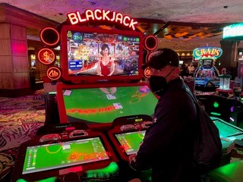
Even video blackjack didn't go well for Paul...
We then headed to Royal Links Golf Club, which is a replica course featuring various holes from Great Britain. The course was in very good shape and was actually pretty decent. Dan got rolling on the 339-yard, Par 4 1st hole, when he hit his approach to 3 feet and drained the birdie to move into a tie with Paul and force an early morning round of Fireball shots.
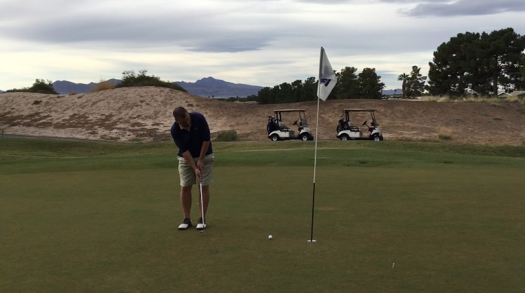
Dan gets rolling on #1.
Despite his continued miserable play, Scott would make a move in the right direction on the 404-yard, Par 4 6th hole. He managed to hit 2 good shots with his approach ending up 6 feet from the cup, and he was able to make a putt for once to move within 1 of Paul and Dan.
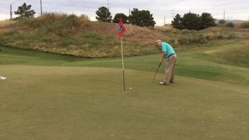
Scott gets his second of the trip on #6.
There were a few chances the rest of the round, but nobody could convert. Dan shot a decent 85. Paul shot 96, while Scott limped home with a 98 thanks in part to yet another 10.
After the round we headed toward Anthem Country Club for the afternoon round. We stopped for lunch at In-N-Out Burger, which we’ve never done before. It was pretty good. We continued on to Anthem Country Club with the Eagles/Raiders game kicking off. Anthem Country Club was in good shape, although not quite up to the level of Dragon Ridge. It was not overly difficult, although we were a bit tired since it was our 4th round in 3 days. There were several decent chances, but no one was able to find the range. Paul played very well shooting 42 on the back 9 to finish with a round of 87. Dan struggled to a 92, while Scott shot 94 with 3 touchdowns on the back 9. The Eagles ended up losing to the Raiders 33-22. The members of the country club were stating a Halloween party when we finished up. They were dressed up and had decorated their golf carts were going to play some night golf.
We headed back to The Mirage, got cleaned up and headed over to The Palazzo for our 8:30 reservation at Lavo. We were there very early hoping to get in earlier, but that was not possible. We sat in the bar area and grabbed a drink and were eventually seated. Dan was VERY excited to order the branzino, because he’d added when the family was in Vegas a few months earlier. We were waited on by Kristina. (Once again, I failed to get a picture… I don’t recall her being anything that required a picture be taken, but still…).
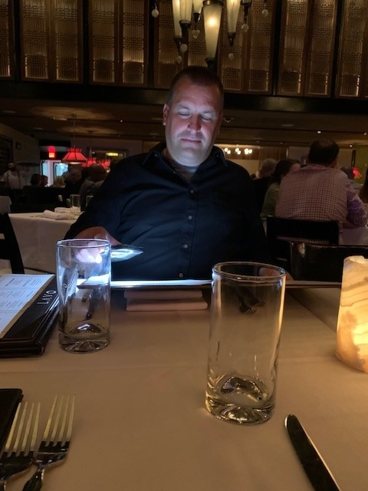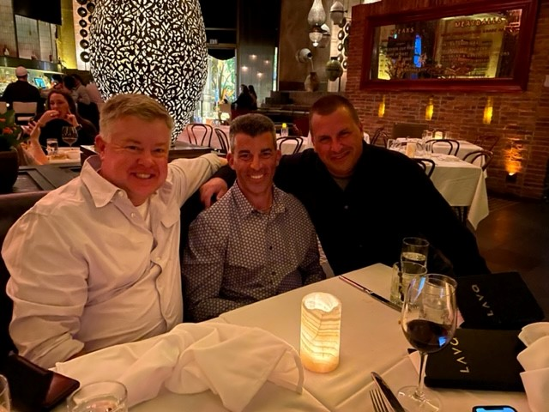
We are getting old…
After dinner, we decided to head to Wynn, since we’d never been there before. Wynn had incredibly high table limits, so we did not stay very long. We then decided to head to Treasure Island, which seemed to be right up our alley. Dan was looking for a spot at a craps table and Paul wasn’t sure what he wanted to do, so Scott convinced both of them to sit with him at a blackjack table. We all got absolutely killed in about 10 minutes, before we all decided to leave the table. Dan and Paul headed to craps while Scott played some Pai Gow. Scott’s luck turned at Pai Gow as he was dealt 2 straight flushes to win big on the bonus. He wasn’t really ready to leave when Paul and Dan were, but he made the smart decision to cash out and head back to The Mirage. I believe Paul and Dan played some more bubble craps before we called it a night.
Monday, October 25, 2022
We were up relatively early for the long drive for our final round at Wolf Creek. The weather seemed pretty good when we finally got there. We loaded up pretty quickly and off we went. Paul and Dan remained tied for the MBBC lead with Scott just one back with the hope that there would be some final round fireworks. There were a few chances on the first 3 holes including a golden opportunity on the second hole that he couldn’t convert, which caused him to curse.
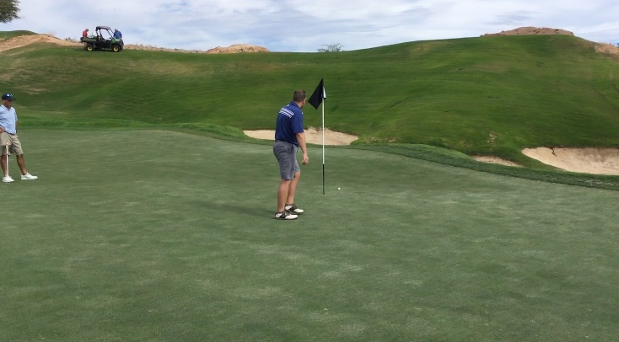
He say curse word...
Paul promptly took advantage on the 279-yard, Par 4 4th hole. Paul hit a terrible drive but was able to hit a good shot onto the green leaving 20 feet for birdie. Paul returned to his first round form and calmly drained the putt to move into a solo lead with 4.
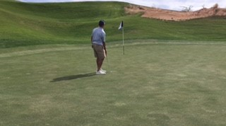
Paul buries his 4th of the trip on #4.
Not long after Paul made his birdie, the winds seemed to pick up dramatically. By the time we reached the back 9, there were sustained winds of at least 20 miles-per-hour and gusts significantly stringer than that. Despite the heavy winds, Paul and Dan, especially, continued playing well and continued to give themselves birdie opportunities. Scott was playing miserably and checked out at some point on the back 9 and was simply along for the ride. Paul had a legitimate opportunity to put the tile on ice on the 12th hole but couldn’t make a relatively short putt. Dan kept hitting greens but was unable to get anything closer than 15-20 feet. Scott was “officially” eliminated after failing to birdie on 17 (He made a 9). When Dan was unable to make birdie on 18, Paul was declared the unlikely 2022 MBBC Champion. (Interesting side note, since Paul stayed in a room by himself on a completely different floor and since Scott and Dan never went to Paul’s room, we never actually saw the trophy. Paul brought it, since Droz was unable to come and essentially “gave it to himself” and took it home. Only Paul knows if there was any kind of trophy ceremony. Dan and Scott also never saw the scoreboard. We only saw pictures of it when Paul would text it to us.)
Scott actually drove home from Wolf Creek with Paul bitching at him at one point that he was driving way too fast. After the long drive back to the hotel, we got dressed to head out to the Champion’s dinner at Hell’s Kitchen. It started raining as we walked to the restaurant. At one point, Paul actually slipped and fell on the slippery stones near the restaurant. It looked pretty bad but he claimed to be uninjured (yet, another indication of the bad ju ju on this trip). Since we were early for our reservation and since the place was absolutely packed, we sat at the bar next to the restaurant and grabbed a round of beers. Paul was a big fan of Saint Archer’s, an IPA from a brewing company based out of San Diego. We were finally seated, but service was incredibly slow and our waiter was kind of a dick. Paul had a short back and forth with the waiter regarding whether he could order the Beef Wellington at a temperature other than medium rare. The food took forever, but was good when we finally got it. Scott actually got a free dessert because the food took so long.
After dinner, we decided to head across the street to The Cromwell. Scott headed back to the Pai Gow table and once again hit a big bonus hand with 4 of a kind. Dan battled back at craps. Unfortunately, Paul left early because he had a 7:00 flight. (He might have also wanted to celebrate his MBBC title alone in his room.) Eventually, Scott and Dan had enough and headed back to The Mirage themselves.

Paul took a cab to the airport early the next morning. Scott took the rental car and returned and caught his flight home. Dan was stuck in Vegas for most of the day and walked around and surprisingly made some more money to end up in the black for the trip.

Everyone got home safely, and we’re now looking forward to the NEXT MBBC (which, oh look… is tomorrow)

Thanks for us.

