3/17/2017 The Man Child and Moses

On 9/23/2017 there will be a very rare sign in the heavens that relates to Revelation chapter 12. It's the sign of the Woman Clothed with the Sun. There is no comparable sign in the heavens for at least two thousand years into the past and one thousand years forward into the future.

The Woman Clothed with the Sun is travailing in birth, giving birth to a male child who will rule all nations. The sign in the sky on 9/23/2017 is therefore a sign of the coming King of Israel.

Because the birth of the man child of Revelation 12 is symbolic of Messiah, we can compare the birth timing with historical events having to do with the nation of Israel. We can also compare the birth of the man child with the life of Moses. Moses was a type, a symbol, of Israel's Messiah. Moses came to rescue the tribes of Israel from slavery and oppression and lead them toward the Promised Land.

Our Creator, YaHuWaH Elohim, rules, and over rules, in the affairs of the nations. YaHuWaH Elohim also has complete control of the motions of the stars and planets in the heavens, and has stated that He uses the heavenly bodies as signs to signal His appointed times.

The Birth of the Man Child and the Life of Moses

Below is a graphic that helps to confirm the validity of the sign of the Woman Clothed with the Sun and the birth of the man child on 9/23/2017.

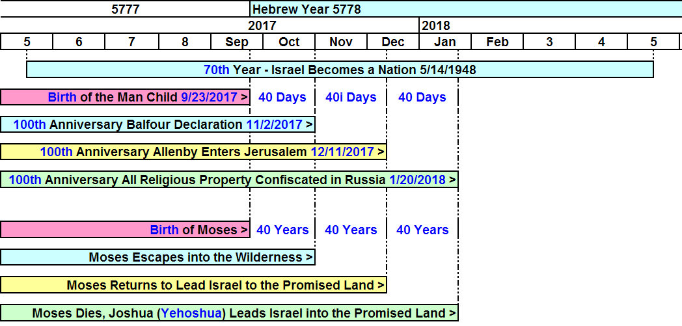

The above sequence of 120 days occurs approximately in the middle of Israel's 70th year as a modern sovereign nation beginning on 5/14/1948.

There were historical events about 100 years ago in 1917 that set the stage for Israel to become a sovereign nation. The 100th year anniversaries of those events are listed in the graphic above. There are some events of 1917 that aren't listed in the graphic, as they would tend to complicate it.

Red Communism and a Flood of Persecution

Not included on the above graphic is the fact that the Russian communist revolution ended on 11/8/1917. The symbol of a red star was immediately chosen to represent the new communistic government of Russia.

About 73 days after the end of the communist revolution on 11/8/1917, all religious property in Russia was ordered confiscated by the new communist government on 1/20/1918.

The confiscation of all religious property fits in with the future formation of the nation of Israel, as the confiscation of all religious property would have been a persecution of Jews, Christians, and Muslims, nudging them to pull up stakes and move out of Russia to another country. Those who resisted the nudge to leave the country may have been exterminated in Josef Stalin's genocides. Stalin's Soviet regime murdered 7 million Ukrainians in 1923-33. Ukraine was sealed off and NKVD death squads executed anti-party people. An additional 2 million people were sent to the Gulag where most died. Religious peoples are targets for extermination by communistic governments.

The United States and Communism

Bible reading and prayer were taken from the public schools of the United States in 1962 and 1963 by judicial decision. These acts were the first steps in the institution of godless communistic government indoctrination in the United States. A godless generation of children grew up being denied a knowledge of prayer and knowledge of their Almighty Creator by the United States government. They became the godless communistic indoctrinated professors that fill the Colleges and Universities, and the godless teachers in public schools today. The United States of America is now becoming the heartless beast that the Soviet Union was 80 years ago.

The 40 Day and the 40 Year Periods

Note in the graphic above how the color coded 40 year sections of the life of Moses agree with 40 day periods after the birth of the man child. Not mentioned in the graphic above is the fact that according to the instructions (Torah) of YaHuWaH Elohim, on the 40th day after birth the male child would be taken to the Temple for dedication to YaHuWaH Elohim.

It would have been on the 40th day after birth that YAHUSHUA (Jesus) was taken to the Temple in Jerusalem for His presentation before YaHuWaH Elohim. It was on that 40th day that Messiah was recognized by two people at the Temple, Anna and Simeon.

Revelation chapter 12 tells us that the man child will be caught up (Greek - Harpazo- taken by force) to YaHuWaH and His throne. We might wonder why he has to be forcefully taken, and who is taking him away.

The 100 year historical events falling at 40 day intervals after the birth of the man child, centered in the 70th year of modern Israel, tend to confirm the validity of the heavenly sign of the Woman Clothed with the Sun travailing in birth as being from YaHuWaH Elohim.

I don't know if these signs will be accompanied by similar physical events in 2017 and 2018, or if they are signs and warnings of future events.

We are aware that the United States has been in a very chaotic political situation since Donald Trump was elected President.

Our heavenly Father has arranged the timing of the signs and events mentioned in this and prior articles for our admonition. We need to be watchful and prepare for the end of the age. As we walk with Him, He will shelter us in the time of storm.

