​
​
October 5, 2017
Effective immediately, Chicago Title is excited to announce our company-wide WireSafe™ Program.
The WireSafe Program is aimed at informing our Realtors® and Broker Partners about the dangers and warning signs of wire fraud. From time to time, you will receive special Alerts from us regarding any new type of fraud we have discovered that is taking place in our industry.
We hope you will find the alerts useful and share them with your clients as soon as you receive them.
Together we can help fight cyberfraud!

ALERT#1Chicago Title has been made aware of communications being sent impersonating FNF* employees. Below please find an email address purporting to belong to FNT (Our sister company).
From: Fidelity National Title [mailto:vgparada1015@eagle.fgcu.edu]
Please note that the domain name eagle.fgcu.edu is NOT affiliated with FNF. As a reminder, the FBI recommends that parties examine the actual email address of the sender in all email communications received prior to responding, clicking on links or opening attachments.
Sample of the email:
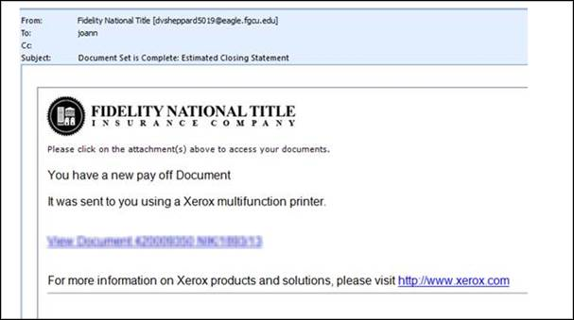​
It’s very common for an attacker to spoof a display name to look like it is coming from us, always verify the sender by hovering over the
“From display name” to see what email address pops up (to hover, move your mouse or cursor over the information that you want to verify.
This is the easiest, and still one of the most effective ways to protect yourself from the frausters.
Again, please alert your buyers NOT TO WIRE ANY MONEY BASED ON AN EMAIL! ALWAYS CALL BEFORE THEY WIRE!

Please share the above Alert with your clients!
%Agent.FirstName% %Agent.LastName%
%Agent.WorkPhone.ParentFormat%
Chicago Title Company
%Agent.Address.Street%
%Agent.Address.City%, %Agent.Address.State% %Agent.Address.Zip%
*Chicago Title is a member of FNF (Fidelity National Financial)

