3/17/2018 The Events of the Week of 2/10/2018, etc.

The week of 2/10/2013 was a symbolic mini-tribulation period.

Here's a list of the events occurring in that week that were of global interest:

02/10/2013 - The Carnival cruise ship Triumph lost electrical power. The ship became a microcosm of some of the human suffering that's coming to the entire earth during the great tribulation period ahead. The weather was hot in the Caribbean Sea. The toilets were overflowing and unusable. Because of a lack of refrigeration, passengers were eating onion sandwiches for days on end. It was noted at the time that if the "i" and the "h" were removed from the name "Triumph", the result is "Trump", mindful of the trumpet judgments mentioned in the book of Revelation, etc.\

02/11/2013 - North Korea exploded an atomic bomb.

02/11/2013 - Pope Benedict, the 265th Pope, announced his resignation, ushering in the election of the 266th pope. The measure of a fish in ancient Greek mathematics was 153 units x 265 units. The vesica pisces "fish symbol" became a symbol of Christianity. Peter and the catch of 153 fish are mentioned at the end of John chapter 21.

Pope Francis, a militant Jesuit and communist, being the 266th Pope, is the first Pope to be "outside the symbolic fish" of Christianity. The account of Jonah being cast from the mouth of a great fish would identify Pope Francis as a prophet of sorts. Think about it.

02/14/2013 after sundown (02/15 YaHuWaH 's time) - The Carnival cruise ship Triumph arrived under tow in Mobile, Alabama. It was the end of a mini tribulation period for the 4,229 passengers and crew.

02/15/2013 - A rare 10' meteor exploded over Siberia injuring about 1,000 people. (The arrival of the Messiah at the end of the age is described symbolically in Daniel chapter 2 as a rock coming from heaven and destroying and replacing the current systems of world government)

02/15/2013 - A rare asteroid event having the potential to destroy all of southern California from north of Los Angeles to San Diego passed very near the earth on the same day as the rare meteor event mentioned above. Asteroid 2012 DA14 passed just 17,200 miles above the earth over Indonesia at its closest approach.

http://earthsky.org/space/asteroid-2012-da14-will-pass-very-close-to-earth-in-2013

Linking 2/11/2013 to the Day of Trumpets in Two Separate Years

The date 2/11/2013 is linked to the Day of Trumpets in both 2019 and 2020 via two separate important events in modern Israel's history. We're told to watch for events that are related to YaHuWaH Elohim's appointed days, such as the Day of Trumpets.

According to the astronomy program, if the sky is clear in Israel on the dates listed below for the Day of Trumpets, the new moon will be able to be observed after sunset for those who follow the Karaite method on 9/29/2019 and also 9/18/2020.

Below is a graphic depicting the relationship of Pope Benedict's resignation announcement on 2/11/2013 with the Day of Trumpets 2019 and the Israeli Six Days War.

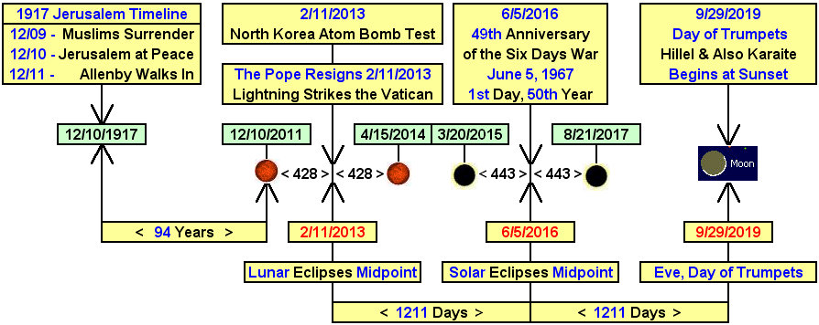

The central date in the graphic is 6/5/2016, the 1st day of the 50th year from the beginning of the Six Days War in Israel, during which Israel captured the city of Jerusalem from Jordan.

Note in the graphic above how the date 2/11/2013 is related with 9/29/2019 when the Day of Trumpets begins at sunset.
The exact central time between the lunar eclipses of 12/10/2011 and 4/15/2014 is 10 minutes after midnight in Rome and 1:10 AM in Jerusalem on 2/11/2013.

June 5, 2016, is the 49th anniversary of the Six Days War, and also the 1st day of the 50th year from the Six Days War. June 5, 2016, is the central focus at 1211 days each from 2/11/2013 and also 9/29/2019.

Below is a graphic depicting the relationship of Pope Benedict's resignation announcement on 2/11/2013 with the Day of Trumpets 2020 and the partitioning of the Promised Land by the UN.

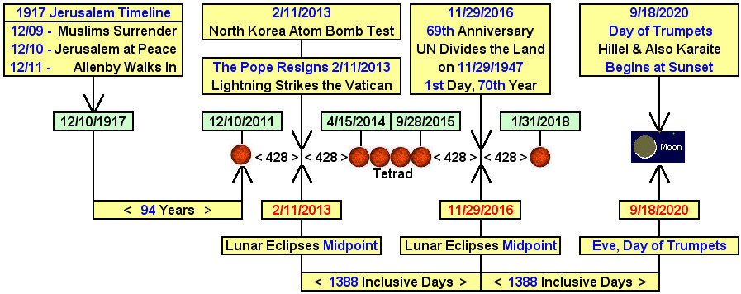

The central date in the graphic is 11/29/2016, the 1st day of the 70th year from the partitioning of the Promised Land by the United Nations on 11/29/1947.

Note in the graphic above how the date 2/11/2013 is related with 9/18/2020 and the Day of Trumpets beginning at sunset. November 29, 2016, is the 69th anniversary of the partitioning of the Promised Land by the United Nations Organization, and also the 1st day of the 70th year from the partitioning of the Promised Land by the United Nations.

The date November 29, 2016, is the central focus from 2/11/2013 and also from 9/18/2020 at 1388 days each.

Summary

The relationships between the dates on the graphics above indicate the supernatural abilities of YaHuWaH Elohim to integrate astronomical events with human life and governments on the earth.

The timelines above are a two fold witness that should attract our attention to current events, as Moses was attracted to a burning bush that wasn't consumed in the fire.
It may be that we will receive instruction from our heavenly Father if we turn aside from the everyday events of our lives to observe the strange occurrences around us.

