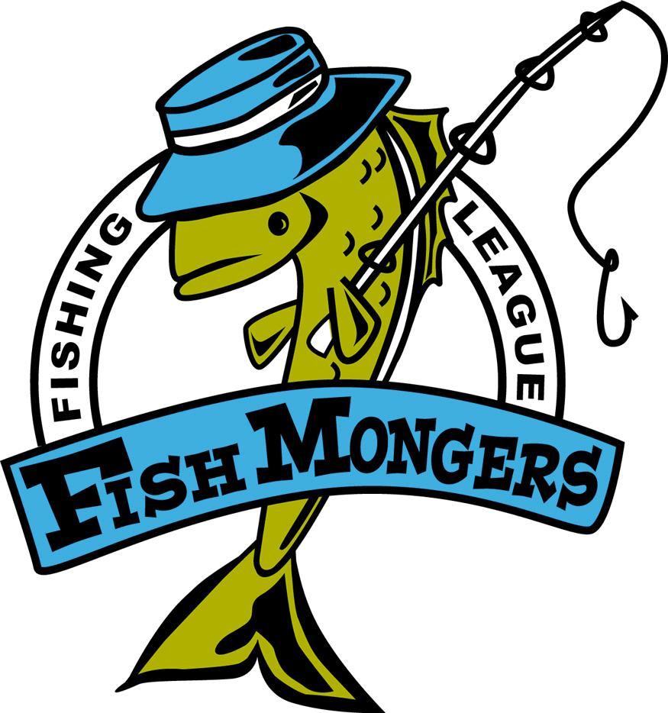
09/14/2007 Gull Final
Team | Skunk | Walleye  23.25 Edward Weinkauf | Northern  34 Ford  Mission | Black Bass  18  Greatens  Mission | Rock Bass  10.75 Lueck Edward | Weekly Points | Total Points
Robertson/ Sundquist |  | 21.5,21.25 | 24.25,25 | 13.75, 13.5 |  | 22 | 84
Weinkauf/  Nelson |  |  | 25,26 | 15,15 |  | 10 | 54
Peterson/  Rud |  |  |  | 14,14 |  | 4 | 52
Bryan Raguse/ Andy Kratochvil |  | 14,18 | 33 |  |  | 6 | 42
Greatens/  Stahl |  |  |  |  | 11 | 1 | 38
Johnson/  Lueck | NS |  |  |  |  | 0 | 25
Anderholm/  Nelson | XX |  |  |  |  | 0 | 25
Ford/  Dave S. | XX |  |  |  |  | 0 | 23

