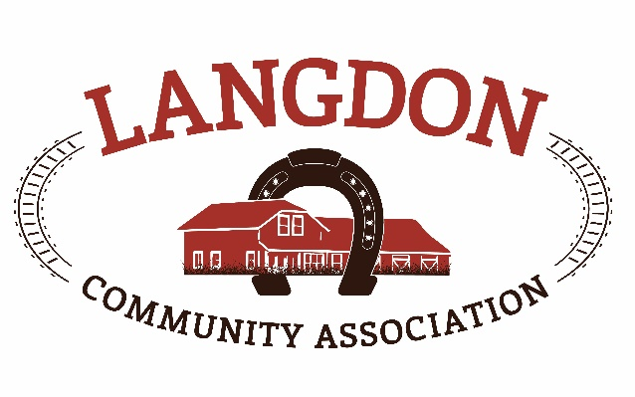
Langdon Community Association
Box 134
Langdon, AB T0J 1X0
www.goodlucktown.ca

LCA Meeting – December 6, 2020
Location: Teams Call

In Attendance:
Chrissy Craig – Chair
Jessica Smythe – Vice Chair
Tom Craig – Capital Projects
Nicole Porquet-Seitz – Director
Crystal Upstone – Events
Brian Ferguson - Treasurer
Corrie Carrobourg – Director
Nicki Black – Secretary
Scott Pike – Parks
Brandi-Lee Mouck – Community Programs
Tony Baker

Meeting called to order at 1932

- Approval of Agenda:
  - Motion to approve the agenda with additions: Jessica & Brian
- Approval of Minutes:
  - Motion to approve the minutes from November 15, 2020: Jessica & Nicole

- Reports See Below reports
Next LCC meeting – January 17, 2021, 6:30 – 7:30pm, before LCA meetings.

- Standing Business
  - Tasks review – reviewed and updated
  - Risk Management – by law review was sent out before the meeting for all to review. Two main points of discussion, 1. Should LCA board dissolve where do funds go to and 2. Increase range for directors to 7 – 15 members. Full reviews will take place once documents are done.
  - Succession Planning –link sent to member to update in Sharepoint.
  - Education – Online Federation of Calgary Communities resources and education class for new board members or new board positions. Courses have been sent out and free to register. Chrissy will forward current courses available.
  - Strategic Planning – details sent to board for review
  - Langdon Community Campus – Deficiencies will be completed in April. Plan to have the first tournament May 3rd weekend. LCA license of occupation up for renewal in January. Plan to renew for 1 year and then negotiate all facilities at that time. In the RVC Rec masterplan, Langdon is number 1 for need of a facility.
  - Newsletter content – use content from previous meeting notes.

- Discussion
- Ball update – Ball diamonds need to be open by May 1st for the season. County will only come out with something by March as they are shut down till January. The committee presented the budget and goals, understanding revenue needs to be finalized with community groups. Budget and operation plans can only be done when there is an understanding of what’s included from the County. Need solid numbers for next meeting for review and approval.
- Rink and AHS Guidelines – no official guidelines for outdoor rink. Complaints two weekends in a row about number of people on the ice and around the rink. RCMP came out to educate those that were there. The socializing in the parking lot is more the problem than the numbers on the ice. Signs with recommendations will be going up shortly and Bylaw will be checking in or compliance by the community.
- Temporary rink – location still to be decided. When temps drop will flood it and get it started.
- Zamboni – currently dumping snow where picnic table will be going and they are ready for delivery. Parking currently blocks Zamboni entrance to the rink. Scott will block off are with barricades as required.
- Raffle – lots of people signed up on the first day, but very few since. Members to promote the event. Chamber will share with all its members too.
- Christmas Lights – some are up and more will be added.
- Christmas Adopt a Planter – all adopted, a few still to be completed. Cobblestone garden center gave us items for the planters at cost. Good community feedback.
- Garbage in the park – the bins around the rink and outside the FH are always overflowing. Chrissy to see if clearing the bins can be included in Sticky’s Maintenance contract. Chrissy to email Al Schule about garbage in the park.
- Fire Inspection – day care had their annual inspection and a few minor maintenance details need to be taken care of. Dave has completed some and working on the remainder. Only one bigger safety need suggested and that is to replace the front doors with push bar safety doors.
- Budget review – reviewed and motions passed.
- Motions
  - Approved by email – none
  - Approved at meeting – Motion to approve the 2021 Operational Budget presented at the meeting – Nicole, second Tom and all in favour.
  - Approved at meeting – Motion to approve the 2021 Capital Budget presented at the meeting – Nicole, second Jessica and all in favour.

Adjourned 2037h

Reports
Events report –
Funds development report –
Communication report –
Parks report – Rink to open with guidelines
Program report –
Fieldhouse report –
Capital Projects Report –
Bingo Report –

Future Meeting (calendar invites sent to your goodlucktown.ca emails)
All meetings at 730pm at The Fieldhouse unless noted

Next meeting January 17, 2021

