12/03/2016 The Culmination of Years

The year 2017 will see a culmination of times in the history of the nation of Israel having 49-50, 69-70, 99-100, and 119-120 year anniversaries.

Here's a graphic depicting some of the events:

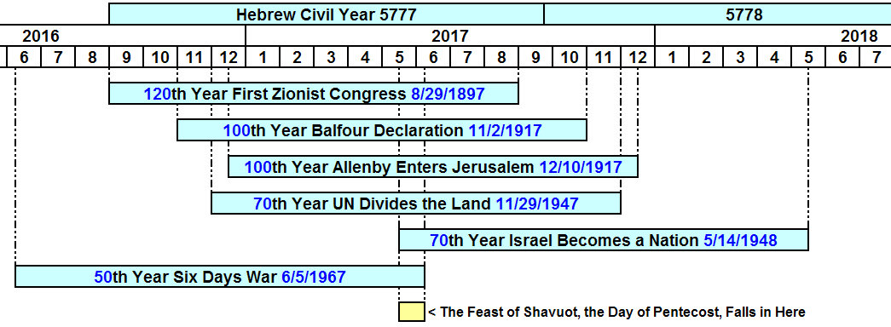

The yellow box above indicates the period that is common to all, being shared with all the others. It's May 14, 2017 to June 5, 2017.

Counting to 50

Note that the Hebrew Karaite Feast of Shavuot and the Christian Day of Pentecost will fall on 6/4/2017, with exactly 50 years from the beginning of the Israeli Six Days War being filled on 6/4/2017. The next day, 6/5/2017, is the 50th anniversary and the 1st day of the 51st year from 6/5/1967.

Because the Feast of Shavuot falls on different days in different years, it's significant that the Feast of Shavuot 2017 falls precisely on the very day that completely fills exactly 50 years from the beginning day of the Six Day War.

The instruction for finding the Feast of Shavuot given by YaHuWaH Elohim was to start counting on the Day of Firstfruits (Resurrection Day) when the very first harvested Barley sheaf is waved before YaHuWaH Elohim and count seven Sabbaths, 49 days. The next day, the 50th, would be Shavuot (Pentecost).

Leviticus 23:15 And ye shall count unto you from the morrow after the sabbath, from the day that ye brought the sheaf of the wave offering; seven sabbaths shall be complete:
16 Even unto the morrow after the seventh sabbath shall ye number fifty days; and ye shall offer a new meat offering unto YaHuWaH .

The Six Days War and the Feasts of YaHuWaH Elohim
The Feast of Shavuot is the beginning of the annual wheat harvest in Israel.

The Feast Days of YaHuWaH Elohim are equated with Israel threshing the nations.

Micah 4:11 Now also many nations are gathered against thee, that say, Let her be defiled, and let our eye look upon Zion.
12 But they know not the thoughts of YaHuWaH , neither understand they His counsel: for He shall gather them as the sheaves into the floor.
13 Arise and thresh, O daughter of Zion: for I will make thine horn iron, and I will make thy hoofs brass: and thou shalt beat in pieces many people: and I will consecrate their gain unto YaHuWaH , and their substance unto the Master of the whole earth.

Informative Links:

Here are some informative links to information concerning the events indicated above.

1. The First Zionist Congress 8/29-31/1897: https://en.wikipedia.org/wiki/First_Zionist_Congress

2. The Balfour Declaration 11/2/1917: https://en.wikipedia.org/wiki/Balfour_Declaration

3. Edmund Allenby enters 12/10/1917: https://en.wikipedia.org/wiki/Edmund_Allenby,_1st_Viscount_Allenby

4. United Nations Partitions the Promised Land 11/29/1947: https://en.wikipedia.org/wiki/United_Nations_Partition_Plan_for_Palestine

5. Israel becomes a Sovereign Nation 5/14/1948: https://en.wikipedia.org/wiki/Israeli_Declaration_of_Independence

6. Israeli Six Day War 6/5/1967: https://en.wikipedia.org/wiki/Six-Day_War

7. The Meaning of Numbers in the Bible: http://asis.com/users/stag/godcount.html

There are other relevant events culminating in 2017 that will be added later. This is enough for now.

