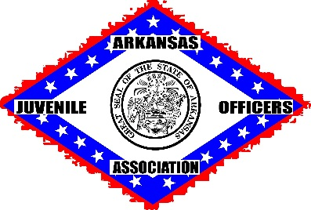

**CONFERENCE REGISTRATION FORM**

**MARCH 5-7, 2025**

**POCOLA, OKLAHOMA (FORT SMITH)**

**CHOCTAW CASINO & RESORT**

NAME: ________________________________________________

ADDRESS: ________________________________________________

JOB TITLE: ________________________________________________

COUNTY(IES): ________________________________________________

TELEPHONE: _______________________FAX______________________

EMAIL: ________________________________________________

ALL OF MY INFORMATION IS THE SAME SINCE LAST CONFERENCE: ____YES ____ NO

(IF YOU ARE A NEW EMPLOYEE IN YOUR COUNTY, PLEASE MARK “NO”)

REGISTRATION: $50

DUES: $20 (ONLY IF YOU HAVE NOT PAID 2024-25 FISCAL YEAR)

TOTAL PAYMENT: _______________

MAKE CHECKS PAYABLE TO ARKANSAS JUVENILE OFFICERS ASSOCIATION.

**MAIL TO: AMY POWELL, AJOA TREASURER**

**511 UNION, SUITE 310**

**JONESBORO, AR 72401**

PLEASE DO NOT FAX THIS FORM.

QUESTIONS? CALL AMY @ 870-219-8143 OR [WWW.AJOAONLINE.COM](http://WWW.AJOAONLINE.COM)

511 Union, Suite 310, Jonesboro, AR 72401 ● 870-933-4545 (ph) ● 870-933-4597 (fax)

Arkansas Juvenile Officers Association