There are indications that some ancient Hebrews have intermarried with Native Americans.

The Ten Commandments have been found engraved on a rock in a field in Las Lunas, NM. The writing is in early Paleo Hebrew. It has been verified by archaeologists to have been created around 700 BC, just after the dispersion of the northern 10 tribes of Israel by Assyria in 721 BC.

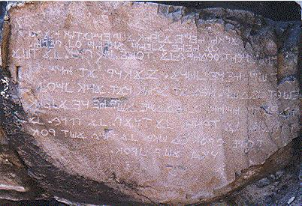
The Ten Commandments in Los Lunas, New Mexico Written Circa 700 BC.
Here's a link to a video that reveals the Name used by the Native American Cherokee for the Great Spirit.
Video 2:14
https://www.youtube.com/watch?v=vkqpFFPfp4c&feature=youtu.be

