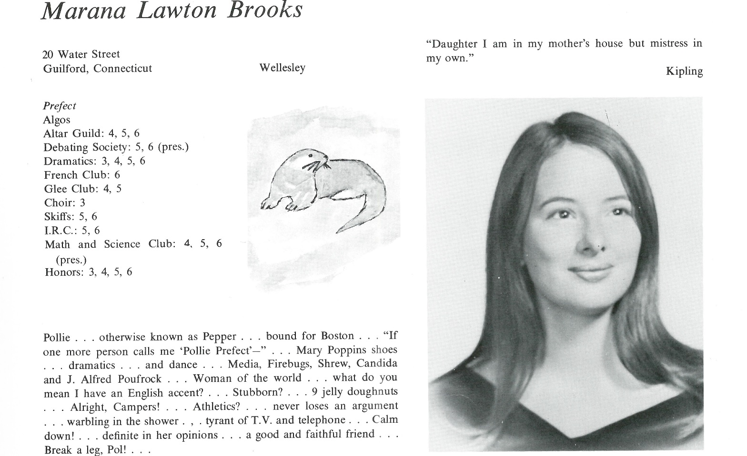

Marana “Polly” L. Brooks

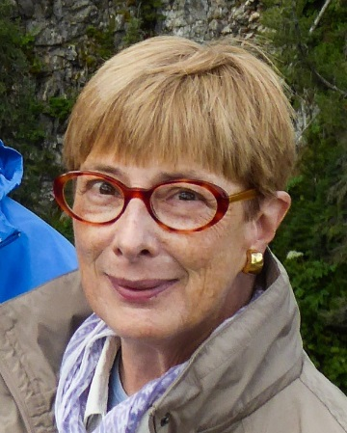Please call me Polly.

After Kent, I spent a year in England, thanks to E-SU, at a wonderful school, Moreton Hall, which is thriving. (The school my sister, Maggi, ’64, went to is no longer.) I keep in touch with people at that school, too. When I was in Edinburgh in April, I saw someone I hadn’t seen since 1968. Others I caught up with when I asked if anyone might be in London when I went to the Chelsea Flower Show (yup) a few years back.

I am grateful to Paul Barstow who taught at Wellesley. He got me my first money prizes, and my first paying job in theatre, at the Provincetown Playhouse –on-the-Wharf. I was supposed to be an apprentice, but the fates said I’d get paid. They said that to Richard Gere, too. We had our first paid acting gigs in O’Neill’s “Great God Brown” – we were not very good.

Paul connected me with the O’Neill Theater Center, where I met Lloyd Richards, who was at NYU, so I auditioned. I may be the only person who ever received both a BFA and an MFA from the Theatre Program (now called Grad Acting) … That was so long ago.

I paid the rent as a ghost writer and development steward for the Theatre Program, which allowed me to audition and work in the theatre in the city.

Since 1978, I’ve lived in Litchfield with my husband, Reto (rhymes with NATO) Morosani, in Litchfield, CT, where we both grew up.

We raised 3 boys, 2 of whom are living. I donated a kidney to the one who eventually requested hospice, and died, comfortably, at home. Because of the boys, I learned a lot about Montessori, AMI and AMS, and took folks from a nearby city to a conference on Montessori magnet schools. I also know more about LD and testing and accommodations than you want to know (don’t ask, unless you need some info- then, ask).

Currently, I’m the 2nd Vice President of Federated Garden Clubs of CT, Inc., in charge of Membership. I just finished 6 years as Chair of Environmental Studies School. I owe this federation the next 6 years.

I have additional nonprofit jobs.

We have Siamese cats, the cats of my childhood, after years of taming whatever ferals were dropped off. We’re in the country, so we have… wildlife. Can I offer you a groundhog? We have Darryl, and his other brother, Darryl.

Thank you for this spring’s opportunity to cold call people with whom I’ve had no contact in 50 years. It has proved precious.



______________________________________________________________

______________________________________________________________ ______________________________________________________________ ______________________________________________________________ ______________________________________________________________ ______________________________________________________________ ______________________________________________________________ ______________________________________________________________ ______________________________________________________________

Attach Picture in .jpg Format

______________________________________________________________

______________________________________________________________

___________________________________________________________________________________ _________________________________________________________________________________________________________________________________________________________________________________________________________________________________________________________________________________________________________________________________________________________________________________________________________________________________________________________________________________________________________________________________________________________________________________________________________________________________________________________________________________________________________________________________________________________________________________________________________________________________________________________________________________________________________________________________________________________________________________________________________________________________________________________________________________________________________________________________________________________________________________________________________________________________________________________________________________________________________________________________________________________________________________________________________________________________________________________________________________________________________________________________________________________________________________________________________________________________________

___________________________________________________________________________________