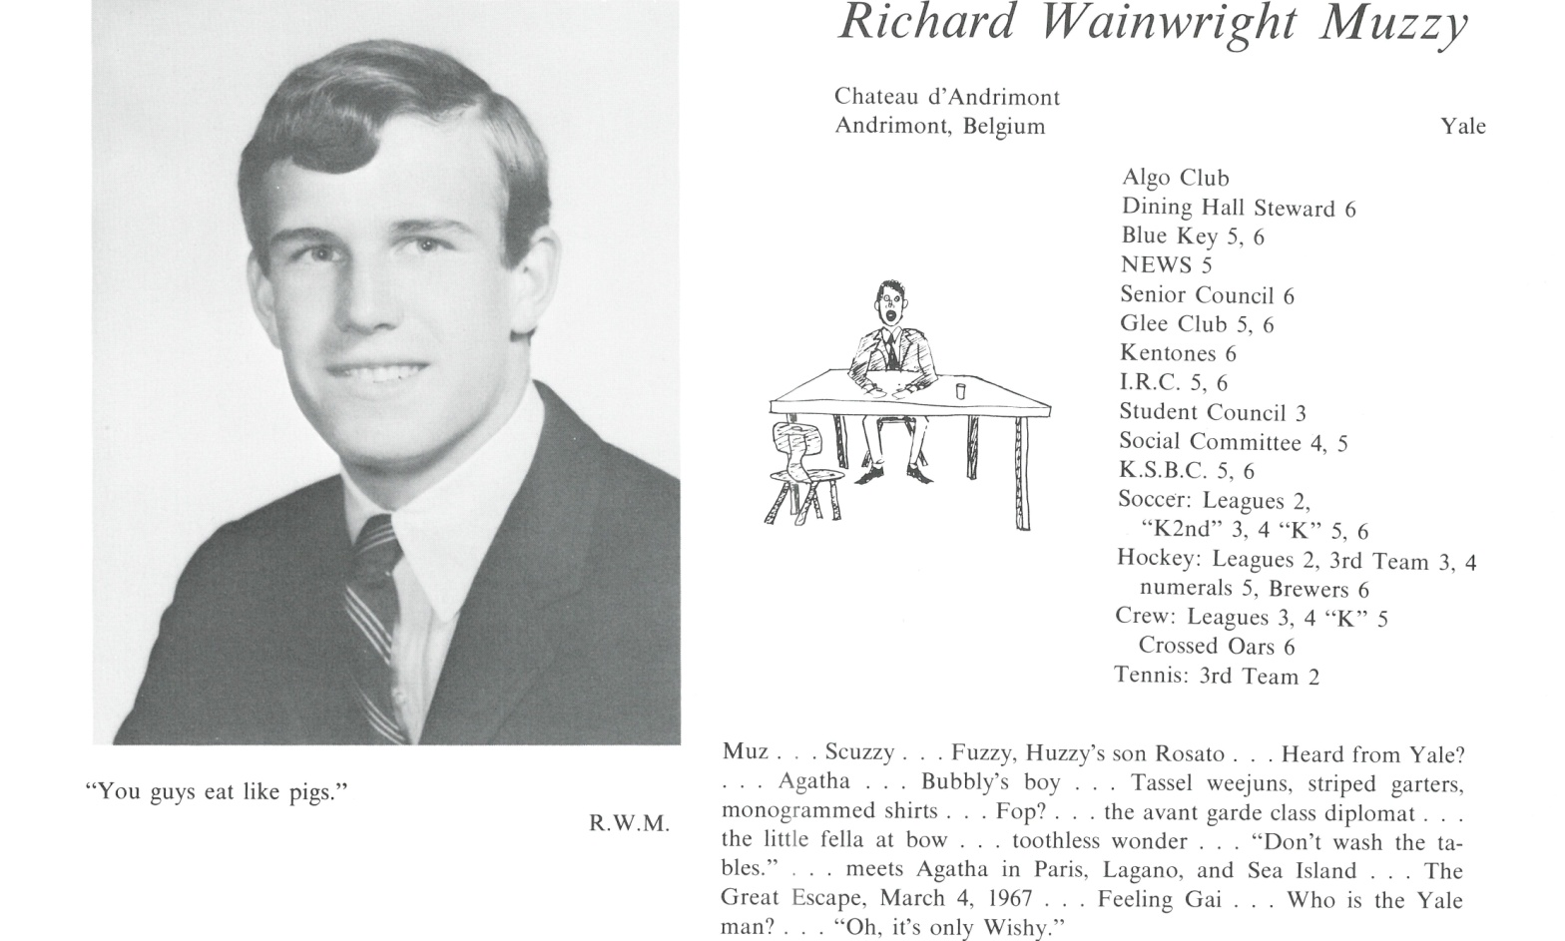

Richard W. Muzzy

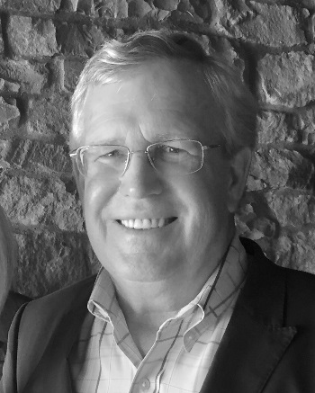I survived four years at Yale, the student protests, union strikes and the Bobby Seal Black Panther trial by finding refuge at the DKE fraternity (President) and the Yale Rugby Club (Match Secretary). This required some supplemental post graduate work so in lieu of business school I opted for training in market research with Alex Harvey Industries in Auckland, NZ (1972) followed by exposure to balance sheets at the First National Bank of Boston (1974) and financial analysis at Banco de Boston in Sao Paulo, Brazil (1975-1977). Unfortunately French at Kent did not make me fluent in Portuguese so, having lost track of almost everyone, we returned to the Mid-West and joined the Holland Hitch Company aka The Holland Group, Inc. I rounded out my business education with Holland starting as Asst. Controller, then VP-Finance, President and later Chairman-CEO (1977-2006). We ultimately sold the company to an investment fund in London and merged with a German company now known as SAF-Holland S.A. now publically traded on the German exchange. I remained on the Board for nine years and made the final exit in 2015. It was an incredibly interesting experience.

Along the way I was involved as Chapter Chairman for the Young Presidents Organization and served on the Board of several Michigan private companies. Married Susan Beebe in 1973 and adopted two children, Philip now 36, married and working for a winemaker in Paso Robles, CA, and Katherine (34) who just finished nursing school in Maine. No grandchildren.

Also, no complaints other than having to put aside all joint jarring sports in favor of fly fishing, duck hunting and golf. Not a bad trade since they all offer the opportunity to be outdoors in some really spectacular locations. I organized a fly fishing safari in retirement that the kids dubbed Dangling with Dick which in turn kept me busy for five summers. We have been involved and supportive of many local organizations primarily in the arts, conservation and urban renewal and currently split our time between Michigan and Florida.

I think Kent School was a challenging experience that delivered some hard learned lessons. I was glad to have five years to stop, look and listen and I believe the values of Temperantia, Fiducia, Constantia are still valid today... "Here endeth the Lesson."  Thank you for being a part of those years.



______________________________________________________________

______________________________________________________________ ______________________________________________________________ ______________________________________________________________ ______________________________________________________________ ______________________________________________________________ ______________________________________________________________ ______________________________________________________________ ______________________________________________________________

Attach Picture in .jpg Format

______________________________________________________________

______________________________________________________________

___________________________________________________________________________________ _________________________________________________________________________________________________________________________________________________________________________________________________________________________________________________________________________________________________________________________________________________________________________________________________________________________________________________________________________________________________________________________________________________________________________________________________________________________________________________________________________________________________________________________________________________________________________________________________________________________________________________________________________________________________________________________________________________________________________________________________________________________________________________________________________________________________________________________________________________________________________________________________________________________________________________________________________________________________________________________________________________________________________________________________________________________________________________________________________________________________________________________________________________________________________________________________________________________________________

___________________________________________________________________________________