ACTIVITY
KIT

- Moth Match - Observation (Similarities)
- Count the Crickets - Math (Whole Numbers)
- Something's Fishy - Observation (Differences)
- Raindrop Rhyme - Language Arts (Rhyming)
- Spider Maze - Fine Motor Skills (Directions)

Copyright © 2018 by Dee Leone Created Using Art by Bali Engel Nature's Lullaby Fills the Night (Sterling Children's Books)
MOTH MATCH

Draw a line between each pair of matching moonlit moths.

Moths with powdery wings so soft gently stir the air aloft.
Their flitter-flutter lullabies barely whisper, "Close your eyes."

(from Nature's Lullaby Fills the Night by Dee Leone)

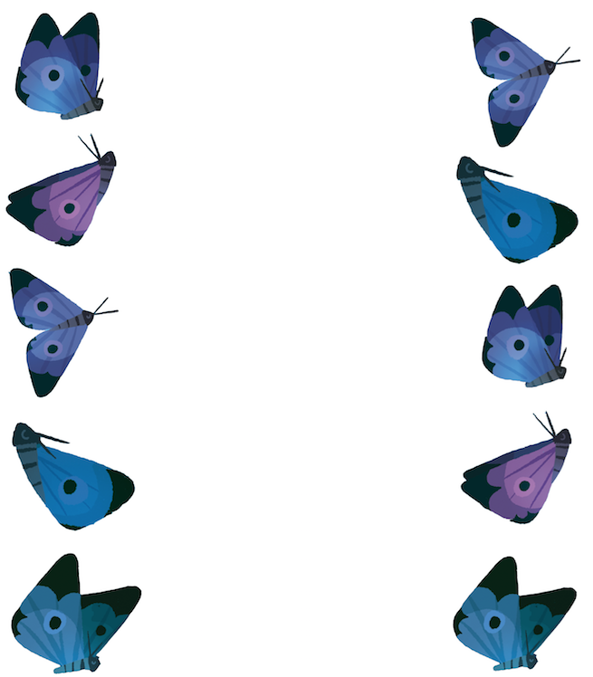

Copyright © 2018 by Dee Leone Created Using Art by Bali Engel Nature's Lullaby Fills the Night (Sterling Children's Books)
COUNT THE CRICKETS

Count the crickets or pairs of musical notes in each group.
Circle the correct number under each picture.

Crickets slide their slender wings like bows across a violin's strings.
A chirping concert fills the air, and music vibrates everywhere.

(from Nature's Lullaby Fills the Night by Dee Leone)

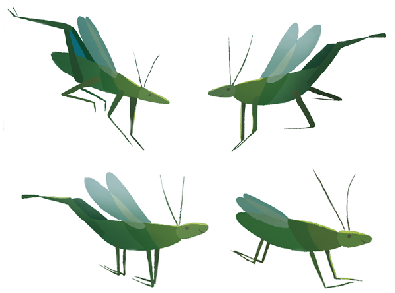

1 2 3 4 5 1 2 3 4 5

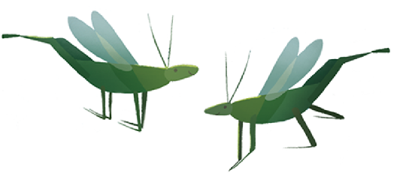

1 2 3 4 5 1 2 3 4 5

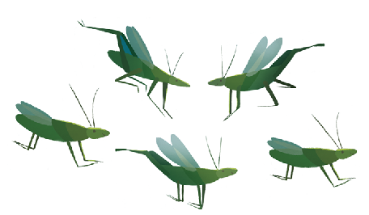

1 2 3 4 5 1 2 3 4 5

Copyright © 2018 by Dee Leone Created Using Art by Bali Engel Nature's Lullaby Fills the Night (Sterling Children's Books)
SOMETHING'S FISHY

Compare the pictures. Each fish on the right is missing something.
Add the missing items to each fish.

Stars drift idly through the sky twinkling their lullaby.
Their glitter dusts the oceans wide, where sleepy little fishes hide.

(from Nature's Lullaby Fills the Night by Dee Leone)



Copyright © 2018 by Dee Leone Created Using Art by Bali Engel Nature's Lullaby Fills the Night (Sterling Children's Books)
RAINDROP RHYME

Draw lines between the raindrops that have rhyming words on them.

A pitter-patter serenade
falls where woven dreams are laid.

(from Nature's Lullaby Fills the Night by Dee Leone)









Copyright © 2018 by Dee Leone Created Using Art by Bali Engel Nature's Lullaby Fills the Night (Sterling Children's Books)
SPIDER MAZE

Help the spider get to the center of the web.

Spiders spin their silky webs
as raindrops land upon their beds.

(from Nature's Lullaby Fills the Night by Dee Leone)

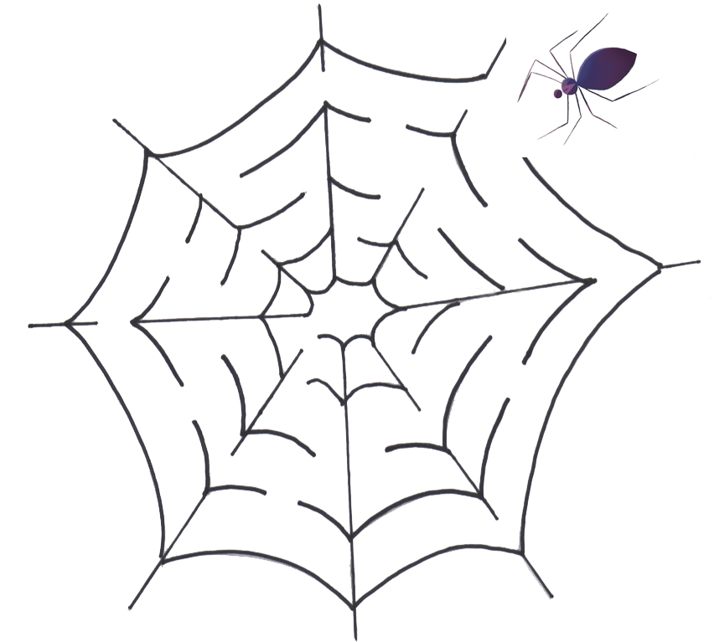

Copyright © 2018 by Dee Leone Created Using Art by Bali Engel Nature's Lullaby Fills the Night (Sterling Children's Books)

ANSWER KEY

Moth Match

Left 1st and Right 3rd
Left 2nd and Right 4th
Left 3rd and Right 1st
Left 4th and Right 2nd
Left 5th and Right 5th

Count the Crickets

4, 3
1, 2
5, 2

Something's Fishy

Add dots to the top purple fish.
Add two triangular stripes to the blue fish.
Add a tail fin marking to the third highest fish.
Add a mouth on the small purple fish.
Add an eye on the bottom fish.

Raindrop Rhymes

wings - strings
red - bed
night - light
snow - grow
nest - rest
sleep - sweep
lake - wake
song - long
bay - play
wide - hide

Copyright © 2018 by Dee Leone Created Using Art by Bali Engel Nature's Lullaby Fills the Night (Sterling Children's Books)

