

2023
International Singles Open

Twenty six players took part in our second International Singles Open and the first competition of our three day weekend of competitions.

Round one saw defending champion Laurent Pellaton take on Margaret Robinson from local club Carrefour with a resounding win for the champion.

Top players from Norway, Benny Bel-Lafkih, Gabriel Bel-Lafkih, Eli Gjengstoe, all part of Norway successful European Cup team in 2022.

Benny played Alex Stewart taking the win 13-8, Gabriel played accomplished local player Brian Harris winning comfortably 13 – 1 and Eli also came out on top winning 13 – 5 against Clifton Gonsalves from the UK.

Eric Boeuf and Julian Rouhard from France whom we also met in the European Cup in Angoloume were playing in their first tournament outside France. Eric played Ross Churchill winning 13-5 and Julian played John Whitworth from the UK also winning 13-5.

Losses for top Jersey players as Andrew Bellamy lost 13 – 12 to Stuart Brown from the UK and Toby lost to Christine Spray from the UK and part of the Petanque Events team.

Round two, saw winners play winners and losers play users. This saw some interesting matches. Eric and Julian from France ending up playing each other with Julian taking the match 13-12.

Eli overcame Geoffroy in the lowest scoring match of the round 8 – 7! Benny lost to Kevin Daly from Carrefour in a shock result. Gabriel however won against Sandra.

Toby beat Brian Harris and Clive Da Silva beat Andrew Bellamy, his second loss.

Keith Pinel just beat Margaret from Carrfour 13-12. Wins for champion Laurent, John Whitworth, Grant Goodwin and Stuart Brown.

Round three, local rivalry was the big match of round three as Toby beat Andrew 13 – 1. Eli got family revenge by beating Kevin Daly and Gabriel made it three from three beating Mo 13 – 0.

Benny handed Eric his second defeat but Julian made it three from three with a win over Laurent. Clifton Gonsalves just beat Clive Da Silva 13-12

Round four, Gabriel lost to Stuart Brown 12-11, this was Stuarts fourth win and guaranteed him a place in the main competition.

Julian beat Eli and Eric beat Geoffroy in some big matches. Toby made it three straight wins beating Clifton, Andrew got his first win over Cassie, Ross Churchill beat Jim Waddell and Mo De Gruchy beat Alex Stewart.

In the final Round to determine the top sixteen for the Main and the remaining players for the plate.

Julian Rouhard topped the rankings with a win over Stuart Brown 13 - 4 who finished second in the rankings with a +4 points difference.

Benny played Eli winning 13 – 3 to finish third with four wins and Laurent beat Kevin and Toby beat Gabriel to also finish on four wins.

Andrew beat Alex to squeeze in to the top 16, in sixteenth place but Geoffroy missed out losing to Christine Spray who finished nineth.

Wins for Ross Churchill, John Whitworth, Clive Da Silva helped them qualify for the main competition.

So the players playing in the Main and Plate competitions were decided, full rankings below.

Final Swiss Rankings

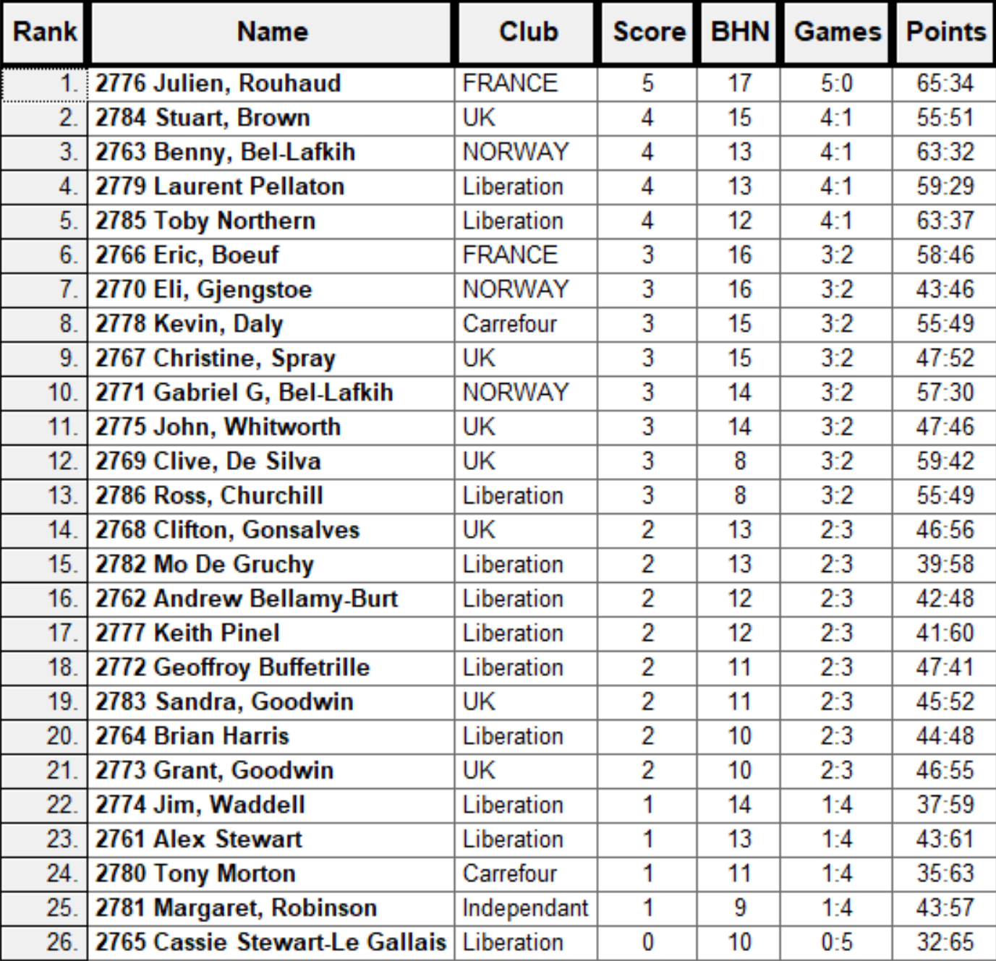

The Plate Competition

Due to an odd number of players, there were several byes in the last 16 round in the Plate Competition.

Alex lost out to his daughter Cassie 13 – 10 and Margaret couldn’t overcome fellow Carrefour player Tony, losing 13 – 4.

In the Quarter Finals there were six Jersey players joined by Sandra and Grant Goodwin.

Liberation player Keith beat Carrefour player Tony 13 – 8 and this was the same score as Geoffroy day got worse losing to Cassie.

Sandra beat Jim 13 – 10 but Grant couldn’t make it losing 13 – 5 to Keith.

In the Semi-finals

Keith made the final with a good win over Brian 13 – 7 and Sandra beat Cassie 13 – 5 as the finalists of the Plate were confirmed.

Cassie took third place with a win over Brian 13 – 12! And Keith Pinel took the Plate title with a 13 - 5 win over Sandra Goodwin

2023 – Plate - Winner – Keith Pinel

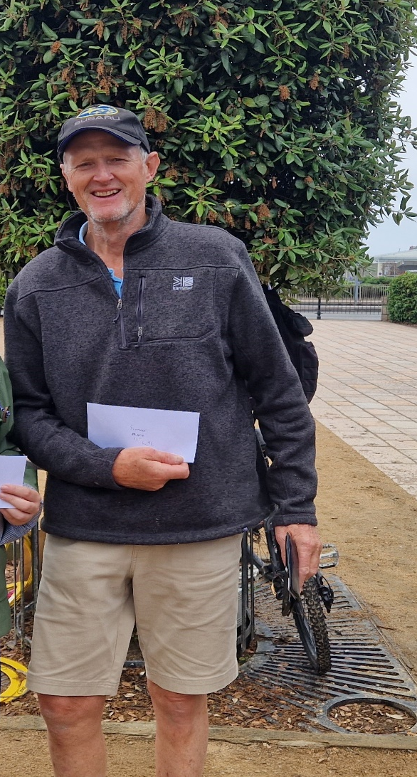

The Main Competition

Last 16

No Swiss curse this time round as Julian made light work of Andrew 13 – 5. Stuart Brown just beat Mo 13 – 10.

Benny overcame Clifton in a fairly close match 13 – 7 but a shock as Champion Laurent lost out to Ross 13 – 11!

In a rain affect round Toby recovered to beat Clive 13-10, but Eric made light work 13-0 over John.

The closest match of the round saw Mum Eli beat Son Gabriel 12-11 and Kevin made the quarter finals beating Christine 13 – 7.

The Main Competition

Quarter Finals

There were big wins for Eli 13 – 1 over Stuart and Benny 13 – 2 over Eric. Julian ended local Carrefour player Kevins run 13 – 7 and Toby fought back to beat Ross 13 – 9.

The Main Competition

Semi Finals

Julian had to fight hard in difficult conditions to overcome Toby doing so 13 – 7 and Benny beat Eli 13 – 3.

Third Place went to Eli beating Toby 13 – 9.

The Final could have been anybody’s with some excellent play. A few coche moves may have swung differently on another day but deserved win for Benny 13 – 11 in the end.

2023 – Main - Winner – Benny Bel-Lafkih

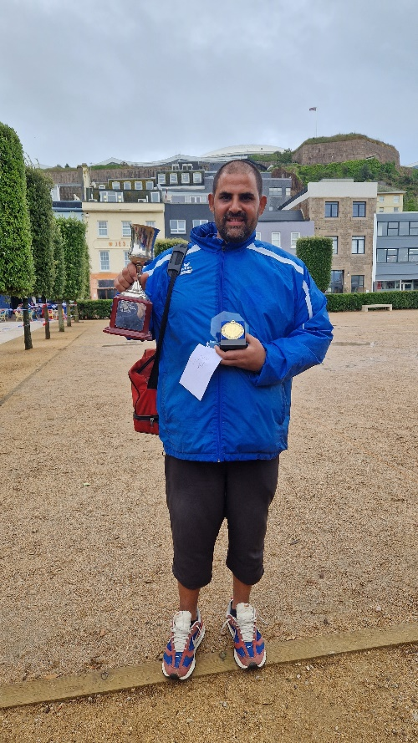

Thanks to all those who helped, especially Dawn Buckley on the day to make it another great competition.

Club email address - liberationpc@gmail.com

Club Website - www.liberationpetanque.co.uk

Kind Regards

Toby Northern

Chairman

Liberation Petanque Club

